ID: {mrn}

(PARAMETERS) | PHASE I | PHASE II | PHASE III
Site | {site}
Laterality | {laterality}
Verified Rx in Sensus EMR | {verifiedInSensus}
Cumulative Dose | {cumulativeDoseGy} Gy | Gy | (cGy) | Gy | (cGy)
Dose per FRACTION | {dosePerFractionCgy} cGy/fx | Gy/fx | (cGy/fx) | Gy/fx | (cGy/fx)
Total Fraction no. | {totalFractions} fractions | fractions | fractions
Time (minutes) | {timeMinutes} minutes | _ minutes | _ minutes
SSD | {ssdCm} cm | 15 cm | 15 cm
Energy | {energy}  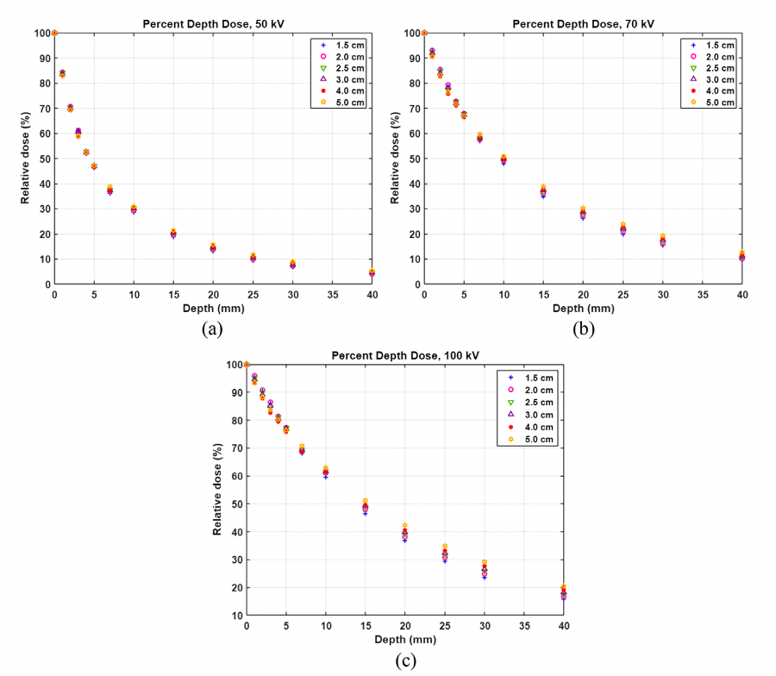 | 70 kV   | 50 kV  
Applicator size | {applicatorSize} | Applicator Size | Applicator Size
Margin | {margin} | mm around lesion | mm around lesion
Technique | {technique} | Superficial XRT | Superficial XRT
Lead Shield #1 Size | Circle, Radius _ cm | Circle, Radius _ cm | Circle, Radius _ cm
Lead Shield #2 Size | Circle, Radius _ cm | Circle, Radius _ cm | Circle, Radius _ cm
Lead Shield #3 Size | Circle, Radius _ cm | Circle, Radius _ cm | Circle, Radius _ cm
Thyroid Shield | {thyroidShield} | YES | YES
Lead Apron | {leadApron} | YES | YES
Nasal Bullet | None | None | None
Eye Shield Interior | None | None | None
Eye Shield Exterior | None | None | None
Lead Glasses | YES | YES | YES
Dose Rate | per plan | per plan | per plan
Beam Arrangement | {beamArrangement} | En Face Kilovoltage Photons | En Face Kilovoltage Photons
Technique | Superficial XRT | Superficial XRT | Superficial XRT
Shielding Design(s) | {shieldingDesign}
Fractions per day | {fractionsPerDay} | 1 | 1
Fractions per week | {fractionsPerWeek} | 1 | 1
Single or Multi phase | {phaseDesign} | Multi-phase | Multi-phase
Standard Fractionation vs. Hypofractionation | {fractionation} | Standard | Standard
Synchronous vs Sequential | {sequencing} | Sequential | Sequential
Imaging (77439 US) | {imagingGuidance} | 20 mHz: Daily isodose tracking dose to depth  50 MhZ: Weekly for comprehensive IGSRT | 20 mHz: Daily isodose tracking dose to depth  50 MhZ: Weekly for comprehensive IGSRT
Alignment | Align lesion in center of field | Align lesion in center of field | Align lesion in center of field
Custom Block | {customBlock} | NO | NO
Complex Shielding (77263) | {complexShielding} | NO | NO
In Vivo Dosimetry/Film | NO | NO | NO
GRID (Spatial Fractionation) | NO | NO | NO
Concurrent Therapy | {concurrentTherapy} | NO | NO
Prior RT | {priorRT} | No prior RT | No prior RT
Pre-Authorized | {preAuthorized} | NA | NA
Consult Images
Outside Biopsy Image
(if any available)
SIM ORDER Drawn Target
Sim Image:
Inked Target
Sim Image:
Shielded nozzle view
Sim Image:
Side nozzle view
Depth of Target (DOT) (Ultrasound) | Depth of Target (DOT): _
Estimated tumor a/b* | 10 | 10 | 10
EQD2 for tumor (a/b_10)
EQD2 for OARs (a/b_3)
BED for tumor (a/b_10)
BED for OARs (a/b_3)
Electronically Signed by: | {signedBy}  Radiation Oncologist
Date Ordered: | {orderedDate}

