SIMULATION ORDER
Lesion inked at border (no margin) | Lesion inked w/ ALL margins.
(Insert as drawing.) | (Insert as drawing.)
Lesion inked w/ Phase I margin. | Lesion inked w/ Phase II margin.
(Insert as drawing.)  Phase I Margin Instruction: {finalFieldDesign} | (Insert as drawing.)  Phase II Margin Instruction:

(Please reduce image size to keep the anticipated prescription table on the same page as table for images.)
ANTICIPATED PRESCRIPTION  Phase I |  |  | ANTICIPATED PRESCRIPTION  Phase II
Anticipated Energy | {anticipatedEnergy} |  | Anticipated Energy | _ | kV
Phase Total Dose | {phaseTotalDoseGy} | Gy | Phase Total Dose |  | Gy
Phase dose per fraction | {dosePerFractionGy} | Gy/Fx | Phase dose per fraction |  | Gy/Fx
Total fraction per phase | {totalFractions} | fractions | Total fraction per phase |  | fractions
Total Dose |  | Gy | Total Dose |  | Gy
Weekly Fractionation Schedule | {weeklySchedule} |  | Weekly Fractionation Schedule

PHOTOS: TREATMENT PLANNING CHECKLIST |  | CHAIR SETUP: {chairSetup}
- 1. Ruler Measurement of required treatment margin. |  | - Face the wall at max angle
- 2. Inked Target Photo |  | - Facing the cabinet
- 3. Sensus Ruler Circle Measurement Image |  | POSITION
- 4. Shielded Image Photo |  | - Upright
- 5. En Face (straight-on) photo of the treatment area |  | - Sitting (reclined) _
- 6. Photo of SRT Sensus screen |  | - Supine
- 7. Transparent field template |  | - Prone
- 8. Light Field Verification Photo |  | MARKERS
SET-UP PHOTOS |  | - Sharpie custom 10mm + 5mm radius lesion
- Distant photo of location of the lesion without ink. |  | - BBs
- Close-up photo of the lesion without ink markings. |  | - Scar
- Full room shot of the entire setup for treatment. |  | - Wire
Pre-XRT Photo |  | ULTRASOUND IMAGING: {imaging}
- Baseline w/o markings |  | - 50 MHz
- with ruler (WIDTH) |  | - 20 MHz
- with ruler (HEIGHT) |  | - 12 MHz
- Photo with ruler x3 for WIDTH & HEIGHT |  | - Formal Read: route to MD
- with ruler Length |  | DERMOSCOPY
SHIELDS/DEVICES |  | - Non-polarized
- Motor chair |  | - Cross Polarized
- Prone Pillow |  | - Linearly Polarized
- Thyroid guard |  | - UV Light
- Lead Apron N/A |  | - Pigment Boost
- Numbing drops N/A |  | INDIVIDUAL DAILY SETUP
- Mouth Guard |  | - Photography
- Nasal Bullets N/A |  | - Dermoscopy
- Mucosa Shield |  | - 20 MHz Ultrasound
- External eyeshield N/A |  | INDIVIDUAL WEEKLY SETUP
- Internal eyeshield N/A |  | - Photography
- Flat patient table |  | - Dermoscopy
- Custom: scalp and parotid shield |  | - 50 MHz Ultrasound
- Leaded Goggles N/A |  | CAREPATH: 10-day care path
PHYSICS REQUIREMENTS
SPECIAL PHYSICS: {specialPhysics} |  | Reason: Adaptive planning
WEEKLY PHYSICS: {weeklyPhysics} |  | Reason: Weekly chart and coverage checks
IN VIVO DOSIMETRY: No |  | Reason: Select
RADIATION ONCOLOGIST: |  | DATE COMPLETED
{radiationOncologist} |  | {dateCompleted}
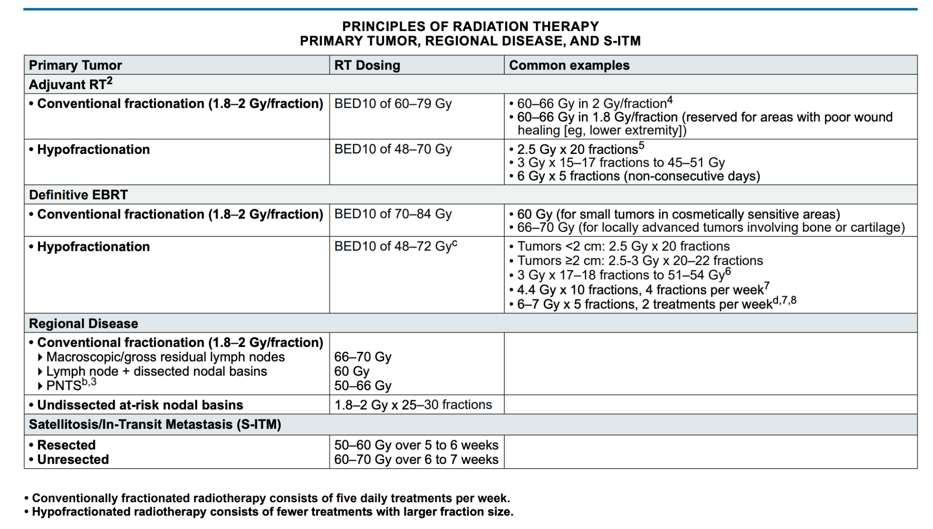

CLINICAL TREATMENT PLAN
ID: {mrn}
ICD Code: _
Lesion w/o ink |  | Dermoscopy inked at border | UV dermoscopy
LESION DETAILS:
Diagnosis: | {diagnosis}
Laterality: | {laterality}
Location: | {site}
REVIEW OF CLINICAL PARAMETERS:
Performance status:
Prior therapies: | No
Radiation sensitivity factors: | Select
Wound healing risk: | Select
Travel Plans: | No
RADIATION THERAPY RISK FACTORS:
Prior RT: | No
Autoimmunity: | No
Pacemaker: | No
Other Implanted Devices: | No
RADIATION THERAPY PLANNING:
Number of targeted regions: | 1 (Simple)
Number of fields: | 1 (Simple)
Beam complexity: | 1 beam or 2 parallel opposed (simple)
Blocking: | Simple or no blocking (simple)
Type of Radiation: | Superficial Radiation Therapy
Medical Necessity Rationale: | - highly complex blocking |  | - modality combination
 | - custom devices |  | - dose-volume calculations
CPT Code: | 77261: Radiation Therapy Planning Simple
Literature Citation Justification: | IGSRT Literature: PMID: 37781716
CONSENT: SIGNATURE |  | Within the 90-day validity period?: No
CONSENT: LATERALITY
Pathologic confirmation of disease:

Toxicity Risks Discussed
Short-term Toxicities | Long-term Toxicities
- Erythema (redness  - Edema (swelling)  - Pain  - Fatigue  - Pruritus (itching),  - Hyperpigmentation (skin pigmentation)  - Hair loss in the treated area  - Dry desquamation (peeling skin)  - Blistering  - Moist desquamation (weeping skin)  - Dermatitis (skin inflammation)  - Ulceration (skin breakdown)  - Non-healing and poorly healing wounds  - Increased risk of infection. | - Persistent erythema (skin redness)  - Hypopigmentation (lightened skin) or hyperpigmentation (darkened skin)  - Skin dryness  - Tenderness on the treated area  - Permanent hair loss of variable degree  - Scarring of skin  - Skin atrophy (thinning)  - Telangiectasias (spider veins)  - Ulceration (skin breakdown) with delayed wound healing or non-healing  - Altered growth, texture, and/or color of hair  - Injury to underlying structures (e.g., eye, salivary glands, brain/headache)  - Mucositis (inflammation of the mucous membranes)  - Gingival reaction (gum irritation))  - Radiation-induced or secondary malignancies

Orthovoltage Clinical Treatment Planning Details: The attending radiation oncologist cited above personally performed and oversaw orthovoltage clinical treatment planning activities for the specified radiation type targeting the target condition. These activities are medically necessary due to the medical necessity rationale, ensuring optimal therapeutic outcomes per evidence-based standards, and demonstrate the work typically included in CPT codes 77261 (simple therapeutic radiology treatment planning, defined as planning for a single treatment area encompassed in a single port or simple parallel opposed ports with simple or no blocking), 77262 (intermediate, defined as planning for multiple treatment areas, multiple ports, or special time-dose constraints), or 77263 (complex, defined as planning requiring highly complex blocking, custom shielding blocks, tangential ports, wedges, rotation or arc therapy, or special blocks/compensators) based on complexity.
Simple Clinical Treatment Planning (77261 - Single Area, Simple Ports/Blocking): For simple orthovoltage therapy (e.g., superficial targets with single port or parallel opposed /simple or no blocking), the planning focused on basic integration:
(i)Reviewed patient history, including prior therapies, comorbidities, and the individual parameters, to tailor a straightforward treatment strategy encompassing a single treatment area with simple or no blocking; (ii)Reviewed the imaging data reviewed to verify alignment of a single port or simple parallel opposed ports with the target volume, adjusting patient positioning and/or immobilization devices for reproducibility; (iii)Incorporated factors into the clinical plan, involving low medical decision-making with analysis of the data elements analyzed and assessment of the risk level of complications, balancing the dose and fractionation and the beam energy against the toxicity risks, aligning with the national guidelines and/or the literature citation.
Intermediate Clinical Treatment Planning
Intermediate Clinical Treatment Planning (77262 - Multiple Areas, Multiple Ports, Special Constraints): For intermediate orthovoltage therapy (e.g., involving multiple treatment areas or ports with special time-dose constraints), the planning involved moderate complexity: (i) Reviewed patient history, including prior therapies, comorbidities, and the individual parameters, to tailor the treatment strategy for multiple areas/ports, incorporating special constraints like fractionation timing or dose limits due to comorbidities; (ii) Reviewed the imaging data reviewed to verify alignment of multiple ports with the target volumes, adjusting patient positioning and/or immobilization devices based on individual parameters such as body habitus, going beyond simple review by incorporating multi-angle verification and/or real-time adjustments; (iii) Incorporated factors into the clinical plan, involving moderate medical decision-making with analysis of the data elements analyzed and assessment of the risk level of complications, balancing the dose and fractionation and the beam energy against the toxicity risks, aligning with the national guidelines and/or the literature citation.
Complex Clinical Treatment Planning (77263 - Highly Complex Blocking, Custom Shielding, Tangential/Rotational Ports):
For complex orthovoltage therapy (e.g., deep targets requiring custom shielding, tangential ports, wedges, or rotational setups), the planning involved high complexity: (i) Reviewed patient history, including prior therapies, comorbidities, and the individual parameters, to tailor the treatment strategy with highly complex blocking, custom shielding, or special compensators for extended fields or irregular anatomy; (ii)Reviewed the imaging data reviewed for detailed contouring and verification of tangential/rotational ports or arc therapy alignments, adjusting patient positioning and/or immobilization devices based on individual parameters, incorporating advanced multi-angle verification and/or real-time adjustments for inhomogeneities; (iii) Incorporated all factors into the clinical plan, involving high medical decision-making with analysis of the data elements analyzed and assessment of the risk level of complications, balancing the dose and fractionation and the beam energy against elevated toxicity risks, aligning with the national guidelines and/or the literature citation.
This orthovoltage clinical treatment planning process is medically necessary and reflects a comprehensive, justified, and individualized patient-centric strategy, separate from technical radiation planning or treatment delivery/management, optimizing outcomes while mitigating risks through evidence-based clinical decision-making.

Ultrasound-Guided Superficial RT Order
To ensure accurate treatment delivery, a prescription for daily image verification utilizing Serial High-Frequency Ultrasound is hereby ordered, valid through the current course of therapy. This daily image-guided monitoring is required to verify the lesion, accurately assess maximal tumor depth, and provide the essential data needed to aid physics review and justify the clinical need for the selected treatment energy. The imaging will be used to verify the treatment shield's alignment with target anatomy, enable ongoing depth dose calculations for adaptive planning, and quantitatively track the tumor's response. This ensures the therapeutic dose consistently covers the entire tumor while minimizing radiation exposure to surrounding healthy tissues.
- Image Guidance Ultrasound Prescription
Frequency | Guidance Purposes | Application (Max imaging depth)
- 12 MhZ | US-Mapping | Soft tissue (up to 6 cm)
- 20 MhZ | Daily Treatment | Subcutaneous / dermis (up to 13 mm)
- 50 Mhz | On-treatment visit | Epidermis (up to 10 mm)
SSD | Wand to skin
Protection | Tegaderm for peri-ocular structures
Dose tracking | Daily dose tracking of percent depth dose isodose curves w/ongoing physics consultation
Unlimited ultrasound images, sufficient for daily tracking and at least one per day capable of measuring the maximum depth of target (DOT) distance.

As the prescribing radiation oncologist, I authorize the Radiation Therapy Technologist (RTT) to perform the following imaging procedures for treatment planning and image-guided radiation therapy (IGRT) verification. These images are essential for accurate tumor targeting, patient positioning, and minimizing exposure to healthy tissues. The RTT may acquire planning X-ray images during simulation sessions and IGRT images prior to or during treatment fractions as specified. All imaging must be conducted under my supervision or per protocol, with images reviewed by me or a qualified physicist for quality and alignment. Documentation of each session, including date, time, modality, and any adjustments, will be recorded in the patient's record to support medical necessity and billing in each patient’s fractionation log.

Electronically signed by:
Clayton B. Hess, MD MPH
Medical Director, Radiation Oncologist
CureRays Radiation Medicine

