**Week 01 tutorial:**

In order to get familiar with the command, initially we started with the GitHub, installation of the Linux and the PowerShell.

1. **Get- NetAdapter:**

This command displays the basic information of the network adapter.

**ip link:**

1. **Get- NetIPAddress:**

The command gives information about the IP address configuration for all IPV6 address on the computer.

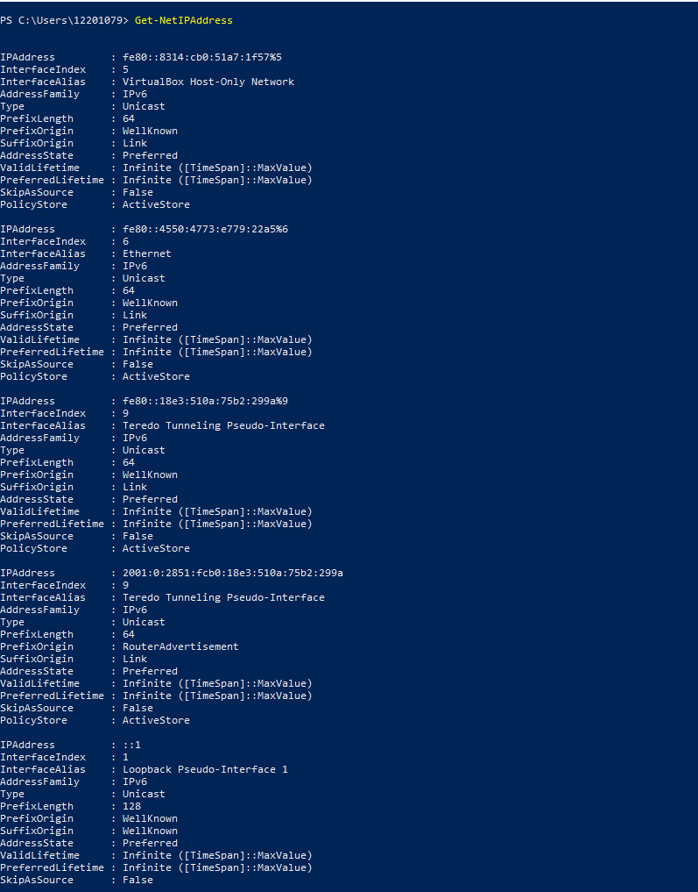

1. **Test-Connection:**

The test-connection helps to ping one or more host and gives back the response.

**Ping:**

1. **Test-NetConnection**

This command shows the information about a the connection whereas the test run on the PowerShell shows the information about the network connection with the information of the host, remote address, source address and the latency of the network.

**Traceroute in Linux:**

1. **Get-NetNeighbor**

**arp**

1. **Get-NetRoute**

**Route:**

1. **Resolve‐DnsName**

This command is executed to display the ip address of the domain name and vice versa.

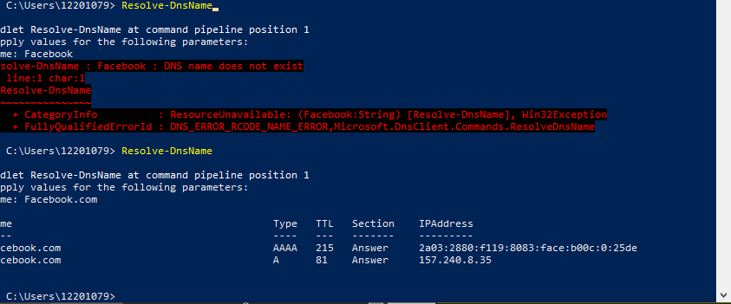

**nsLookup:**

This command is executed to display the ip address of the domain name and vice versa.

**Week 02 Tutorial**

Ping your OpenWRT Linux Server

The main objective of this tutorial is to capture the packets and ping the OpenWRT server. Once the packages are captured then transfer it to Windows. Here are the step by step process done in the PowerShell along with Linux ‘OpenWRT server’.

Initially we have to capture the packet in Linux, executing the command ‘tcpdump –i eth0 –n –w ping1.pcap ‘arp or icmp’. The below figure shows the execution of the command in the OpenWRT server.

Once the packets are captured then we need to ping the server in Window Host. In order to do that we have to execute the command ‘Test-Connection 192.168.56.2 –Count 10’. It will show the below result.

The next step is to check in captured packet in your computer. We check that file into the FileZilla.

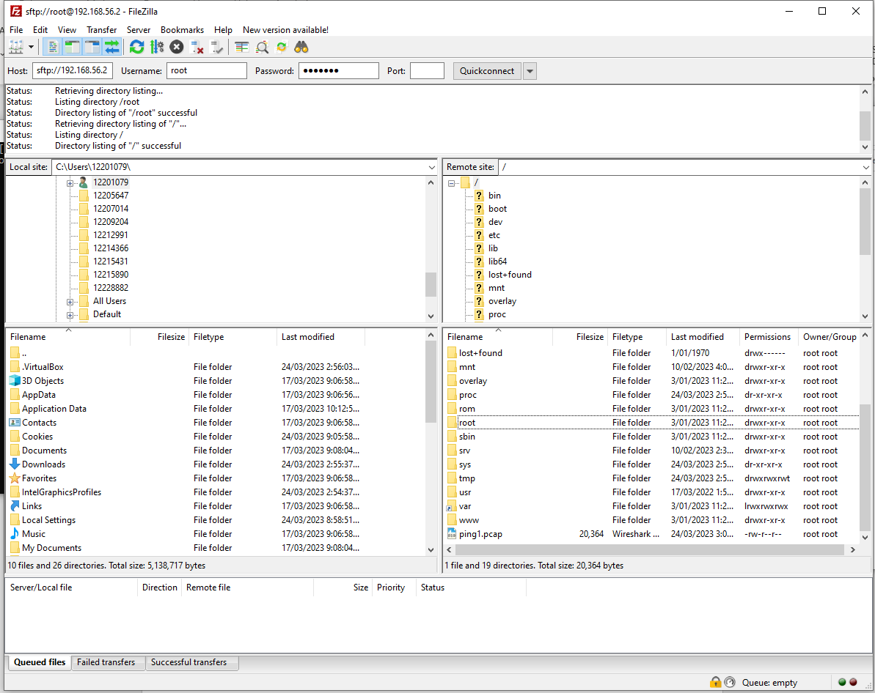

**Week 03 Tutorial**

1. **ARP Table**

Address Resolution Protocol is the protocol which are used to map mac address to ip address. The following figure shows the execution of the command ‘arp –a’ which displays the network which are active within the our network and also it provides the physical address, which is also known as the MAC address.

However, when we try to ping the address beyond the address the host will not receive any respond but when we try to ping the address within the network it will receive the respond.

1. **Analyse Ping Packet Capture**
2. **Inspecting the packets in Wireshark.**

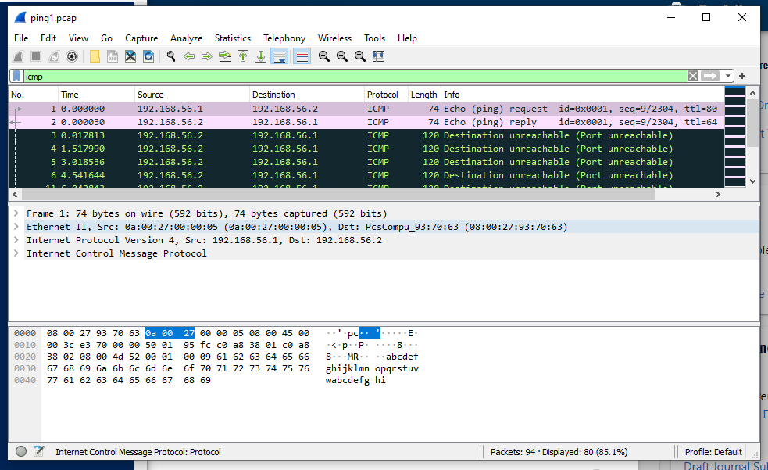

1. **Draw a network diagram, labelling the devices with IP addresses and MAC addresses where known:**

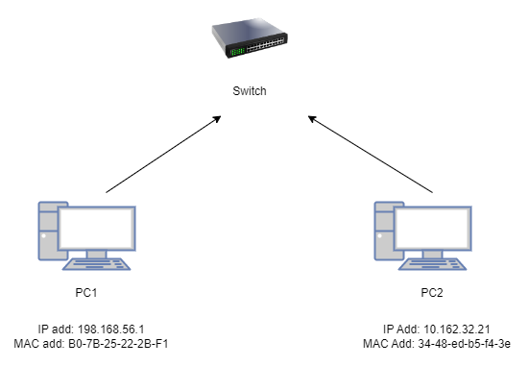

1. **Explain the purpose of ARP packets. Who sent them? Why? Who did they send to?**

The purpose of the ARP packets are to find out the MAC address. The ARP packets are sent by the host which consists of a MAC address of the destination IP address. The arp packets are sent in order to know the MAC address of a particular destination IP address. The ARP packets are send to the source device who requires the MAC address of the targeted IP address.

1. **Draw a packet diagram for the 1st ARP packet that shows encapsulation. Label the size (in Bytes) of the entire packet as well as of the different headers, data, footers (where they exist).**

|  |  |
| --- | --- |
| **Destination Address(6 bytes)**  **MAC add: 0a:00:27:00:00:05** | |
| **Source Address(6 bytes)**  **MAC add: 08:00:27:93:70:63** | |
| **Type 0**  **(2 bytes)** | **Checksum(4 bytes)** |
| **Data** | |

**Fig: Packet Diagram for 1st ARP packet**

1. **Explain the first two ICMP packets.**

The first two ICMP packets are:



The first ICMP with the source address 192.168.56.1(MAC address 0a:00:27:00:00:05), with the total length of 74 bytes which request the message. The version of the internet protocol is 4. The length of the header is 20 bytes.

The second ICMP which reply the message has the destination address 192.168.56.2 (MAC address 08:00:27:93:70:63) with the total 74 bytes. The internet protocol version is also 4. The length of the header is 20 bytes.

1. **Draw a packet diagram for the first ICMP packet.**

|  |  |  |
| --- | --- | --- |
| **Type(8)** | **Code(0)** | **ICMP Checksum** |
| **Identifier(0)** | | **Sequence Number** |
| **Data(32 bytes)** | | |

**Fig: Packet Diagram for first ICMP packet**

1. 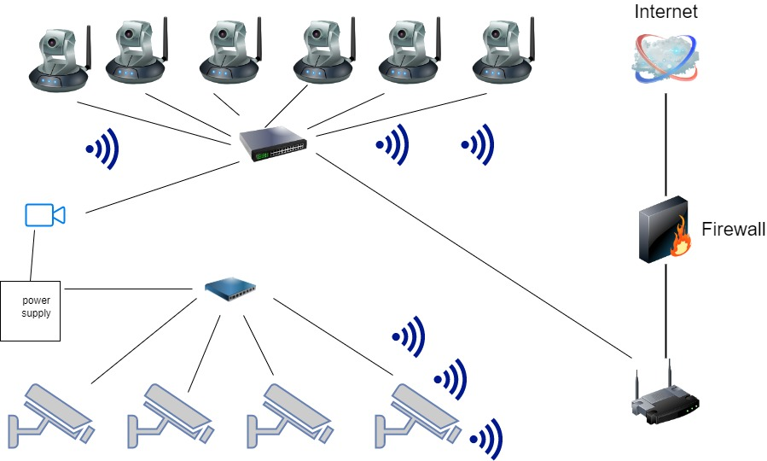**Design a Small Network  
   a. A diagram of the network.**

**b. Explanation of the design (e.g. why did you choose a particular design/equipment), and any installation advice.**

For the network design, the older cameras are connected with power point which is connected with the power supply which is connected with video recorder whereas, the new cameras are connected with the switch.

The video recorder is used for the old cameras since it is powered by the power point and it records both cameras. Switch is used so that it makes easier for the installation.

The video recording should be kept in a secure place. The Switch must be installed in a proper place.

**c. Table listing equipment to be purchased.**

|  |  |
| --- | --- |
| Switch | 1 unit with 6 ports |
| Video Recorder | 1 unit |
| New Cameras | 6 unit |
| Power supply | 1 unit |
| Power Point | 1 unit |

**Learning Reflection:**

The command that will be useful outside of the unit is ‘ip addr’ since it will be useful to get the ip address of the system.