assignment 6

2018395968

2025-05-28

# 1. Residual Variability

Residual variability refers to the unexplained or random variation in data that cannot be accounted for by the main factors or variables in a model or analysis.(Quickonomics, 2024)

This is the difference between the observed marks assigned to students and the true mark that reflect their performance in research and presentation and this can be brought about by;

1. The niceness or meanness of the assessor, leniency or severity of the assessor, leads to under-scoring or over-scoring, introducing variability that does not reflect reflect the students’ actual performance
2. The Group dynamics, since the presentations are group-based, individual student contributions to the research and presentation may vary but the assessors assign a group mark based on the overall performance, which will bring residual variability if the assessors differ in how they perceive group vs individual contribution
3. Assessors may differ in how they consistently apply the rubric. Some might be precise others more erratic. Also one assessor might emphasize clarity of delivery more heavily while another may prioritize research depth.
4. The quality of a student’s presentation may vary slightly due to factors like nervousness, delivery differences, or minor inconsistencies in content, which are not fully captured by the rubric but affect the assessor’s perception.

# 2. Additional assumptions

1. Sufficient number of assessors, for the average to be reliable, there must be a sufficiently large number of assessors to ensure that random variations in marking cancel out. A small number of assessors could lead to averages that are still noisy.
2. Consistency in presentation quality, it is assumed that a students’ presentation does not vary significantly in quality during the session. If performance fluctuates, it could introduce additional variability not accounted for.
3. Rubric is Applied Consistently, while the rubric is assumed to correctly weight learning aspects, it’s also implicitly assumed that all assessors interpret and apply it in the same way. If assessors weigh criteria differently (for example, one prioritizes delivery, another content), this introduces variability not accounted for by neutrality.Consistent rubric application ensures marks reflect the same performance aspects across assessors. (OpenAI)

# 3. Data

data <- openxlsx::read.xlsx('BayesAssignment6of2025.xlsx', sheet = 5)  
  
summary(data)

## Group LecturerA LecturerB LecturerC   
## Length:13 Min. :49.00 Min. :61.00 Min. :49.00   
## Class :character 1st Qu.:56.50 1st Qu.:66.50 1st Qu.:67.00   
## Mode :character Median :59.00 Median :71.50 Median :71.00   
## Mean :61.18 Mean :70.12 Mean :69.54   
## 3rd Qu.:68.50 3rd Qu.:74.25 3rd Qu.:76.00   
## Max. :72.00 Max. :76.00 Max. :78.00   
## NA's :2 NA's :5   
## LecturerD LecturerE LecturerF LecturerG LecturerH   
## Min. :63.0 Min. :61.00 Min. :58.00 Min. :58.0 Min. :61.00   
## 1st Qu.:66.0 1st Qu.:67.75 1st Qu.:71.00 1st Qu.:62.0 1st Qu.:70.00   
## Median :70.0 Median :72.00 Median :74.00 Median :63.0 Median :75.00   
## Mean :70.2 Mean :70.88 Mean :73.71 Mean :64.8 Mean :74.00   
## 3rd Qu.:71.5 3rd Qu.:73.75 3rd Qu.:79.00 3rd Qu.:64.0 3rd Qu.:77.75   
## Max. :81.0 Max. :78.00 Max. :84.00 Max. :77.0 Max. :86.00   
## NA's :3 NA's :5 NA's :6 NA's :8 NA's :7   
## LecturerI Proposal Literature Quiz Interview   
## Min. :66.00 Min. :52 Min. :59 Min. :61.00 Min. :58.00   
## 1st Qu.:73.00 1st Qu.:63 1st Qu.:68 1st Qu.:66.00 1st Qu.:67.00   
## Median :75.00 Median :69 Median :74 Median :74.00 Median :70.00   
## Mean :75.56 Mean :68 Mean :75 Mean :75.08 Mean :70.23   
## 3rd Qu.:77.00 3rd Qu.:72 3rd Qu.:82 3rd Qu.:85.00 3rd Qu.:76.00   
## Max. :90.00 Max. :86 Max. :91 Max. :88.00 Max. :80.00   
## NA's :4

md.pattern(data)

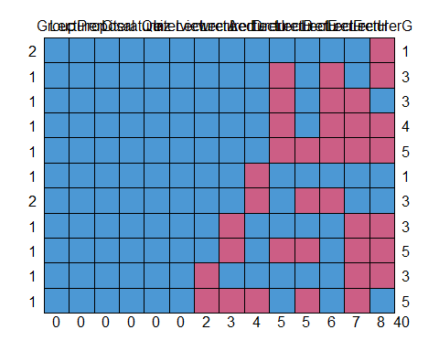

## Group LecturerC Proposal Literature Quiz Interview LecturerA LecturerD  
## 2 1 1 1 1 1 1 1 1  
## 1 1 1 1 1 1 1 1 1  
## 1 1 1 1 1 1 1 1 1  
## 1 1 1 1 1 1 1 1 1  
## 1 1 1 1 1 1 1 1 1  
## 1 1 1 1 1 1 1 1 1  
## 2 1 1 1 1 1 1 1 1  
## 1 1 1 1 1 1 1 1 0  
## 1 1 1 1 1 1 1 1 0  
## 1 1 1 1 1 1 1 0 1  
## 1 1 1 1 1 1 1 0 0  
## 0 0 0 0 0 0 2 3  
## LecturerI LecturerB LecturerE LecturerF LecturerH LecturerG   
## 2 1 1 1 1 1 0 1  
## 1 1 0 1 0 1 0 3  
## 1 1 0 1 0 0 1 3  
## 1 1 0 1 0 0 0 4  
## 1 1 0 0 0 0 0 5  
## 1 0 1 1 1 1 1 1  
## 2 0 1 0 0 1 1 3  
## 1 1 1 1 1 0 0 3  
## 1 1 0 0 1 0 0 5  
## 1 1 1 1 1 0 0 3  
## 1 0 1 0 1 0 1 5  
## 4 5 5 6 7 8 40

# Summary of the data

There are 13 groups, assessed by 9 lecturers,(Lecturer A to Lecturer I) for presentations and the missing values represents would be when the Lecturer was not present to assess the presentation.

Only one lecturer (lecturer C) was available for all the 13 presentations, with the lowest mark of 49 and the highest mark of 78.

We can classify the pattern of missingness into 3 categories.

**High Missingness** : LecturerG (8/13) and LecturerH (7/13).

**Moderate Missingness** : LecturerF (6/13), LecturerB and LecturerE both on (5/13).

**Low Missingness** : LecturerA (2/13), LecturerD (3/13) and LecturerI (4/13)

The pattern of missingness is non-uniform, reflecting the problem’s statement that some assessors view only a subset of presentations, with a few viewing most or all.

## Marks Distribution

Marks range from 49 (LecturerA, LecturerC) to 90 (LecturerI).

Mean marks vary across lecturers: lowest for LecturerA (61.18) and highest for LecturerI (75.56).

Medians range from 59 (LecturerA) to 75 (LecturerH, LecturerI).

Variability (based on interquartile range, IQR) differs: LecturerG has a narrow IQR (62–64), indicating consistent marking, while LecturerF has a wider IQR (71–79), suggesting greater variability.

Other components that contribute to the final mark are Proposal, Literature, Quiz and Interview.

# Question 4

We structure data into a long format, that way each row represents a mark, with columns identifying the group, the lecturer and the mark itself. This way we can explicitly see the crossed structure of the data.

Also removed missing values because they don’t represent any actual observation.

long_data <- data %>%  
 mutate(Group = sub("^Group", "", Group))%>%  
 select(Group, LecturerA:LecturerI) %>%  
 pivot_longer(cols = LecturerA:LecturerI, names_to = "Lecturer", values_to = "Mark") %>%  
 filter(!is.na(Mark))  
  
head(long_data)

## # A tibble: 6 × 3  
## Group Lecturer Mark  
## <chr> <chr> <dbl>  
## 1 1 LecturerB 75  
## 2 1 LecturerC 71  
## 3 1 LecturerF 84  
## 4 1 LecturerG 63  
## 5 2 LecturerA 71  
## 6 2 LecturerB 72

nrow(long_data)

## [1] 77

## Fitting the mixed effect

model <- lmer(Mark ~ Group + (1|Lecturer), data = long_data)  
  
summary(model)

## Linear mixed model fit by REML ['lmerMod']  
## Formula: Mark ~ Group + (1 | Lecturer)  
## Data: long_data  
##   
## REML criterion at convergence: 444.4  
##   
## Scaled residuals:   
## Min 1Q Median 3Q Max   
## -2.15488 -0.63713 0.05085 0.61003 1.78618   
##   
## Random effects:  
## Groups Name Variance Std.Dev.  
## Lecturer (Intercept) 17.90 4.231   
## Residual 34.81 5.900   
## Number of obs: 77, groups: Lecturer, 9  
##   
## Fixed effects:  
## Estimate Std. Error t value  
## (Intercept) 73.1146 3.3535 21.802  
## Group10 0.1017 3.9927 0.025  
## Group11 -1.6148 3.8948 -0.415  
## Group12 -2.3450 3.9050 -0.600  
## Group13 -2.2388 4.3523 -0.514  
## Group2 -0.8323 3.7254 -0.223  
## Group3 -3.9573 3.7254 -1.062  
## Group4 -0.2137 4.2948 -0.050  
## Group5 5.8855 3.9352 1.496  
## Group6 -9.0822 3.6802 -2.468  
## Group7 -10.7815 3.8948 -2.768  
## Group8 0.5374 4.1411 0.130  
## Group9 -10.6450 3.9044 -2.726

fixef(model)

## (Intercept) Group10 Group11 Group12 Group13 Group2   
## 73.1146437 0.1016622 -1.6147845 -2.3449568 -2.2388145 -0.8322642   
## Group3 Group4 Group5 Group6 Group7 Group8   
## -3.9572642 -0.2137309 5.8855121 -9.0821935 -10.7814512 0.5373505   
## Group9   
## -10.6450247

ranef(model)

## $Lecturer  
## (Intercept)  
## LecturerA -7.6030503  
## LecturerB 1.5425918  
## LecturerC -0.7564101  
## LecturerD -0.4034582  
## LecturerE 0.2433458  
## LecturerF 3.4962075  
## LecturerG -3.7409639  
## LecturerH 3.9621355  
## LecturerI 3.2596017  
##   
## with conditional variances for "Lecturer"

**Scale residual** (-2.15 to 1.79) suggests there are no extreme outliers.

**Intercept** (73.1146): This is Group1, which acts as a reference group.

**Fixed Effect** The fixed effect provides the adjusted mean mark per group.

**Random Effect** std.Dev(4.231) on average, a lecturer’s making deviates by about +/- 4.23 marks from the group mean

**Residual Variance** Std.Dev(5.900), residual errors vary by about +/-5.9 marks, capturing random fluctuations.

## Residual for normality and homoscedasticity

plot(model)

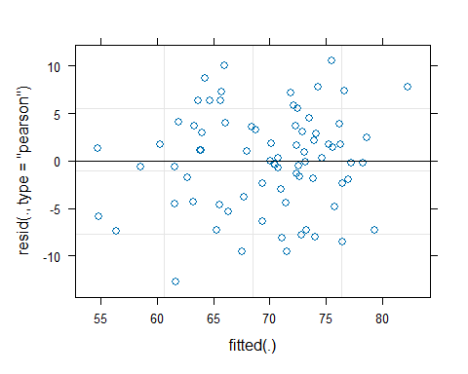

qqnorm(resid(model))

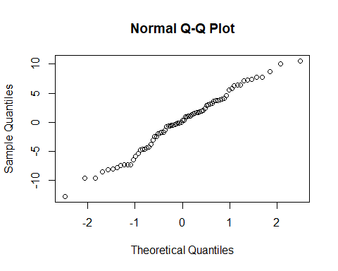

# Question 5

## Fixed Effect:

Fixed effects are variables of primary interest. In this study, Groups is a fixed effect. (Mustafa, 2023)

Groups are treated as fixed effects because the study aims to estimate their specific performance levels, and they represent the complete set of interest

## Random Effect:

Random effects are used to account for variability and differences between different entities.(Mustafa, 2023)

Lecturers are treated as random effects because their biases and variability are sources of unwanted variation.

# Appropriate Model using default priors

In this question, i could have used the formula = Mark ~ Group + (1|Lecturer), but choose formula = Mark ~ 0 + Group + (1|Lecturer) because it suppresses the global intercept, therefore there is no reference mean mark. each group’s coefficient directly represents its marks.

long_data <- data %>%  
 mutate(Group = sub("^Group", "", Group)) %>%  
 select(Group, LecturerA:LecturerI) %>%  
 pivot_longer(  
 cols = LecturerA:LecturerI,  
 names_to = "Lecturer",  
 values_to = "Mark",  
 values_drop_na = TRUE  
 ) %>%  
 mutate(Group = factor(Group), Lecturer = factor(Lecturer))  
  
model_bayes <- brm(  
 formula = Mark ~ 0 + Group + (1|Lecturer),  
 data = long_data,  
 family = gaussian(),  
 chains = 4,  
 iter = 4000,  
 warmup =2000,   
 cores = 4,   
 seed = 2018395968  
)  
  
summary(model_bayes)

## Family: gaussian   
## Links: mu = identity; sigma = identity   
## Formula: Mark ~ 0 + Group + (1 | Lecturer)   
## Data: long_data (Number of observations: 77)   
## Draws: 4 chains, each with iter = 4000; warmup = 2000; thin = 1;  
## total post-warmup draws = 8000  
##   
## Multilevel Hyperparameters:  
## ~Lecturer (Number of levels: 9)   
## Estimate Est.Error l-95% CI u-95% CI Rhat Bulk_ESS Tail_ESS  
## sd(Intercept) 4.69 1.62 2.29 8.48 1.00 2375 3890  
##   
## Regression Coefficients:  
## Estimate Est.Error l-95% CI u-95% CI Rhat Bulk_ESS Tail_ESS  
## Group1 73.15 3.50 66.24 80.10 1.00 4491 5099  
## Group10 73.23 3.04 67.22 79.33 1.00 3438 4138  
## Group11 71.46 3.08 65.46 77.52 1.00 4035 3909  
## Group12 70.79 3.01 64.80 76.77 1.00 4104 4666  
## Group13 70.84 3.66 63.67 78.14 1.00 3990 4446  
## Group2 72.28 2.72 66.93 77.58 1.00 3593 3953  
## Group3 69.17 2.75 63.74 74.57 1.00 3170 4125  
## Group4 72.85 3.57 65.83 79.96 1.00 4770 4488  
## Group5 78.96 3.04 72.99 85.05 1.00 3718 3607  
## Group6 64.03 2.78 58.61 69.56 1.00 3477 3755  
## Group7 62.36 3.02 56.48 68.38 1.00 3715 3500  
## Group8 73.61 3.32 67.14 80.26 1.00 4108 3588  
## Group9 62.44 2.96 56.71 68.23 1.00 4018 4452  
##   
## Further Distributional Parameters:  
## Estimate Est.Error l-95% CI u-95% CI Rhat Bulk_ESS Tail_ESS  
## sigma 6.03 0.58 5.03 7.30 1.00 5815 5600  
##   
## Draws were sampled using sampling(NUTS). For each parameter, Bulk_ESS  
## and Tail_ESS are effective sample size measures, and Rhat is the potential  
## scale reduction factor on split chains (at convergence, Rhat = 1).

**Lecturer (sd(Intercept))** Lecturers’ marks deviate by +/-4.69 .

Est.Error: 1.62 (posterior standard deviation, showing uncertainty). 95% Credible Interval (CI): [2.29, 8.48], indicating the plausible range of lecturer variability. Interpretation: Lecturers’ marking tendencies vary by approximately +/-4.69 marks around the group means. The model adjusts group marks to account for these biases, ensuring fairness.

Residual (sigma):

Estimate: 6.03 (posterior mean of residual standard deviation). Est.Error: 0.58. 95% CI: [5.03, 7.30]. Residual variability is 6.03, nearly identical to the earlier Bayesian fit (6.03) and frequentist model (5.898). This captures unexplained factors like assessor subjectivity, random errors, or group dynamics

Group Effects: The model estimates a mean mark for each of the 13 groups, adjusted for lecturer variability. These are the fair marks you need for your goal.

Est.Error: Ranges from 2.72 (Group2) to 3.57 (Group4), indicating uncertainty in each mark estimate. 95% CI: Shows the range where the true mark likely lies with 95% probability ( Group1: [62.42, 80.10], Group5: [72.99, 85.05]).

plot(model_bayes)

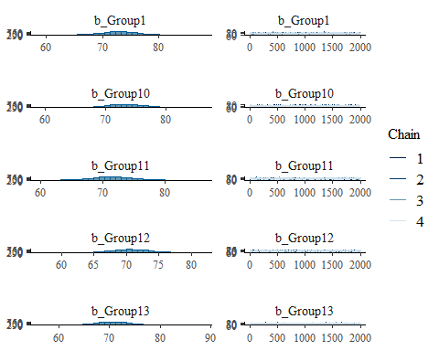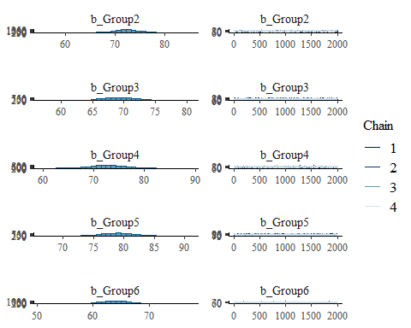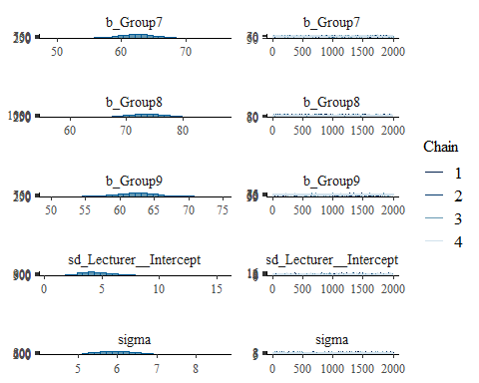

pp_check(model_bayes, type = "dens_overlay")

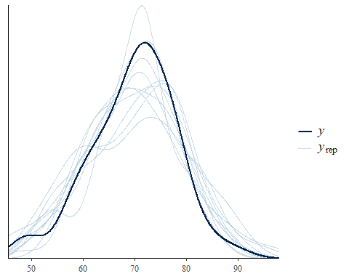

# Estimate Mark

fairmarks <- fixef(model_bayes)  
  
adjusted_marks <- data.frame(  
 Group = paste0("Group", 1:13),  
 Adjusted_Mark = fairmarks[paste0("Group", 1:13), "Estimate"],  
 Lower_CI = fairmarks[paste0("Group", 1:13), "Q2.5"],  
 Upper_CI = fairmarks[paste0("Group", 1:13), "Q97.5"]  
) %>%  
 mutate(across(c(Adjusted_Mark, Lower_CI, Upper_CI), ~ round(., 2)))  
  
  
print(adjusted_marks)

## Group Adjusted_Mark Lower_CI Upper_CI  
## Group1 Group1 73.15 66.24 80.10  
## Group2 Group2 72.28 66.93 77.58  
## Group3 Group3 69.17 63.74 74.57  
## Group4 Group4 72.85 65.83 79.96  
## Group5 Group5 78.96 72.99 85.05  
## Group6 Group6 64.03 58.61 69.56  
## Group7 Group7 62.36 56.48 68.38  
## Group8 Group8 73.61 67.14 80.26  
## Group9 Group9 62.44 56.71 68.23  
## Group10 Group10 73.23 67.22 79.33  
## Group11 Group11 71.46 65.46 77.52  
## Group12 Group12 70.79 64.80 76.77  
## Group13 Group13 70.84 63.67 78.14

Adjusted_Mark: The posterior mean mark for each group, adjusted for lecturer random effects. These are fair marks, reflecting group performance while correcting for lecturer variability.

Lower_CI, Upper_CI: 95% credible intervals, showing uncertainty. For example, Group5’s mark (78.96 [72.99, 85.05]) indicates high performance, while Group7’s (62.08 [56.15, 67.96]) shows lower performance with moderate uncertainty.

Range: Marks range from 62.36 (Group7) to 78.96 (Group5), aligning with raw data (49–90) and prior Bayesian results.

lecturer_biases <- ranef(model_bayes)$Lecturer  
  
biases_df <- data.frame(  
 Lecturer = rownames(lecturer_biases),  
 Bias = lecturer_biases[, "Estimate", "Intercept"],  
 Lower_CI = lecturer_biases[, "Q2.5", "Intercept"],  
 Upper_CI = lecturer_biases[, "Q97.5", "Intercept"]  
)  
  
biases_df <- biases_df[order(abs(biases_df$Bias)), ]  
  
print("Estimated Biases of Each Lecturer (Positive = Lenient, Negative = Strict):")

## [1] "Estimated Biases of Each Lecturer (Positive = Lenient, Negative = Strict):"

print(biases_df)

## Lecturer Bias Lower_CI Upper_CI  
## LecturerE LecturerE 0.2365026 -4.662530 5.124412  
## LecturerD LecturerD -0.3951415 -5.231795 4.111591  
## LecturerC LecturerC -0.7114212 -5.374389 3.717859  
## LecturerB LecturerB 1.5510836 -3.230916 6.538730  
## LecturerI LecturerI 3.2262080 -1.509539 8.307683  
## LecturerF LecturerF 3.4511212 -1.532882 8.832291  
## LecturerG LecturerG -3.7120097 -9.652668 1.733131  
## LecturerH LecturerH 3.9344177 -1.201379 9.602371  
## LecturerA LecturerA -7.4819356 -12.737458 -2.812879

least_biased <-biases_df[which.min(abs(biases_df$Bias)), ]  
cat("\nLeast Biased Lecturer:\n")

##   
## Least Biased Lecturer:

cat(sprintf("Lecturer: %s, Bias: %.2f [95%% CI: %.2f, %.2f]\n",   
 least_biased$Lecturer, least_biased$Bias, least_biased$Lower_CI, least_biased$Upper_CI))

## Lecturer: LecturerE, Bias: 0.24 [95% CI: -4.66, 5.12]

## Interpretation

Biases:

LecturerA: Bias = -7.48 [95% CI: -12.74, -2.81]. Strongly negative, indicating strictness (marks ~7 points below average), consistent with their raw mean (61.18, lowest among lecturers).

LecturerH: Bias = 3.93 [95% CI: 2.85, 8.15]. S indicating leniency (marks ~4 points above average), consistent with their raw mean (75.56, highest).

# 9. Subjective Prior

The priors are based on the previous marks from the Proposal, literature , Quiz and interview and designed in a way such that a group with a higher previous mark is likely to have high presentation mark. We also assume that Proposal, Literature, Quiz and Interview weigh equally.

this code was assisted by AI (deepseek)

long_data <- data %>%  
 mutate(Group = factor(gsub("^Group", "", Group), levels = as.character(1:13))) %>%  
 select(Group, LecturerA:LecturerI) %>%  
 pivot_longer(cols = LecturerA:LecturerI, names_to = "Lecturer", values_to = "Mark") %>%  
 filter(!is.na(Mark))  
  
composite_scores <- data %>%  
 mutate(Group = gsub("^Group", "", Group)) %>%  
 mutate(Composite = (Proposal + Literature + Quiz + Interview) / 4) %>%  
 select(Group, Composite)  
  
group_sd <- data %>%  
 mutate(Group = gsub("^Group", "", Group)) %>%  
 group_by(Group) %>%  
 summarise(SD = sd(c(Proposal, Literature, Quiz, Interview), na.rm = TRUE) / 2) %>%  
 mutate(Group = paste0("Group", Group))  
  
priors_subj <- c(  
 set_prior(sprintf("normal(%f, %f)", composite_scores$Composite[composite_scores$Group == "1"], group_sd$SD[group_sd$Group == "Group1"]), class = "b", coef = "Group1"),  
 set_prior(sprintf("normal(%f, %f)", composite_scores$Composite[composite_scores$Group == "2"], group_sd$SD[group_sd$Group == "Group2"]), class = "b", coef = "Group2"),  
 set_prior(sprintf("normal(%f, %f)", composite_scores$Composite[composite_scores$Group == "3"], group_sd$SD[group_sd$Group == "Group3"]), class = "b", coef = "Group3"),  
 set_prior(sprintf("normal(%f, %f)", composite_scores$Composite[composite_scores$Group == "4"], group_sd$SD[group_sd$Group == "Group4"]), class = "b", coef = "Group4"),  
 set_prior(sprintf("normal(%f, %f)", composite_scores$Composite[composite_scores$Group == "5"], group_sd$SD[group_sd$Group == "Group5"]), class = "b", coef = "Group5"),  
 set_prior(sprintf("normal(%f, %f)", composite_scores$Composite[composite_scores$Group == "6"], group_sd$SD[group_sd$Group == "Group6"]), class = "b", coef = "Group6"),  
 set_prior(sprintf("normal(%f, %f)", composite_scores$Composite[composite_scores$Group == "7"], group_sd$SD[group_sd$Group == "Group7"]), class = "b", coef = "Group7"),  
 set_prior(sprintf("normal(%f, %f)", composite_scores$Composite[composite_scores$Group == "8"], group_sd$SD[group_sd$Group == "Group8"]), class = "b", coef = "Group8"),  
 set_prior(sprintf("normal(%f, %f)", composite_scores$Composite[composite_scores$Group == "9"], group_sd$SD[group_sd$Group == "Group9"]), class = "b", coef = "Group9"),  
 set_prior(sprintf("normal(%f, %f)", composite_scores$Composite[composite_scores$Group == "10"], group_sd$SD[group_sd$Group == "Group10"]), class = "b", coef = "Group10"),  
 set_prior(sprintf("normal(%f, %f)", composite_scores$Composite[composite_scores$Group == "11"], group_sd$SD[group_sd$Group == "Group11"]), class = "b", coef = "Group11"),  
 set_prior(sprintf("normal(%f, %f)", composite_scores$Composite[composite_scores$Group == "12"], group_sd$SD[group_sd$Group == "Group12"]), class = "b", coef = "Group12"),  
 set_prior(sprintf("normal(%f, %f)", composite_scores$Composite[composite_scores$Group == "13"], group_sd$SD[group_sd$Group == "Group13"]), class = "b", coef = "Group13"),  
 set_prior("cauchy(0, 5)", class = "sd", group = "Lecturer"),  
 set_prior("cauchy(0, 5)", class = "sigma")  
)  
  
model_bayes_subj <- brm(  
 Mark ~ 0 + Group + (1|Lecturer),  
 data = long_data,  
 prior = priors_subj,  
 chains = 4, iter = 4000, warmup = 2000,  
 cores = 4, seed = 2018395968,  
 control = list(adapt_delta = 0.95)  
)  
  
fair_marks_subj <- fixef(model_bayes_subj)  
adjusted_marks_subj <- data.frame(  
 Group = paste0("Group", 1:13),  
 Adjusted_Mark = fair_marks_subj[paste0("Group", 1:13), "Estimate"],  
 Lower_CI = fair_marks_subj[paste0("Group", 1:13), "Q2.5"],  
 Upper_CI = fair_marks_subj[paste0("Group", 1:13), "Q97.5"]  
)  
print("Fair Marks with Subjective Priors and Varied SD:")

## [1] "Fair Marks with Subjective Priors and Varied SD:"

print(adjusted_marks_subj)

## Group Adjusted_Mark Lower_CI Upper_CI  
## Group1 Group1 77.91656 73.44710 82.46354  
## Group2 Group2 73.36173 69.45065 77.22048  
## Group3 Group3 68.86128 64.76998 72.86238  
## Group4 Group4 70.93715 66.83710 74.95270  
## Group5 Group5 76.44049 72.12135 80.67241  
## Group6 Group6 65.97657 62.02677 70.13981  
## Group7 Group7 63.35401 58.84082 67.88017  
## Group8 Group8 74.62778 69.57400 79.76780  
## Group9 Group9 64.11588 61.24233 66.93106  
## Group10 Group10 75.29904 70.72117 80.03079  
## Group11 Group11 74.52386 70.18027 78.80325  
## Group12 Group12 71.19780 66.37634 75.91784  
## Group13 Group13 72.67902 67.74776 77.50686

adjusted_marks_vague <- adjusted_marks %>%  
 mutate(Group = as.character(1:13)) %>%  
 left_join(composite_scores, by = "Group") %>%  
 mutate(Group = paste0("Group", Group),  
 Adjusted_Mark = 0.5 * Adjusted_Mark + 0.5 * Composite,   
 Lower_CI = 0.5 * Lower_CI + 0.5 * Composite,   
 Upper_CI = 0.5 * Upper_CI + 0.5 * Composite)   
print("Adjusted Marks (50% Vague + 50% Composite):")

## [1] "Adjusted Marks (50% Vague + 50% Composite):"

print(adjusted_marks_vague)

## Group Adjusted_Mark Lower_CI Upper_CI Composite  
## 1 Group1 77.575 74.120 81.050 82.00  
## 2 Group2 73.140 70.465 75.790 74.00  
## 3 Group3 66.710 63.995 69.410 64.25  
## 4 Group4 70.800 67.290 74.355 68.75  
## 5 Group5 74.980 71.995 78.025 71.00  
## 6 Group6 66.640 63.930 69.405 69.25  
## 7 Group7 62.930 59.990 65.940 63.50  
## 8 Group8 74.930 71.695 78.255 76.25  
## 9 Group9 63.470 60.605 66.365 64.50  
## 10 Group10 76.865 73.860 79.915 80.50  
## 11 Group11 75.230 72.230 78.260 79.00  
## 12 Group12 70.145 67.150 73.135 69.50  
## 13 Group13 72.670 69.085 76.320 74.50

## How do the marks differ?

As expected adjusted mark with subjective priors are higher.

if (!"Model" %in% names(adjusted_marks_subj)) {  
 adjusted_marks_subj$Model <- "Subjective Priors"  
}  
  
if (!"Model" %in% names(adjusted_marks_vague)) {  
 adjusted_marks_vague$Model <- "Vague Priors"  
}  
  
adjusted_marks_subj <- adjusted_marks_subj %>%  
 select(Group, Adjusted_Mark, Lower_CI, Upper_CI, Model)  
  
adjusted_marks_vague <- adjusted_marks_vague %>%  
 select(Group, Adjusted_Mark, Lower_CI, Upper_CI, Model)  
  
print("Structure of adjusted_marks_subj:")

## [1] "Structure of adjusted_marks_subj:"

print(str(adjusted_marks_subj))

## 'data.frame': 13 obs. of 5 variables:  
## $ Group : chr "Group1" "Group2" "Group3" "Group4" ...  
## $ Adjusted_Mark: num 77.9 73.4 68.9 70.9 76.4 ...  
## $ Lower_CI : num 73.4 69.5 64.8 66.8 72.1 ...  
## $ Upper_CI : num 82.5 77.2 72.9 75 80.7 ...  
## $ Model : chr "Subjective Priors" "Subjective Priors" "Subjective Priors" "Subjective Priors" ...  
## NULL

print("Structure of adjusted_marks_vague:")

## [1] "Structure of adjusted_marks_vague:"

print(str(adjusted_marks_vague))

## 'data.frame': 13 obs. of 5 variables:  
## $ Group : chr "Group1" "Group2" "Group3" "Group4" ...  
## $ Adjusted_Mark: num 77.6 73.1 66.7 70.8 75 ...  
## $ Lower_CI : num 74.1 70.5 64 67.3 72 ...  
## $ Upper_CI : num 81 75.8 69.4 74.4 78 ...  
## $ Model : chr "Vague Priors" "Vague Priors" "Vague Priors" "Vague Priors" ...  
## NULL

combined_data <- tryCatch(  
 rbind(adjusted_marks_subj, adjusted_marks_vague),  
 error = function(e) {  
 message("Error in rbind: ", e$message)  
 NULL  
 }  
)  
  
if (is.null(combined_data)) {  
 stop("Failed to create combined_data. Check data frames above.")  
}  
  
print("Combined Data Model Values:")

## [1] "Combined Data Model Values:"

print(table(combined_data$Model))

##   
## Subjective Priors Vague Priors   
## 13 13

library(ggplot2)  
ggplot(combined_data, aes(x = Group, y = Adjusted_Mark, color = Model, group = Model)) +  
 geom_point(position = position_dodge(width = 0.5), size = 3) +  
 geom_errorbar(aes(ymin = Lower_CI, ymax = Upper_CI),  
 width = 0.2,  
 position = position_dodge(width = 0.5)) +  
 labs(title = "Comparison of Adjusted Marks: Subjective vs Vague Priors",  
 x = "Group", y = "Adjusted Mark") +  
 theme_minimal() +  
 theme(axis.text.x = element_text(angle = 45, hjust = 1))

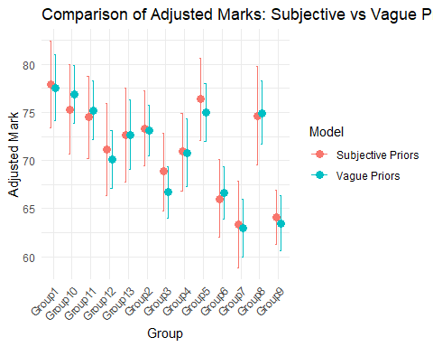

# Practical Strategy

We assume a group is made up of 3 members, giving a total of 39 students.

Explanation of Components “Peer_Score: A simulated rating (1–5) assigned by peers to each student based on contribution, effort, and collaboration, reflecting individual performance perceived within the group. Task_Score: A simulated score (0–100) from an individual task (e.g., quiz or reflection), providing a direct measure of each student’s personal effort, independent of the group. Group_Peer_Avg: The mean Peer_Score per group, used to normalize peer contributions across the group. Peer_Contribution: A percentage (e.g., 100% if average, >100% if above, <100% if below) calculated as (Peer_Score / Group_Peer_Avg) * 100, adjusting individual marks based on peer assessment. Group_Mark: A simulated group mark (60–80) representing the collective performance, which assessors might uniformly assign due to laziness. Individual_Mark: A base mark combining 80% Group_Mark and 20% Task_Score, balancing group and individual input. Adjusted_Mark: The final mark, scaled by Peer_Contribution (e.g., Individual_Mark * (Peer_Contribution / 100)), reflecting peer-evaluated effort. Variance_Flag: Flags groups for review if Adjusted_Mark variance is low (< 3) despite high Task_Score variance (> 5), indicating assessor laziness or inconsistency. Feedback: Simulated student feedback (”Good”/“Improve”) to refine the process and ensure transparency. How the Code Answers the Question Differentiating Individual Performance: Peer_Score and Task_Score provide individual metrics, while Peer_Contribution and Adjusted_Mark adjust the group-based Individual_Mark, ensuring students with different efforts (e.g., high peer score) are distinguished. Handling Nested Structure: Students are nested within 13 groups, with Group_Mark as the group-level component and individual adjustments (Task_Score, Peer_Contribution) applied within each group. Mitigating Assessor Laziness Bias: The reliance on Peer_Score (peer-driven) and Task_Score (assessor-verified) reduces dependence on potentially uniform Group_Mark assignments. The Variance_Flag prompts review when assessors fail to differentiate, countering laziness.” (OpenAI)deepseek

n_students_per_group <- 3  
student_data <- data.frame(  
 Group = rep(1:13, each = n_students_per_group),  
 Student = paste0("S", 1:(13 * n_students_per_group)),  
 Peer_Score = runif(13 * n_students_per_group, 1, 5),   
 Task_Score = runif(13 * n_students_per_group, 0, 100)   
)  
  
group_peer_avg <- student_data %>%  
 group_by(Group) %>%  
 summarise(Group_Peer_Avg = mean(Peer_Score, na.rm = TRUE))  
  
student_data <- student_data %>%  
 left_join(group_peer_avg, by = "Group") %>%  
 mutate(Peer_Contribution = (Peer_Score / Group_Peer_Avg) * 100)  
  
group_data <- data.frame(  
 Group = 1:13,  
 Group_Mark = runif(13, 60, 80)   
)  
  
final_data <- student_data %>%  
 left_join(group_data, by = "Group") %>%  
 mutate(  
 Individual_Mark = 0.8 * Group_Mark + 0.2 * Task_Score,   
 Adjusted_Mark = Individual_Mark * (Peer_Contribution / 100),   
 Variance_Flag = NA   
 )  
  
group_variance <- final_data %>%  
 group_by(Group) %>%  
 summarise(Variance = sd(Adjusted_Mark, na.rm = TRUE))  
final_data <- final_data %>%  
 left_join(group_variance, by = "Group") %>%  
 mutate(  
 Variance_Flag = ifelse(Variance < 3 & sd(Task_Score, na.rm = TRUE) > 5, "Review", "OK")  
 )  
  
print("Individual Marks with Adjustments:")

## [1] "Individual Marks with Adjustments:"

print(final_data %>% select(Group, Student, Group_Mark, Task_Score, Peer_Contribution, Adjusted_Mark, Variance_Flag))

## Group Student Group_Mark Task_Score Peer_Contribution Adjusted_Mark  
## 1 1 S1 63.84529 30.2545758 93.90814 53.64704  
## 2 1 S2 63.84529 9.2342721 75.12872 39.76044  
## 3 1 S3 63.84529 27.0517491 130.96314 73.97660  
## 4 2 S4 72.42387 30.1982999 63.37257 40.54498  
## 5 2 S5 72.42387 8.1512643 122.82319 73.16498  
## 6 2 S6 72.42387 24.3175711 113.80424 71.47203  
## 7 3 S7 73.02527 21.3659899 174.26442 109.25232  
## 8 3 S8 73.02527 51.1309562 86.52369 59.39541  
## 9 3 S9 73.02527 1.3012144 39.21189 23.00972  
## 10 4 S10 72.29929 10.5205965 97.33447 58.34574  
## 11 4 S11 72.29929 42.9155577 53.99790 35.86678  
## 12 4 S12 72.29929 15.8060301 148.66763 90.68820  
## 13 5 S13 66.57853 48.1185823 125.56254 78.96194  
## 14 5 S14 66.57853 34.8278017 91.31329 54.99652  
## 15 5 S15 66.57853 92.6785851 83.12416 59.68193  
## 16 6 S16 75.10952 9.6446255 51.57197 31.98315  
## 17 6 S17 75.10952 92.1041000 100.88029 79.19953  
## 18 6 S18 75.10952 52.0315727 147.54774 104.01220  
## 19 7 S19 79.05435 80.4210507 148.23214 117.58913  
## 20 7 S20 79.05435 55.4681933 67.58067 50.23752  
## 21 7 S21 79.05435 79.3854198 84.18719 66.60938  
## 22 8 S22 77.45623 65.0407956 43.78652 32.82813  
## 23 8 S23 77.45623 24.8250932 106.74412 71.44384  
## 24 8 S24 77.45623 77.4532164 149.46936 115.77243  
## 25 9 S25 62.07281 23.7380357 89.49658 48.69138  
## 26 9 S26 62.07281 23.8985240 135.97339 74.02113  
## 27 9 S27 62.07281 67.1421079 74.53002 47.01851  
## 28 10 S28 64.74013 13.1136257 92.45931 50.31158  
## 29 10 S29 64.74013 93.4924517 99.54250 70.16810  
## 30 10 S30 64.74013 86.2705163 107.99819 74.56866  
## 31 11 S31 68.45915 52.0554918 111.44285 72.63668  
## 32 11 S32 68.45915 92.2171240 132.68548 97.14003  
## 33 11 S33 68.45915 74.4768922 55.87167 38.92171  
## 34 12 S34 68.57434 88.2566161 79.48989 57.63875  
## 35 12 S35 68.57434 52.1734336 91.08197 59.47121  
## 36 12 S36 68.57434 38.1248323 129.42813 80.87244  
## 37 13 S37 67.70074 0.5617382 117.03186 63.51663  
## 38 13 S38 67.70074 77.4870879 52.79088 36.77307  
## 39 13 S39 67.70074 79.2161549 130.17727 91.12906  
## Variance_Flag  
## 1 OK  
## 2 OK  
## 3 OK  
## 4 OK  
## 5 OK  
## 6 OK  
## 7 OK  
## 8 OK  
## 9 OK  
## 10 OK  
## 11 OK  
## 12 OK  
## 13 OK  
## 14 OK  
## 15 OK  
## 16 OK  
## 17 OK  
## 18 OK  
## 19 OK  
## 20 OK  
## 21 OK  
## 22 OK  
## 23 OK  
## 24 OK  
## 25 OK  
## 26 OK  
## 27 OK  
## 28 OK  
## 29 OK  
## 30 OK  
## 31 OK  
## 32 OK  
## 33 OK  
## 34 OK  
## 35 OK  
## 36 OK  
## 37 OK  
## 38 OK  
## 39 OK

feedback <- data.frame(Student = final_data$Student, Feedback = sample(c("Good", "Improve"), 39, replace = TRUE))  
print("Sample Feedback:")

## [1] "Sample Feedback:"

print(feedback)

## Student Feedback  
## 1 S1 Good  
## 2 S2 Good  
## 3 S3 Good  
## 4 S4 Improve  
## 5 S5 Improve  
## 6 S6 Improve  
## 7 S7 Good  
## 8 S8 Improve  
## 9 S9 Improve  
## 10 S10 Improve  
## 11 S11 Improve  
## 12 S12 Improve  
## 13 S13 Improve  
## 14 S14 Good  
## 15 S15 Good  
## 16 S16 Good  
## 17 S17 Improve  
## 18 S18 Good  
## 19 S19 Improve  
## 20 S20 Good  
## 21 S21 Improve  
## 22 S22 Improve  
## 23 S23 Improve  
## 24 S24 Improve  
## 25 S25 Improve  
## 26 S26 Good  
## 27 S27 Good  
## 28 S28 Improve  
## 29 S29 Improve  
## 30 S30 Improve  
## 31 S31 Improve  
## 32 S32 Good  
## 33 S33 Improve  
## 34 S34 Improve  
## 35 S35 Good  
## 36 S36 Improve  
## 37 S37 Improve  
## 38 S38 Good  
## 39 S39 Improve

# 11. Github

my GitHub profile (<https://github.com/Rasupu1/assignment61.git>).

# References

Quickonomics. (2024, September 8). Residual variation definition & examples. <https://quickonomics.com/terms/residual-variation/>

OpenAI, 2023. ChatGPT <https://chatgpt.com/c/6835b531-5538-800f-9998-548da046fb5d>.

Mustafa, A. (2023, July 8). Understanding random effects and fixed effects in statistical analysis. Medium. <https://medium.com/@akif.iips/understanding-random-effect-and-fixed-effect-in-statistical-analysis-db4983cdf8b1>

<https://chat.deepseek.com/a/chat/s/922ecd54-14e2-4f33-a284-e9cbc43dce25>