Methodology
- Research design
This study will design, develop, and evaluate Sarusara AI, a mobile-oriented decision-support system for identifying visible nitrogen (N), phosphorus (P), and potassium (K) deficiency symptoms in paddy leaves, estimating the proportion of leaf area affected, and translating validated agronomic rules into field-scaled fertilizer estimates. The study combines image-based classification and segmentation experiments with software development and rule-based estimator validation.
The work will use an iterative, Agile-inspired development procedure. Requirements, data, models, the image-processing pipeline, the fertilizer estimator, and the mobile interface will be developed in short cycles. Each cycle will produce a reviewable increment, which will be assessed against functional requirements and, where applicable, held-out validation data. Feedback from the supervisor, agricultural specialists, and intended users will inform the next cycle. Iteration will not replace controlled model evaluation: train, validation, and test partitions will remain separated, model selection will use training/validation data only, and the test set will be held back until the final configuration is fixed.The computer-vision task will be staged. The first stage will classify images into th supported nutrient categories. The second stage will localize the leaf and annotate/segment the symptomatic regions. A severity index will be calculated from these masks. The fertilizer estimator will be a distinct rule-based module whose inputs, formulae, assumptions, and outputs can be tested independently of the image classifier. This separation will make it possible to identify whether an error arises from classification, segmentation, severity calculation, or recommendation logic.

- Research questions and objectives
The methodology is based on the following questions:
- How well can field-captured paddy leaf images separate the nutrient deficiency classes including healthy leaves?
- What is the optimal class-wise performance and mobile inference properties of image processing pipeline and deep-learning architecture?
- What is the accuracy of the leaf and symptom regions segmented and what is the agreement between the pixel-area severity index and expert reference annotations?
- Is it possible to translate the government agronomic recommendations into a fertilizer estimator that can adjust the proportion of nutrients/fertilizers according to the size of the field, and then adjust it according to the context of the crop?
- Is there a usable mobile decision-support prototype that results from these assembled in an iterative process which outputs can be traced and assessed?
The overall goals of the project are the development of a locally relevant dataset, the comparison of several deep learning models, the development of image processing and the localization of symptoms, calculation of severity and the validation of the models, the development of an area-based fertilizer estimator, and the evaluation of the integrated mobile system.

- Iterative development process
Development will proceed in short, Agile inspired iterations having a predetermined goal, implementation, review, and backlog update. The iterations will include:
- requirements and initial dataset audit;
- image capture, labelling and data management;
- baseline preprocessing and classifier;
- architecture and preprocessing comparisons;
- leaf/symptom segmentation and severity index;
- fertilizer-rule encoding and estimator tests; and
- mobile integration and end-to-end evaluation.
Deliverables will be reviewed with supervisor and (where available) agronomy advisor at the end of each iteration. Any defect, data gaps, and performance failures will be captured and prioritized for the next iteration. Implementation is an iterative process, and the research comparisons will be reproducible. The experiment log will be stored with the version of the datasets used, group split, preprocessing decisions, model architecture, hyperparameters, random seed, software versions, checkpoint, and evaluation results, and will be version-controlled. After a final model and thresholds are determined by validation data, the test data (not used in model or thresholds selection) will be used for final evaluation and no tuning will be performed.
- Dataset collection and ground truth

  - Local paddy leaf collection
The study will comprise of paddy leaf images that are available in a public repository along with paddy leaves collected in Sri Lanka for more generalization in terms of image capturing environment, cultivation practices, field condition, and varieties of paddy in Sri Lanka. Collected leaves will consist of leaves that are exhibiting symptoms from each of the target N, P, K categories and healthy leaves as a reference/control category. Healthy examples will be gathered from the local fields, and, if possible, matched with symptomatic examples based on site, cultivar, growth stage, date/season and capture conditions. This matching will help to minimize the chance of getting location, background or camera variations learned rather than plant symptoms.
Photographs will be taken using common cell phone cameras under diverse, but controlled, field conditions. The capturing protocol will ask for a clear image of the entire leaf, and for optional close-up images to record symptoms; image ID, pseudonymous plant/plot ID (excluding the plant and plot ID), site or district at an anonymous level, date/season, cultivar if it is known, growth stage, device used, light conditions, and capture notes. The images will be kept as they are. If the same leaf or plant is viewed several times, the repeated views will have the same group ID, thus all views of the same leaf or plant will remain in the same data partition. Consent and permissions will be obtained as needed and farmer information will not be saved with image labels. At least 1,500 images will be the target met by the proposal, but the number of images will not be the only basis for deciding that the goal has been achieved. Class counts and number of independent plants, plots, sites, seasons and devices will be reported in the study. Images will be checked for quality (blur, occlusion, duplicate, and labeling). Exceptions and explanations will be recorded. Class-aware sampling/training loss weighting can be applied to the training data if the classes are still imbalanced.

Government reference data and agronomic sources
Local agronomic reference inputs used to define severity interpretation and fertilizer-estimator rules will be based on government data. The Department of Agriculture (DOA), including the Rice Research and Development Institute publishes paddy fertilizer recommendations by cultivation context, soil-analysis results and leaf-colour index; it also gives the divisional fertilizer recommendations which depend on the soil information.
These documents and tables will be checked and documented against the issuing organization, publication/version number, zone, irrigation/rain-fed context, growth stage, units and source URL. The keyword study context often refers to information from the Department of Census and Statistics on paddy extent, yield, and production, and is not intended to be used as labels for images.There are no pixel masks available in the government sources to compute the image-based severity index.
The government records will be used in agronomic interpretation, in reference to severity categories where an applicable official severity scale exists and in the rules for fertilizer use, and image-level severity values will be generated based on images collected locally and annotated by experts in this study. Where an official severity scale isn't available for a nutrient symptom, the study will not assign an imaginary threshold to a government agency. It will clarify and confirm any study specific ordinal grade with agricultural experts and present it as a study protocol.

Labeling and annotation protocol
Each class will have a label handbook that specifies the visual and agronomic requirements. Initial labelling will include healthy/no visible target deficiency and N, P and K deficiency. If other diseases are present in the field with images, other nutrient problems, mixed deficiencies, or ambiguous symptoms, they will be annotated as such, not as one of the targeted classes. There will also be evidence recorded of the diagnosis: visual assessment, agronomist review, controlled treatment, soil/tissue analysis or other evidence. Visual labels will be recognized as such and not be submitted as laboratory verified nutrient status.
A subset of images, such as difficult and mixed cases, will be independently evaluated by two trained annotators. Disagreements will be resolved by a specialist in agriculture. The appropriate statistic will be reported for inter-rater agreement (e.g. Cohen's kappa for categorical labels). If there is any low-confidence case, these will be flagged and the analysis will include the treatment of low-confidence cases. Severity will be calculated in two steps: 1) an image of the visible leaf area will be created by the annotator and 2) an image of the nutrient-symptom areas which the annotator selects on the leaf will be created. Diseased/deficient portions of each annotated leaf should be distinguished from the healthy portions of the leaf.
For cases where more than one deficiency symptom is present, individual nutrient deficiency masks will be developed nutrient by nutrient, based on available evidence. Leaf boundaries, yellowing/discoloration transitions, holes, shadows, occlusion, overlapping leaves, and uncertain pixels will be marked in annotations. Two raters will independently annotate a representative subset, and compare annotations for inter-rater reliability.

Data partitioning
Images will be divided into approximately 70% training, 15% validation, and 15% test data using stratified group splitting. Plant, plot, or capture-session group IDs will be used as grouping units so related images cannot appear in both training and test sets. Where the number and distribution of sites permit, a later collection period or site will be reserved as an additional external test. Exact and near-duplicate images will be identified before partitioning. The split manifest and random seed will be saved. Preprocessing thresholds and model selection will use the training and validation partitions only.
- Image processing and feature extraction
The images will go through a uniform pipeline and original images will be saved. The pipeline is a baseline that will decode to RGB, correct orientation, maintain aspect ratio, resize or pad to model input dimensions, apply the networking normalizations needed for the model architecture chosen. Only in the training phase, images will be augmented to include plausible rotations, flips, scale/crop variations, and moderate brightness/contrast/color variations. Augmentation will not change the appearance of symptoms in an exaggerated manner. Transformations for validation and test will be deterministic.
Controlled ablation will be used to evaluate image processing effects as opposed to each effect alone without ablation. Possible operations include: Clustering (for initial leaf-background separation); Excess Green/color-based masking; CLAHE on the luminance channel; and Gray World or other white-balance correction. Denoising will only be added when noise is seen in the images that affect the recognition. Each pipeline will be executed on the same set of data partitions, allowing for a determination of the effect of the tested operation on pipeline performance. The model will be based on the image tensor and learned convolutional features for classification. Features of the image that can be interpreted will also be extracted for segmentation and severity: color-channel values or distributions, local contrast, texture, connected-region size and shape, and number of pixels. These hand-made features may be used as a thresholding reference value and an error analysis reference value. They will not be able to be used to replace the expert masks as the reference target.
- Deep learning model development and comparison
A number of deep-learning models will be trained and tested and the most successful one will be chosen for the target use case. The current ResNet-50 training script will serve as a baseline that can be reproduced. Candidates model architectures will be: a light-weight mobile architecture (e.g. MobileNet), a second transfer-learning model (e.g. EfficientNet), and a small CNN baseline if computation and data size permits. Comparable partitions, input data and training budgets will be employed to make a fair comparison. Where possible multiple random seeds will be applied to finalists.
A single-label task will result in a softmax distribution across healthy, N, P, K and other supported classes. Evaluation and threshold selection will proceed according to the multi-label protocol; if the adjudicated examples exhibit multiple nutrient deficiencies, a multi-label formulation, with independent sigmoid outputs will be applied to those labels. Early stopping and checkpoint selection will be based on validation, NOT test performance. Class weighting will only be considered based on the numbers of players in the training set.
The results will be reported in terms of accuracy, balanced accuracy, per-class Precision-Recall-F1, macro-F1, confusion matrix, per-class Precision-Recall curves and average precision. Resampling will be used to calculate confidence intervals, at the plant/plot group level when appropriate. Class, site, growth stage, lighting, device, and background will be the factors studied in error analysis. When assessing mobile suitability, model size and inference latency will be evaluated on documented target devices on which the model has been named. Even if a model is accurate, if it is too large or slow for the intended application, it will not be selected as a high performing model.

Leaf and symptom localization and severity index

mask extraction from image features
The severity will be attributed based on leaf and symptom masks (not on classification confidence or on bounding-box size). First, a mask sized to a leaf will be created. The thresholding and clustering using color or Excess Green will give a baseline for separating green leaf and soil, water and other background. If this baseline is not reliable due to field backgrounds, shadows or overlapping leaves, a semantic-segmentation model will be learned from manually annotated leaf masks. The mask will be evaluated for areas of disconnected background components, gaps and excluded occluded areas.
Secondly, a symptom mask will be created only in the leaf mask. The candidate symptoms will be presented using color (in CIELAB/HSV), local contrast and texture, all of which have a simple thresholding baseline. The main training method will be a semantic-segmentation method trained with expert-annotated nutrient symptom pixels. Colors thresholds or model probabilities will be chosen on the training/validation data and fixed prior to final testing evaluation. Where nutrients are present in more than one class, nutrient-specific symptom masks will be assessed for N, P, and K, if there is evidence from the annotators.
The number of valid leaf pixels and the number of pixels containing target symptoms within the leaf mask will be used as the main image features for calculating severity. Other exploratory features might include region size distribution, connected symptom-region count, region symbol proportion, boundary/shape descriptors, and texture features, such as gray-level co-occurrence matrix (GLCM) contrast, energy and homogeneity. These features could be useful in characterizing symptom patterns or predicting expert assigned grades, but the continuous severity index will still be masked area ratio.

severity index calculation
For one leaf image, the severity index (SI) will be calculated as:
SI (%) = 100 x (number of target-symptom pixels inside the valid leaf mask / number of valid visible leaf pixels).
Only the pixels that are marked as the target nutrient symptom and within the leaf mask will be included in the numerator. The denominator will contain pixels of leaves that can be analysed. Outliers such as background, severe occlusion and unusable pixel will be removed with pre-defined annotation rules. For each leaf image SI will be computed. If multiple leaves are taken from a single plant, then an individual leaf score and plant-level, area-weighted aggregate (based on a predetermined rule) will be reported. Where a symptom class can be separated and labelled as a specific N, P or K SI, this will be reported separately, and any mixed or uncertain areas will be marked off separately.
The government agronomic material will be adopted as the source of applicable guidance for the leaf-colour index, the context of fertilizer recommendations, and all severity categories as officially recognized. It will not be claimed to have provided pixel level SI values. If the thresholds are categorical, then they will be transcribed as provided in the official material, with source/version, and then verified by an agricultural specialist. If the official thresholds are not applicable, any official ordinal severity bands will be created as study-specific severity bands and not be drawn from government data.

Severity validation
Predicted leaf and symptom masks will be compared with expert masks using Dice coefficient and Intersection over Union (IoU), with visual boundary review. The continuous SI will be compared with expert area estimates using mean absolute error (MAE), root mean squared error (RMSE), and an agreement analysis. If ordinal grades are used, their thresholds will be fixed before test evaluation and evaluated using a confusion matrix and class-wise agreement. Grad-CAM and related saliency maps may be used to inspect model attention but will not be treated as segmentation masks or as measured symptom area.

Fertilizer estimator development and testing
The fertilizer estimator will be created as an independent and transparent module. It will convert a valid agronomic nutrient requirement into the amount of available commercial fertilizers and adjust the amount to the field size of the user. The estimator will apply government recommended DOA paddy fertilizer recommendations as the main rule sets which include differences for agro-ecological zone, irrigation/rainfed system, available divisional baseline based on soil analysis, crop stage, and leaf-colour index as appropriate [1, 2]. Conditions and assumptions will be kept in the same for each rule, as will be the source and effective date/version, and the units. The rules will be encoded and then reviewed by a qualified agricultural specialist prior to testing.
Input to the estimator will be field area, field unit, location/zone (if applicable), cultivation system, crop age or stage, and soil or leaf-colour information (if available). An absent soil-test value or required agronomic input will be detected by the estimator and only an explicitly approved default value will be used or an estimate will not be generated. A nutrient recommendation will be calculated into product mass based on the nutrient concentration of the fertilizer product that is declared. The calculation will be validated dimensionally and scaled by field area, and will output the field area recommendation, the total field quantity, the units, when to apply the rule, and the rule source. Implementation will be with the selected commercial products (e.g., Urea, DAP/TSP, and MOP) where the nutrient composition is suitable for the referenced recommendation. It will not be assumed that substitution or fertilizer grade will be as specified in the current DOA guidance but will be confirmed.
The estimator will have a set of cases to hand-calculate that will cover various field sizes, zones, water regimes, soil/leaf-colour input and crop stage. Unit tests will test area conversion, product nutrient fraction, split application totals, missing inputs, boundary values and rounding. The doubling of field area will result in an estimated doubling of mass for the same agronomic recommendation, and the same will be true of unit conversions, as verified by a property check. The quantities of output will be compared to the relevant DOA tables or worked examples and will be checked by an agricultural specialist. When a rate (kg/ha) is specified in a nutrient in a rule and the area is A (ha), the amount of the field nutrient (or product) will be R x A (kg/ha), where R is the specified nutrient rate (kg/ha) and A is the field area (ha) to which the rate is applied. No recommendations will be deduced directly from image SI without the existence of a scientifically and agronomically proven mapping from SI to nutrient dose. The prototype will demonstrate the graphical discovery and calculation of the fertilizer estimate as independent but interwoven results, including uncertainty and source information.

Integrated mobile system and evaluation
The mobile prototype will enable the user to capture or select a paddy leaf picture, check the image-quality prompt, get the output of the classifier and the level of confidence, see the localized symptom regions and SI if validated, input the field/crop inputs, and see an area-scaled fertilizer estimate with its source and assumption. Images that do not have high confidence, are out of scope, mixed or of poor quality will be marked for retaking or field/agronomic assessment rather than giving unsupported certainty. Only information required for evaluation will be captured in the system and farmers' identity and exact location will be protected.
There will be both component-level and end-to-end system evaluation. Classification, segmentation, SI agreement and fertilizer arithmetic/reference correctness will be evaluated for the components. End-to-end testing will be used to determine the following: Flow of the integrated flow results in the desired outcome for predetermined scenarios; the flow is safe if input is invalid or missing; units and recommendation context are clearly shown. If user evaluation is possible, a small study with representative users/Agricultural personnel will be conducted to measure the task completion, comprehension and usability which will be reported separately from model accuracy.

Reproducibility, validity, and ethics
The project will maintain a data dictionary, image and annotation protocol, exclusion log, grouped split manifest, source register for official agronomic data, model configurations, experiment logs, and estimator test cases. The final test data will remain untouched until the pipelines and thresholds are fixed. Results will report class balance, number of independent collection groups, missing or uncertain labels, site/device coverage, and deviations from protocol.
Potential limitations include visual similarity between nutrient deficiency and biotic disease, limited local data, uneven class/site representation, symptom variation by cultivar and growth stage, and changes in official fertilizer guidance. The system will therefore be framed as decision support rather than a replacement for soil testing or qualified agronomic advice. Personal data will be minimized, image collection permissions will be respected, and recommendations will not be presented as definitive where required agronomic inputs are missing.

Application architecture
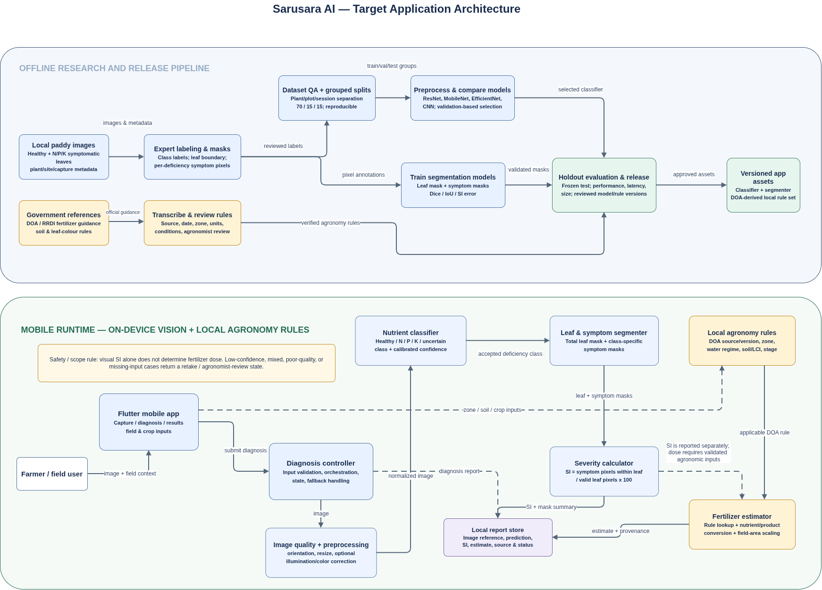

UML class diagrams

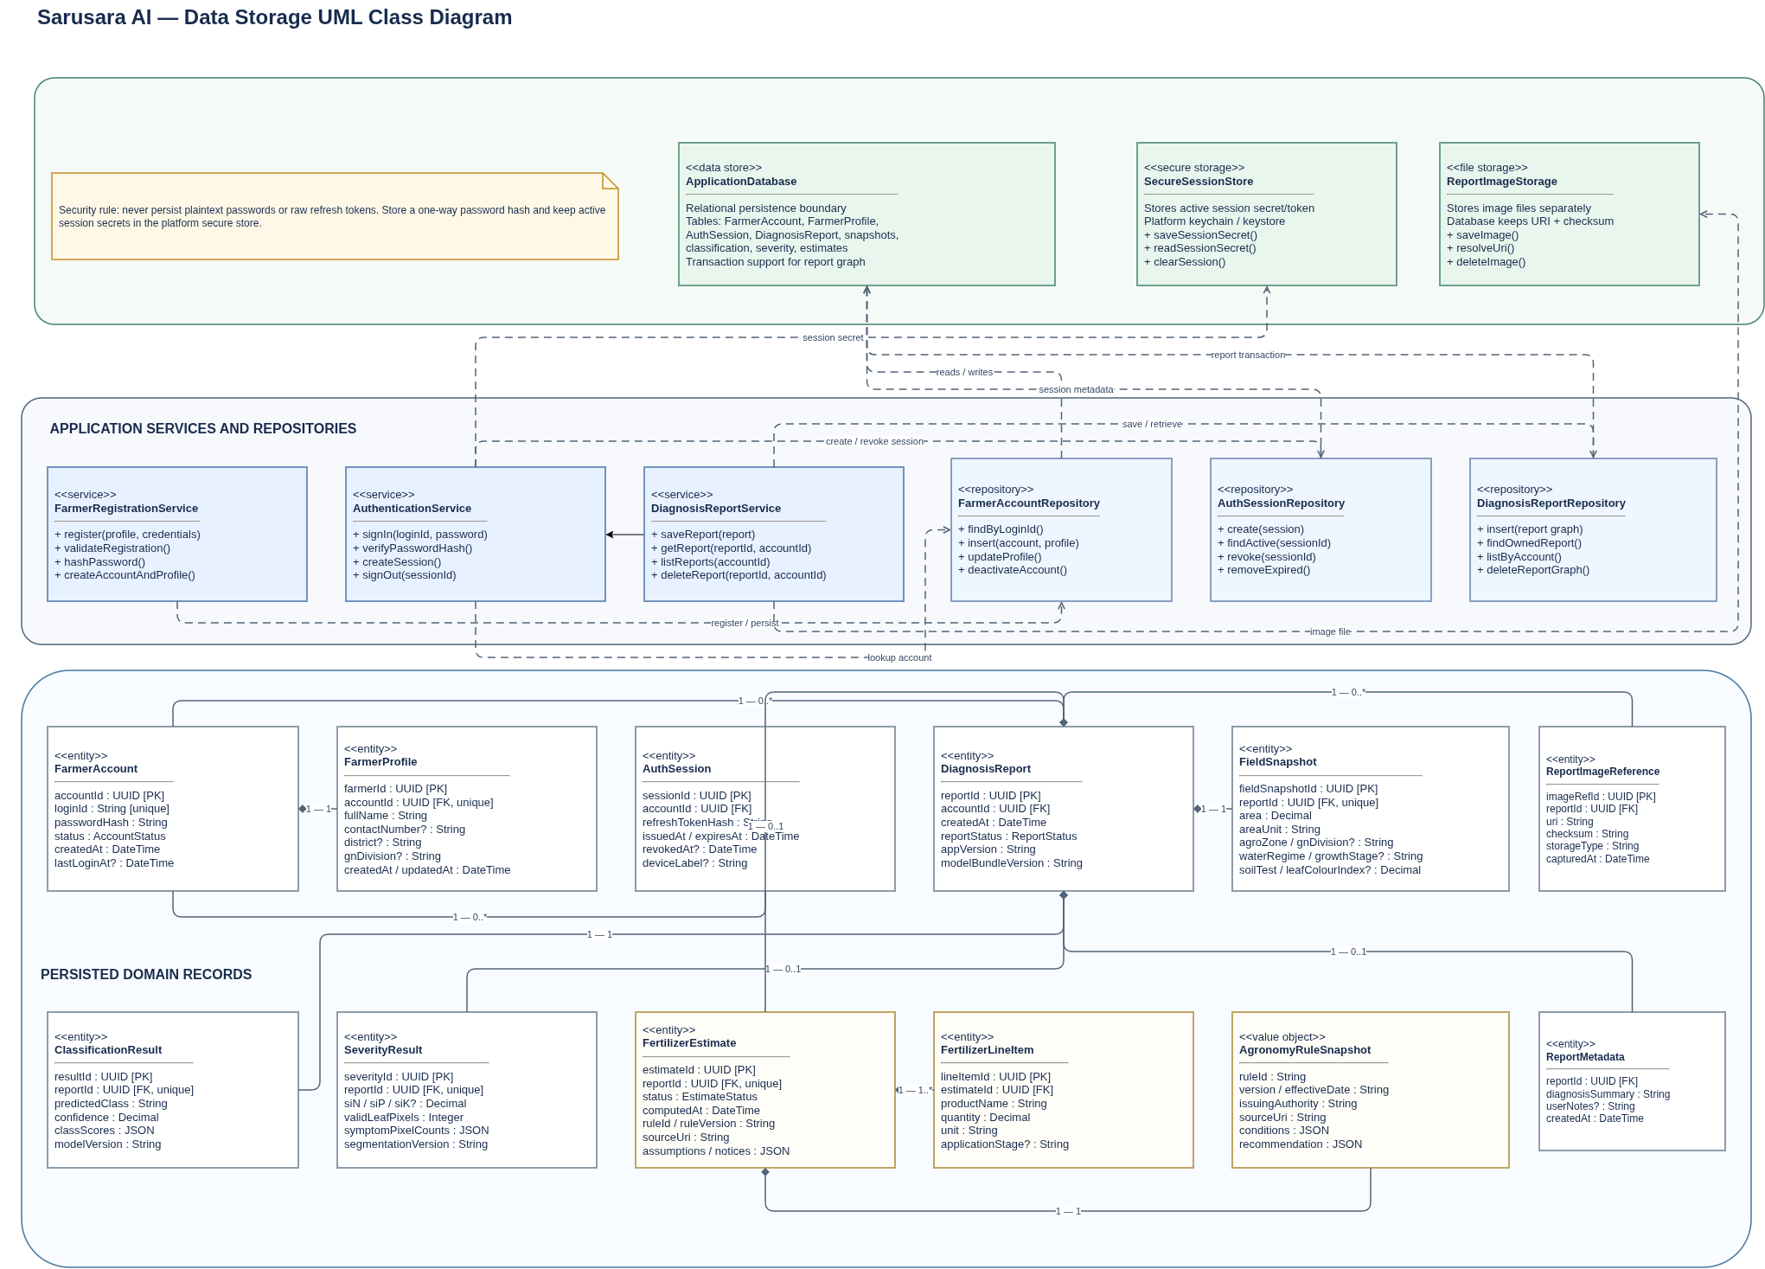

UML class diagrams
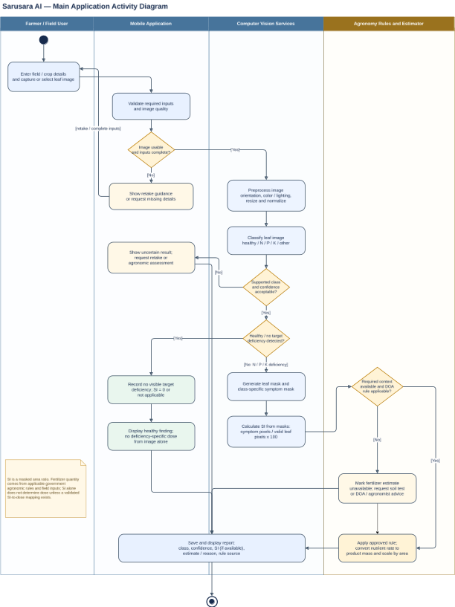

References
- Department of Agriculture, Sri Lanka, Rice Research and Development Institute: Rice in Sri Lanka: Fertilizer Recommendations. https://doa.gov.lk/rrdi_fertilizerrecomendation/ (accessed 22 October 2026)
- Department of Agriculture, Sri Lanka: Fertilizer Recommendation for Paddy Cultivation in Sri Lanka: Grama Niladhari Division Level. https://doa.gov.lk/fertilizer-recommendation/ (accessed 22 October 2026)
- Department of Census and Statistics, Sri Lanka: Paddy Statistics. https://www.statistics.gov.lk/Agriculture/StaticalInformation/PaddyStatistics (accessed 22 October 2026)

