Major Project Report

# Inventory Management System

Course: Data Structures and Algorithms

Student Name: RASYA K R

Institution: Corizo

**Problem Statement**

Managing inventory is a fundamental task for businesses. The aim of this project is to build a simple CLI-based Inventory Management System using Python, which will allow adding, deleting, updating, and searching items. It will also alert low stock items and calculate total inventory value.

**Features Implemented**

- Add new items to inventory.

- Delete items by Item ID.

- Update existing item quantity or price.

- Search items by Item ID.

- Display entire inventory with sorting.

- Low stock alerts based on threshold.

- Calculate total inventory value.

- Persistent storage using JSON file.

# Screenshots

## Add Item

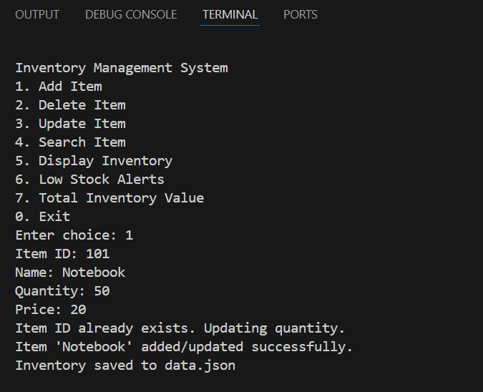

## Delete item

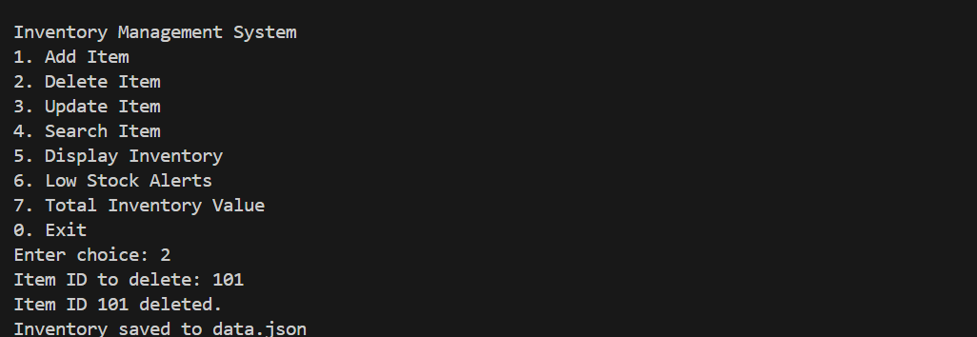

## Update item

## Search Item

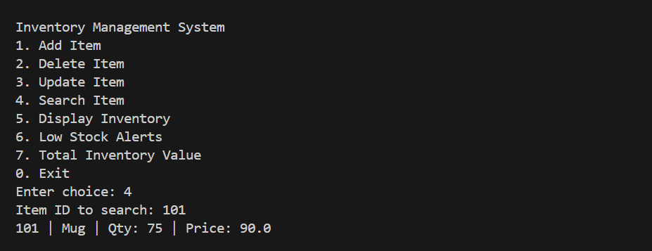

## Display Inventory

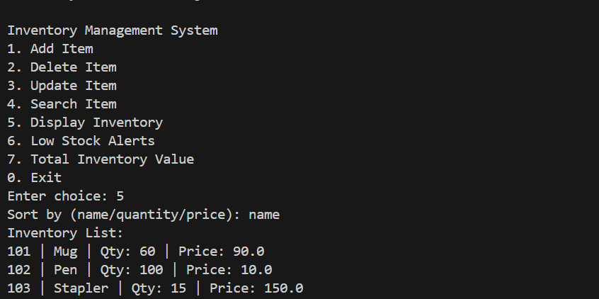

## Low Stock Alert

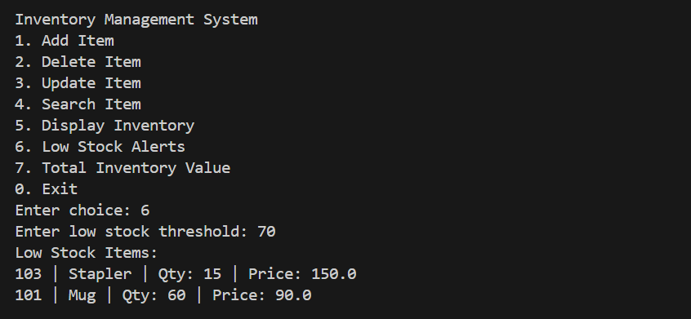

## Total Inventory Value

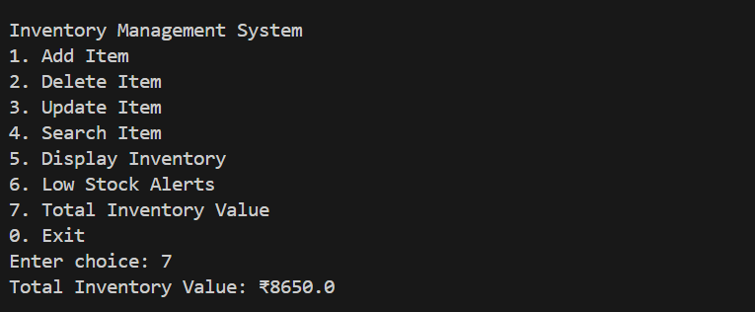

# Conclusion

This project helped in applying various Data Structure concepts like Lists, Dictionaries, Sorting, and File Handling in Python. Building this Inventory Management System strengthened understanding of CRUD operations and data persistence. Further improvements like Undo/Redo operations using Stack can be implemented as an extension.