SQL ASSIGNMENT

1 Install MySQL or PostgreSQL on your system:

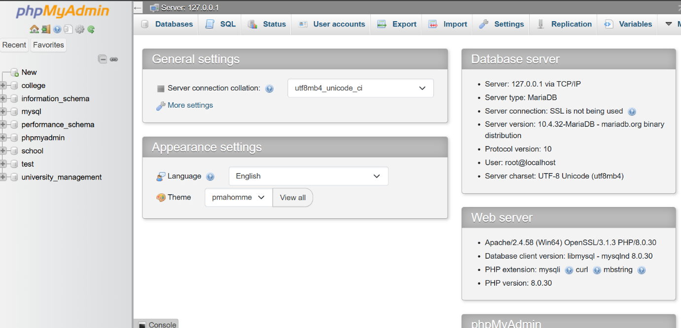

create a new database named 'music_streaming_app' using the command line or GUI tool of your choice.

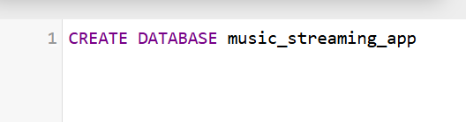

2 Inside the 'music_streaming_app' database, create a table called 'playlists' with columns: playlist_id (integer, primary key), name (varchar), and created_by (varchar)

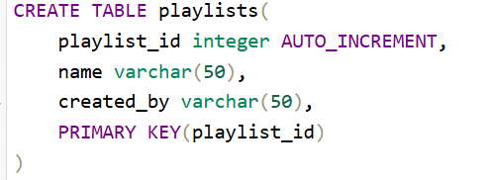

3. Insert three sample rows into the 'playlists' table representing playlists like 'Bollywood Hits', 'Chill Vibes', and 'Workout Mix', each created by a different user.

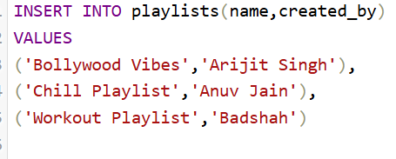

4 Write an SQL SELECT query to display all playlists created by the user 'Amit' from the 'playlists' table.<br><br><em><strong>Hint:</strong> Use the WHERE clause to filter by the 'created_by' column.</em>

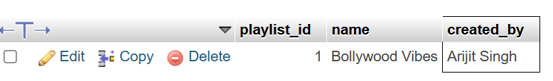

5 Open ChatGPT or Copilot and ask it to explain the difference between a table, a row, and a column in SQL using an example from a food delivery app like Zomato. Paste the explanation you receive into your assignment.

Difference Between a Table, Row, and Column in SQL (Zomato Example)
In SQL, data is organized into tables, rows, and columns.
1. Table
A table is a collection of related data stored in a structured format. For example, a food delivery app like Zomato may have a table called Restaurants.
Restaurant_ID | Restaurant_Name | City
1 | Spice Villa | Surat
2 | Pizza Hub | Ahmedabad
Here, Restaurants is the table.
2. Column
A column represents a specific type of information in a table. In the Restaurants table, Restaurant_ID, Restaurant_Name, and City are columns.
Columns define what kind of data is stored.
3. Row
A row represents a single record in a table. For example:
| 1 | Spice Villa | Surat |
This is one row because it contains all the information about one restaurant.
Summary
- Table = Collection of related data (e.g., Restaurants table).
- Column = A field or attribute (e.g., Restaurant_Name).
- Row = One complete record (e.g., Spice Villa, Surat).
Think of a table like an Excel sheet:
- The entire sheet is the table.
- Vertical fields are columns.
- Horizontal records are rows.

