1.List three apps you use daily (such as Zomato, Instagram, or Flipkart) and describe one feature in each app that likely uses machine learning. For each, state whether it is an example of supervised, unsupervised, or reinforcement learning.

ans :=
1. Zomato — Restaurant recommendations based on your past orders, ratings, location, and preferences. This is mainly supervised learning, since it learns from labeled examples such as clicks, ratings, and completed orders.

2. Instagram — Suggested posts and Reels in the feed. This likely uses supervised learning to predict whether you will watch, like, share, or follow based on past user behavior.

3. Flipkart — Product grouping and “similar products” recommendations. This can use unsupervised learning, which finds patterns and groups similar products or customers without needing explicit labels.

2.Given the following scenarios, classify each as supervised, unsupervised, or reinforcement learning: 1) Netflix recommending movies based on your watch history, 2) Spotify grouping similar songs into playlists, 3) A self-driving car learning to park by trial and error. Write your answers with a one-line explanation for each choice.

ans :=
1) Netflix use the supervised machine learning because they have the history data and they according give you appropiate suggestion of movies

2)Spotify is use unsupervised learning because whey you play any song that time they suggestion that singer or that type of song they recommend using clustering and without any previous data

3)Self Driving is the best example of the reinforcement machine learning because they train using the reward and penalty if they accuratly drive they according given reward and and if they make any mistake that time given penalty

3.Draw a simple diagram (hand-drawn or digital) showing the basic ML workflow: Data → Preprocessing → Modeling → Evaluation → Deployment. Under each step, write a one-line example of what happens at that stage for a food delivery app like Swiggy.

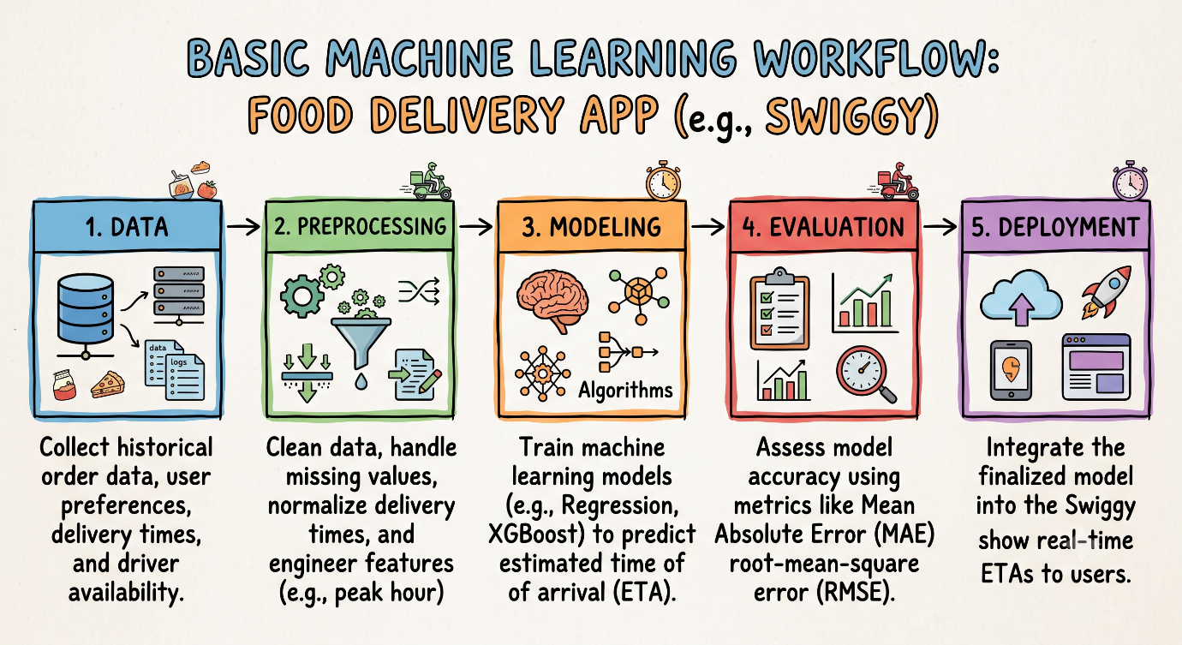

4.Imagine you are building a spam filter for WhatsApp messages. Write a short paragraph explaining how traditional programming would approach this problem versus how machine learning would approach it.<br><br><em><strong>Hint:</strong> Focus on rules vs learning from data.</em>

In traditional programming, a developer manually defines explicit, hardcoded rules using conditional logic—such as writing an if-else statement to flag messages containing specific keywords like "lottery", "claim prize", or suspicious links. While straightforward, this approach is rigid and constantly breaks down whenever spammers alter their phrasing or use deliberate misspellings (e.g., "l0tt3ry"), requiring humans to continuously write new rules. In contrast, machine learning feeds a model thousands of labeled WhatsApp messages (both spam and non-spam) so the algorithm can discover statistical patterns and associations on its own. Instead of depending on static keywords, the ML model learns contextual nuances and subtle combinations of features directly from data, allowing it to adapt dynamically and catch novel spam tactics without needing manual code changes for every variation.

