**Design of 16-Bit Processor in Verilog**

**(by Ratan Abhinav Sharma)**

**DESIGN DESCRIPTION**

Implementation of 16-Bit simple instruction set Processor supporting 27 instructions including Arithmetic, Logical, Load & Store, Jump and Halt instructions in Verilog using Xilinx Vivado application.

**DESIGN ARCHITECTURE**

Program Memory

32-Bit Instruction Register

32 16-Bit General Purpose Registers

Data Memory (16-Bit)

Arithmetic & Logical Unit (ALU)

Input & Output buffers din and dout (16-Bit)

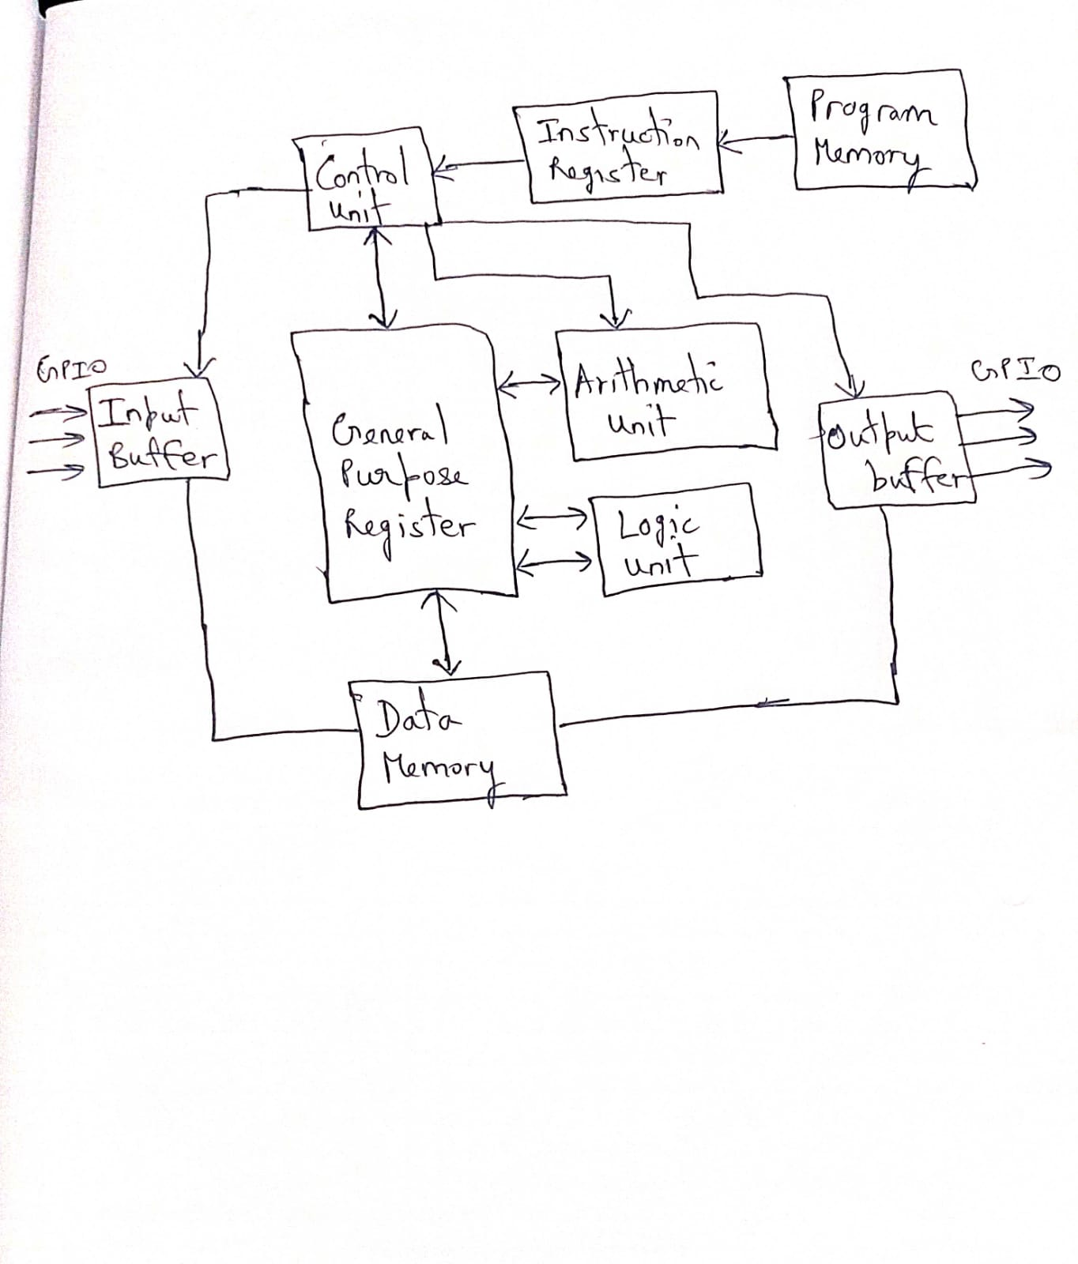

**Simulation Results for Arithmetic, Logical and Store & Load Inst.**

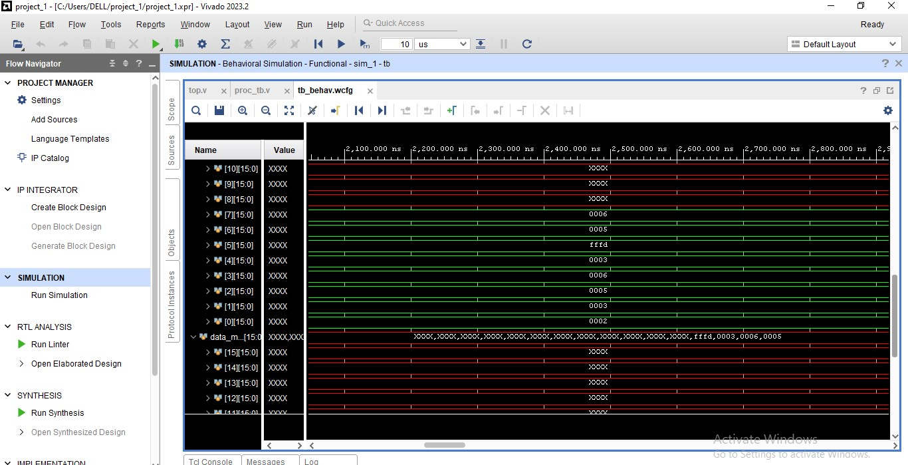

MOV R0, #2

MOV R1, #3;

ADD R2, R0, R1;

MUL R3, R0, R1;

ROR R4, R0, R1;

RNAND R5, R0, R1;

STOREREG 0, R2;

STOREREG 1, R3;

STOREREG 2, R4;

STOREREG 3, R5;

SENDREG R6, 0;

SENDREG R7, 1;

**Corresponding OpCode in Program Memory:**

00001_00000_00000_1_0000_0000_0000_0010

00001_00001_00000_1_0000_0000_0000_0011

00010_00010_00000_0_0000_1000_0000_0000

00100_00011_00000_0_0000_1000_0000_0000

00101_00100_00000_0_0000_1000_0000_0000

01001_00101_00000_0_0000_1000_0000_0000

01101_00000_00010_0_0000_0000_0000_0000

01101_00000_00011_0_0000_0000_0000_0001

01101_00000_00100_0_0000_0000_0000_0010

01101_00000_00101_0_0000_0000_0000_0011

10001_00110_00000_0_0000_0000_0000_0000

10001_00111_00000_0_0000_0000_0000_0001

**SIMULATION RESULTS FOR JUMP INSTRUCTIONS**

**(Multiplication of 5 and 6 without MUL inst)**

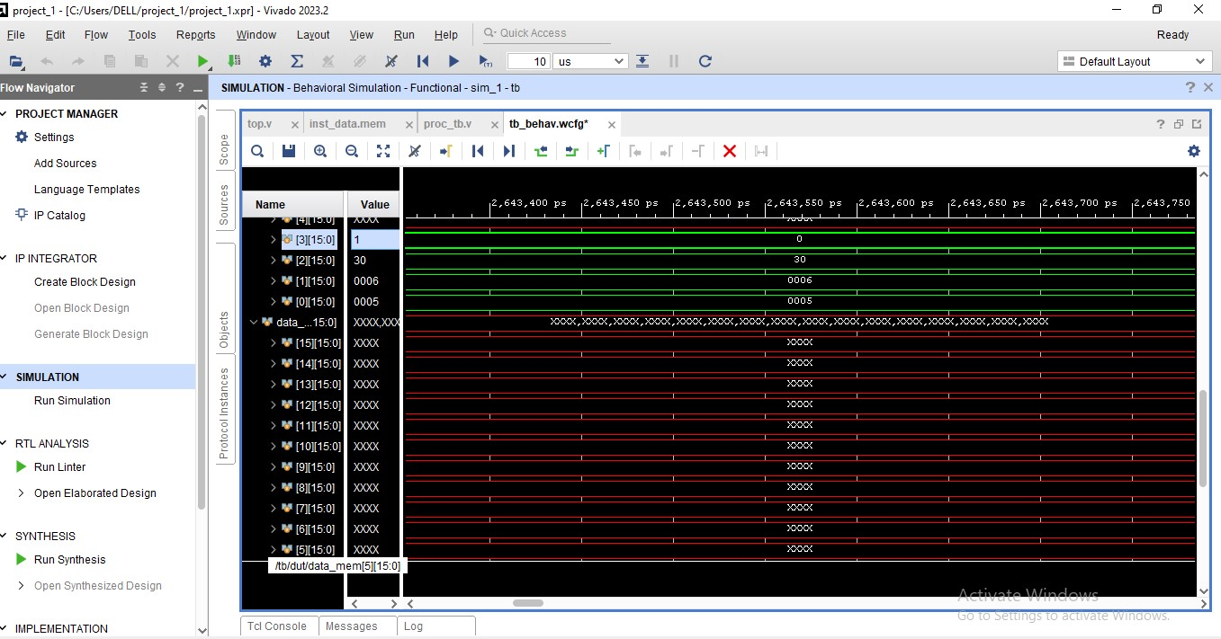

MOV R0, #5;

MOV R1, #6;

MOV R2, #0;

MOV R3, #6;

ADD R2, R2, R0;

SUB R3, R3, #1;

JNZ @ 4;

HALT;

**CORRESPONDING OPCODE IN PROGRAM MEMORY**

00001_00000_00000_1_0000_0000_0000_0101

00001_00001_00000_1_0000_0000_0000_0110

00001_00010_00000_1_0000_0000_0000_0000

00001_00011_00000_1_0000_0000_0000_0110

00010_00010_00010_0_0000_0000_0000_0000

00011_00011_00011_1_0000_0000_0000_0001

11000_00000_00000_0_0000_0000_0000_0100

11011_00000_00000_0_0000_0000_0000_0000

**TESTBENCH CODE**

