E-COMMERCE SALES
& CUSTOMER ANALYTICS
End-to-End Data Analytics Project Report
Python • PostgreSQL • Power BI
Dataset analyzed: 7,535 raw records → 7,478 records after documented cleaning

Executive Summary
This project follows a practical analytics workflow: inspect the raw data, clean data-quality issues, calculate revenue, analyze sales and customer patterns, store the prepared data in PostgreSQL, and communicate the results through an interactive Power BI dashboard. The goal is to make sales performance easier to monitor and to turn detailed transaction records into business-focused questions.
Metric | Value
Cleaned records | 7,478
Distinct orders | 7,478
Distinct customers | 2,129
Total revenue | ₹22,668,497
Average order value | ₹3,031
Metric note: revenue is calculated from Quantity × Unit_Price × (1 − Discount). Average order value is total calculated revenue divided by the number of distinct Order_ID values. If the source data represents multiple product lines per order, this is an order-level average.

1. Business Problem and Objectives
An e-commerce business can have thousands of transactions but still struggle to see which products, locations, payment methods, and customer groups are contributing most to performance. This project organizes the data and presents key measures in a form that can be explored interactively.
- Measure total revenue, order volume, customer count, and average order value.
- Track how revenue changes over time.
- Compare revenue by category, city, and product.
- Understand the mix of payment methods and order statuses.
- Compare new and returning customer groups.
- Build a dashboard that responds to slicer selections.

2. Dataset and Data Dictionary
The raw file contains 7,535 rows and 16 source columns after removing any exported index column. The analysis uses order dates, customer identifiers, product details, discounts, payment information, order status, customer type, ratings, and shipping days.
Field | Business meaning
Order_ID | Identifier for an order
Order_Date | Timestamp for the order
Customer_ID | Identifier for a customer
Gender, Age | Customer demographic attributes
City | City associated with the transaction
Category, Product | Product group and product name
Quantity | Units purchased
Unit_Price | Price per unit
Discount | Discount fraction applied
Payment_Mode | Payment method
Order_Status | Status of the order
Customer_Type | New or returning customer label
Rating | Customer rating
Shipping_Days | Shipping duration in days
Revenue | Calculated measure created during analysis

3. Data Preparation and Cleaning
Cleaning decisions should be explainable in business terms. The steps below are the rules used to prepare this report's analysis copy of the raw dataset. Compare these with the final Python script you used in your project before describing them as your exact implementation.
- Text standardization: Trimmed leading/trailing spaces from key text columns so values such as city/category labels are grouped consistently.
- Date and numeric types: Parsed Order_Date as a date/time field and converted numeric columns to numeric types for valid calculations.
- Duplicate records: Removed 35 exact duplicate rows after excluding any exported index column. A duplicate should be checked against business keys before removal in a production dataset.
- Missing numeric values: Filled missing Age and Rating values with their column medians in this analysis copy; medians are less sensitive to extreme values than means.
- Missing categories: Filled missing categorical values with the most frequent value as a simple fallback. In a real project, the best choice depends on the meaning of the field.
- Invalid transactions: Removed 12 rows with Quantity ≤ 0 and 10 rows with Unit_Price ≤ 0 (counts are before filtering and can overlap).
- Revenue: Created Revenue as Quantity × Unit_Price × (1 − Discount), assuming Discount is stored as a fraction such as 0.10 for 10%.
After these documented preparation steps, the analysis dataset contains 7,478 rows. Missing cells remaining in the selected analysis columns: 0. This count is a quality-check signal, not proof that every field is semantically correct.

4. Analysis Story: What the Charts Help Us Ask
A strong dashboard tells a sequence of stories: how much value the business generated, when that value changed, where and what it sold, how customers paid, what happened to orders, and how customer groups compare. The charts below are calculated from the prepared dataset for this report.

4.1 Revenue Over Time
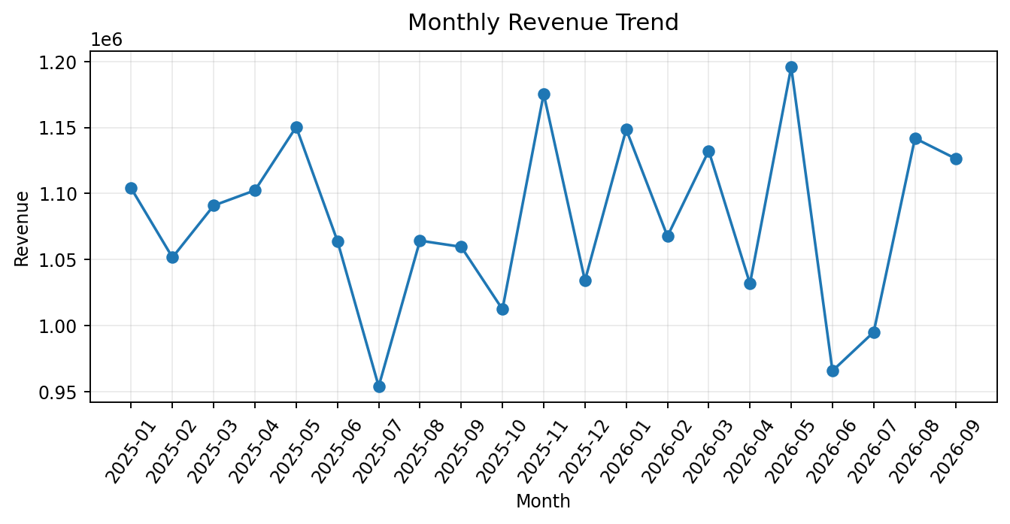
Figure 1. Monthly revenue based on the calculated Revenue field.
How to tell the story: the line chart makes monthly changes visible. In this dataset, the highest-revenue month is 2026-05 (₹1,195,743) and the lowest-revenue month is 2025-07 (₹954,040). This describes the observed dataset; it does not by itself explain why the change occurred.

4.2 Which Categories Contribute Revenue?
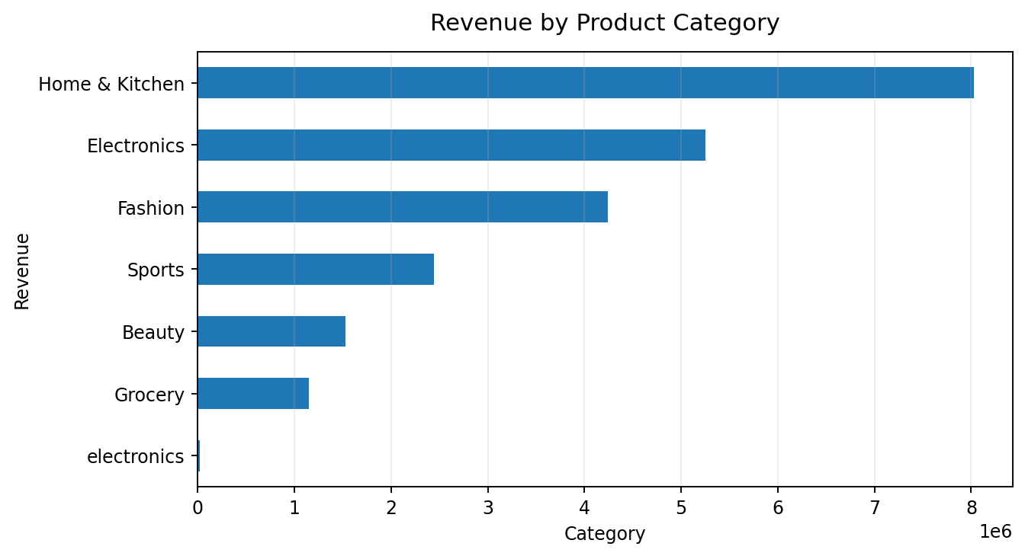
Figure 2. Revenue contribution by product category.
The leading category by calculated revenue is Home & Kitchen (₹8,025,409). A business discussion can then ask whether this category is driven by higher prices, more units, or a combination. Revenue alone does not prove profitability because product costs are not included.

4.3 Which Cities Contribute Most?
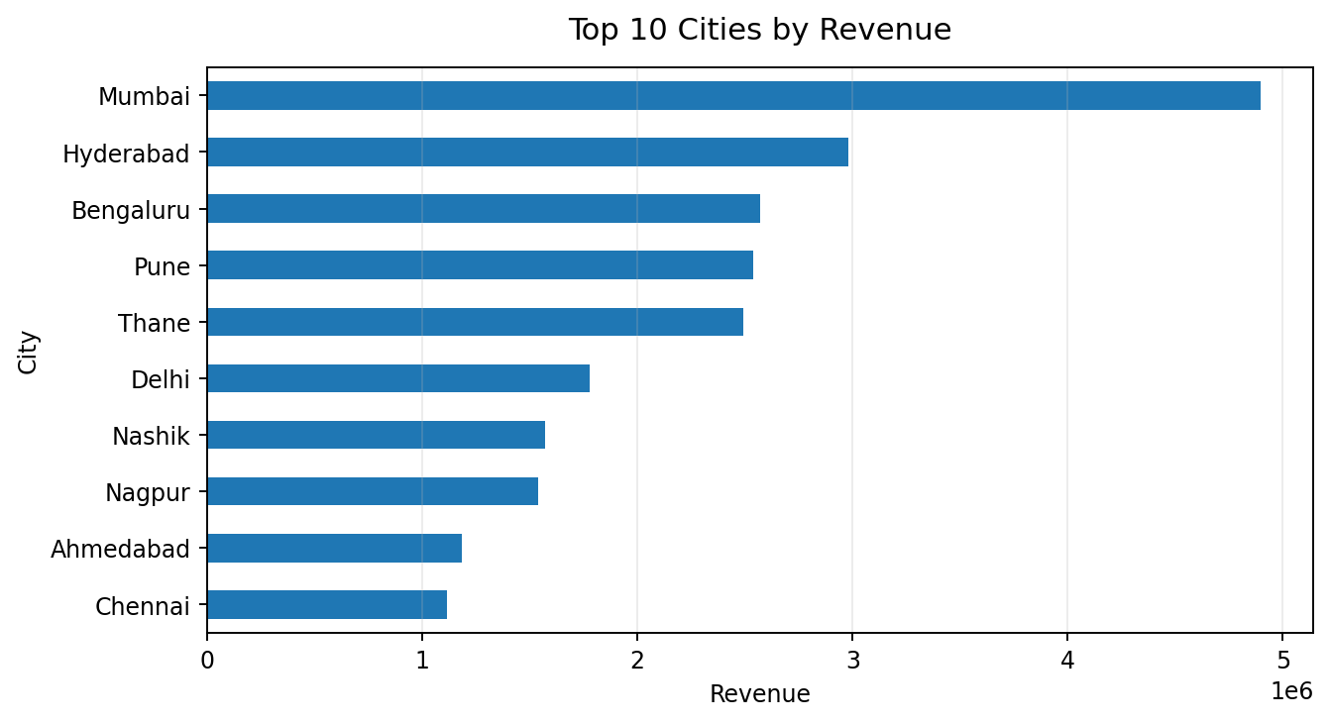
Figure 3. Ten highest-revenue cities.
The highest-revenue city in this dataset is Mumbai (₹4,897,635). This can help prioritize a deeper look at demand and operations, but population, marketing spend, and delivery costs would be needed before recommending expansion.

4.4 Which Products Lead Revenue?
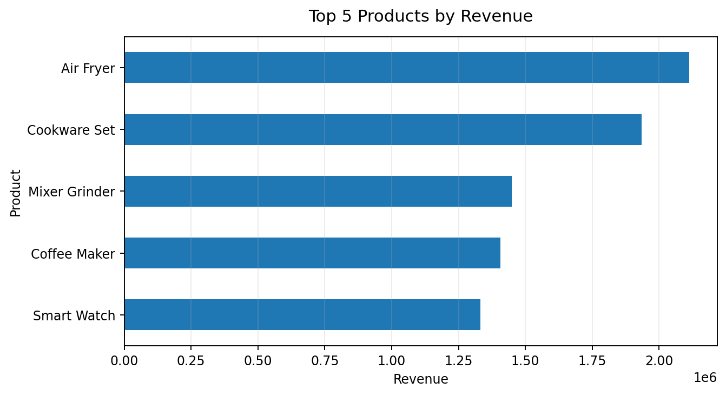
Figure 4. Top five products by calculated revenue.
The top product by calculated revenue is Air Fryer (₹2,111,922). The next useful question is whether its revenue comes from quantity sold or unit price; a product-level quantity comparison can help answer that.

4.5 Payment Mode and Order Status
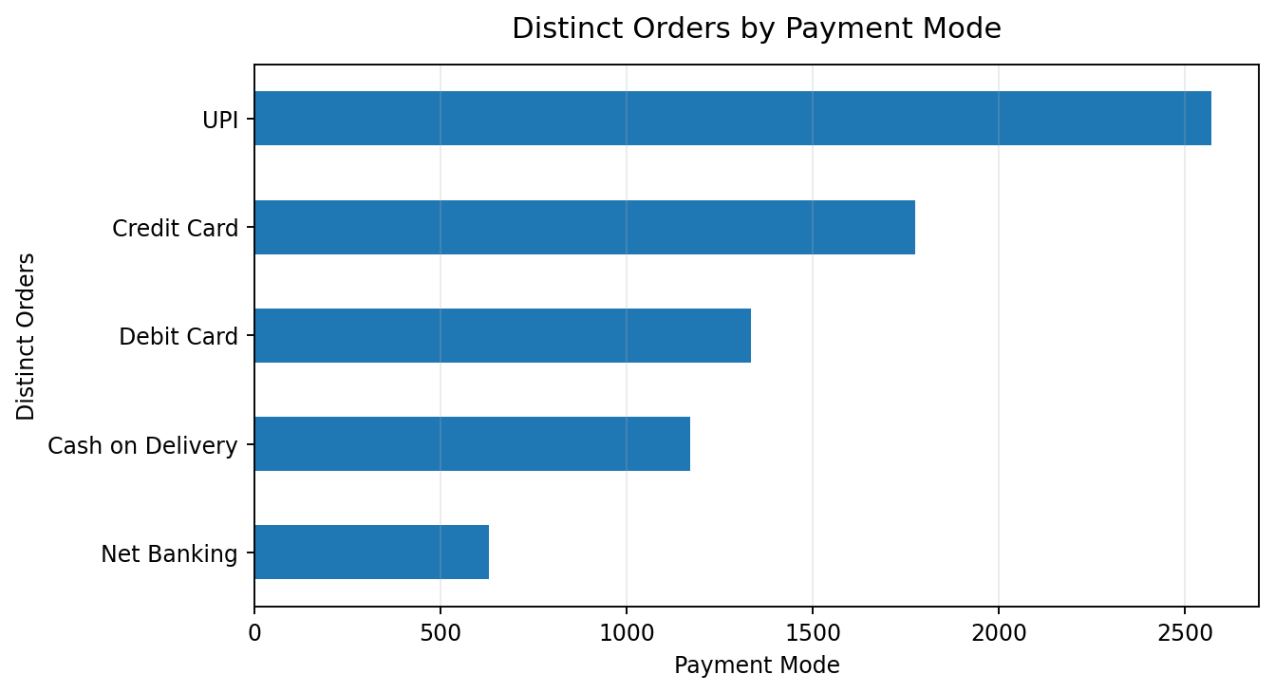
Figure 5. Distinct order count by payment mode.
The most common payment mode by distinct orders is UPI (2,571 orders). Payment popularity can inform checkout design, but payment preference alone does not indicate payment failure or customer satisfaction.
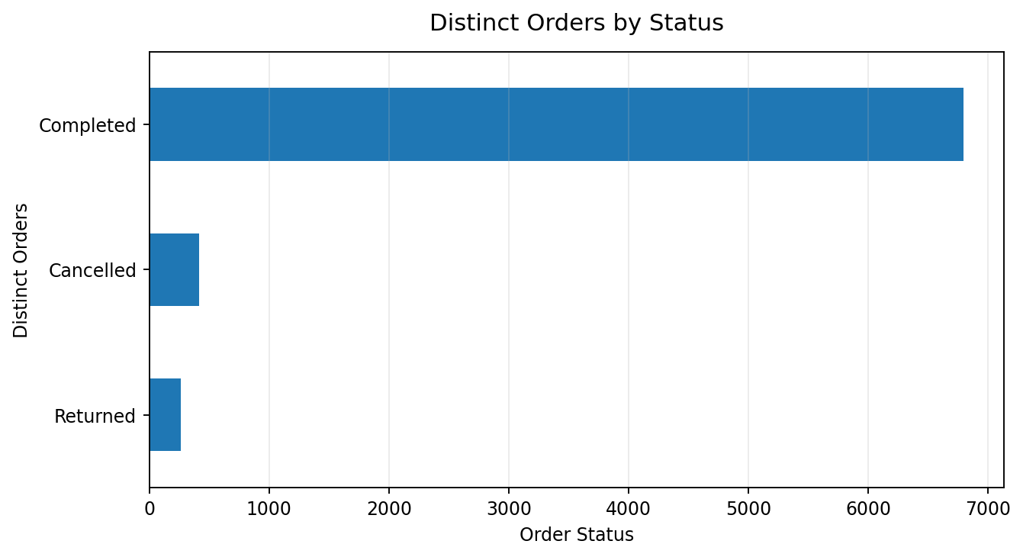
Figure 6. Distinct order count by status.
The most frequent order status is Completed (6,797 distinct orders). To assess operational performance, compare cancelled or delayed orders with total orders and investigate their causes.

4.6 New vs Returning Customers
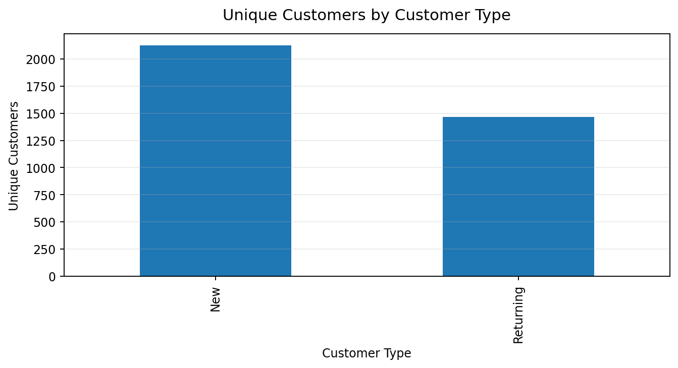
Figure 7. Unique customers grouped by customer type.
The largest customer-type group by distinct customer IDs is New (2,124 unique customer IDs). This is a descriptive comparison. A proper retention analysis would track the same customers across time periods.

5. KPI Definitions
KPI | Definition
Total Revenue | Sum of the calculated Revenue field.
Total Orders | Distinct count of Order_ID.
Total Customers | Distinct count of Customer_ID.
Average Order Value | Total Revenue ÷ distinct Order_ID count.
Revenue by Category/City/Product | Sum of Revenue grouped by the selected dimension.
Orders by Payment Mode/Status | Distinct count of Order_ID grouped by payment mode or order status.
New vs Returning Customers | Distinct count of Customer_ID grouped by Customer_Type; validate whether customer labels are consistent over time.

6. Power BI Dashboard Design
The Power BI report is designed to bring headline metrics and supporting explanations together. KPI cards summarize the overall picture, while the charts answer specific questions. Slicers let a user filter the page by relevant dimensions and see how the metrics change.
- KPI cards: Total Revenue, Total Orders, Average Order Value, Total Customers.
- Monthly Revenue Trend: line chart for change over time.
- Revenue by Category: treemap to compare contribution across categories.
- Revenue by City: horizontal bar chart for a clear ranking.
- Orders by Payment Mode: bar chart for comparison across payment options.
- Orders by Status: donut chart for the distribution of statuses.
- New vs Returning Customers: 100% stacked column chart for proportion comparison.
- Top 5 Products by Revenue: bar chart filtered to the top five products.
- Slicers: interactively filter the page; test whether all relevant visuals respond as intended.

7. Business Recommendations — How to Frame Them
Recommendations should follow evidence. Use the chart to identify a pattern, state what it suggests, then name the next check before proposing action.
- Revenue concentration: If one category or product contributes a large share, investigate stock availability, margins, and dependence on a small number of products.
- City performance: Compare top and lower-performing cities with customer count, marketing activity, and shipping cost before reallocating resources.
- Order status: If cancellations are material, break them down by city, payment mode, and product to look for operational patterns.
- Customer mix: If returning customers are a small share, analyze repeat purchase intervals and customer cohorts before choosing a retention campaign.
- Monthly changes: Investigate peaks and drops with product, category, discount, and order-status filters instead of assuming a cause from the line chart alone.

8. Project Limitations and Validation
- Revenue is not profit; cost, returns, taxes, and shipping expenses may not be included.
- A category or city ranking is descriptive and does not explain causation.
- Median/mode imputation is a simple rule; document why each field was imputed and consider an explicit 'Unknown' category where appropriate.
- Order IDs may repeat across product lines in some datasets; confirm the grain of the data before interpreting order counts and average order value.
- Customer_Type labels may be row-level labels rather than stable customer-level segments. Retention claims require customer history over time.
- Verify that Power BI measures use the same definitions as the Python analysis and that slicers filter all intended visuals.

9. Interview-Ready Project Explanation
“I built an E-Commerce Sales & Customer Analytics project to practice an end-to-end analytics workflow. I used Python and Pandas to inspect and clean the dataset, handled duplicate and invalid records, and calculated revenue using quantity, unit price, and discount. I loaded the prepared data into PostgreSQL for SQL analysis and built a Power BI dashboard with KPI cards, trend and comparison charts, and interactive slicers. The dashboard helps explore revenue by month, category, city, and product, as well as order status, payment methods, and customer types. I also validated the metrics and used the charts to identify areas that deserve deeper business investigation.”
Personalize this explanation so it matches the exact code and SQL queries you wrote. Do not claim a step or insight you cannot explain during follow-up questions.

10. Questions to Practice Before an Interview
- Why did you choose this project?
- What was the dataset size before and after cleaning?
- How did you handle missing values, and why?
- How did you identify duplicates?
- Why remove zero or negative quantities and unit prices?
- How is revenue calculated, and how is discount stored?
- What is the difference between total orders and total customers?
- Why did you use a line chart for monthly revenue?
- Why use a treemap for category revenue and a bar chart for city revenue?
- How does a Power BI slicer affect the dashboard?
- What is one insight from your actual analysis, and what business action might follow?
- What would you improve if you had more time?

Appendix: Analysis Notes
Raw records loaded: 7,535
Exact duplicate rows detected after removing exported index: 35
Rows after duplicate removal: 7,500
Rows with Quantity ≤ 0 before filtering: 12
Rows with Unit_Price ≤ 0 before filtering: 10
Final rows in report analysis: 7,478
Final analysis columns, including calculated Revenue and Month: 18
This report includes charts computed from the available raw CSV using the cleaning rules described here. If your final Python cleaning script used different imputation or filtering choices, update the documentation to match that script before submitting or presenting it.

