Sport Brand Annotation Assistant
Prototype walkthrough — September 2026
Upload three brand logos. It finds where each brand appeared in a full match broadcast, works out what kind of placement each appearance is, and an analyst confirms the best two.
Broadcast | 633,325 frames, 3h 31m
Given to it | 3 logo files, nothing else
Found | 6 placements, unprompted
Took | ~6 minutes on warm caches
The output is deliberately small — two approved example frames per placement, each with a box drawn round the branding, exported as an Excel workbook for the ML team’s exposure-value scan.
Everything here is one real run on the 2026 World Cup final. It is a prototype, and the limitations section is not decorative.

The demo: three logos in, six placements out
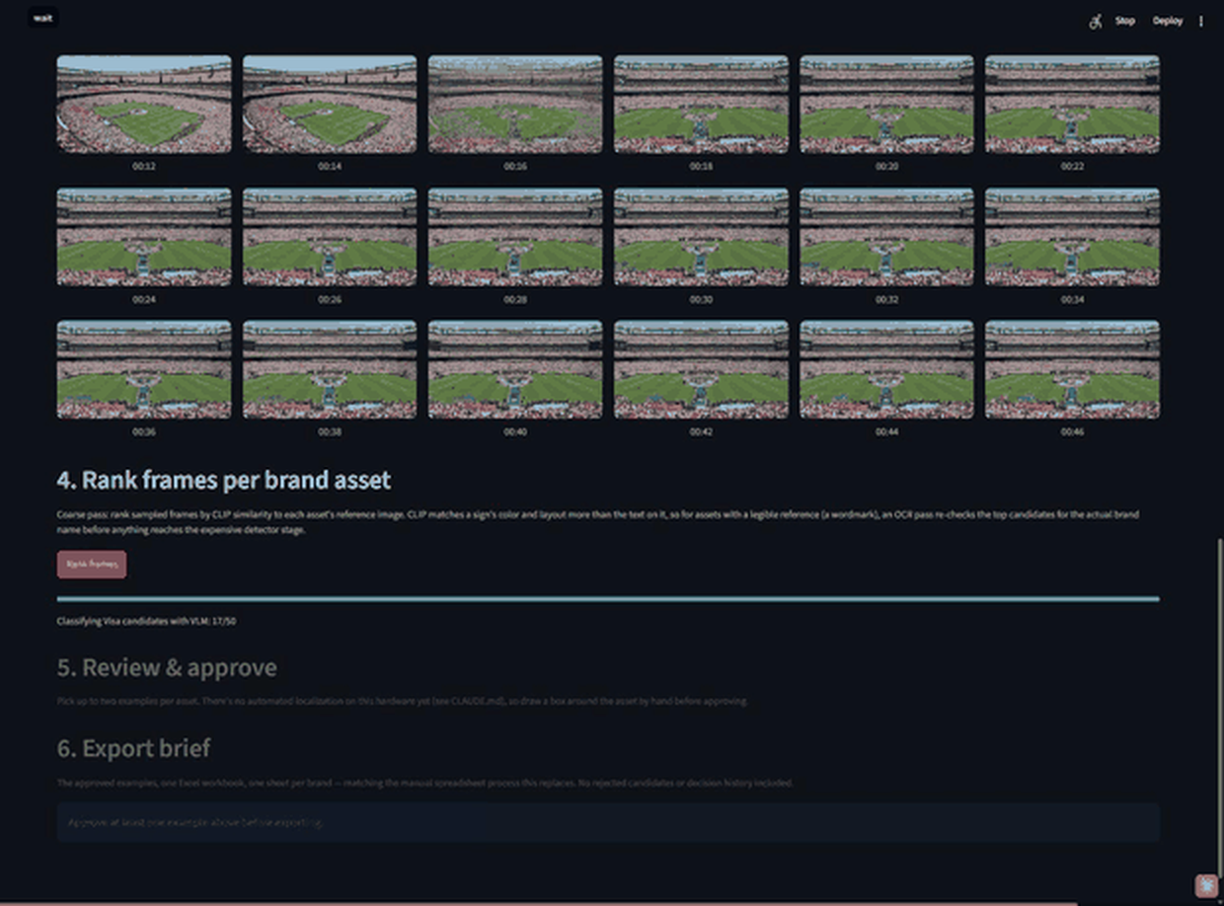
The live run classified results for Hisense, Adidas and Visa.
Cache the video once and it will save.
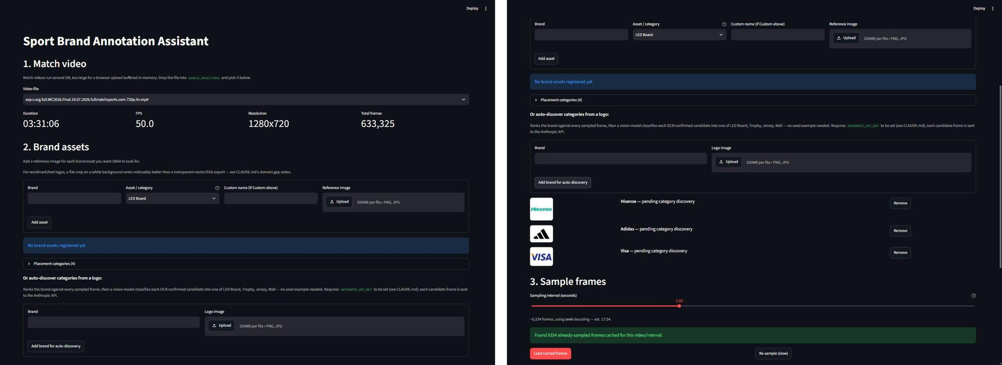
Left: an empty session. Right: three brands queued, each with a name and a logo file. No category, no example crop from the match.
Nobody told it to look for a jersey, a board, a trophy or a wall. It reported these back:
Brand | Reference logo | Placements discovered | Appearances
Hisense | Wordmark — legible text | LED Board / Wall | 22 / 2
Adidas | Graphic mark — no text at all | Jersey / LED Board / Trophy | 6 / 8 / 1
Visa | Wordmark — legible text | LED Board | 23
Adidas is the interesting one. Its reference is the bare three-stripe mark with no readable text, so the text-matching stage does nothing for it — and it still separated jersey appearances from perimeter boards from the trophy presentation.
The placement types for auto discovery can be added to tell the model what to look for.
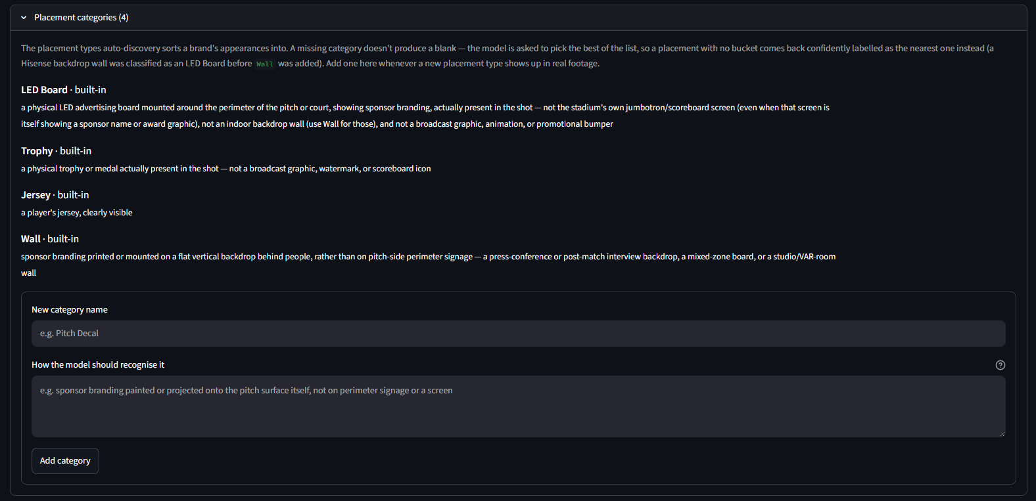
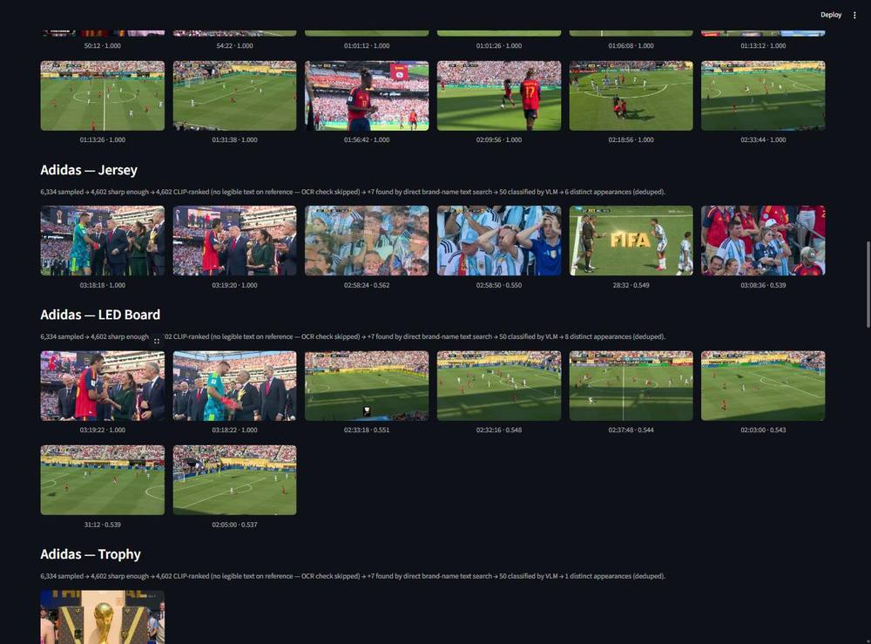
One logo file produced three separate placement types, each with its own candidate list.

The output: what gets handed over
The analyst picks up to two examples per placement, drags a box around the branding, and approves. Export produces one Excel workbook, one sheet per brand, one row per approved example — asset, frame number, timestamp, and the image with the box burned in.

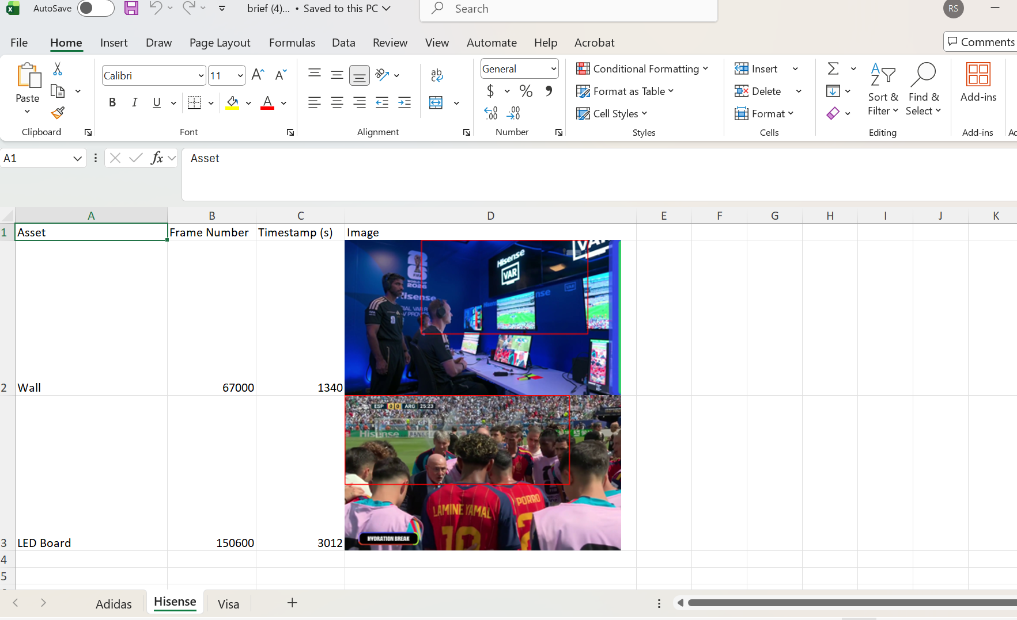
brief.xlsx: three sheets, one per brand.

How it works: four cheap filters before one expensive one
The machine this runs on has no usable GPU, so nothing can afford to look at every frame twice. Each stage only sees what the cheaper stage before it let through. Visa’s numbers:
Frames | Stage | What happens
6,334 | Sampled, one frame every 2 seconds | From 633,325. Cached per video — every brand after the first reuses it.
4,602 | Sharp enough to bother with | A blur filter drops motion-blurred and mid-cut frames.
4 | Look like the logo, and read as the brand | Image-similarity ranking, then OCR re-checks the top 50 for the logo’s own wording.
+140 | Have “Visa” written somewhere in the frame | A direct text search of every sharp frame, ignoring the logo image entirely. On a wordmark brand this does most of the recall work.
50 | Sent to a vision model with the logo alongside | Is this brand actually visible, and on what kind of placement? Claude Haiku, capped at 50 frames per brand.
23 | Distinct appearances, near-duplicates collapsed | All classified LED Board. The analyst reviews these and keeps two.
Two costs are per video (sampling, and reading the text out of every frame) and one is per brand (the vision-model calls). That split is what makes adding the fourth, tenth or ninetieth brand cheap.

Scale: what a supercars weekend would cost
Measured on the left, projected on the right for 90+ brands and 200+ assets. The projections are extrapolations from this run, not measurements.
 | This match (measured) | Race weekend (projected)
Vision-model calls | 148 calls · ~$0.35 | ~4,500 calls · ~$11
…if searched per placement instead | — | ~10,000 calls · ~$24
Vision-model wall time | ~4 min | ~2 h sequential · ~15 min if parallelised
The headline. API spend is roughly $10–25 per event
Honesty: what this prototype can’t do
- It gets things wrong, confidently. In this same run the trophy in a Louis Vuitton presentation trunk was classified as an Adidas Trophy placement. There is no Adidas branding in that frame. The analyst review step exists precisely for this — nothing is accepted automatically — but do not read the candidate lists as findings.
- Reading text off signage is doing most of the work. That is ideal for static perimeter boards in even light. On a car at 200 mph — small, curved, motion-blurred, often no text at all — it is the technique that transfers worst. Motorsport would likely need a detector trained on liveries instead.
- Every box is drawn by hand. An open-vocabulary detector was tested and failed completely on perimeter boards and jerseys, so it was dropped. That is why box-drawing is the scaling bottleneck above.
- It is one app on one laptop. CPU-only, single video at a time, no queue, no users, no test suite. Fine for proving the idea; not what you would run weekly against a race calendar.
- A missing placement type becomes a wrong answer, not a blank. The model picks the nearest option from a fixed list, so motorsport categories (sidepod, rear wing, halo, driver suit, pit wall…) would need to be added before the first real event.
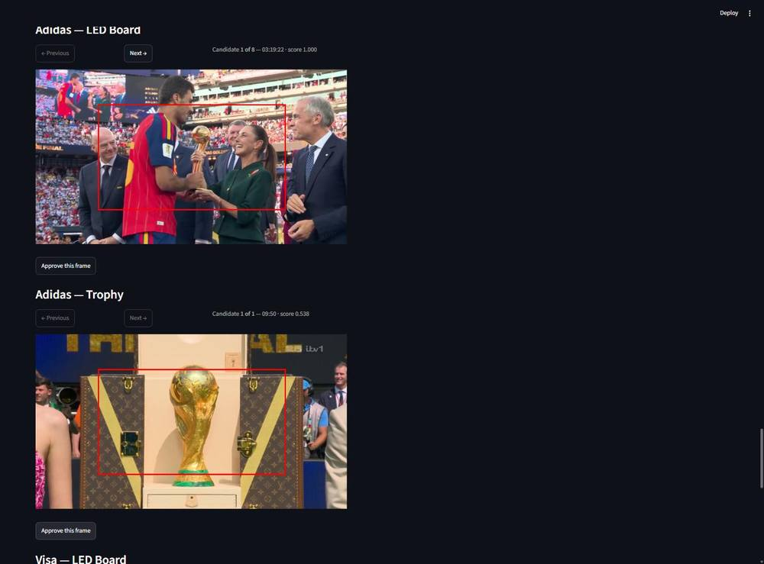
A real false positive: classified as Adidas — Trophy at score 0.538. It is a Louis Vuitton trunk. This is why a human approves every example.

Next: if this goes further
- Run the vision-model calls in parallel. Small change, turns hours into minutes.
- Move ingest and ranking off the browser session into a queue with workers; keep the app for review only.
- Get a GPU. The staged design came from not having one; a detector needs one.
- Fine-tune a detector on liveries. Highest value — it fixes recall on cars and proposes the boxes, which is the analyst-time problem.
- Use the contracted asset list. In motorsport you already know which brands should appear, which turns open discovery into checklist verification — a much easier question.

