COMPETENCY-BASED LEARNING MATERIALS (CBLM)

AI BASIC PYTHON DEVELOPER

TECHNICAL AND VOCATIONAL CERTIFICATE I — LEVEL II
Core Competency: Apply Structured Computer Programming
Module Title: Apply Structured Computer Programming
Learning Outcome: LO5 – Develop a Program Based on Control Flow Statements
Nominal Duration: Theory 3.5 Hours / Practical 12 Hours

L.O 05: DEVELOP A PROGRAM BASED ON CONTROL FLOW STATEMENTS
Upon completion of this learning outcome, students or trainees will have the following competencies:
- Explain Python decision-making and control flow.
- Identify logical conditions used in Python programs.
- Identify and apply comparison operators.
- Identify and apply logical operators.
- Develop programs using if statements.
- Develop programs using if-else statements.
- Develop programs using if-elif-else statements.
- Apply shorthand if statements.
- Apply shorthand if-else conditional expressions.
- Initialize and assign values to variables.
- Compare two variables using conditional statements.
- Display output when specified conditions are true or false.
- Apply multiple conditions in decision-making.
- Apply nested conditional statements.
- Apply the pass statement where appropriate.
- Draw process flow diagrams for conditional statements.
- Test and debug control-flow programs.
- Apply conditional statements to simple practical problems.

INFORMATION SHEET No. 5.1

Title: Understanding Python Control Flow and Conditional Statements

Objective
Upon reading this Information Sheet, the trainee must be able to:
- Explain decision-making and control flow.
- Identify logical conditions.
- Identify comparison operators.
- Identify logical operators.
- Explain the syntax of if.
- Explain if-else.
- Explain if-elif-else.
- Apply multiple conditions.
- Explain shorthand conditional statements.
- Explain nested conditions.
- Explain the pass statement.
- Initialize and assign variables for conditional evaluation.
- Explain basic flowchart symbols.
- Draw decision-making process flow diagrams.
- Apply conditional statements to practical problems.

1. Introduction to Control Flow
Control flow refers to the order in which instructions in a computer program are executed.
Normally, Python executes statements sequentially from top to bottom.
Example:
print("Step 1")
print("Step 2")
print("Step 3")
Output:
Step 1
Step 2
Step 3
Sometimes a program must make a decision.
For example:
- Is the student score greater than or equal to 50?
- Is a person 18 years old or older?
- Is the password correct?
- Is b greater than a?
- Is a number positive, negative, or zero?
Conditional statements allow Python to make these decisions.

2. Decision-Making in Python
Decision-making means evaluating a condition and performing an action according to whether that condition is True or False.

General concept:
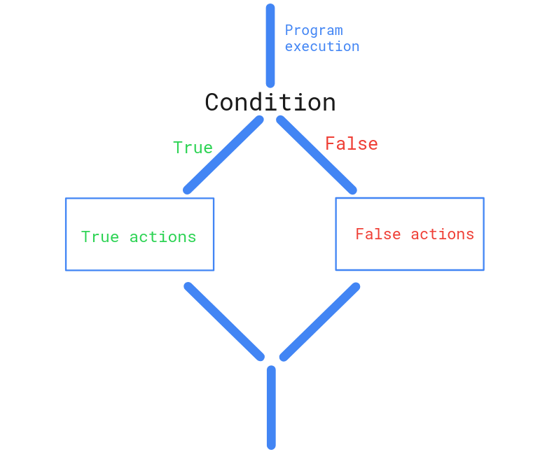
Example:
age = 20
if age >= 18:
print("Adult")
Python evaluates:
age >= 18
If the result is True, Python executes:
print("Adult")

3. Logical Conditions
A logical condition is an expression that produces:
True
or:
False
Example:
a = 5
b = 10
print(b > a)
Output:
True
The expression:
b > a
is a logical condition.

4. Comparison Operators
Comparison operators compare two values.
Operator | Description | Example
== | Equal to | a == b
!= | Not equal to | a != b
> | Greater than | a > b
< | Less than | a < b
>= | Greater than or equal to | a >= b
<= | Less than or equal to | a <= b
Example:
a = 5
b = 10
print(a == b)
print(a != b)
print(a < b)
print(a > b)
print(a <= b)
print(a >= b)
Output:
False
True
True
False
True
False

5. Logical Operators
Logical operators combine or modify conditions.
Python provides three main logical operators:
Operator | Description
and | True when both conditions are true
or | True when at least one condition is true
not | Reverses the condition

6. The and Operator
The and operator requires both conditions to be true.
Example:
age = 20
score = 80
if age >= 18 and score >= 50:
print("Eligible")
Both conditions must be true.

Truth Table
Condition A | Condition B | A and B
True | True | True
True | False | False
False | True | False
False | False | False

7. The or Operator
The or operator requires at least one condition to be true.
Example:
score = 45
attendance = 90
if score >= 50 or attendance >= 80:
print("Condition satisfied")

Truth Table
Condition A | Condition B | A or B
True | True | True
True | False | True
False | True | True
False | False | False

8. The not Operator
The not operator reverses a Boolean result.
Example:
is_blocked = False
if not is_blocked:
print("Access allowed")
If:
is_blocked = False
then:
not is_blocked
becomes:
True

9. The if Statement
The if statement executes a block of code when a condition is true.
Syntax:
if condition:
statement
Example:
a = 5
b = 10
if b > a:
print("b is greater than a")
Output:
b is greater than a
This example directly addresses the LO5 assessment requirement.

10. Structure of an if Statement
if condition:
statement
Important components are:
- if keyword
- Condition
- Colon :
- Indented code block
Example:
score = 80
if score >= 50:
print("Pass")

11. Indentation in Conditional Statements
Python uses indentation to define the statements belonging to a condition.
Correct:
age = 20
if age >= 18:
print("Adult")
Incorrect:
age = 20
if age >= 18:
print("Adult")
The second example causes an indentation error.
A standard Python indentation level normally uses four spaces.

12. The if-else Statement
An if-else structure allows the program to choose between two alternatives.
Syntax:
if condition:
statement_if_true
else:
statement_if_false
Example:
age = 16
if age >= 18:
print("Adult")
else:
print("Minor")
Output:
Minor

13. if-else Process
The program evaluates a condition.
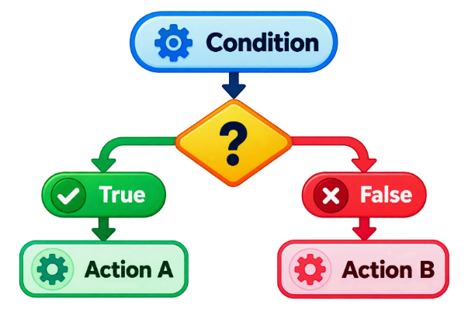
Figure 1: if-else
Only one of the two branches is executed.

14. The elif Statement
elif means “else if”.
It allows multiple conditions to be evaluated.
Syntax:
if condition1:
statement1
elif condition2:
statement2
else:
statement3
Example:
score = 75
if score >= 80:
print("Grade A")
elif score >= 70:
print("Grade B")
else:
print("Grade C")
Output:
Grade B

15. Multiple elif Statements
A program can contain several elif conditions.
Example:
score = 65
if score >= 90:
print("Grade A")
elif score >= 80:
print("Grade B")
elif score >= 70:
print("Grade C")
elif score >= 60:
print("Grade D")
else:
print("Grade F")
Output:
Grade D
Python evaluates the conditions from top to bottom and executes the first matching branch.

16. Order of Conditions
The order of conditions is important.
Consider:
score = 85
if score >= 50:
print("Pass")
elif score >= 80:
print("Excellent")
The output is:
Pass
The first condition is already true, so Python does not evaluate the next branch.
A better structure is:
score = 85
if score >= 80:
print("Excellent")
elif score >= 50:
print("Pass")
else:
print("Fail")
Output:
Excellent

17. Shorthand if
Python allows a simple if statement to be written on one line.
Normal:
a = 5
b = 10
if b > a:
print("b is greater than a")
Shorthand:
if b > a: print("b is greater than a")
This form should be used only when the statement remains clear and readable.

18. Shorthand if-else
A simple conditional expression can also be written on one line.
Example:
a = 10
b = 5
print("A") if a > b else print("B")
Output:
A
A more useful form assigns a result:
age = 20
status = "Adult" if age >= 18 else "Minor"
print(status)
Output:
Adult
This syntax is commonly called a conditional expression.

19. Nested if Statements
A nested if is an if statement inside another conditional statement.
Example:
age = 20
has_id = True
if age >= 18:
if has_id:
print("Entry allowed")
else:
print("ID required")
else:
print("Entry denied")
A nested structure is useful when the second decision should only be evaluated after the first condition is satisfied.

20. Multiple Conditions with and
Example:
age = 20
score = 80
if age >= 18 and score >= 50:
print("Qualified")
Output:
Qualified

21. Multiple Conditions with or
Example:
score = 45
attendance = 90
if score >= 50 or attendance >= 80:
print("Condition satisfied")
Output:
Condition satisfied

22. Combining Logical Operators
More than one logical operator can be used.
Example:
age = 20
score = 80
is_active = True
if age >= 18 and score >= 50 and is_active:
print("Eligible")
For readability, parentheses may be used in more complex expressions:
if (age >= 18 and score >= 50) or is_active:
print("Condition satisfied")

23. The pass Statement
Python does not allow an empty code block.
The pass statement acts as a placeholder.
Example:
score = 80
if score >= 50:
pass
The program does nothing inside the if block, but the syntax remains valid.
Another example:
age = 20
if age >= 18:
pass
else:
print("Minor")
pass is useful when a code block will be implemented later.

24. Python Keywords Used in Conditional Statements
Important keywords include:
If elif else and or not pass True False
These keywords have special meanings and should not be used as ordinary variable names.

25. Initializing Variables
Initialization means creating a variable and assigning an initial value.
Example:
a = 5
b = 10
Here:
a → 5
b → 10
The values can then be used in conditional expressions.

26. Required Variable Comparison
Initialize:
a = 5
b = 10
Check whether b is greater than a:
if b > a:
print("b is greater than a")
Output:
b is greater than a
The condition:
b > a
returns:
True
Therefore, the statement is displayed.

27. What Happens When the Condition is False?
Consider:
a = 20
b = 10
if b > a:
print("b is greater than a")
Because:
10 > 20
is false, nothing is printed.
An else branch can handle this case:
a = 20
b = 10
if b > a:
print("b is greater than a")
else:
print("b is not greater than a")
Output:
b is not greater than a

28. Comparing Two Numbers
A complete comparison program can determine whether the first number is greater, the second number is greater, or both are equal.
Example:
a = 10
b = 20
if a > b:
print("a is greater than b")
elif b > a:
print("b is greater than a")
else:
print("a and b are equal")
Output:
b is greater than a

29. Practical Example — Pass or Fail
score = 70
if score >= 50:
print("Pass")
else:
print("Fail")
This decision has two possible outcomes:
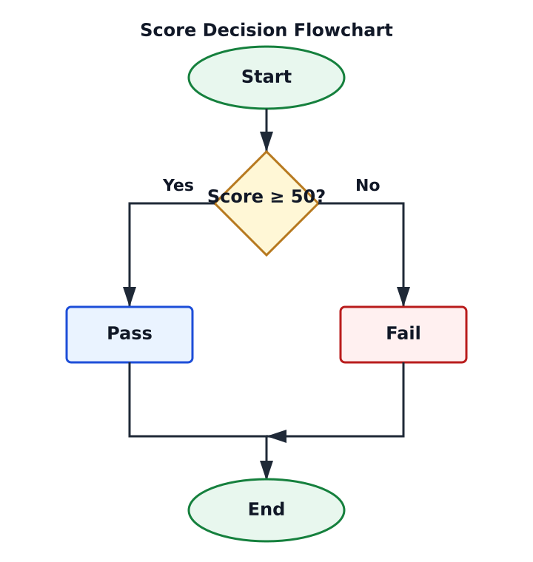

30. Practical Example — Positive, Negative or Zero
number = -5
if number > 0:
print("Positive")
elif number < 0:
print("Negative")
else:
print("Zero")
Output:
Negative

31. Practical Example — Student Grade
score = 85
if score >= 90:
grade = "A"
elif score >= 80:
grade = "B"
elif score >= 70:
grade = "C"
elif score >= 60:
grade = "D"
else:
grade = "F"
print("Grade:", grade)
Output:
Grade: B

32. Practical Example — Login Decision
username = "admin"
password = "1234"
if username == "admin" and password == "1234":
print("Login successful")
else:
print("Invalid username or password")
This demonstrates multiple conditions with and.

33. Practical Example — Age Category
age = 25
if age < 13:
print("Child")
elif age < 18:
print("Teenager")
elif age < 60:
print("Adult")
else:
print("Senior")
Output:
Adult

34. Flowcharts for Control Statements
A flowchart visually represents the steps and decisions in a program.
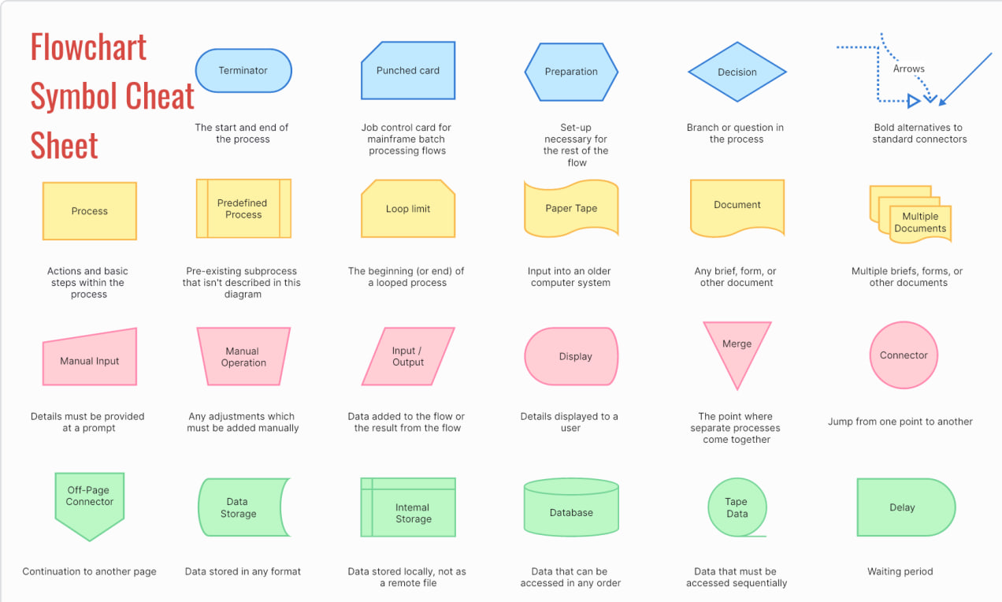
Common symbols include:
Symbol | Purpose
Oval | Start / End
Rectangle | Process
Diamond | Decision
Parallelogram | Input / Output
Arrow | Direction of flow
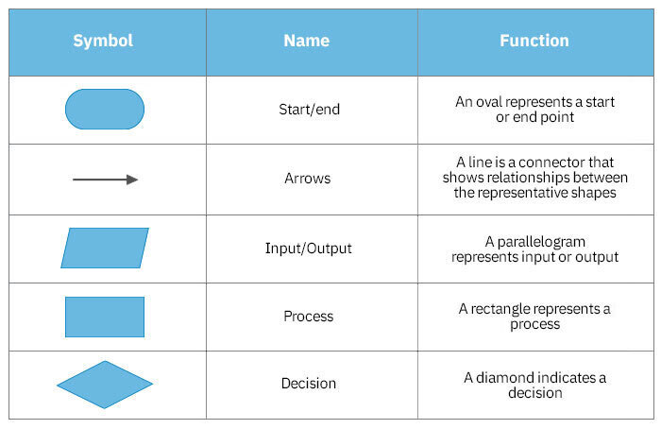

35. Start/End Symbol
The oval represents:
START
or:
END

36. Process Symbol
A rectangle represents processing.
Example:
a = 5 , b= 10

37. Decision Symbol
A diamond represents a condition or decision.
a > b
Example:

The decision normally has two branches:
True / Yes
False / No

38. Input/Output Symbol
A parallelogram represents input or output.
For example:
Print "b is greater than a"
is an output operation.

39. Flowchart for Required LO5 Program
Program:
a = 5
b = 10
if b > a:
print("b is greater than a")
Process flow:
START
↓
a 5
b = 10
↓
◇ b > a? ◇
/ \
Yes
↓ ↓
b is greater than a
\ /
↓
END

40. Flowchart for if-else
Example:
score = 70
if score >= 50:
print("Pass")
else:
print("Fail")
Flow:
START
↓
score = 70
↓
◇ score >= 50? ◇
/ \
Yes No
↓ ↓
Pass Fail
\ /
↓
END

41. Flowchart for if-elif-else
Example logic:
Score >= 80 → Excellent
Score >= 50 → Pass
Otherwise → Fail
Flow:
START
↓
Read Score
↓
◇ Score >= 80? ◇
/ \
Yes No
↓ ↓
"Excellent" ◇ Score >= 50? ◇
/ \
Yes No
↓ ↓
"Pass" "Fail"
\ /
↓
END

42. Developing a Control-Flow Program
A simple development process is:
Analyze Problem
↓
Identify Inputs
↓
Identify Conditions
↓
Identify Outputs
↓
Draw Flowchart
↓
Write Python Code
↓
Run Program
↓
Test Conditions
↓
Debug Errors
↓
Verify Output

43. Testing Conditional Programs
Conditional programs should be tested using different cases.
For example:
if b > a:
print("b is greater than a")
elif a > b:
print("a is greater than b")
else:
print("a and b are equal")
Test at least:
Test | a | b | Expected Result
1 | 5 | 10 | b is greater than a
2 | 10 | 5 | a is greater than b
3 | 10 | 10 | a and b are equal
Testing all major branches helps verify program correctness.

44. Common Conditional Statement Errors

Missing Colon
Incorrect:
if age >= 18
print("Adult")
Correct:
if age >= 18:
print("Adult")

Incorrect Indentation
Incorrect:
if age >= 18:
print("Adult")
Correct:
if age >= 18:
print("Adult")

Assignment Instead of Comparison
Incorrect:
if age = 18:
Correct:
if age == 18:
print("Age is 18")
Remember:
= assignment
== comparison

Incorrect Keyword
Incorrect:
elseif
Python uses:
elif

45. Debugging Control-Flow Programs
When a conditional program produces an error or incorrect result:
- Check variable values.
- Check comparison operators.
- Check logical operators.
- Check the colon.
- Check indentation.
- Check condition order.
- Check if, elif, and else structure.
- Run different test cases.
- Compare actual output with expected output.
- Correct the program and run it again.

SELF-CHECK No. 1

Part A — Multiple Choice
1. What is control flow?
A. Computer hardware B. The order in which program statements execute
C. A Python variable D. A Python string
2. Which keyword begins a conditional statement?
A. for B. if C. print D. input
3. Which operator means greater than?
A. < B. > C. == D. !=
4. Which operator checks equality?
A. = B. == C. >= D. <=
5. Which is a logical operator?
A. and B. print C. input D. type
6. Which logical operator requires both conditions to be true?
A. or B. not C. and D. if
7. Which logical operator requires at least one condition to be true?
A. or B. and C. not D. else
8. Which keyword is used for an additional condition?
A. elseif B. else if C. elif D. then
9. Which keyword handles the remaining alternative?
A. if B. elif C. else D. pass
10. Which statement acts as a placeholder?
A. print B. pass C. input D. break
11. Which flowchart symbol represents a decision?
A. Rectangle B. Diamond C. Oval D. Arrow
12. Which symbol represents Start/End?
A. Oval B. Diamond C. Rectangle D. Parallelogram
13. Given a = 5 and b = 10, what is b > a?
A. False B. True C. 5 D. 10
14. Which is valid Python?
A. if b > a: B. if b > a then C. if (b > a) then D. IF b > a
15. What is the correct Python keyword for “else if”?
A. elseif B. elif C. else_if D. ifelse

ANSWER KEY No. 5.1

Part A
No. | Answer
1 | B
2 | B
3 | B
4 | B
5 | A
6 | C
7 | A
8 | C
9 | C
10 | B
11 | B
12 | A
13 | B
14 | A
15 | B

OPERATION SHEET No. 5.1

Title: Create and Execute Python Conditional Statements

Performance Objective
Given a computer with Python installed and an approved Python development environment, the trainee must initialize variables, apply comparison and logical operators, create if, elif, and else statements, execute the program, test different conditions and verify the results.

Description
This operation demonstrates how to create and execute a basic Python decision-making program.

Picture/Overview
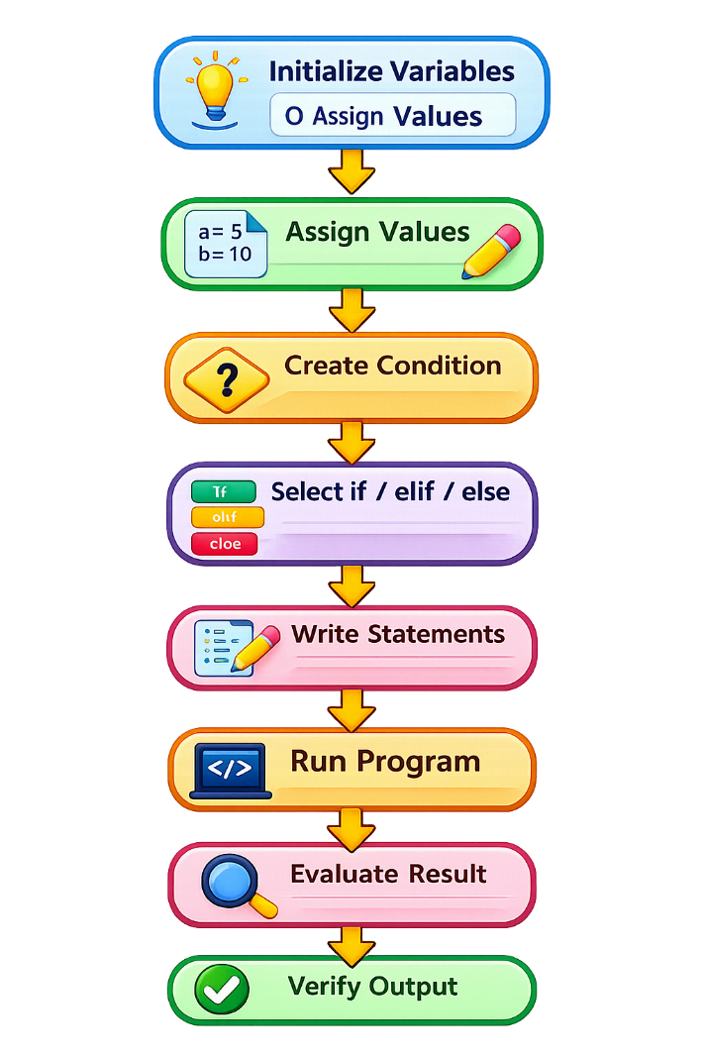
Figure 2:

Tools, Equipment and Materials
No. | Description | Unit | Qty
1 | Desktop Computer/Laptop | Unit | 1
2 | Keyboard and Mouse | Set | 1
3 | Python 3.x | Copy | 1
4 | Python IDLE/IDE | Software | 1
5 | Command Prompt/Terminal | Software | 1
6 | Python Programming Reference | Copy | 1
7 | CBLM/Worksheet | Copy | 1

Supplier
Training institution / authorized software provider.

Procedure/Step | Key Performance
No. | Procedure/Step | Key Performance
1 | Open Python IDLE/IDE | Development environment opens correctly
2 | Create new Python file | Source file is created
3 | Initialize variables a and b | Variables are correctly created
4 | Assign values | Appropriate values are stored
5 | Create comparison | Correct comparison operator is used
6 | Create if statement | Correct syntax and colon are used
7 | Apply indentation | Code block is correctly indented
8 | Display true result | Required message is printed
9 | Add elif and else | Alternative conditions are correctly structured
10 | Apply logical operators | and, or, or not is correctly used
11 | Save program | .py extension is used
12 | Execute program | Program executes successfully
13 | Test different values | Major branches are tested
14 | Verify output | Results match conditions

Operation Procedure
Create:
a = 5
b = 10
Check:
if b > a:
print("b is greater than a")
Extend:
if a > b:
print("a is greater than b")
elif b > a:
print("b is greater than a")
else:
print("a and b are equal")
Test:
a = 5, b = 10
a = 10, b = 5
a = 10, b = 10
Save as:
control_flow.py
Run and verify all three test cases.

Assessment Method
- Direct observation
- Practical demonstration
- Source-code inspection
- Program execution
- Output verification

TASK SHEET No. 5.1

Title: Apply Logical Conditions and Operators

Performance Task
Create logical conditions using comparison and logical operators.

Performance Objective
Given variable values, the trainee must correctly apply comparison operators and the logical operators and, or, and not.

Description
Use:
a = 5
b = 10
to evaluate different conditions.

Picture/Overview
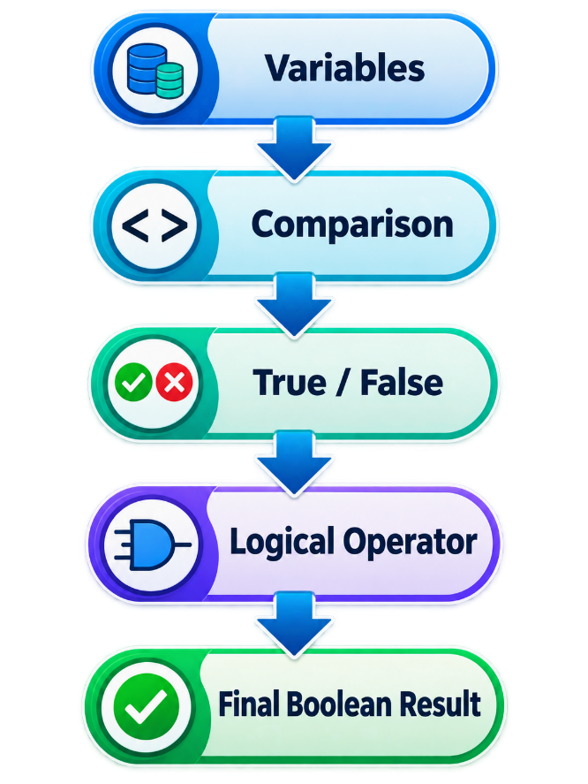
Figure 3:

Tools, Equipment and Materials
No. | Description | Unit | Qty
1 | Computer/Laptop | Unit | 1
2 | Python 3.x | Copy | 1
3 | Python IDE | Software | 1
4 | Programming Worksheet | Copy | 1

Supplier
Training institution.

Procedure/Step | Key Performance
No. | Procedure/Step | Key Performance
 | 1. Initialize variables | Correct variables are created
 | 2. Apply > and < | Results are correct
 | 3. Apply == and != | Results are correct
 | 4. Apply >= and <= | Results are correct
 | 5. Apply and | Correct Boolean result is produced
 | 6. Apply or | Correct Boolean result is produced
 | 7. Apply not | Boolean result is reversed correctly
 | 8. Verify results | Actual results match expected results

Practical Exercise
a = 5
b = 10
print(a > b)
print(a < b)
print(a == b)
print(a != b)
print(a <= b)
print(a >= b)
print(a < b and b == 10)
print(a > b or b == 10)
print(not a > b)
Complete:
Expression | Expected Result | Actual Result
a > b | False | ______
a < b | True | ______
a == b | False | ______
a != b | True | ______
a <= b | True | ______
a >= b | False | ______
a < b and b == 10 | True | ______
a > b or b == 10 | True | ______
not a > b | True | ______

Assessment Method
- Direct observation
- Practical exercise
- Worksheet review
- Output verification

TASK SHEET No. 5.2

Title: Develop if and if-else Statements

Performance Task
Develop a Python program using if and if-else.

Performance Objective
Given two initialized variables, the trainee must check whether b is greater than a and display the appropriate result.

Description
The trainee will practice the core LO5 requirement:
a = 5
b = 10
and evaluate:
b > a

Picture/Overview
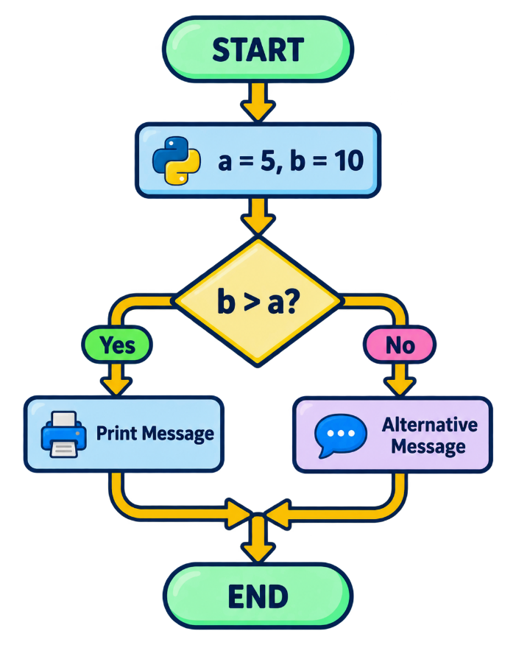
Figure 4:

Tools, Equipment and Materials
No. | Description | Unit | Qty
1 | Computer/Laptop | Unit | 1
2 | Python 3.x | Copy | 1
3 | Python IDE | Software | 1
4 | Worksheet | Copy | 1

Supplier
Training institution.

Procedure/Step | Key Performance
No. | Procedure/Step | Key Performance
1 | Create a | Variable is initialized
2 | Create b | Variable is initialized
3 | Assign values | a=5, b=10
4 | Create if | Correct syntax is applied
5 | Evaluate b > a | Correct condition is used
6 | Print true message | Required message appears
7 | Add else | False branch is handled
8 | Test different values | Both outcomes are tested

Practical Exercise A
a = 5
b = 10
if b > a:
print("b is greater than a")

Practical Exercise B
Modify:
a = 20
b = 10
Use:
if b > a:
print("b is greater than a")
else:
print("b is not greater than a")
Record results:
a | b | Expected Result | Actual Result
5 | 10 | b is greater than a | __________________
20 | 10 | b is not greater than a | __________________

Assessment Method
- Direct observation
- Practical demonstration
- Program execution
- Output verification

TASK SHEET No. 5.3

Title: Develop if-elif-else Decision Statements

Performance Task
Develop a Python program that evaluates multiple conditions.

Performance Objective
Given a numeric score, the trainee must use if, elif, and else to classify the result according to specified conditions.

Description
Create a simple grading decision.

Picture/Overview
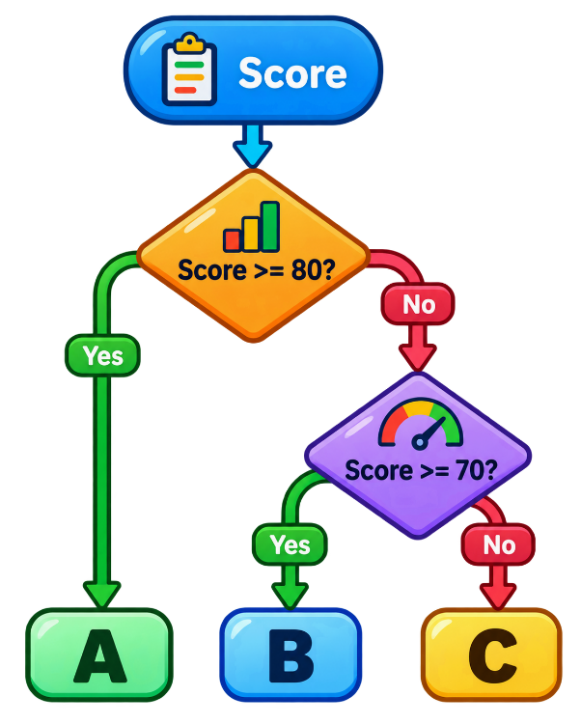
Figure 5:

Tools, Equipment and Materials
No. | Description | Unit | Qty
1 | Computer/Laptop | Unit | 1
2 | Python 3.x | Copy | 1
3 | Python IDE | Software | 1
4 | Worksheet | Copy | 1

Supplier
Training institution.

Procedure/Step | Key Performance
No. | Procedure/Step | Key Performance
1 | Create score variable | Correct value is assigned
2 | Create first if | Highest condition is evaluated
3 | Add elif | Additional condition is evaluated
4 | Add else | Remaining case is handled
5 | Apply indentation | Blocks are correctly structured
6 | Execute program | Program runs successfully
7 | Test multiple scores | Different branches are verified

Practical Exercise
Develop:
score = 75
if score >= 80:
print("Grade A")
elif score >= 70:
print("Grade B")
else:
print("Grade C")
Test:
Score | Expected Result | Actual Result
85 | Grade A | __________
75 | Grade B | __________
60 | Grade C | __________

Assessment Method
- Direct observation
- Practical exercise
- Program execution
- Output verification

TASK SHEET No. 5.4

Title: Apply Shorthand and Nested Conditional Statements

Performance Task
Develop shorthand and nested Python conditional statements.

Performance Objective
Given simple decision requirements, the trainee must apply shorthand conditional expressions and nested conditional statements where appropriate.

Description
This activity introduces compact and nested decision structures.

Picture/Overview
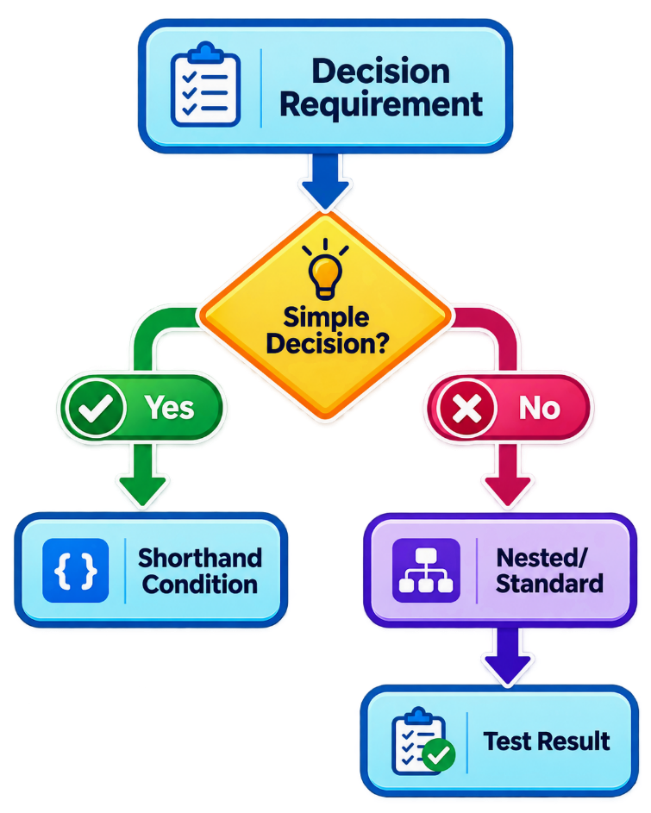
Figure 6:

Tools, Equipment and Materials
No. | Description | Unit | Qty
1 | Computer/Laptop | Unit | 1
2 | Python 3.x | Copy | 1
3 | Python IDE | Software | 1
4 | Worksheet | Copy | 1

Supplier
Training institution.

Procedure/Step | Key Performance
No. | Procedure/Step | Key Performance
1 | Identify decision requirement | Appropriate structure is selected
2 | Apply shorthand if | One-line condition is correct
3 | Apply conditional expression | True/false values are correct
4 | Create outer condition | First decision is correct
5 | Create nested condition | Second decision is correctly nested
6 | Apply indentation | Nested blocks are correct
7 | Execute and test | Required branches are verified

Practical Exercise A — Shorthand if
a = 5
b = 10
if b > a: print("b is greater than a")

Practical Exercise B — Conditional Expression
age = 20
status = "Adult" if age >= 18 else "Minor"
print(status)

Practical Exercise C — Nested if
age = 20
has_id = True
if age >= 18:
if has_id:
print("Entry allowed")
else:
print("ID required")
else:
print("Entry denied")
Test:
Age | Has ID | Expected Result
20 | True | Entry allowed
20 | False | ID required
16 | True | Entry denied

Assessment Method
- Direct observation
- Practical demonstration
- Source-code inspection
- Output verification

TASK SHEET No. 5.5

Title: Draw Process Flow Diagrams for Control Statements

Performance Task
Draw process flow diagrams representing if, if-else, and if-elif-else decision structures.

Performance Objective
Given conditional program requirements, the trainee must identify appropriate flowchart symbols, arrange them logically, connect them using arrows and correctly represent true and false decision branches.

Description
The trainee converts Python decision logic into a graphical process representation.

Picture/Overview
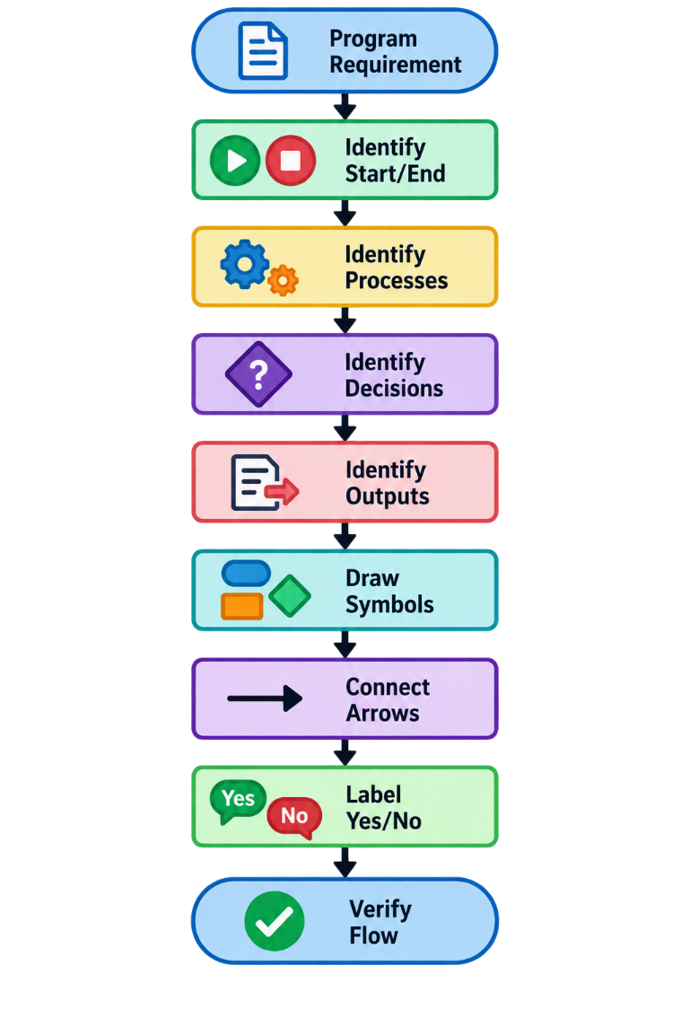
Figure 7:

Tools, Equipment and Materials
No. | Description | Unit | Qty
1 | Flowchart Worksheet | Copy | 1
2 | Pencil/Pen | Unit | 1
3 | Ruler | Unit | 1
4 | Computer/Laptop | Unit | 1
5 | Flowchart Software, if available | Copy | 1
6 | CBLM | Copy | 1

Supplier
Training institution.

Procedure/Step | Key Performance
No. | Procedure/Step | Key Performance
1 | Analyze program | Logic is correctly identified
2 | Draw Start symbol | Oval is correctly used
3 | Draw process | Rectangle is correctly used
4 | Draw decision | Diamond is correctly used
5 | Draw output | Appropriate symbol is used
6 | Connect symbols | Arrows show correct direction
7 | Label decision branches | Yes/No or True/False is shown
8 | Draw End symbol | Flow terminates correctly
9 | Compare with Python logic | Diagram matches program

Exercise A
Draw a flowchart for:
a = 5
b = 10
if b > a:
print("b is greater than a")

Exercise B
Draw a flowchart for:
score = 70
if score >= 50:
print("Pass")
else:
print("Fail")

Exercise C
Draw a flowchart for:
number = 0
if number > 0:
print("Positive")
elif number < 0:
print("Negative")
else:
print("Zero")

Assessment Method
- Flowchart review
- Direct observation
- Oral questioning
- Practical assessment

JOB SHEET No. 5.1

Title: Develop a Student Result Decision Program

Performance Task
Develop a complete Python program that applies control-flow statements to evaluate a student’s result and eligibility status.

Performance Objective
Given a computer, Python development environment and program requirements, the trainee must analyze the decision problem, draw a process flow diagram, initialize variables, apply comparison and logical operators, implement if, elif, else and nested conditions, execute and test the program, debug errors and verify the final output.

Description
Develop:
student_result_decision.py
The program will evaluate student information and demonstrate the major control-flow concepts covered in LO5.

Picture/Overview
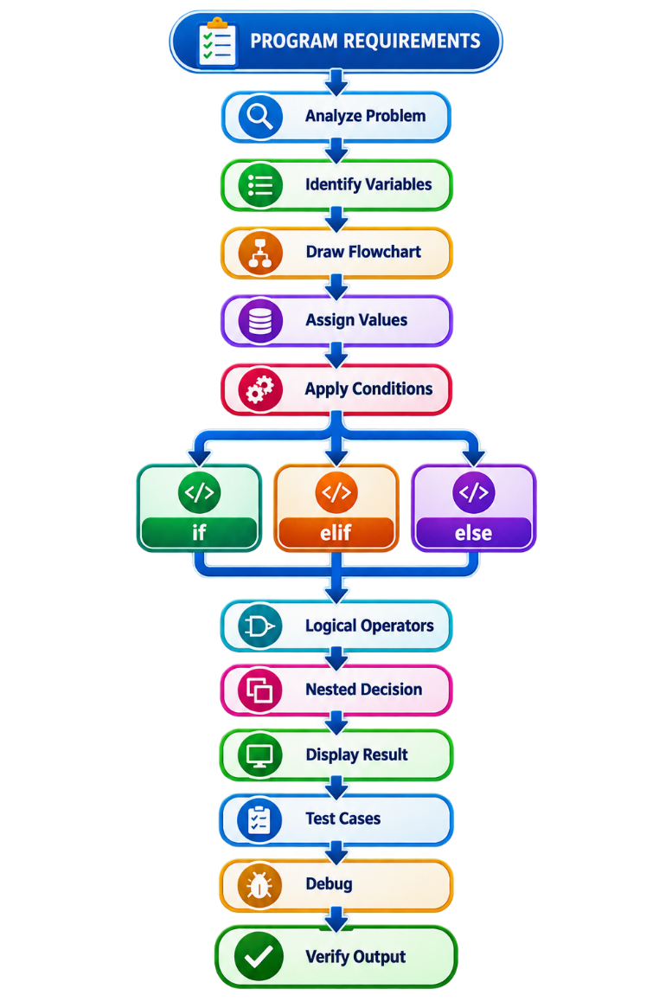
Figure 8:

Tools, Equipment and Materials
No. | Description | Unit | Qty
1 | Desktop Computer/Laptop | Unit | 1
2 | Keyboard and Mouse | Set | 1
3 | Python 3.x | Copy | 1
4 | Python IDLE/IDE | Software | 1
5 | Programming Worksheet | Copy | 1
6 | Flowchart Worksheet | Copy | 1
7 | Python Reference Material | Copy | 1

Supplier
Training institution / authorized software provider.

Procedure/Step | Key Performance
No. | Procedure/Step | Key Performance
1 | Analyze requirements | Inputs, conditions and outputs are identified
2 | Draw flowchart | Decision logic is represented correctly
3 | Open Python IDE | Development environment opens
4 | Create program file | Source file is created
5 | Initialize variables | Required variables are created
6 | Assign values | Appropriate values are stored
7 | Apply comparison operators | Conditions are correctly constructed
8 | Apply logical operators | Multiple conditions are correctly evaluated
9 | Create if | First decision is correctly implemented
10 | Create elif | Additional decisions are correctly implemented
11 | Create else | Remaining case is handled
12 | Apply nested condition | Nested decision operates correctly
13 | Apply shorthand condition | Simple conditional expression is correctly demonstrated
14 | Save program | .py extension is used
15 | Execute program | Program runs
16 | Test different values | All major branches are tested
17 | Identify errors | Syntax/logical errors are recognized
18 | Debug program | Errors are corrected
19 | Re-execute program | Corrected program runs
20 | Verify output | Results match requirements

Program Requirements
The program must contain:
- Student name.
- Student score.
- Student attendance.
- if.
- elif.
- else.
- Comparison operators.
- Logical operators.
- Nested conditional statement.
- Shorthand conditional expression.
- Appropriate output statements.
- At least three test cases.

Part 1 — Variables
Create:
student_name = "Dara"
score = 85
attendance = 90

Part 2 — Determine Grade
Use:
90–100 → Grade A
80–89 → Grade B
70–79 → Grade C
60–69 → Grade D
Below 60 → Grade F

Part 3 — Determine Pass/Fail
A student passes when:
Score >= 60
AND
Attendance >= 75

Part 4 — Nested Condition
If the student passes, check whether:
Score >= 90
If true:
Excellent Performance
Otherwise:
Satisfactory Performance

Part 5 — Shorthand Condition
Use a conditional expression to determine:
Eligible
or:
Not Eligible
based on attendance.

Example Program
# Student Result Decision Program
student_name = "Dara"
score = 85
attendance = 90
print("STUDENT RESULT")
print("Name:", student_name)
print("Score:", score)
print("Attendance:", attendance)
# Determine grade
if score >= 90:
grade = "A"
elif score >= 80:
grade = "B"
elif score >= 70:
grade = "C"
elif score >= 60:
grade = "D"
else:
grade = "F"
print("Grade:", grade)
# Determine pass/fail
if score >= 60 and attendance >= 75:
print("Result: Pass")
# Nested condition
if score >= 90:
print("Performance: Excellent")
else:
print("Performance: Satisfactory")
else:
print("Result: Fail")
# Shorthand conditional expression
eligibility = "Eligible" if attendance >= 75 else "Not Eligible"
print("Eligibility:", eligibility)

Expected Output for Test Case 1
For:
student_name = Dara
score = 85
attendance = 90
Expected:
STUDENT RESULT
Name: Dara
Score: 85
Attendance: 90
Grade: B
Result: Pass
Performance: Satisfactory
Eligibility: Eligible

Test Cases
Test | Score | Attendance | Expected Grade | Expected Result | Eligibility
1 | 95 | 90 | A | Pass | Eligible
2 | 75 | 80 | C | Pass | Eligible
3 | 55 | 90 | F | Fail | Eligible
4 | 85 | 60 | B | Fail | Not Eligible
The trainee should execute the program using each test case and record the actual result.

WORKSHEET No. 5.2

Title: Python Control Flow Practice and Verification Worksheet
Trainee Name: ______________________________________
Date: _______________________________________________

Part A — Comparison Operators
Complete the table.
Operator | Meaning
== | __________________________
!= | __________________________
> | __________________________
< | __________________________
>= | __________________________
<= | __________________________

Part B — Logical Operators
Complete:
Operator | Meaning
and | __________________________
or | __________________________
not | __________________________

Part C — Evaluate Conditions
Given:
a = 5
b = 10
Determine:
Condition | True/False
b > a | __________
a > b | __________
a == b | __________
a != b | __________
a < b and b == 10 | __________
a > b or b == 10 | __________
not a > b | __________

Part D — Complete the if Statement
Complete:
a = 5
b = 10
_____ b > a:
print("b is greater than a")
Answer: __________________

Part E — Complete if-else
score = 45
if score >= 50:
print("Pass")
_____:
print("Fail")
Answer: __________________

Part F — Complete if-elif-else
score = 75
if score >= 80:
print("Grade A")
_____ score >= 70:
print("Grade B")
_____:
print("Grade C")
Answers:

Part G — Shorthand Conditional Expression
Complete:
age = 20
status = "Adult" _____ age >= 18 _____ "Minor"
Answers:

Part H — Flowchart Symbols
Complete:
Purpose | Symbol
Start/End | __________________
Process | __________________
Decision | __________________
Input/Output | __________________
Direction of flow | __________________

Part I — Debugging
Correct:
age = 20
if age >= 18
print("Adult")
Correct code:

Correct:
score = 80
if score >= 50:
print("Pass")
Correct code:

PERFORMANCE CHECKLIST No. 5.1

Title: Develop a Program Based on Control Flow Statements
Name:
Date:
Did you use all these performance criteria during your task?
No. | Criteria | Yes | No
1 | Identified Python decision-making concepts | ☐ | ☐
2 | Identified logical conditions | ☐ | ☐
3 | Identified comparison operators | ☐ | ☐
4 | Applied == correctly | ☐ | ☐
5 | Applied != correctly | ☐ | ☐
6 | Applied > and < correctly | ☐ | ☐
7 | Applied >= and <= correctly | ☐ | ☐
8 | Identified logical operators | ☐ | ☐
9 | Applied and correctly | ☐ | ☐
10 | Applied or correctly | ☐ | ☐
11 | Applied not correctly | ☐ | ☐
12 | Applied an if statement correctly | ☐ | ☐
13 | Applied an if-else structure correctly | ☐ | ☐
14 | Applied an if-elif-else structure correctly | ☐ | ☐
15 | Applied multiple elif conditions appropriately | ☐ | ☐
16 | Applied shorthand if appropriately | ☐ | ☐
17 | Applied shorthand conditional expression appropriately | ☐ | ☐
18 | Initialized variable a | ☐ | ☐
19 | Initialized variable b | ☐ | ☐
20 | Assigned values to variables correctly | ☐ | ☐
21 | Checked whether b is greater than a | ☐ | ☐
22 | Printed the required statement when the condition was true | ☐ | ☐
23 | Applied correct indentation | ☐ | ☐
24 | Applied nested conditional statements | ☐ | ☐
25 | Applied pass where appropriate | ☐ | ☐
26 | Selected an appropriate conditional structure for the problem | ☐ | ☐
27 | Identified flowchart Start/End symbol | ☐ | ☐
28 | Identified flowchart Process symbol | ☐ | ☐
29 | Identified flowchart Decision symbol | ☐ | ☐
30 | Identified flowchart Input/Output symbol | ☐ | ☐
31 | Drew arrows showing correct process direction | ☐ | ☐
32 | Labeled True/False or Yes/No decision branches | ☐ | ☐
33 | Drew a process flow diagram for an if statement | ☐ | ☐
34 | Drew a process flow diagram for if-else | ☐ | ☐
35 | Drew a process flow diagram for multiple conditions | ☐ | ☐
36 | Flowchart matched the Python program logic | ☐ | ☐
37 | Saved the program with .py extension | ☐ | ☐
38 | Executed the Python program successfully | ☐ | ☐
39 | Tested true and false conditions | ☐ | ☐
40 | Tested multiple decision branches | ☐ | ☐
41 | Identified basic syntax errors | ☐ | ☐
42 | Identified basic logical errors | ☐ | ☐
43 | Corrected identified errors | ☐ | ☐
44 | Verified final program output | ☐ | ☐

Comment:

Overall Assessment
Competent: ☐ Yes ☐ No
Needs Further Practice: ☐ Yes ☐ No

Name and Signature of Trainer
Name:
Signature:
Date:

