Automated Spice Mixer

ECE4011 Senior Design Project

Section L03, Team Automated Spice Mixer

Project Advisors, Dr. Thomas R. Collins

Philippe Laban, Team Leader

Sunny Patel

Michael Kuchnik

Ratchapong Tangkijvorakul

Revised

January 19, 2016

**Table of Contents**

Executive Summary iii

Automated Spice Mixer 1

1. Introduction 1

1.1 Objective 1

1.2 Motivation 1

1.3 Background 2

2. Project Description and Goals 3

3. Technical Specifications 4

4. Design Approach and Details 5

4.1 Design Approach 5

System Overview 5

Computing Resources 5

Storage Container Layout 6

Weighing and Dispensing Mechanism 8

Electric Power 9

Graphic User Interface for LCD Screen 9

Database / Data storage 10

4.2 Codes and Standards 11

Food Codes and Standards 11

Computing Codes and Standards 11

Engineering and Safety Codes and Standards 11

4.3 Constraints, Alternatives and Tradeoffs 12

Alternatives 12

Constraints 12

Trade-offs 12

5. Schedule, Tasks and Milestones 13

6. Project Demonstration 13

7. Marketing and Cost Analysis 13

7.1 Marketing Analysis 13

7.2 Cost Analysis 14

8. Current Status 17

9. References 18

Appendix A 21

Appendix B 25

Appendix C 26

# **Executive Summary**

Household kitchen appliances have historically seen improvements in areas such as ergonomics, aesthetics, materials, and mechanical design. However, in order to enhance the user experience with kitchen appliances, improvements can be made to components of the system by adding the Internet of Things (IoT) aspect. The Automated Spice Mixer Team will design a device that will automatically retrieve and weigh the powders of various recipes. Internet connection will be used to download recipes and display real-time data regarding the amount of the remaining ingredients. Once the appropriate proportions of each ingredient is fetched, the device will mix the ingredients to a specification provided in the recipe.

The system will include an algorithm that can perform unit conversions between various mass and volume metrics. It will have a weighing mechanism on the bottom of each container for measuring the remaining mass. The design will include a credit-card sized computer, the Raspberry Pi, that will perform all the data processing as well as controlling the motor and process of dispensing. In addition, it will be responsible for retrieving recipes from the Internet and any other networking tasks. The product will have a touch screen Liquid Crystal Display (LCD) display that can extend the user experience and provide a conceptual model similar to smart phones.

The Automated Spice Mixer device can be applied in the commercial food industry, where major fast food restaurant chains can use it to create mixtures automatically as orders are being received. This will help improve efficiency within these restaurants. The device can also be sold for use in homes, where it can organize kitchen space and allow recipes to be done with lower manual intervention. The expected outcome of the design is a fully functional prototype that will cost about 204 USD.

# Automated Spice Mixer

# 1. Introduction

The Automated Spice Mixer Team will design a device that will automatically retrieve and weigh the powders conforming to various recipes. Another design specification is to provide easy unit conversions between various mass and volume metrics. Furthermore, the device will have Internet connection for downloading recipes and interacting with cloud resources. Real-time data concerning the remaining ingredients can be displayed locally and pushed to a server. The team is requesting 204 USD to develop a prototype of the system.

## 1.1 Objective

The team will design and prototype a system that is able to automate the extraction and mixing of various powdered ingredients. It will allow recipes to be downloaded from an online database so that users will not have to manually control the device. The device will keep track of the amount of remaining spices. Measurement conversion algorithms will automatically convert recipe measurements to an internal form so that differences in units are not visible to the user. The device will be accessible via a touchscreen on the device or a mobile phone.

## 1.2 Motivation

Cooking is heavily influenced by both the use of store-purchased spice mixtures, such as taco mix, as well as the use of raw ingredients, such as flour and sugar, in recipes. For both of these use cases, a mixture is required, taking a precise amount of each of the ingredients. In the first case, a mix of spices that is bought in stores cannot be reused in other recipes. Money invested in pre-made mixtures cannot be utilized efficiently. In the second case, significant time is spent measuring the exact amount of an ingredient, especially when a recipe is followed frequently.

In addition, people often lose track of their kitchen inventory which can lead to disorganization and inefficient planning of grocery shopping as well as unnecessary stress in households. Keeping individuals informed is important and requires an efficient responsive data-collection and visualization system. Overall, the user can better utilize both the resources of spices and time, which saves money. Currently, there is no product in the market that automates spice mixing. The device can be used by people who occasionally mix spices or restaurants that are required to mix spices fast and frequently.

## 1.**3 Background**

Embedded systems have been utilized in industry to dispense mixtures of liquids in the past. For example, a soda dispenser machine has successfully been able to mix syrup in the correct proportions to create custom recipes of soft drinks [1]. Additionally, a mix of IoT appliances are entering the market, resulting in a large amount of smart devices. No previous work on powder dispensers for this category of use has been found.

Regarding graphic user interface (GUI), a similar product that uses GUI to inform users about food data is commercially available. LG Electronics produces a smart fridge equipped with a HomeChat application that lets people receive real-time food status updates from their refrigerators directly on their smartphones. The device provides added feature by providing information on what items are reaching their expiration dates. Users can request recipes based on the ingredients they already have. No pricing information is available for this product [2].

# 2. Project Description and Goals

The fundamental goal of theAutomated Spice Mixer Team is to create an internet of thing device enables users to extract precise measurement of powdered spices as well as the ability to access internet to download recipes. Reporting the amount of spices left will be done by the device in the background. The features of the system include:

* The ability to extract precise measurement of powder required
* Automating the mixing of various recipes from unmixed powdered ingredients such as flour and sugar
* Simplifying unit conversions between mass and volume in different unit systems
* Connecting to the Internet to download recipes
* Connecting to the Internet to upload the remaining amount of spices in the system to an online database

# 3. Technical Specifications

The technical specification is set to provide a baseline for testing the device: when testing the prototype, the specifications provided should be met. Table 1 gives the mechanical and electrical technical specifications for the device.

|  |  |
| --- | --- |
| **Hardware Feature** | **Specification** |
| Number of containers | $≥$ 8 containers |
| Speed of Carousel Rotation | up to $30 rpm$ |
| Minimum Torque of Carousel | $$≥ 5 kg⋅cm$$ |
| Volume of individual containers | $$≥ 300 cm^{3}$$ |
| Dimension | $$≤ 40cm× 40cm × 40cm$$ |
| Computer Power | $$12 VDC / 1000 mA$$ |
| Motor Power | $$12 VDC / 800 mA$$ |
| Weight Limit Per Sensor | $$≥ 5 kg$$ |
| Weight Precision | $$0.05\%$$ |

Table 1. Mechanical/Electrical Technical Specifications

# 4. Design Approach and Details

## 4.1 Design Approach

### System Overview

Figure 1 shows the block diagrams of the main components of the design for the Automated Spice Mixer.

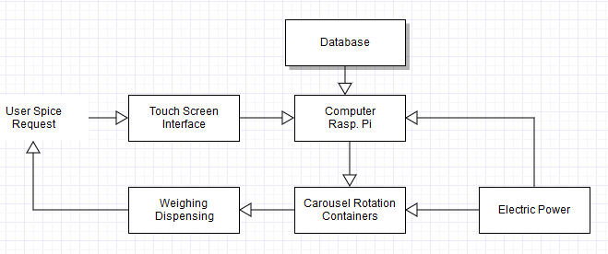

Figure 1. Block Diagram of overall system

### Computing Resources

The computing platform for the spice mixer will need enough computing resources to manage network connectivity, robotics control, and any analytics which may be leveraged for higher accuracy such as computer vision or machine learning. The first two requirements call for a powerful processor. Analytics are often highly parallelizable and would benefit from a GPU. Additionally, low power consumption would be a benefit and small size is a must.

The Raspberry Pi B+ was chosen for the spice mixer. It is a 35 USD board with a Quad-core ARM Cortex A7, 1GB RAM, a Broadcom VideoCore IV GPU, and basic peripheral support with a camera port [3]. ARM processors have taken over the market for mobile and embedded devices, with a high market share in IoT applications [4]. Of the ARM series, the A-series cores have the highest performance and are meant for applications which require a robust OS and networking support, without the need for real-time applications as found in the M-series [5]. The GPU on the Raspberry Pi would be a powerful accelerator for any signal processing or analytics which may be needed.

Linux will be used as the operating system for the device. The choice to use the operating system is to better utilize resources and allow device abstraction. Device drivers allow the user to abstract away the hardware details of the specific device the user is controlling. Using the device abstraction allows networking and motor control to be accessed by multiple programs, without duplicating code [6]. Additionally, peripherals such as cameras may be required to use a provided driver. Linux was chosen due to its maturity on embedded devices and the ease of customizability with open-source software.

Microcontrollers will be used throughout the device to control motors and sensor systems. This will provide an abstraction between components of the device, allowing each component to be individually engineered and tested. Additionally, time constraints will be better supported with a microcontroller with no operating system or a real-time operating system. These microcontrollers will be cheap and have low energy requirements, and controllers possessing an ARM M-series core are candidates for these tasks.

### Storage Container Layout

The Horizontal Carousel (HC) layout is the most advantageous layout for the Spice Mixer application. The advantage of an HC layout is that it only requires one motor for accessing containers, compared to 2 or 3 for a Vertical Lift module layout [7]. The top of the carousel is designed to be a removable lid, which fulfills two design goals: easy access to the containers, and the ability to remove containers from the carousel for cleaning and filling. Figure 2 shows the layout of the horizontal carousel, the containers are clipped to a rail, which is attached to the central motor that enables the rotation of the frame. The radius of the frame is $15 cm$.

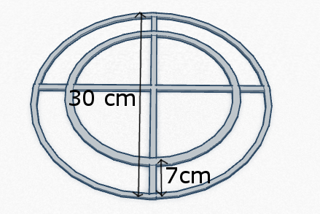

Figure 2. Dimensions of the rails

The ROB-13656 RoHS stepper motor [8] was chosen for the central motor that rotates the rails and containers. This motor was chosen for its small size $(56mm× 56mm × 46mm)$ and its holding torque of $120 N∙cm$, judged sufficient for this application. The containers will be printed in a plastic material, Figure 3 gives a sketch of a single container with its dimensions. The rail will support eight containers, two per quadrant.

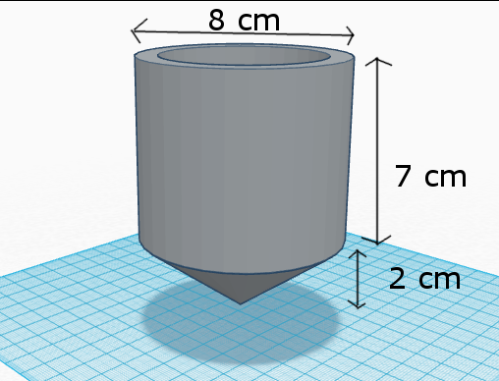

Figure 3. Dimensions of a container

### Weighing and Dispensing Mechanism

The system will use an electronic scale and LCD connected to the raspberry pi. The pi will be able to display a GUI on the connected LCD (showing relevant data). The electronic scale can be small enough to fit within the layout of the Spice Mixer. Using the micro load cell with the dispenser, underneath the container in use, will allow the Raspberry Pi to track the current weight of the container. Because it can constantly check the weight, it allows the system to track when spices are low in quantity and when the weight falls below a certain threshold. When this occurs, the user is notified on the LCD screen on which spices are low in quantity. When the user refills the spice, the weight will be above the minimum threshold. The RB-Phi-118 micro load cell can measure up to 5 kg with 0.05% precision, which satisfies the technical requirement [9]. The RB-Phi-118 will be connected to a load cell shield called the RB-Onl-38. This component extracts the measurable data and makes it accessible by the computer [10].

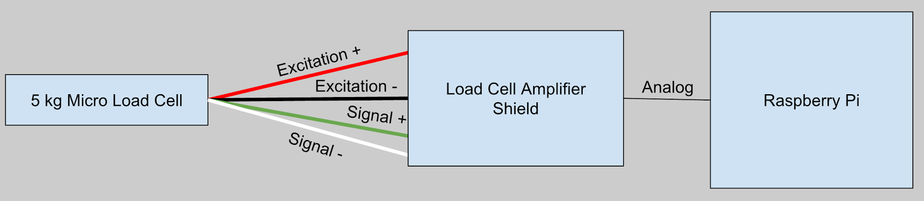

Figure 4. 5 kg Micro Load Cell connected to a Raspberry Pi via Load Cell Amplifier Shield

As seen in Figure 4 the RB-Onl-38 load cell amplifier shield is connected to a Raspberry Pi using an analog connection. The micro load cell has four output wires that connect to Strain 1 on the amplifier shield. Because the micro load cell is smaller than normal sized load cells, the measurements can be off by $+/- 0.05\%$ due to many variables such as temperature, creep, vibration, drift, and other error sources [11]. This weighing of the container enables control over the quantity that is dispensed, and the computer controls when the tube is open (and dispensing), once the appropriate quantity of powder has been dispensed, the computer can remove the dispenser from the container.

### Electric Power

There are several devices that require powering: the computer, the rotational motor, the weighing and movement motors. The device will have two power supplies, one that will provide power for the Raspberry Pi, which will be connected to the sensors, and the other for the motors. The AC Power Supply Adapter Charger $6V DC 1500mA$,sold by Metroaccess, transforms $240V AC$ to $6V DC$ power that can be used for the computer as well as the motors.

### Graphic User Interface for LCD Screen

GUI will be displayed using a LCD - 7” Touch Screen. The interface will have to provide a user-friendly interface for three main functionalities: select and dispense single spices, select a recipe from a list of feasible recipes, and track the current inventory of spices in the carrousel. Because typical users will be cooking while using the device, the interface must be intuitive and provide large, easily recognizable buttons. User-preferred units of measurements will be stored for convenience and shown by default.

The interface will be designed according to four Gestalt principles of visual design.

* *Proximity* will ensure object have even spacing which allows user to be able to differentiate group of operation.
* *Similarity* will ensure that the design have consistent text style in term of fonts and capitalization.
* *Common Fate* will ensure that the buttons are lined up in a grid in this interface.
* *Closure* will ensure that user to feel that the elements in a composition are aligned in such a way that they perceives that "the information could be connected."

### Database / Data storage

Several types of information must be stored for the system to work.  Some of the data will be stored on the machine itself, in the file system, and will be available whether the machine has internet connectivity or not. For instance, the conversion table between different volumetric units and the table of densities for main cooking powders will be stored in the file system as comma-separated value files $(.csv).$ However, other types of data will be stored remotely and accessed through the internet. For instance, recipes will be stored in a standard format on a free-to-use, online database such as Firebase or Google Sheets. The recipes will be written in a conventional format using an $XML$ basis. This will allow users to remotely create new recipes and modify existing recipes.

## 4.2 Codes and Standards

### Food Codes and Standards

1. *FDA Food Code 4-201.11 Equipment and Utensils* - Regarding durability and strength, the equipment shall be designed and constructed to be durable and to retain their characteristic qualities under normal use conditions [12].
2. *FDA Food Code 4-202.11 Food-Contact Surfaces* - Regarding cleanability , the nozzle shall be smooth, free of breaks, open seams, cracks, chips, inclusions, pits, and similar imperfections. Free of sharp internal angles, corners, and crevices [12].

### Computing Codes and Standards

1. *IEEE 802.11* - This is a standard for wireless local area connection communication. It will be used with the device and a router supporting the 802.11b/g standard will be required to form the wireless network [13].
2. *LCD Interface* - Several interfaces exist to connect monitors to embedded device including the prominent LVDS, and VGA connectors. Additionally, touch screen sensors require a controller which typically interfaces with the embedded device through a Serial/COM or USB port. Even though different controllers are required for the different touch sensors, the computer connections are standardized [14].

### Engineering and Safety Codes and Standards

1. *FCC Declaration of Conformity* - Electronic devices must be checked to ensure that they do not radiate excessive amounts of radio signal if they are to be sold in the US [15].

## 4.3 Constraints, Alternatives and Tradeoffs

### Alt*ernative*s

Alternatives for the computing include choice of embedded platform as well as operating system. Two alternative platforms are the Beagleboard Black [16] and the Qualcomm Dragonboard [17]. According to ARM product descriptions, the DragonBoard has the most powerful processor, followed by the Beagleboard Black, and Raspberry Pi [18].

Alternatives to the weighing mechanism include the choice to use a normal load cell instead of a micro load cell. The normal load cell is larger than the micro load cell, which may have an issue with the size of the Spice Mixer, but it can give more accurate measurements for containers that are larger and have more weight [19].

### Constraints

The size of individual containers is a constraint as each container can hold at most $200g$ of powder, assuming a density similar to flour density. The number of containers held by the machine is also a constraint as some users might have more spices than the eight available containers.

The size of the containers directly affects the size of load cells that can be used for the weighing mechanism. If the containers are too large, the micro load cells will not be accurate. Depending on the container size, the size of the load cell can be determined for greatest accuracy.

### Trade-offs

There is a trade-off between the speed of delivery of the machine and the accuracy of the amount dispensed by the machine. Another trade-off exists between the size of the motor and power required. A larger central motor can be used instead of the HS-805BB Giant Scale Servo Motor**,** to improve the number and size of the containers, but will take up more space and require more power.

# 5. Schedule, Tasks and Milestones

The project will be developed over 3 months. **Appendix A** contains the list of all major milestones, the person(s) assigned to those tasks, and their relative risk levels. **Appendix B** contains the Gantt chart giving the timeline and ordering of the different tasks, with start date and end date.

# 6. Project Demonstration

The project will be designed to be portable and will be tested in Van Leer, Georgia Institute of Technology. The formal demonstration will consist of one person doing the following:

1. Fill the machine with spices and powdered ingredients.
2. Choose a recipe available in the machine at random.
3. Request a specified amount of servings through a simple user interface.

The machine will automatically serve the quantity specified, with an error in measurement of less than $10\%.$

# 7. Marketing and Cost Analysis

## 7.1 Marketing Analysis

Even though no spice dispensers have been made commercially available, there are several products that resemble the concept of the Spice Mixer. Equipped with a HomeChat application, LG Electronics smart fridge lets people receive real-time food status updates from their refrigerators directly on their smartphones. Users can also request recipes based on the ingredients they already have.

In the context of spice handling for the kitchen, there have not been any Automated Storage and Retrieval Systems (AS/RS) developed yet. There exist AS/RS systems of the same scale, but they are built for biology and chemistry laboratory settings [20]. These AS/RS systems have a typical minimum cost of 50,000 USD, and have many more features than the Automated Spice Mixer project such as handling temperature, humidity and air quality of the containers.

## 7.2 Cost Analysis

The total development cost for a prototype of the Automated Spice Mixer is approximately $203.75 USD$. Table 2 shows a breakdown of the material costs of the prototype. The most costly equipment is the LCD - 7” Touch Screen at 62.95 USD. For the finished product, a customized Raspberry Pi will be designed to minimize costs and optimize functionality.

|  |  |  |  |
| --- | --- | --- | --- |
| **Product Description** | **Quantity** | **Unit Price (USD)** | **Total Price (USD)** |
| Raspberry Pi B+ | $$1$$ | $$35.00$$ | $$35.00$$ |
| LCD - 7" Touch Screen | $$1$$ | $$62.95$$ | $$62.95$$ |
| Giant Scale Servo Motor | $$1$$ | $$39.95$$ | $$39.95$$ |
| Power Supply | $$2$$ | $$9.95$$ | $$19.90$$ |
| 3D Printed Containers | $$10$$ | $$2.00$$ | $$20.00$$ |
| Load Cell Amplifier Shield | $$1$$ | $$19.95$$ | $$19.95$$ |
| 5 kg Micro Load Cell | $$1$$ | $$7.00$$ | $$7.00$$ |
| **Total Cost** | | | $$203.75 USD$$ |

Table 2. Equipment costs

The development costs shown in Table 3 were determined with an assumed labor cost of 40 USD per hour. The Python and C programming for drivers portion of the Raspberry Pi will have the highest number of labor hours due to the complexity of the implementation of the motor, nozzle, weighing mechanism, and user interface design.

|  |  |  |  |  |
| --- | --- | --- | --- | --- |
| **Project Component** | **Labor**  **(Hours)** | **Labor Cost**  **(USD)** | **Part Cost**  **(USD)** | **Total Costs**  **(USD)** |
| **Raspberry Pi** | | | | |
| Python Programming | $$300$$ | $$12,000$$ | $$0$$ | $$12,000.00$$ |
| C Programming | $$100$$ | $$4,000$$ | $$0$$ | $$4,000.00$$ |
| Building/Wiring | $$120$$ | $$4,800$$ | $$35.00$$ | $$4,835.00$$ |
| **LCD - 7" Touch Screen** | | | | |
| User Interface Design | $$50$$ | $$2,000$$ | $$0$$ | $$2,000.00$$ |
| GUI Programming | $$100$$ | $$4,000$$ | $$0$$ | $$4,000.00$$ |
| Building/Wiring | $$10$$ | $$400$$ | $$62.95$$ | $$462.95$$ |
| **Electrical Design** | | | | |
| Building/Wiring | $$10$$ | $$400$$ | $$59.85$$ | $$459.85$$ |
| **Mechanical Design** | | | | |
| 3D Printed Container Design | $$75$$ | $$3,000$$ | $$0$$ | $$3,000.00$$ |
| 3D Printing Material | $$100$$ | $$4,000$$ | $$20.00$$ | $$4,020.00$$ |
| Building/Wiring | $$10$$ | $$400$$ | $$0$$ | $$400.00$$ |
| **Weighing Mechanism** | | | | |
| Load Weighing Sensors | $$0$$ | $$0$$ | $$26.95$$ | $$26.95$$ |
| Building/Wiring | $$10$$ | $$400$$ | $$0$$ | $$400.00$$ |
| **TOTAL COST** | $$885$$ | $$35,400$$ | $$203.75$$ | $$36,488.75$$ |

Table 3. Development costs

The production run will consist of 5000 units sold over a 5-year period at a price of 250 USD per unit. More specialized controllers can be used once the performance requirements of the device are better studied. Most of the components can be integrated into a few packages so that they can be mass produced at a low cost. Assembly will be done manually until it is profitable to fully automate the production of components. The device will be sold to home goods stores with a small sales team. The equipment cost can be purchased at a discount for 100 USD per unit.  A group of technicians will be employed at 20 USD an hour to solder the board, perform testing, and assemble the final product. Sale expense in the form of advertising will make up $6\%$ of the final selling price, which will be 15 USD. At 250 USD per unit, the expected revenue is 1,250,000 USD, yielding a profit of 107.8 USD per unit. The production costs, profit, and selling price of the system are displayed in Table 4.

|  |  |
| --- | --- |
| **Description** | **USD** |
| Parts Cost | $$100$$ |
| Assembly Labor | $$10$$ |
| Testing Labor | $$10$$ |
| Sales Expense | $$15$$ |
| Amortized Development Costs | $$7.2$$ |
| Profit | $$107.8$$ |
| **Selling Price** | $$250$$ |

Table 4. Selling price and profit per unit (Based on 5,000 unit production)

# 8. Current Status

The spice mixer outlined in this document will attempt to solve the problem of the mixture of powders found in recipes. Recipes will be obtained from a server on the internet, and automatic measuring of each powder will be done via a controlled dispensing unit. A preliminary design has been outlined, however, further technical design will be required. Once all the parts for this design have been obtained via purchase or 3D printing, the assembly and integration of the components can proceed. Tools on campus will be used for assembly.

The team is currently purchasing parts to be used in the device. For example, a microcontroller will be purchased to begin communication with the phone to ensure that data transfer can occur. Finally, user interface are being designed for the LCD screen to display.

# 9. References

[1] *Coca-Cola Freestyle* [Online]. Available: http://www.coca-colafreestyle.com/home/ [Accessed: Nov. 25, 2015]

[2] K. Wagstaff. *Out of Milk? LG's New Smart Fridge Will Let You Know* [Online]. Available: http://www.nbcnews.com/tech/gift-guide/out-milk-lgs-new-smart-fridge-will-let-you-know-n99531 [Accessed: Oct. 26, 2015]

[3] Adafruit, Inc. "Raspberry Pi," [Online]. Available: http://www.adafruit.com/category/105?gclid=COXVhbTO4MgCFdgUgQod5EwDbg.  [Accessed: Nov. 25, 2015].

[4] ARM Holdings, Inc., "Embedded intelligence – connecting billions of smart sensors into the Internet of Things." [Online]. Available: http://ir.arm.com/phoenix.zhtml?c=197211&p=irol-embeddedintelligence. [Accessed: Nov. 25, 2015].

[5] ARM Holdings, Inc., "Cortex-A Series,"[Online]. Available: http://www.arm.com/products/processors/cortex-a/index.php. [Accessed: Nov. 25, 2015].

[6] J. Corbet, A. Rubini, and G. Kroah-Hartman, *Linux Device Drivers. 3rd Edition*: O'Reilly Media, Inc., 2005, pp. 1-14.

[7] B. Sarker and P. Babu, 'Travel time models in automated storage/retrieval systems: A critical review', *International Journal of Production Economics*, vol. 40, no. 2-3, pp. 173-184, 1995.

[8] Robotshop, *HS-805BB+ MEGA 1/4 SCALE SERVO* [Online]. Available: http://www.robotshop.com/media/files/pdf/hs805.pdf [Accessed: Nov. 25, 2015]

[9] *Load Sensor - 50kg SEN-10245* [Online]. Available: https://www.sparkfun.com/products/10245 [Accessed: Nov. 25, 2015].

[10] S. Al-Mutlaq. *Load Cell Amplifier HX711 Breakout Hookup Guide* [Online]. Available: https://learn.sparkfun.com/tutorials/load-cell-amplifier-hx711-breakout-hookup-guide?_ga=1.111563076.1914762931.1448984727 [Accessed: Nov. 26, 2015].

[11] Cdn.sparkfun.com, 2015. [Online]. Available: https://cdn.sparkfun.com/assets/learn_tutorials/3/8/3/Correct_HX711_breaout_board_hookup_bb.jpg. [Accessed: 02- Dec- 2015].

[12] Antoine Perrier, Nicolas Vuillerme, Vincent Luboz, Marek Bucki, Francis Cannard, Bruno Diot, Denis Colin, Delphine Rin, Jean-Philippe Bourg, Yohan Payan, "Smart Diabetic Socks: Embedded device for diabetic foot prevention", Innovation and research in biomedical engineering, vol.32, no.2, pp.72-76, 2014.

[13] FDA 2001 Food Code - Chapter 4: Equipment, Utensils, and Linens [Online]. Available: http://www.fda.gov/Food/GuidanceRegulation/RetailFoodProtection/FoodCode/ucm089200.htm [Accessed: Oct. 26, 2015].

[14] "IEEE Standard for Information technology--Telecommunications and information exchange between systems Local and metropolitan area networks--Specific requirements Part 11: Wireless LAN Medium Access Control (MAC) and Physical Layer (PHY) Specifications," *IEEE Std 802.11-2012 (Revision of IEEE Std 802.11-2007),* pp. 1-2793, 2012.

[15] *Display Interface Specifications* [Online]. Available: http://mipi.org/specifications/display-interface [Accessed: Dec. 1, 2015].

[16] *Specifications, Tolerances, and other Technical Requirements for Weighing and Measuring Devices* [Online]. Available: http://www.nist.gov/pml/wmd/pubs/upload/hb44-05-all.pdf [Accessed: Nov. 27, 2015].

[17] Equipment Authorization procedures [Online]. Available: https://www.fcc.gov/oet/ea/procedures.html [Accessed: Nov. 29, 2015].

[18] BeagleBone, Inc., "BeagleBone Black," [Online]. Available: http://beagleboard.org/BLACK. [Accessed: Oct. 25, 2015].

[19] *Qualcomm Inc., Dragonboard 410C Manual.* [Online]. Available: https://www.96boards.org/products/ce/dragonboard410c/ [Accessed: Nov. 25, 2015].

[20] *ARM Holdings, Inc., "Cortex-A Series,"* [Online]. Available: http://www.arm.com/products/processors/cortex-a/index.php. [Accessed: Nov. 25, 2015].

# **Appendix A**

|  |  |  |
| --- | --- | --- |
| **Task Name** | **Task Lead** | **Risk Level** |
| Planning, Presentation, and Documentation | All | Low |
| Technical Review Paper | All | Low |
| Project Proposal | All | Low |
| Parts Ordering | All | Low |
| Final Project Presentation | All | Low |
| Final Project Demonstration | All | Medium |
| Final Project Report | All | Low |
| Touch Screen - User Interface | SP, RT | Low |
| Make User Interface | RT | Low |
| Make controller for touchscreen | SP | Medium |
| Computing | All | Medium |
| Connect wire to computers | All | Low |
| Install Linux | MK | Low |
| Make driver for motors and sensors | MK | High |
| Networking and Cloud | SP, RT | Low |
| Test networking | RT | Low |
| Develop server program and features | SP | Medium |
| Mechanical | All | Medium |
| 3D print components | PL | Medium |
| Test and debug Layout | PL, RT | Medium |
| Calibrate and test motor system | RT | High |
| Test dispensing from containers | PL, SP | Low |
| Test Motors under container Strain | PL | Low |

# Appendix B

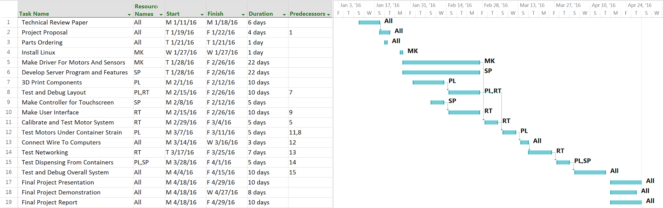

# Appendix C

