Automated Spice Mixer

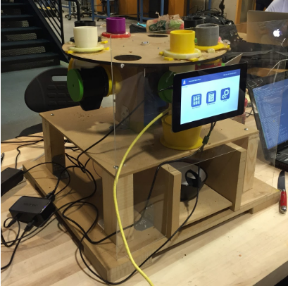

<https://www.youtube.com/watch?v=aabmIrRTatQ>

ECE4012L5A Senior Design Project

Section L05A, Team Automated Spice Mixer

Project Advisors, Dr. Thomas R. Collins

Philippe Laban, Team Leader

Sunny Patel

Michael Kuchnik

Ratchapong Tangkijvorakul

Revised

May 04, 2016

**Table of Contents**

Executive Summary iii

Automated Spice Mixer 1

1. Introduction 1

1.1 Objective 1

1.2 Motivation 1

1.3 Background 2

2. Project Description and Goals 3

3. Technical Specifications 4

4. Design Approach and Details 5

4.1 Design Approach 5

System Overview 5

Computing Resources 5

Storage Container Layout 6

Weighing and Dispensing Mechanism 7

Electric Power 9

Graphic User Interface for LCD Screen 10

Database / Data storage 11

4.2 Codes and Standards 12

Food Codes and Standards 12

Computing Codes and Standards 13

Engineering and Safety Codes and Standards 13

5. Project Demonstration 14

6. Marketing and Cost Analysis 15

6.1 Marketing Analysis 15

6.2 Cost Analysis 16

7. Current Status 17

8. Issues, Hacks, and Direction for the Future 17

9. References 20

# **Executive Summary**

Household kitchen appliances have historically seen improvements in areas such as ergonomics, aesthetics, materials, and mechanical design. However, in order to enhance the user experience with kitchen appliances, improvements can be made to components of the system by adding the Internet of Things (IoT) aspect. The Automated Spice Mixer Team designed a device that automatically dispenses and weighs the powders of various recipes. An Internet connection was used to display real-time data regarding the amount of the remaining ingredients. Once the appropriate proportions of each ingredient was fetched, the device mixed the ingredients to a specification provided in the recipe.

The system includes an algorithm that can perform unit conversions between various mass and volume metrics. It has a weighing mechanism on the bottom of the bowl for measuring the remaining mass. The design will include a credit-card sized computer, the Raspberry Pi 2 B, that performed all the data processing as well as controlling an MBED that is responsible for the motor and process of dispensing. In addition, it was responsible for networking tasks such as SSH and connecting to the database. The product has a Liquid Crystal Display (LCD) touch screen display that extended the user experience and provided a conceptual model similar to smart phones.

The Automated Spice Mixer device can be applied in the commercial food industry, where major fast food restaurant chains can use it to create mixtures automatically as orders are being received. This will help improve efficiency within these restaurants. The device can also be sold for use in homes, where it can organize kitchen space and allow recipes to be done with lower manual intervention. A fully functional prototype costs roughly 260 USD.

# Automated Spice Mixer

# 1. Introduction

The Automated Spice Mixer Team has designed a device that automatically retrieves and weighs the powders conforming to various recipes. The device provides easy unit conversions between various mass and volume metrics. Furthermore, the device has Internet connection for downloading recipes and interacting with cloud resources. Real-time data concerning the remaining ingredients can be displayed locally and pushed to a server. The team has spent an estimated USD to develop this prototype.

## 1.1 Objective

The team has designed and prototyped a system that is able to automate the extraction and mixing of various powdered ingredients. It will allow recipes to be downloaded from an online database so that users will not have to manually control the device. The device keeps track of the amount of remaining spices. Measurement conversion algorithms automatically convert recipe measurements to an internal form so that differences in units are not visible to the user. The device is accessible via a touchscreen on the device, and supports a web GUI which is mobile phone compatible.

## 1.2 Motivation

Cooking is heavily influenced by both the use of store-purchased spice mixtures, such as taco mix, as well as the use of raw ingredients, such as cinnamon and sugar, in recipes. For both of these use cases, a mixture is required, taking a precise amount of each of the ingredients. In the first case, a mix of spices that is bought in stores cannot be reused in other recipes. Money invested in pre-made mixtures cannot be utilized efficiently. In the second case, significant time is spent measuring the exact amount of an ingredient, especially when a recipe is followed frequently.

In addition, people often lose track of their kitchen inventory which can lead to disorganization and inefficient planning of grocery shopping as well as unnecessary stress in households. Keeping individuals informed is important and requires an efficient responsive data-collection and visualization system. Overall, the user can better utilize both the resources of spices and time, which saves money. Currently, there is no product in the market that automates spice mixing. The device can be used by people who occasionally mix spices or restaurants that are required to mix spices fast and frequently.

## 1.**3 Background**

Embedded systems have been utilized in industry to dispense mixtures of liquids in the past. For example, a soda dispenser machine has successfully been able to mix syrup in the correct proportions to create custom recipes of soft drinks [1]. Additionally, a mix of IoT appliances are entering the market, resulting in a large amount of smart devices. No previous work on powder dispensers for this category of use has been found.

Regarding graphic user interface (GUI), a similar product that uses GUI to inform users about food data is commercially available. LG Electronics produces a smart fridge equipped with a HomeChat application that lets people receive real-time food status updates from their refrigerators directly on their smartphones. The device provides added feature by providing information on what items are reaching their expiration dates. Users can request recipes based on the ingredients they already have. No pricing information is available for this product [2].

# 2. Project Description and Goals

The fundamental goal of the Automated Spice Mixer Team was to create an internet of things device which enables users to extract precise measurement of powdered spices as well as giving users the ability to access internet resources to download recipes. Reporting the amount of spices is done by the device in the background. The features of the system include:

* Dispensing precise quantities of powder requested
* Automating the mixing of various spice recipes from unmixed powdered ingredients such as cinnamon, salt, oregano...
* Simplifying unit conversions between mass and volume in different unit systems
* Downloading recipes from the Internet and realizing them easily
* Accessing current spice stock through the Internet on a phone or computer

# 3. Technical Specifications

The technical specification is set to provide a baseline for testing the device: when testing the prototype, the specifications provided should be met. Table 1 gives the mechanical and electrical technical specifications desired at the beginning of the design as well as the actual specifications of the final product. Most specifications were met.

|  |  |  |
| --- | --- | --- |
| **Hardware Feature** | **Specification (Desired)** | **Actual Specification Met** |
| Number of containers | containers | mounted containers + empty slots |
| Speed of Carousel Rotation | up to |  |
| Minimum Torque of Carousel |  |  |
| Volume of individual containers |  |  |
| Dimension |  |  |
| Computer Power |  |  |
| Motor Power |  |  |
| Weight Limit Per Sensor |  |  |
| Weight Precision |  |  |

Table 1. Mechanical/Electrical Technical Specifications

# 4. Design Approach and Details

## 4.1 Design Approach

### System Overview

Figure 1 shows the block diagrams of the main components of the design for the Automated Spice Mixer.

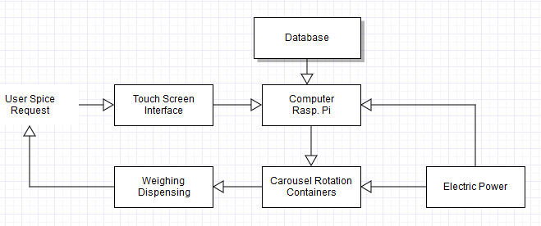

Figure 1. Block Diagram of overall system

### Computing Resources

The computing platform for the spice mixer will need enough computing resources to manage network connectivity, and robotics control. The first two requirements call for a powerful processor. Analytics are often highly parallelizable and would benefit from a GPU. Additionally, low power consumption would be a benefit and small size is a must.

The Raspberry Pi 2 B was chosen for the spice mixer. It is a USD board with a Quad-core ARM Cortex A7, 1GB RAM, a Broadcom VideoCore IV GPU, and basic peripheral support with a camera port [3]. ARM processors have taken over the market for mobile and embedded devices, with a high market share in IoT applications [4]. Of the ARM series, the A-series cores have the highest performance and are meant for applications which require a robust OS and networking support, without the need for real-time applications as found in the M-series [5]. The GPU on the Raspberry Pi would be a powerful accelerator for any signal processing or analytics which may be needed.

Linux was used as the base for the operating system for the Raspberry Pi. The choice to use the operating system is to better utilize resources and allow device abstraction. Device drivers allow the user to abstract away the hardware details of the specific device the user is controlling. Using the device abstraction allows networking and motor control to be accessed by multiple programs, without duplicating code [6]. Linux was chosen due to its maturity on embedded devices and the ease of customizability with open-source software. Specifically, KivyPie was used as the operating system distribution. It was chosen because it was specifically meant for displaying GUI applications.

Microcontrollers are used throughout the device to control motors and sensor systems. This configuration provides an abstraction between components of the device, allowing each component to be individually engineered and tested. Additionally, time constraints are better supported with a microcontroller with no operating system or a real-time operating system. These microcontrollers are cheap and have low energy requirements, and controllers possessing an ARM M-series core were chosen for these tasks. Specifically, ARM MBED was chosen as the microcontroller to connect to motors and sensors.

### Storage Container Layout

The Horizontal Carousel (HC) layout is used as it is the most advantageous layout for the Spice Mixer application. The advantage of an HC layout is that it only requires one motor for accessing containers (which rotates the carousel), compared to two or three for a Vertical Lift module layout [7]. The top of the carousel is designed to be a removable lid, which fulfills two design goals: easy access to the containers for refilling and debugging purposes. Figure 2 shows the CAD design of the horizontal carousel with eight containers mounted.

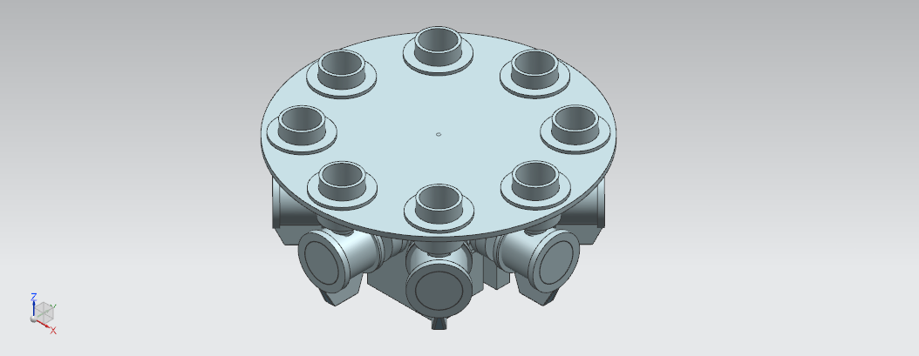

Figure 2. Carousel Layout with containers mounted

The Pololu stepper motor #1209 [8] was chosen for the central motor that rotates the rails and containers. This motor was chosen for its small size () and its holding torque of , which was tested and is sufficient for this application.

### Weighing and Dispensing Mechanism

The system uses a micro load cell that is connected to the MBED via a load cell amplifier. The micro load cell is positioned under the dispensing area. When the user selects a certain spice to be dispensed, the system begins to weigh the dispensed spice allowing for accurate measurements. When the user refills the spice, the micro load cell is used to weight the spice before adding it to the container. The weighing scale also has a “zeroing” feature to ignore the weight of the bowl or container placed on the micro load cell. The micro load cell can measure up to 0.78 kg with precision, which satisfies the technical requirement [9]. The load cell amplifier will extract the measurable data and makes it readable by the MBED, which will communicate to the Raspberry Pi 2 B via an USB connection [10].

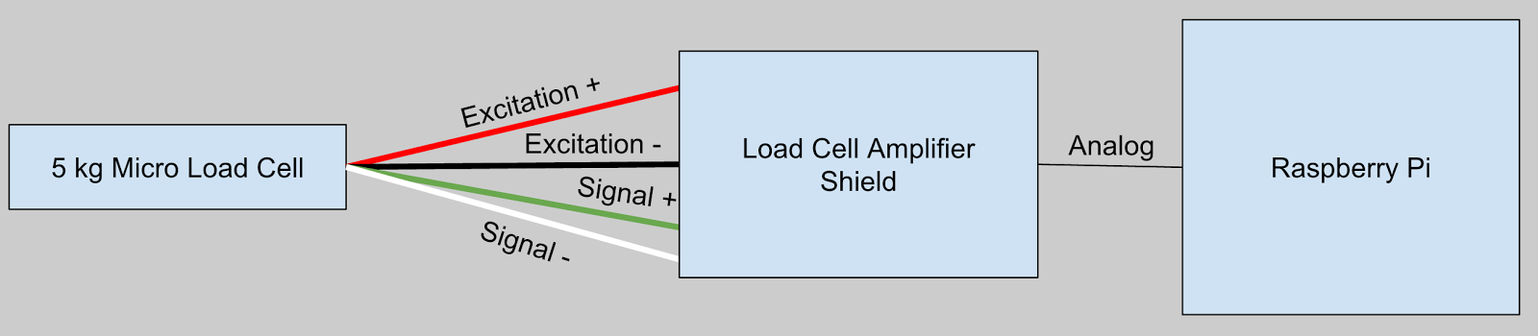

Figure 3. Micro Load Cell connected to a Raspberry Pi via Load Cell Amplifier Shield

As seen in Figure 3 the load cell amplifier shield is connected to a MBED using an pin connection. The micro load cell has four output wires that connect to the amplifier shield. Because the micro load cell is smaller than normal sized load cells, the measurements can be off by due to many variables such as temperature, creep, vibration, drift, and other error sources [11]. This weighing of the container enables control over the quantity that is dispensed and once the appropriate quantity of spice/powder has been dispensed, the MBED can signal to the Raspberry Pi 2 B to stop dispensing.

*Dispensing Mechanism*

The dispensing is done using a rotary valve setup at the bottom of each container. The central structure contains a Scotch Yoke system that enables a motor to stand out and align with a rotary valve of a selected container. Once that is done the motor rotates the valve in small intervals to dispense spice from the container. Between each interval, weighing occurs to get an accurate dispensed amount.   
Figure 4 shows the scotch yoke design with the mounted dispensing motor. Figure 5 shows the detailed valve assembly for a single container.

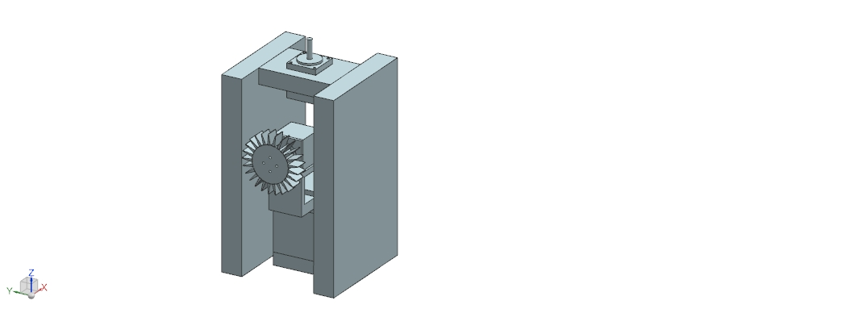 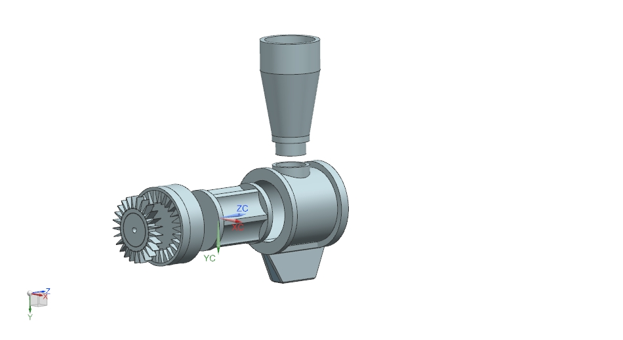

Figure 4. Scotch Yoke Design                                          Figure 5. Valve Assembly of Container

### Electric Power

There are several devices that require powering: the Raspberry Pi, the touchscreen, the mBed, the 3 motors and the load cell. The device is powered by one plug connected to the wall (). This is fed to two different power sources. The first one is a phone charger that delivers at , which powers the Raspberry Pi, the Touchscreen and the mBed (through serial port between the Raspberry Pi and the mBed). The second power supply is a delivering at that powers the motors. Because the motors require different voltage levels, two DC/DC buck converters were used to power 2 of the motors at and the third motor at . The communication between the mBed and the sensors, as well as the power for the motors was all setup on a PCB board with standard 4 pin connectors, which is shown in Figure 6.

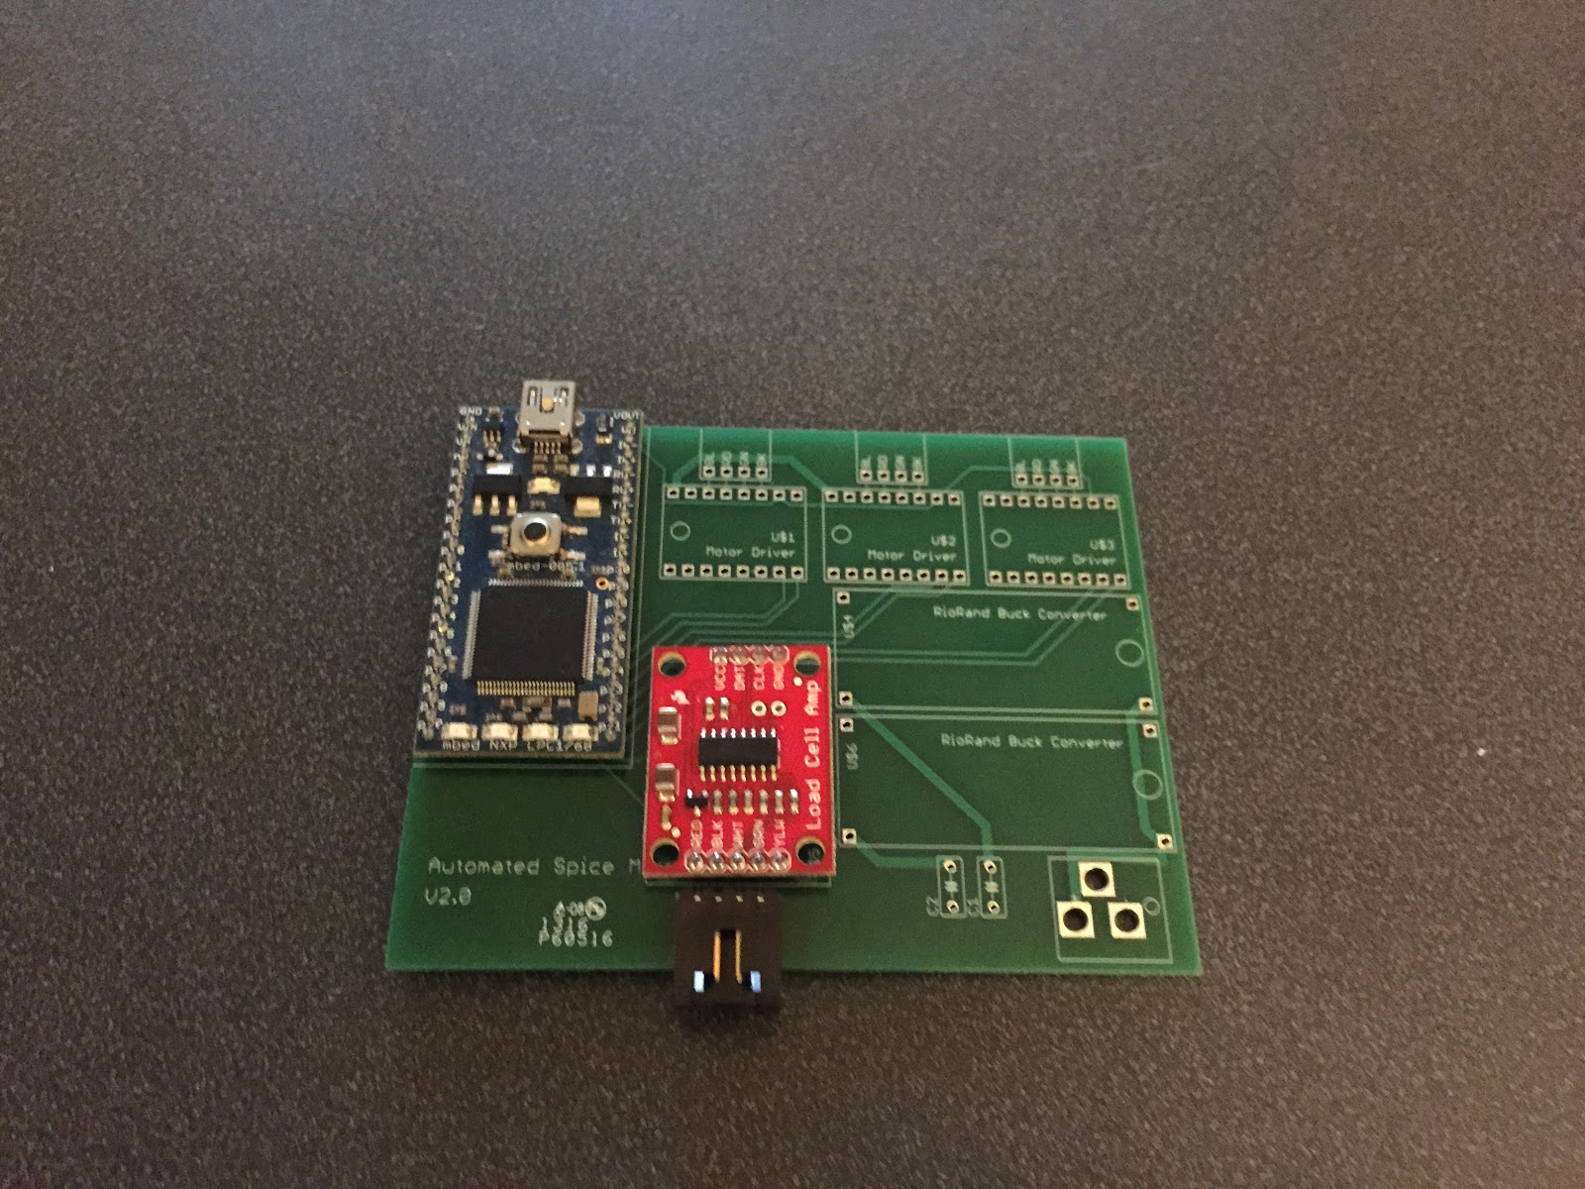

**Figure 6.** PCB board design with mBed and Load Cell Amplifier setup

### Graphic User Interface for LCD Screen

The GUI was displayed on a 7” LCD Touch Screen. The interface provided a user-friendly interface with three main functionalities: select and dispense single spices, select a recipe from a list of feasible recipes, and track the current inventory of spices in the carrousel as seen in Figure 7. Because typical users will be cooking while using the device, the interface was intuitive and provided large, easily recognizable buttons. User-preferred units of measurements was stored for convenience and shown by default.

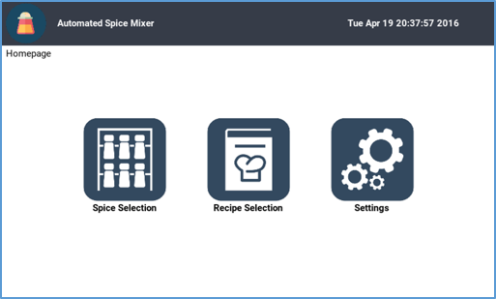

**Figure 7.** Homescreen layout of the GUI written in Kivy

The interface was designed according to four Gestalt principles of visual design.

* *Proximity* ensured that the object has even spacing which allows users to be able to differentiate groups of operation.
* *Similarity* ensured that the design had consistent text styles in term of fonts and capitalization.
* *Common Fate* ensured that the buttons are lined up in a grid within the interface.
* *Closure* ensured that the user feels that the elements in a composition are aligned in such a way that they perceive that "the information could be connected."

### Database / Data storage

There is two type of data that is used by the machine: local data that is used for unit conversion and operation of the machine and live data that gives the user access to recipes and current stock amount on the machine. The local data is stored such as the conversion table between different volumetric units and the table of densities for main cooking powders is stored in the file system as comma-separated value files (.csv). The live data containing the recipes available on the machine and the current stock of the different containers is stored on Firebase. This enables the user to check the current stock amount online at [Spice Mixer Online Application](http://spicemixer.azurewebsites.net). The recipes are written in a conventional format using an JSON basis, which enables users to create their own recipes and upload them to the device remotely.

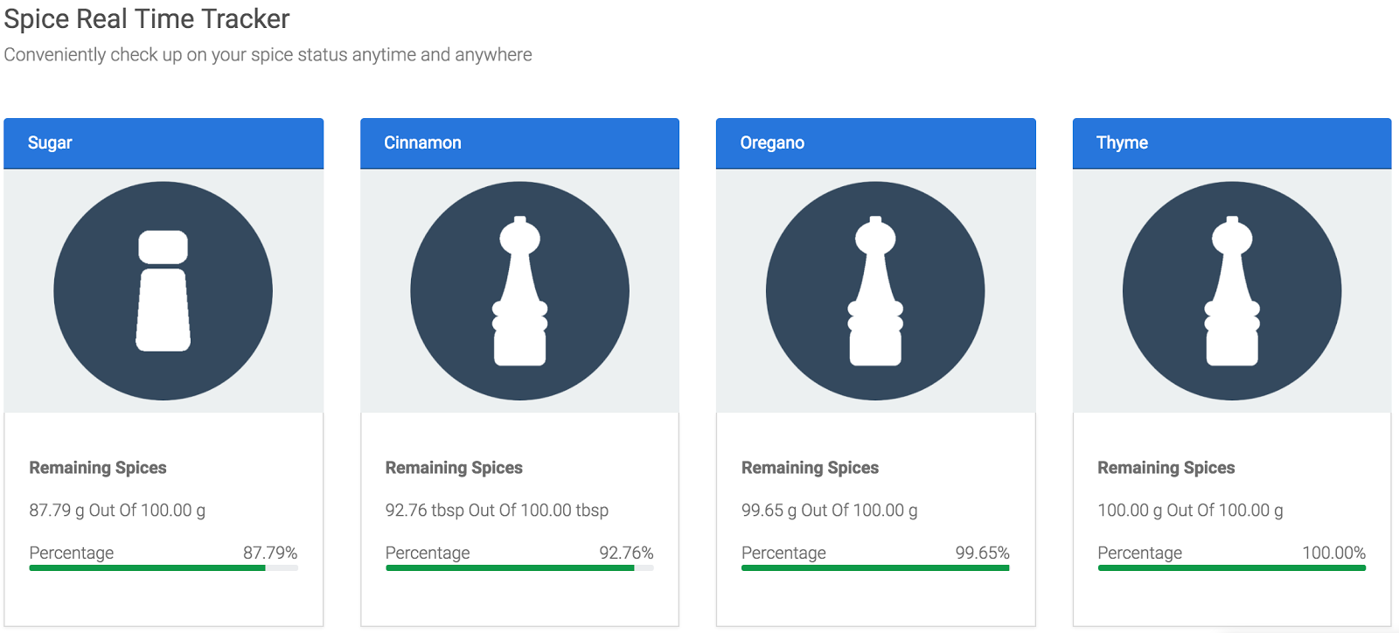

**Figure 8.** Homescreen design for our website. Accessible from any Internet connected device.

## 4.2 Codes and Standards

### Food Codes and Standards

1. *FDA Food Code 4-201.11 Equipment and Utensils* - Regarding durability and strength, the equipment shall be designed and constructed to be durable and to retain their characteristic qualities under normal use conditions [12].
2. *FDA Food Code 4-202.11 Food-Contact Surfaces* - Regarding cleanability , the nozzle shall be smooth, free of breaks, open seams, cracks, chips, inclusions, pits, and similar imperfections. Free of sharp internal angles, corners, and crevices [12].

### Computing Codes and Standards

1. *IEEE 802.11* - This is a standard for wireless local area connection communication. It will be used with the device and a router supporting the 802.11b/g standard will be required to form the wireless network [13].
2. *LCD Interface* - Several interfaces exist to connect monitors to embedded device including the prominent LVDS, and VGA connectors. Additionally, touch screen sensors require a controller which typically interfaces with the embedded device through a Serial/COM or USB port. Even though different controllers are required for the different touch sensors, the computer connections are standardized [14].

### Engineering and Safety Codes and Standards

1. *FCC Declaration of Conformity* - Electronic devices must be checked to ensure that they do not radiate excessive amounts of radio signal if they are to be sold in the US [15].

# 5. Project Demonstration

The project was tested in the McCamish Pavilion, Georgia Institute of Technology. The formal demonstration consisted of one person doing the following:

1. Fill the machine with spices and powdered ingredients.
2. Choose a spice or recipe available in the machine at random.
3. Request a specified amount of servings through a simple user interface.

The machine will automatically serve the quantity specified. The demonstration was successful of the time. Some of the issues encountered are described in detail in Section 8. A video representing the different mechanical structures of the device as well as a demo of the product is available at the following web link:

<https://www.youtube.com/watch?v=aabmIrRTatQ>

# 6. Marketing and Cost Analysis

## 6.1 Marketing Analysis

Even though no spice dispensers have been made commercially available, there are several products that resemble the concept of the Spice Mixer. Equipped with a HomeChat application, LG Electronics smart fridge lets people receive real-time food status updates from their refrigerators directly on their smartphones. Users can also request recipes based on the ingredients they already have. In the context of spice handling for the kitchen, there have not been any Automated Storage and Retrieval Systems (AS/RS) developed yet. There exist AS/RS systems of the same scale, but they are built for biology and chemistry laboratory settings [20]. These AS/RS systems have a typical minimum cost of 50,000 USD, and have many more features than the Automated Spice Mixer project such as handling temperature, humidity and air quality of the containers.

## 6.2 Cost Analysis

The total development cost for a prototype of the Automated Spice Mixer was approximately 260 USD. Table 2 shows a breakdown of the material costs of the prototype for both electrical and mechanical components. The most costly equipment is the LCD - 7” Touch Screen at 40 USD.

|  |  |  |  |
| --- | --- | --- | --- |
| **Product Description** | **Quantity** | **Unit Price (USD)** | **Total Price (USD)** |
| Raspberry Pi B |  |  |  |
| LCD - 7" Touch Screen |  |  |  |
| Stepper Motor |  |  |  |
| Stepper Motor |  |  |  |
| Low Power Stepper Motor Shields |  |  |  |
| DC/DC Buck Converters |  |  |  |
| Power Supply |  |  |  |
| MBED LPC1768 |  |  |  |
| PCB Board Printing |  |  |  |
| Load Cell Amplifier Shield |  |  |  |
| Micro Load Cell |  |  |  |
| 3D Printed Materials |  |  |  |
| Wood Frame, Mounting Disks, Epoxy Glass |  |  |  |
| Bearings, Fittings, Hinges, Brackets |  |  |  |
| **Total Cost** | | |  |

Table 2. Equipment costs

# 7. Current Status

The spice mixer outlined in the document currently supports dispensing of a single spice, as well as recipes. A scale is integrated into the system and provides feedback for the amount of spice dispensed. The positions of the system are saved in files to remember the state of the system. A GUI on the touchscreen LCD allows users to select spices and recipes. Users can modify and query various statistics of the containers through the GUI. The spice mixer is internet connected and syncs its local database of spice data with the cloud. Mechanical and electrical components all function. The system can be refined to cut down cost, improve aesthetics, and improve reliability.

# 8. Issues, Hacks, and Direction for the Future

The spice mixer was composed of a mechanical section, an electronics section, and a software section. The complexity of each individual subsystem and the interactions between them created an environment ripe with erroneous states. The error rate of about 25% for the spice mixer is divided into a few distinct parts:

1. Mechanical alignment. Mechanical parts were 3d printed to only approximate specifications. Furthermore, the assembly was done manually and therefore the overall precision of the system was limited. In order to function correctly, the carrousel would have to rotate exactly the correct amount of degrees. The skotch-yoke would have to extend the exact amount to connect to the dispensing containers, and the rotor would have to precisely lock into the containers for dispensing. Our system required periodic mechanical calibration to align components.
2. Communication from Raspberry Pi to MBED. The Raspberry Pi would send packets of commands over USB serial to the MBED. Randomly, the MBED would lose communication with the Raspberry Pi. The team suspects a few sources of problems: power instability (discussed below), USB serial driver issues, and buffer-level issues. The USB serial being used did not treat the MBED as a typical USB device, and communication between a laptop offered near perfect reliability. It is possible that the MBED would drop data due to interrupts not handling fast enough, and causing an overflow of internal buffers.
3. Power Issues. The Raspberry Pi and the MBED exhibited some instability. The MBED was directly connected to the Raspberry Pi for power. Occasionally, the MBED would shut down due to the brown-out circuit being triggered. Reproducing this proved difficult and the team suspects it was a function of GUI computation, which dynamically increased load on the Raspberry Pi. Some power saving features on the MBED were used to diminish these issues, and the Raspberry Pi was configured to disable current throttling on USB ports. This eliminated most issues, but did not eliminate them all.
4. Touchscreen control. The Raspberry Pi touchscreen is highly responsive when used on the Raspberry Pi alone. When the MBED is plugged into the Raspberry Pi, the touchscreen becomes hypersensitive and reads spurious values. This is solved by disabling the MBED dynamically (as discussed below). The MBED and touchscreen are never used simultaneously, so this is a valid solution.
5. Overheating. When the MBED is turned on, the motors become active, which creates overheating over time in the DC buck converters, as they are running close to their limit for a long period of time. A crafty solution was to turn off the MBED dynamically, which would turn off the motors and allow the Buck converters to cool down. The Raspberry Pi comes with circuitry to support hardware shutdown of IO devices, such as ethernet and USB ports. When the system is off, the MBED is shut down by disabling that port, which cuts off power to the MBED. This also allows the device to use very low power when the device is not in use, as all motors are turned off unless they are needed.

# 9. References

[1] *Coca-Cola Freestyle* [Online]. Available: http://www.coca-colafreestyle.com/home/ [Accessed: Nov. 25, 2015]

[2] K. Wagstaff. *Out of Milk? LG's New Smart Fridge Will Let You Know* [Online]. Available: http://www.nbcnews.com/tech/gift-guide/out-milk-lgs-new-smart-fridge-will-let-you-know-n99531 [Accessed: Oct. 26, 2015]

[3] Adafruit, Inc. "Raspberry Pi," [Online]. Available: http://www.adafruit.com/category/105?gclid=COXVhbTO4MgCFdgUgQod5EwDbg.  [Accessed: Nov. 25, 2015].

[4] ARM Holdings, Inc., "Embedded intelligence – connecting billions of smart sensors into the Internet of Things." [Online]. Available: http://ir.arm.com/phoenix.zhtml?c=197211&p=irol-embeddedintelligence. [Accessed: Nov. 25, 2015].

[5] ARM Holdings, Inc., "Cortex-A Series,"[Online]. Available: http://www.arm.com/products/processors/cortex-a/index.php. [Accessed: Nov. 25, 2015].

[6] J. Corbet, A. Rubini, and G. Kroah-Hartman, *Linux Device Drivers. 3rd Edition*: O'Reilly Media, Inc., 2005, pp. 1-14.

[7] B. Sarker and P. Babu, 'Travel time models in automated storage/retrieval systems: A critical review', *International Journal of Production Economics*, vol. 40, no. 2-3, pp. 173-184, 1995.

[8] Pololu, Stepper Motor: Bipolar, 200 Steps/Rev, 35×36mm, 2.7V, 1 A/Phase [Online]. Available: https://www.pololu.com/product/1209 [Accessed: April 15th, 2016]

[9] *Load Sensor - 50kg SEN-10245* [Online]. Available: https://www.sparkfun.com/products/10245 [Accessed: Nov. 25, 2015].

[10] S. Al-Mutlaq. *Load Cell Amplifier HX711 Breakout Hookup Guide* [Online]. Available: https://learn.sparkfun.com/tutorials/load-cell-amplifier-hx711-breakout-hookup-guide?_ga=1.111563076.1914762931.1448984727 [Accessed: Nov. 26, 2015].

[11] Cdn.sparkfun.com, 2015. [Online]. Available: https://cdn.sparkfun.com/assets/learn_tutorials/3/8/3/Correct_HX711_breaout_board_hookup_bb.jpg. [Accessed: 02- Dec- 2015].

[12] Antoine Perrier, Nicolas Vuillerme, Vincent Luboz, Marek Bucki, Francis Cannard, Bruno Diot, Denis Colin, Delphine Rin, Jean-Philippe Bourg, Yohan Payan, "Smart Diabetic Socks: Embedded device for diabetic foot prevention", Innovation and research in biomedical engineering, vol.32, no.2, pp.72-76, 2014.

[13] FDA 2001 Food Code - Chapter 4: Equipment, Utensils, and Linens [Online]. Available: http://www.fda.gov/Food/GuidanceRegulation/RetailFoodProtection/FoodCode/ucm089200.htm [Accessed: Oct. 26, 2015].

[14] "IEEE Standard for Information technology--Telecommunications and information exchange between systems Local and metropolitan area networks--Specific requirements Part 11: Wireless LAN Medium Access Control (MAC) and Physical Layer (PHY) Specifications," *IEEE Std 802.11-2012 (Revision of IEEE Std 802.11-2007),* pp. 1-2793, 2012.

[15] *Display Interface Specifications* [Online]. Available: http://mipi.org/specifications/display-interface [Accessed: Dec. 1, 2015].

[16] *Specifications, Tolerances, and other Technical Requirements for Weighing and Measuring Devices* [Online]. Available: http://www.nist.gov/pml/wmd/pubs/upload/hb44-05-all.pdf [Accessed: Nov. 27, 2015].

[17] Equipment Authorization procedures [Online]. Available: https://www.fcc.gov/oet/ea/procedures.html [Accessed: Nov. 29, 2015].

[18] BeagleBone, Inc., "BeagleBone Black," [Online]. Available: http://beagleboard.org/BLACK. [Accessed: Oct. 25, 2015].

[19] *Qualcomm Inc., Dragonboard 410C Manual.* [Online]. Available: https://www.96boards.org/products/ce/dragonboard410c/ [Accessed: Nov. 25, 2015].

[20] *ARM Holdings, Inc., "Cortex-A Series,"* [Online]. Available: http://www.arm.com/products/processors/cortex-a/index.php. [Accessed: Nov. 25, 2015].