Members:
1) Name: Ananta Akash Podder
Registration No.: 2016331102
2) Name: Md. Mahir Labib
Registration No.: 2016331031

Screenshots:

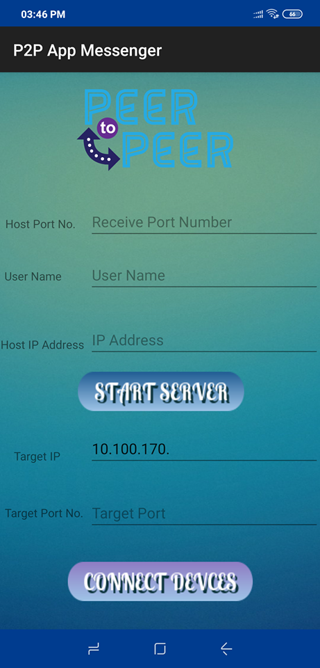
Splash Screen Server&Client
Interface
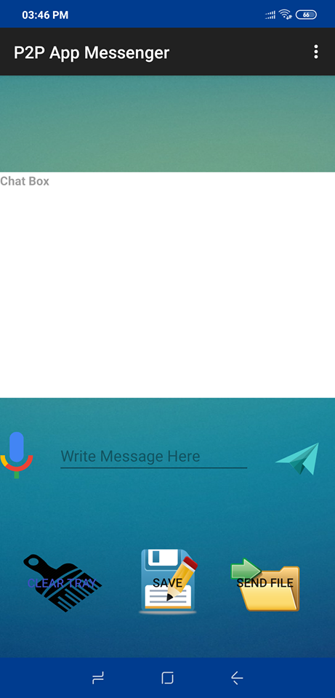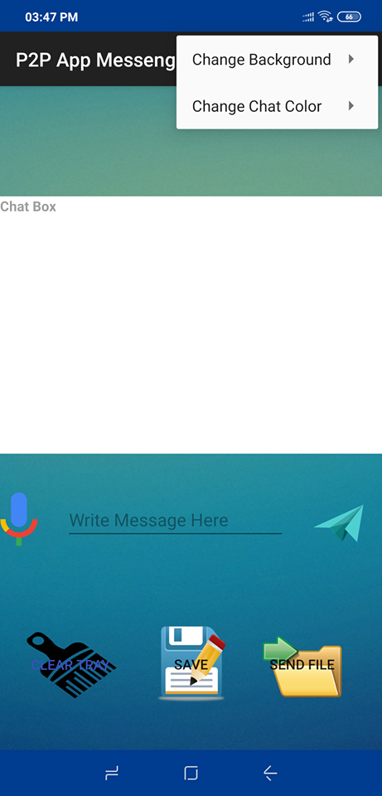
Chat Interface Menu Options

