Emission pattern of Three Regions in Henan

1. Introduction

Volatile organic compounds (VOCs) are typical air pollutants1, 2. Many are carcinogenic3-6 and adversely affect human health7, but also ambient air quality and climate change8-10. Besides, VOCs are essential precursors of O3 and secondary organic aerosol (SOA) 11-14. VOCs come from a wide range of sources, mainly biogenic sources and anthropogenic emission sources15. The biogenic emissions of VOCs worldwide account for more than ten times those of anthropogenic emissions16. However, anthropogenic emissions are the primary sources of VOCs in areas where human activities are concentrated areas 17-20. There are many anthropogenic sources of VOCs, including industrial sources, vehicle exhaust emissions, and biomass combustion emissions 21-23. Among them, the industrial VOCs are the primary anthropogenic source in China24, accounting for more than 50% of the total VOCs emissions from all anthropogenic sources25, 26, and the highly complex sources and chemical properties of VOCs are essential factors that make it difficult to control them effectively in a short period of time24. Reducing industrial VOC emissions is vital to prevent further and control VOCs27-29. Industrial park sources are the most complex and diverse30, characterized by significant and concentrated pollutant emissions24 and strong diffusivity, leading to many VOCs. Because of its unorganized emission, achieving accurate traceability in the region can be challenging. Thus, focusing on monitoring and accurately monitoring industrial parks is essential. Effective control of industrial VOCs emission source is necessary to reduce VOCs emission from anthropogenic sources in China31, 32.

However, existing monitoring methods have problems such as high cost, complicated operation, and complex maintenance. It isn't easy to achieve high-density monitoring33. The ground-based air quality monitoring usually needs to be more present throughout the world33-36. Even in well-developed cities, the spatial density of monitoring networks is less than one every 10 kilometers37, and there are few in other small and medium cities like Xinxiang and Kaifeng38. In particular, the long-term online monitoring of TVOCs in small and medium cities has yet to be reported. Applying them in a high-density pattern to timely identify specific sources in the field is impossible. Therefore, an urgent need to complement existing air quality monitoring methodologies with flexible and affordable alternatives33. The booming of sensor technologies brings bright prospects for solving this problem1. This study integrated monitoring networks based on an electrochemical sensor array (SAM). It was used for monitoring the concentration distribution of total volatile organic compounds (TVOCs). The SAM can accurately trace the source of VOCs to identify and supervise pollution sources effectively. They have the advantages of low-cost, high temporal, spatial resolution, flexible deployment, and easy maintenance. And because of the low cost, they are being deployed in the urban air quality monitoring networks39, which can provide higher spatial resolution and coverage and can be deployed more densely than the governmental monitoring stations40. Therefore, high-density monitoring, accurate traceability, and adequate supervision and control of VOCs in the region can be realized. Besides, few studies have focused on the impact of VOC emissions from chemical industry parks on human and environmental health in small and medium cities. Therefore, it is necessary to determine the characteristics of VOCs emitted from chemical industry parks and their impact on the surrounding residents.

The study takes a chemical industry park, a plastic weaving park, and an urban area as examples, sensor networks with high temporal and spatial resolution were deployed, and TVOC concentration was monitored. Based on the concentration data of TVOCs collected from August 2022 to July 2023, the material variation characteristics of TVOCs in three different regions were analyzed, and the pollution sources in the highly polluted blocks were accurately located. Finally, the air diffusion model AERMOD is used to simulate the diffusion of pollutants, thus determining the impact of contaminants on the surrounding residential areas.

2. Data and methods

2.2. VOCs sensor networks deployment

A high-resolution SAMs network has been successfully established by distributing 95 SAM sets across three regions in Henan: Zhoukou (ZK), Kaifeng (KF), and Xinxiang (XX), with their areas illustrated in Fig. 1. The individual SAMs were meticulously controlled and placed, with each being documented for its proximity to infrastructure and industry. The sensors were deployed on wire poles and lampposts.

The data will be collected by Low power consumption VOCs sensors (QXWL-TMK3) produced by TC Air Technology Co., Ltd, which are based on electrochemical catalytic reaction. Each individual sensor will continuously generate a dataset that includes the level of each chemical compounds, the coordination of sensor placement with the corresponding time.TVOC concentrations were collected from the SAMs from August 2022 to November 2023.

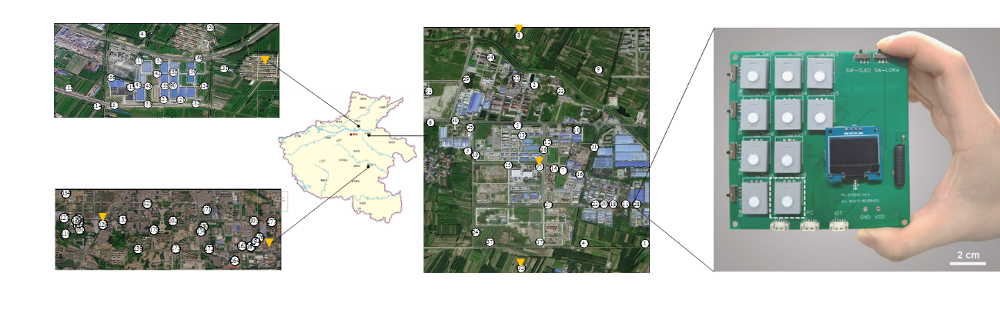

Fig. 1. Layout plan of Henan province

Table 1 Information of Sensing Network in Henan Province

|  |  |  |  |
| --- | --- | --- | --- |
| **Distribution position** | **Grid range** | **Number of sensors** | **Number of meteorological monitors** |
| Plastic weaving park in XX | 0.6 km*0.5 km | 32 | 1 |
| Chemical industrial park in KF | 2.0 km*2.5 km | 36 | 3 |
| Urban in ZK | 6.0 km*1.0 km | 27 | 2 |

2.2. study areas

Yuwangtai Chemical Industrial Area , serving as a prominent center for fine chemical manufacturing in Kaifeng. The area hosts a diverse array of enterprises specializing in medicinal biology, material synthesis, and advanced technology. Situated at approximately 114.4° E longitude and 34.7°N latitude, the district benefits from its strategic position in a region dominated by a continental monsoon climate.

The Plastic Weaving Industrial Park in Xinxiang is a pivotal cluster within the polymer-based manufacturing sector, comprising a diverse array of enterprises focused on the synthesis of plastic textiles and related materials. Situated at approximately 113.9 °E longitude and 35.0 °N latitude, the region is characterized by distinct seasonal variations, marked by cold, dry winters and warm, humid summers, which play a significant role in influencing the operational dynamics of the industries located here.

The data collected from Zhoukou pertains to a residential area centered around the coordinates 114.6°E, 33.6°N. This region encompasses a variety of land uses, including residential zones, parklands, schools, gas stations, and car markets.The local climate is characterized by a temperate regime with distinct seasons, featuring hot summers and cold winters, which influences the daily lives and activities of the residents. This climatic pattern plays a crucial role in shaping the outdoor and recreational activities within the parklands and school areas, as well as affecting the energy consumption patterns of homes and businesses throughout the year.

2.3. Data processing

The dataset was rigorously processed to compute daily mean VOC levels and to discern seasonal patterns. During preprocessing, redundant entries and anomalous data points, potentially attributable to extreme operational conditions, were meticulously filtered out to ensure the integrity of the analysis.

1. Results

3.1. Variations of TVOCs in urban areas and industrial parks

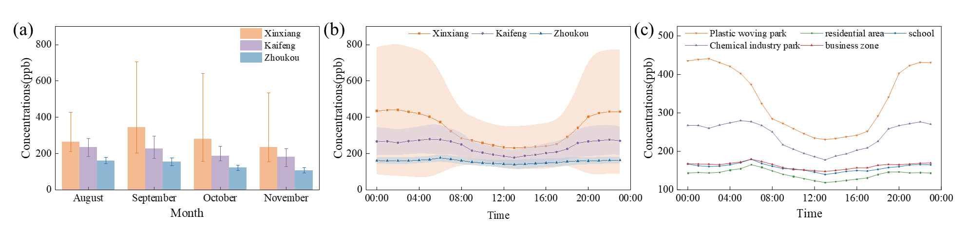

Fig. 2 Diurnal variations of TVOC concentrations in the three areas.

Fig. 2 shows significant diurnal variations of TVOC concentrations in the three areas. Due to the influence of vehicle exhaust, TVOCs of urban areas exhibited bimodal profiles42, 43, which were consistent with the morning and evening rush hours (peak at 06:00-08:00 and 18:00-20:00). The morning peak was more distinct due to the accumulation of pollutants during the whole night43. The diurnal variations of TVOC monitoring in two industrial parks were quite different from those in urban areas. In two industrial parks, there was a U-shaped distribution of TVOCs: the concentrations reached highest at 20:00-06:00. It indicates nighttime emissions from some industries44, which had a relationship with the nearby industrial emission process, the intensity of photolysis loss and diurnal variation of atmospheric boundary layer45, 46. Although the diurnal variations of TVOC monitoring in two industrial parks differ from that in urban areas, they also have similar variations. As shown in Figure 2, the concentrations of TVOCs were higher during the nighttime than in the daytime due to the solar radiation and higher temperature during the daytime2. The presence of solar radiation and the higher temperature during the day facilitated the photochemical reactions that generate O347, and thus the concentrations of the TVOCs minimum value at noon. There was a slight increase in the concentration of all TVOCs at night, attributed to the change in the boundary layer height-the low VOCs concentration occurring in the afternoon (e.g., 12:00 and 16:00) in three areas. The photochemical consumption of VOCs probably led to decreased VOCs in the afternoon41.

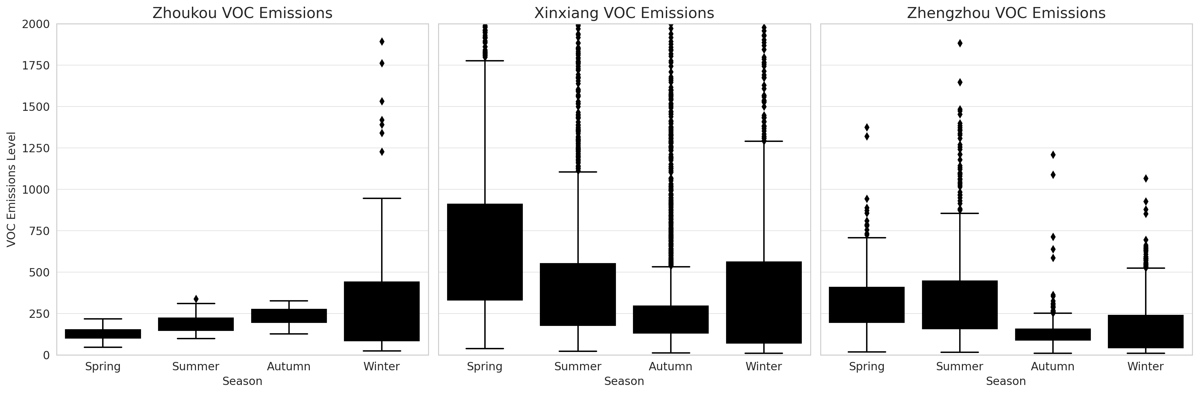Fig 2. seasonal variation in three region

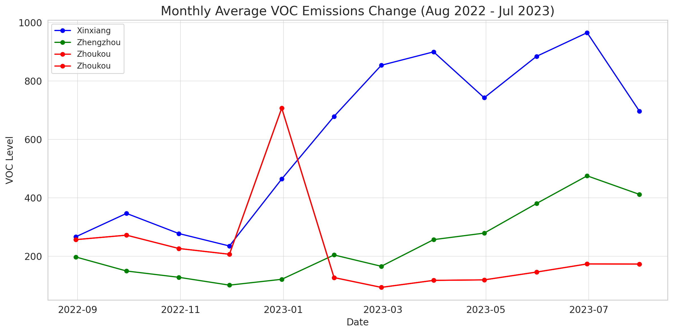

Fig 3. monthly variation in the year in three region

1. Discussion
   1. Geographical and Meteorological Influences

Zhoukou's residential emissions presented a distinct pattern, influenced by domestic heating in winter and biogenic emissions in summer. The lower industrial activity level in this region generally results in much lower VOC levels compared to industrial areas. The seasonal distribution of VOC emissions shows a clear pattern, with higher levels in winter and lower levels in summer. This can be attributed to increased fossil fuel combustion for heating and a higher frequency of temperature inversions, which trap pollutants near the surface.

The VOC levels in Kaifeng showed significant fluctuations correlating with the operational cycles of the fine chemical industrial park. The proximity to the Yellow River and the region's topography may facilitate the accumulation of pollutants during certain meteorological conditions, such as temperature inversions in winter.

In Xinxiang, the plastic weaving industry's emissions were predominant. The region's meteorological patterns, with prevailing winds from the northwest, often disperse pollutants, mitigating their potential impact. However, calm weather conditions can lead to episodic spikes in VOC concentrations.

4.2 Land Use and Seasonal Distribution

Each region's land use significantly impacts the VOC emission profile. Industrial activities in Kaifeng and Xinxiang contribute to higher VOC levels, particularly in colder months when heating demands increase. Zhoukou's emissions are more consistent year-round, with a slight increase in winter due to residential heating.