eDNA Data Analysis

# eDNA Data Analysis Workshop 2022

## Learning Outcomes:

1. Students are able to appropriately analyse data from an eDNA field sampling campaign;
2. Students are able to interpret and understand statistical outputs from the R package ‘vegan’.

library(vegan)

## Loading required package: permute

## Loading required package: lattice

## This is vegan 2.6-2

library(flextable)  
eDNA2022 <- read.csv(file = "eDNA2022.csv")  
eDNA2022$Site <- as.factor(eDNA2022$Site)

## List of all the species and their common names

altnames <-   
 c("MosqFish", "Goby", "Mullet", "Bream", "BnjoFrog", "GToadlet", "MlrdDuck",  
 "SpotDove", "SwampHen", "Crake", "WFHeron", "Lorikeet", "Cattle", "Sheep",  
 "Mouse", "Rat", "HydroidB", "HydroidO", "BwnJelly", "MoonJely", "Dog")  
names_table <-   
 data.frame(Taxonomic = gsub("."," ",colnames(eDNA2022[,4:24]), fixed = T),  
 Common=c("Mosquito Fish","Bridled Goby","Gray Mullet","Black Bream",  
 "Western Banjo Frog", "Gunther's Toadlet", "Mallard Duck",  
 "Spotted Turtle Dove", "Purple Swamphen", "Spotted Crake",  
 "White Faced Heron", "Rainbow Lorikeet", "Cattle", "Sheep",  
 "Mouse", "Rat", "HydroidB", "HydroidO", "Brown Jellyfish",  
 "Moon Jellyfish", "Domestic Dog"),  
 Abbrviated=altnames)  
flextable(names_table,cwidth = c(3,2,2))

| Taxonomic | Common | Abbrviated |
| --- | --- | --- |
| Gambusia holbrooki | Mosquito Fish | MosqFish |
| Arenigobius bifrenatus | Bridled Goby | Goby |
| Mugil cephalus | Gray Mullet | Mullet |
| Acanthopagrus butcheri | Black Bream | Bream |
| Limnodynastes dorsalis | Western Banjo Frog | BnjoFrog |
| Pseudophryne guentheri | Gunther's Toadlet | GToadlet |
| Anas platyrhynchos | Mallard Duck | MlrdDuck |
| Spilopelia chinensis | Spotted Turtle Dove | SpotDove |
| Porphyrio porphyrio | Purple Swamphen | SwampHen |
| Porzana tabuensis | Spotted Crake | Crake |
| Egretta novaehollandiae | White Faced Heron | WFHeron |
| Trichoglossus rubritorquis | Rainbow Lorikeet | Lorikeet |
| Bos taurus | Cattle | Cattle |
| Ovis sp | Sheep | Sheep |
| Mus musculus | Mouse | Mouse |
| Rattus sp | Rat | Rat |
| Blackfordia polytentaculata | HydroidB | HydroidB |
| Obelia bidentata | HydroidO | HydroidO |
| Phyllorhiza punctata | Brown Jellyfish | BwnJelly |
| Aurelia sp | Moon Jellyfish | MoonJely |
| Canis lupus familiaris | Domestic Dog | Dog |

allSpecies <- eDNA2022[,4:24]  
colnames(allSpecies) <- altnames

## Detrended correspondence analysis - all species

AF_dca_all <- decorana(allSpecies)  
AF_dca_all

##   
## Call:  
## decorana(veg = allSpecies)   
##   
## Detrended correspondence analysis with 26 segments.  
## Rescaling of axes with 4 iterations.  
##   
## DCA1 DCA2 DCA3 DCA4  
## Eigenvalues 0.5537 0.3602 0.2545 0.17011  
## Decorana values 0.5632 0.3154 0.1915 0.07493  
## Axis lengths 3.2842 2.6926 2.1577 1.75539

plot(AF_dca_all)

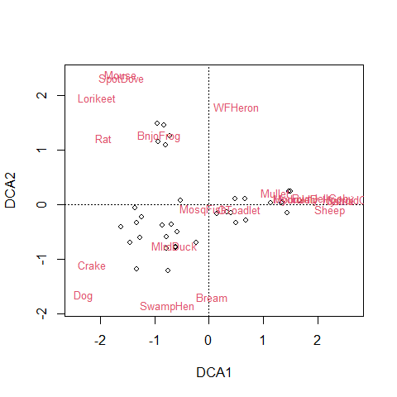

## non-metric multidimensional scaling

AF_nmds_all <- metaMDS(allSpecies, distance = "jaccard")

AF_nmds_all

##   
## Call:  
## metaMDS(comm = allSpecies, distance = "jaccard")   
##   
## global Multidimensional Scaling using monoMDS  
##   
## Data: allSpecies   
## Distance: jaccard   
##   
## Dimensions: 2   
## Stress: 0.1554552   
## Stress type 1, weak ties  
## Two convergent solutions found after 20 tries  
## Scaling: centring, PC rotation, halfchange scaling   
## Species: expanded scores based on 'allSpecies'

# nmds again with Bray

AF_nmds_all_B <- metaMDS(allSpecies) # uses Bray by default

AF_nmds_all_B

##   
## Call:  
## metaMDS(comm = allSpecies)   
##   
## global Multidimensional Scaling using monoMDS  
##   
## Data: allSpecies   
## Distance: bray   
##   
## Dimensions: 2   
## Stress: 0.1554552   
## Stress type 1, weak ties  
## Two convergent solutions found after 20 tries  
## Scaling: centring, PC rotation, halfchange scaling   
## Species: expanded scores based on 'allSpecies'

## Analysis with just the aquatic species

These are: *Gambusia holbrooki, Arenigobius bifrenatus, Mugil cephalus, Acanthopagrus butcheri, Limnodynastes dorsalis, Pseudophryne guentheri, Blackfordia polytentaculata, Obelia bidentata, Phyllorhiza punctata, Aurelia sp.*

fish <- allSpecies[,c(1:6,17:20)]  
head(fish)

## MosqFish Goby Mullet Bream BnjoFrog GToadlet HydroidB HydroidO BwnJelly  
## 1 1 0 0 0 1 0 0 0 0  
## 2 1 0 0 0 1 1 0 0 0  
## 3 1 0 0 0 0 1 0 0 0  
## 4 1 0 0 0 1 1 0 0 0  
## 5 1 0 0 0 1 0 0 0 0  
## 6 1 0 0 0 1 0 0 0 0  
## MoonJely  
## 1 0  
## 2 0  
## 3 0  
## 4 0  
## 5 0  
## 6 0

### for interest look at the dissimilarity matrix

AF_diss_aquat <- vegdist(fish,   
 distance = "bray")  
options(max.print=2000)  
print(AF_diss_aquat, digits = 2)

## 1 2 3 4 5 6 7 8 9 10 11 12  
## 2 0.200   
## 3 0.500 0.200   
## 4 0.200 0.000 0.200   
## 5 0.000 0.200 0.500 0.200   
## 6 0.000 0.200 0.500 0.200 0.000   
## 7 0.000 0.200 0.500 0.200 0.000 0.000   
## 8 0.000 0.200 0.500 0.200 0.000 0.000 0.000   
## 9 0.500 0.200 0.000 0.200 0.500 0.500 0.500 0.500   
## 10 0.333 0.500 0.333 0.500 0.333 0.333 0.333 0.333 0.333   
## 11 1.000 0.500 0.333 0.500 1.000 1.000 1.000 1.000 0.333 1.000   
## 12 0.500 0.200 0.000 0.200 0.500 0.500 0.500 0.500 0.000 0.333 0.333   
## 13 0.778 0.600 0.556 0.600 0.778 0.778 0.778 0.778 0.556 0.750 0.750 0.556  
## 14 0.800 0.636 0.600 0.636 0.800 0.800 0.800 0.800 0.600 0.778 0.778 0.600  
## 15 0.750 0.556 0.500 0.556 0.750 0.750 0.750 0.750 0.500 0.714 0.714 0.500  
## 16 0.800 0.636 0.600 0.636 0.800 0.800 0.800 0.800 0.600 0.778 0.778 0.600  
## 17 0.800 0.636 0.600 0.636 0.800 0.800 0.800 0.800 0.600 0.778 0.778 0.600  
## 18 0.800 0.636 0.600 0.636 0.800 0.800 0.800 0.800 0.600 0.778 0.778 0.600  
## 19 0.750 0.778 0.750 0.778 0.750 0.750 0.750 0.750 0.750 0.714 1.000 0.750  
## 20 0.778 0.600 0.556 0.600 0.778 0.778 0.778 0.778 0.556 0.750 0.750 0.556  
## 21 0.750 0.556 0.500 0.556 0.750 0.750 0.750 0.750 0.500 0.714 0.714 0.500  
## 22 0.556 0.400 0.556 0.400 0.556 0.556 0.556 0.556 0.556 0.750 0.750 0.556  
## 23 0.500 0.333 0.500 0.333 0.500 0.500 0.500 0.500 0.500 0.714 0.714 0.500  
## 24 0.500 0.333 0.500 0.333 0.500 0.500 0.500 0.500 0.500 0.714 0.714 0.500  
## 25 0.500 0.600 1.000 0.600 0.500 0.500 0.500 0.500 1.000 1.000 1.000 1.000  
## 26 0.000 0.200 0.500 0.200 0.000 0.000 0.000 0.000 0.500 0.333 1.000 0.500  
## 27 0.200 0.333 0.600 0.333 0.200 0.200 0.200 0.200 0.600 0.500 1.000 0.600  
## 28 0.200 0.333 0.600 0.333 0.200 0.200 0.200 0.200 0.600 0.500 1.000 0.600  
## 29 0.200 0.333 0.600 0.333 0.200 0.200 0.200 0.200 0.600 0.500 1.000 0.600  
## 30 0.200 0.333 0.600 0.333 0.200 0.200 0.200 0.200 0.600 0.500 1.000 0.600  
## 31 0.200 0.333 0.600 0.333 0.200 0.200 0.200 0.200 0.600 0.500 1.000 0.600  
## 32 0.500 0.600 0.500 0.600 0.500 0.500 0.500 0.500 0.500 0.333 1.000 0.500  
## 33 0.333 0.500 0.333 0.500 0.333 0.333 0.333 0.333 0.333 0.000 1.000 0.333  
## 34 0.333 0.500 0.333 0.500 0.333 0.333 0.333 0.333 0.333 0.000 1.000 0.333  
## 35 0.333 0.500 0.333 0.500 0.333 0.333 0.333 0.333 0.333 0.000 1.000 0.333  
## 36 0.333 0.500 0.333 0.500 0.333 0.333 0.333 0.333 0.333 0.000 1.000 0.333  
## 37 0.429 0.250 0.429 0.250 0.429 0.429 0.429 0.429 0.429 0.667 0.667 0.429  
## 38 0.429 0.250 0.429 0.250 0.429 0.429 0.429 0.429 0.429 0.667 0.667 0.429  
## 39 0.500 0.333 0.500 0.333 0.500 0.500 0.500 0.500 0.500 0.714 0.714 0.500  
## 40 0.714 0.500 0.429 0.500 0.714 0.714 0.714 0.714 0.429 0.667 0.667 0.429  
## 41 0.500 0.200 0.000 0.200 0.500 0.500 0.500 0.500 0.000 0.333 0.333 0.000  
## 42 0.500 0.200 0.000 0.200 0.500 0.500 0.500 0.500 0.000 0.333 0.333 0.000  
## 43 0.500 0.200 0.000 0.200 0.500 0.500 0.500 0.500 0.000 0.333 0.333 0.000  
## 44 0.500 0.200 0.000 0.200 0.500 0.500 0.500 0.500 0.000 0.333 0.333 0.000  
## 13 14 15 16 17 18 19 20 21 22 23 24  
## 2   
## 3   
## 4   
## 5   
## 6   
## 7   
## 8   
## 9   
## 10   
## 11   
## 12   
## 13   
## 14 0.067   
## 15 0.231 0.143   
## 16 0.067 0.000 0.143   
## 17 0.200 0.125 0.286 0.125   
## 18 0.200 0.125 0.286 0.125 0.000   
## 19 0.385 0.286 0.333 0.286 0.143 0.143   
## 20 0.143 0.067 0.231 0.067 0.067 0.067 0.231   
## 21 0.231 0.286 0.333 0.286 0.143 0.143 0.333 0.231   
## 22 0.286 0.333 0.385 0.333 0.200 0.200 0.385 0.286 0.077   
## 23 0.385 0.429 0.333 0.429 0.286 0.286 0.333 0.385 0.167 0.077   
## 24 0.231 0.286 0.333 0.286 0.286 0.286 0.500 0.231 0.167 0.077 0.167   
## 25 0.778 0.800 0.750 0.800 1.000 1.000 1.000 1.000 1.000 0.778 0.750 0.750  
## 26 0.778 0.800 0.750 0.800 0.800 0.800 0.750 0.778 0.750 0.556 0.500 0.500  
## 27 0.600 0.636 0.556 0.636 0.818 0.818 0.778 0.800 0.778 0.600 0.556 0.556  
## 28 0.600 0.636 0.556 0.636 0.818 0.818 0.778 0.800 0.778 0.600 0.556 0.556  
## 29 0.600 0.636 0.556 0.636 0.818 0.818 0.778 0.800 0.778 0.600 0.556 0.556  
## 30 0.600 0.636 0.556 0.636 0.818 0.818 0.778 0.800 0.778 0.600 0.556 0.556  
## 31 0.600 0.636 0.556 0.636 0.818 0.818 0.778 0.800 0.778 0.600 0.556 0.556  
## 32 0.556 0.600 0.500 0.600 0.800 0.800 0.750 0.778 0.750 0.778 0.750 0.750  
## 33 0.750 0.778 0.714 0.778 0.778 0.778 0.714 0.750 0.714 0.750 0.714 0.714  
## 34 0.750 0.778 0.714 0.778 0.778 0.778 0.714 0.750 0.714 0.750 0.714 0.714  
## 35 0.750 0.778 0.714 0.778 0.778 0.778 0.714 0.750 0.714 0.750 0.714 0.714  
## 36 0.750 0.778 0.714 0.778 0.778 0.778 0.714 0.750 0.714 0.750 0.714 0.714  
## 37 0.500 0.538 0.455 0.538 0.385 0.385 0.455 0.500 0.273 0.167 0.091 0.273  
## 38 0.500 0.538 0.455 0.538 0.385 0.385 0.455 0.500 0.273 0.167 0.091 0.273  
## 39 0.385 0.429 0.333 0.429 0.286 0.286 0.333 0.385 0.167 0.077 0.000 0.167  
## 40 0.333 0.385 0.273 0.385 0.231 0.231 0.273 0.333 0.091 0.167 0.091 0.273  
## 41 0.556 0.600 0.500 0.600 0.600 0.600 0.750 0.556 0.500 0.556 0.500 0.500  
## 42 0.556 0.600 0.500 0.600 0.600 0.600 0.750 0.556 0.500 0.556 0.500 0.500  
## 43 0.556 0.600 0.500 0.600 0.600 0.600 0.750 0.556 0.500 0.556 0.500 0.500  
## 44 0.556 0.600 0.500 0.600 0.600 0.600 0.750 0.556 0.500 0.556 0.500 0.500  
## 25 26 27 28 29 30 31 32 33 34 35 36  
## 2   
## 3   
## 4   
## 5   
## 6   
## 7   
## 8   
## 9   
## 10   
## 11   
## 12   
## 13   
## 14   
## 15   
## 16   
## 17   
## 18   
## 19   
## 20   
## 21   
## 22   
## 23   
## 24   
## 25   
## 26 0.500   
## 27 0.200 0.200   
## 28 0.200 0.200 0.000   
## 29 0.200 0.200 0.000 0.000   
## 30 0.200 0.200 0.000 0.000 0.000   
## 31 0.200 0.200 0.000 0.000 0.000 0.000   
## 32 0.500 0.500 0.200 0.200 0.200 0.200 0.200   
## 33 1.000 0.333 0.500 0.500 0.500 0.500 0.500 0.333   
## 34 1.000 0.333 0.500 0.500 0.500 0.500 0.500 0.333 0.000   
## 35 1.000 0.333 0.500 0.500 0.500 0.500 0.500 0.333 0.000 0.000   
## 36 1.000 0.333 0.500 0.500 0.500 0.500 0.500 0.333 0.000 0.000 0.000   
## 37 0.714 0.429 0.500 0.500 0.500 0.500 0.500 0.714 0.667 0.667 0.667 0.667  
## 38 0.714 0.429 0.500 0.500 0.500 0.500 0.500 0.714 0.667 0.667 0.667 0.667  
## 39 0.750 0.500 0.556 0.556 0.556 0.556 0.556 0.750 0.714 0.714 0.714 0.714  
## 40 1.000 0.714 0.750 0.750 0.750 0.750 0.750 0.714 0.667 0.667 0.667 0.667  
## 41 1.000 0.500 0.600 0.600 0.600 0.600 0.600 0.500 0.333 0.333 0.333 0.333  
## 42 1.000 0.500 0.600 0.600 0.600 0.600 0.600 0.500 0.333 0.333 0.333 0.333  
## 43 1.000 0.500 0.600 0.600 0.600 0.600 0.600 0.500 0.333 0.333 0.333 0.333  
## 44 1.000 0.500 0.600 0.600 0.600 0.600 0.600 0.500 0.333 0.333 0.333 0.333  
## 37 38 39 40 41 42 43  
## 2   
## 3   
## 4   
## 5   
## 6   
## 7   
## 8   
## 9   
## 10   
## 11   
## 12   
## 13   
## 14   
## 15   
## 16   
## 17   
## 18   
## 19   
## 20   
## 21   
## 22   
## 23   
## 24   
## 25   
## 26   
## 27   
## 28   
## 29   
## 30   
## 31   
## 32   
## 33   
## 34   
## 35   
## 36   
## 37   
## 38 0.200   
## 39 0.091 0.091   
## 40 0.200 0.200 0.091   
## 41 0.429 0.429 0.500 0.429   
## 42 0.429 0.429 0.500 0.429 0.000   
## 43 0.429 0.429 0.500 0.429 0.000 0.000   
## 44 0.429 0.429 0.500 0.429 0.000 0.000 0.000

AF_nmds_aquat <- metaMDS(fish, trymax = 500,   
 distance = "bray")

AF_nmds_aquat

##   
## Call:  
## metaMDS(comm = fish, distance = "bray", trymax = 500)   
##   
## global Multidimensional Scaling using monoMDS  
##   
## Data: fish   
## Distance: bray   
##   
## Dimensions: 2   
## Stress: 0.08664753   
## Stress type 1, weak ties  
## Two convergent solutions found after 20 tries  
## Scaling: centring, PC rotation, halfchange scaling   
## Species: expanded scores based on 'fish'

plot(AF_nmds_aquat, type="p",display = "sites", cex = 1.2)  
text(AF_nmds_aquat, display = "species", col = "dodgerblue", cex = 0.8)

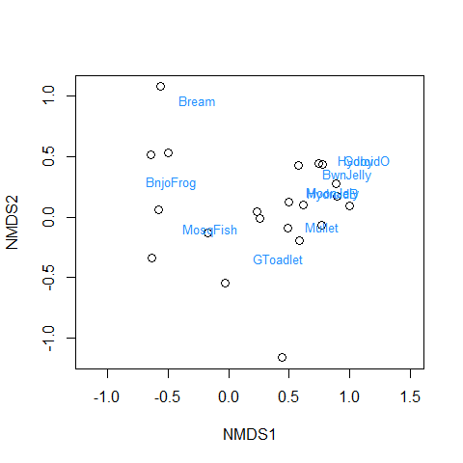

### alternative to vegan plots

palette(c("black","grey80","grey92",  
 rainbow(4,s=0.5,end=0.25),rainbow(4,s=0.5,start=0.45,end=0.8)))  
plot(AF_nmds_aquat$points, pch=c(rep(21:25, 2),21)[eDNA2022$Site],   
 xlim = c(-1.2,1.8),   
 bg = seq(1,11)[eDNA2022$Site],   
 cex = 1.4, col.main = "steelblue", main = "Just aquatic species")  
text(jitter(AF_nmds_aquat$points[,1], factor = 500),  
 jitter(AF_nmds_aquat$points[,2], factor=50),   
 labels=eDNA2022$SiteID, cex=1,   
 col=c("black","grey40","grey70",  
 rainbow(4,v=0.75,end=0.25),  
 rainbow(4,v=0.75,start=0.45,end=0.8))[eDNA2022$Site])  
text(AF_nmds_aquat, display = "species", col = "grey33", font=3, cex = 0.9)

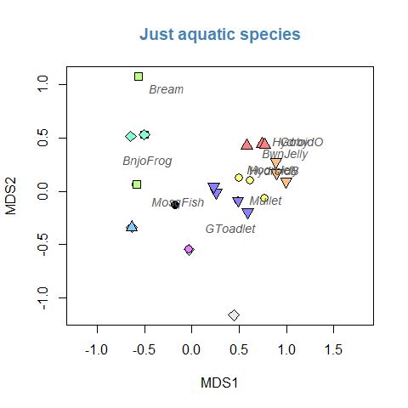

This plot mimics the nmmds plot in Deirdre’s handout (note that the sign of dimension MDS2 is reversed)

plot(AF_nmds_all$points, pch=c(rep(21:25, 2),21)[eDNA2022$Site],   
 xlim = c(-1.6,2.2), ylim = c(1.2,-1.2),   
 bg=seq(1,11)[eDNA2022$Site],   
 cex = 1.4, main = "All species")  
text(jitter(AF_nmds_all$points[,1], factor = 500),  
 jitter(AF_nmds_all$points[,2], factor=50), labels=eDNA2022$SiteID, cex=1,   
 col=c("black","grey40","grey70",  
 rainbow(4,v=0.75,end=0.25),  
 rainbow(4,v=0.75,start=0.45,end=0.8))[eDNA2022$Site])  
text(AF_nmds_all, display = "species", col = "#80008080", font=3, cex = 1.1)

