Dataset
Title:
Soil-landscape mapping South-Western Australia
Custodian:
Department of Agriculture Western Australia
Jurisdiction:
Western Australia

Contact
Contact Organisation Name:
Department of Agriculture Western Australia
Contact Organisation Jurisdiction:
Western Australia
Contact Position:
Land Resource Assessment and Monitoring Project
Mail Address 1:
Locked Bag No. 4
Mail Address 2:

Suburb or Place or Locality:
Bentley Delivery Centre
State or Locality 2:
WA
Country:
Australia
Postcode:
6983
Telephone:
08 9368 3925
Facsimile:
08 9368 3939
Electronic Mail Address:
pgoulding@agric.wa.gov.au

Description
Abstract:
Soil-landscape mapping covering the south-west (agricultural area) of Western Australia.

Scale of mapping varies between 1:20, 000 and 1:250, 000.

Mapping conforms to a nested hierarchy established to deal with the varying levels of information resulting from the variety of scales in mapping.

For further information refer to Department of Agriculture Resource Management Technical Report No. 280.

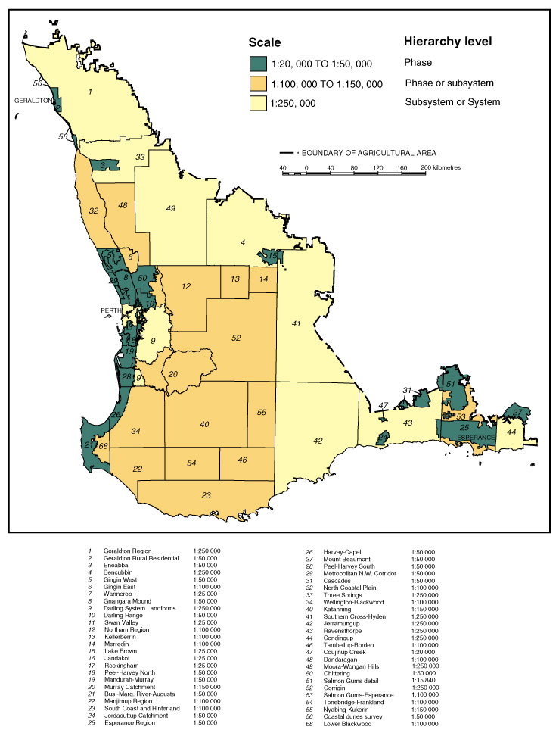

Search Words:
GEOSCIENCES Geomorphology
SOIL
SOIL Chemistry
SOIL Physics

Geographic Extent:
Agricultural area of Western Australia defined by limit of clearing.

Data Currency
Beginning Date:
01-01-1987
Ending Date:
Current

Dataset Status
Progress:
Complete
Maintenance & Update Frequency:
As required. Southern Cross-Hyden and Moora-Wongan Hills survey areas are currently undergoing revision to larger scale mapping.

Access
Stored Data Format:
DIGITAL Intergraph design files.
DIGITAL Map unit attribute data stored in Oracle database.
Available Format Types:
DIGITAL Intergraph IGDS
DIGITAL Intergraph GeoMedia warehouse
DIGITAL ArcView shapefile
NON DIGITAL Plots and reports
DIGITAL Word, Excel, Access map unit attribute reports
Access Constraints:
Subject to data licencing agreement.

Data Quality
Lineage:
Data was collected through field observations and sampling and interpretation of aerial photography and satellite imagery at a variety of scales. Data was transferred to aerial photography or satellite images and georeferenced for digitising in MicroStation. A few surveys were scanned and georeferenced using Intergraph MGE Projection Manager.

Soil survey was carried out according to the standards set in "Australian Soil and Land Survey - Guidelines for Conducting Surveys", Gunn et al., CSIRO, 1988.

Positional Accuracy:
Variable depending upon scale of survey + or – 50 to 250 m.
Attribute Accuracy:
Accuracy of attribution is variable depending upon scale of survey.

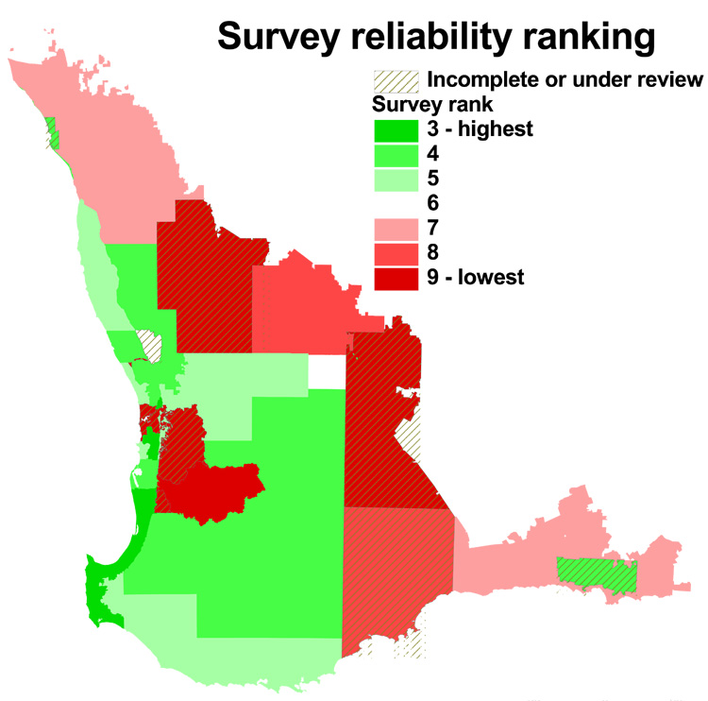

Logical Consistency:
Clean linework and one label per polygon. Data checked using Mappa MDL Application and Intergraph MGE GIS software.
Completeness:
Agricultural area of Western Australia.

Metadata Date
03-02-2005

Additional Metadata
Datum: Geocentric Datum of Australia 1994.
Projection: Universal Transverse Mercator, in native zone (50 or 51).
Grid: Map Grid of Australia 1994.

