Soil-landscape mapping data maintained by Dept. of Agriculture and Food WA

Coverage: Agricultural area of Western Australia

Format: ArcView shapefile (spatial data), MS Access (attribute data)

Datum: GDA94

Projection: UTM zone 50

Data: The data residing in this directory is the Department of Agriculture’s soil-landscape mapping for the agricultural area of Western Australia. For further information about the survey program see the document

‘Soil-landscape mapping in South-Western Australia – Overview of Methodology and outputs’ Resource Management Technical Report No. 280. (tr280.pdf)

Soil-landscape subsystems/phases (Suitable for mapping at regional scales, approx. 1:100, 000)

Soils_gda94_.shp

The subsystem/phase level mapping is the most detailed coverage available across the agricultural area. For manageability, this has been split into three tiles as shown in figure 1. Since this mapping is an amalgam of surveys at differing scales, the individual three character survey codes shown in Figure 1 have been retained as an attribute in the digital data. Surveys shown as not being incorporated into the hierarchy are not part of the three digital data tiles, but may be available separately, enquiries to the contact listed below.

Map unit descriptions and proportional allocation of WA Soil Groups to map units based on the three survey tiles are found in the legend subdirectory. The field MAPPING_UN in the digital data can be joined to the field MAP_UNIT in the descriptions and MUWASoilgrps database tables. For further information about Soil Groups of Western Australia see the document

‘Soil Groups of Western Australia – A simple guide to the main soils of Western Australia’ Resource Management Technical Report No. 246. (tr246*.pdf, 5 parts)

Anzlic Page 0 metadata is maintained on a survey basis, and can be found in the metadata directory. File names begin with the three character survey code.

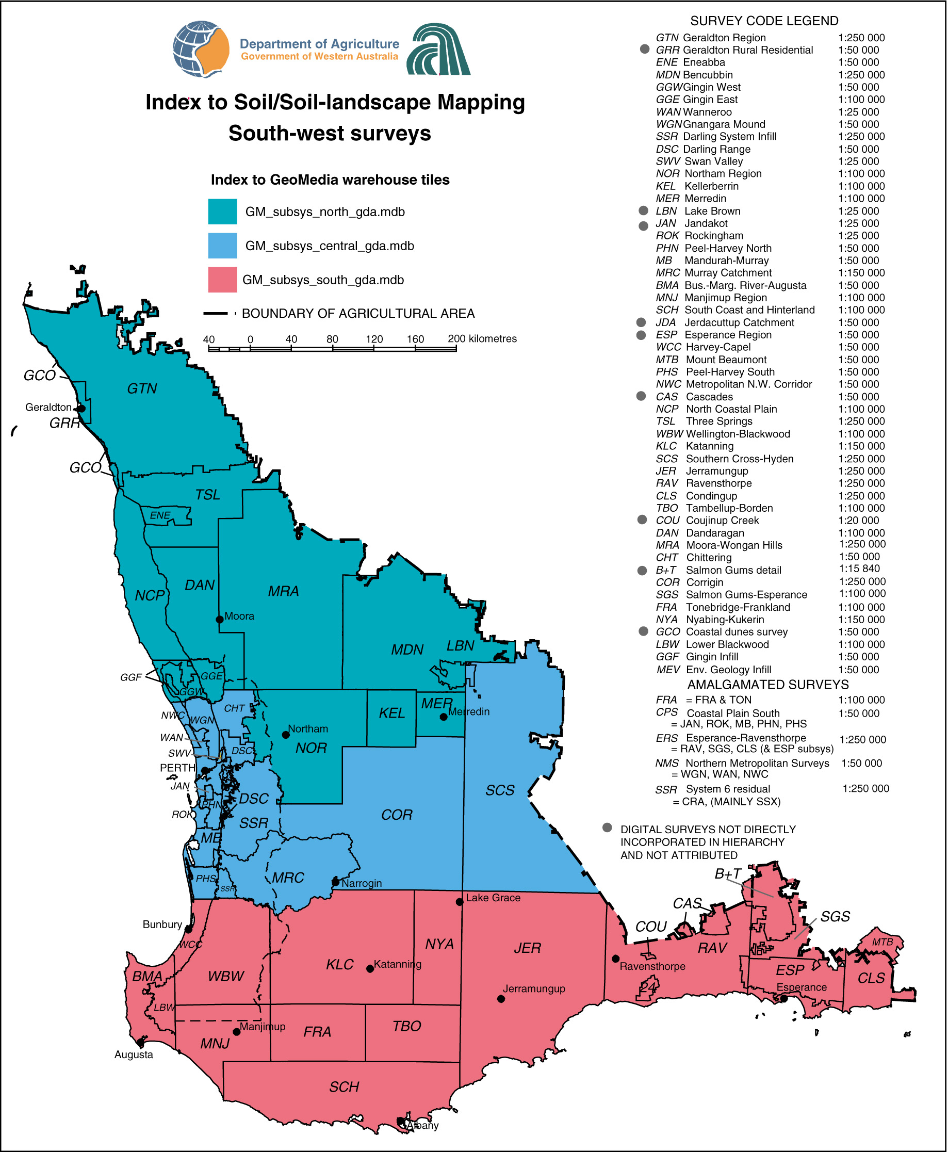

Figure 1: Index to soil-landscape subsystem/phase level mapping and digital data tiles

A selected set of land capability and land quality attributes for each of the three survey tiles is maintained in the Land_Qualities_Capability_Attribution subdirectory. The field MAPPING_UN in the digital data can be joined to the field MU_SYMBOL in the land quality and land capability database tables.

For further information about the land capability/quality assessment see the document

‘Land Evaluation Standards for Land Resource Mapping – Guidelines for assessing land qualities and determining land capability in south-west Western Australia’ Resource Management Technical Report No. 298. (tr298*.pdf, 4 parts).

Further land quality and land capability attribution may be available, enquiries to the contact listed below.

Contact:

Digital Data Enquires:

Phil Goulding or Jeff Watson

Client and Resource Information System
Dept. of Agriculture Western Australia
Locked Bag No. 4
Bentley Delivery Centre W.A. 6983
Tel. (08)9368 3925 Fax. (08) 9368 3939
Email. pgoulding@agric.wa.gov.au
jwatson@agric.wa.gov.au

Land Capability/Land Quality Data enquiries:

Dennis van Gool

Land Resource Assessment and Monitoring
Dept. of Agriculture Western Australia
Locked Bag No. 4
Bentley Delivery Centre W.A. 6983
Tel. (08)9368 3899 Fax. (08) 9368 3939
Email. dvangool@agric.wa.gov.au

