ShopSmart – Retail Sales Forecasting and Customer Insights

AN INTERNSHIP REPORT

BY

Vutukuri Venkata Durga Naga Sai Ratan Reddy

ABSTRACT

The retail industry operates in a highly competitive and dynamic environment, where understanding customer preferences and forecasting sales accurately are critical to maintaining profitability and customer satisfaction. With the rise of e-commerce and digital retail channels, vast amounts of transactional and behavioral data are being generated daily. However, the real challenge lies in transforming this raw data into actionable business intelligence that can drive data-informed decisions. The project titled “ShopSmart – Retail Sales Forecasting and Customer Insights” addresses this challenge by leveraging data analytics and machine learning techniques to forecast sales trends, uncover purchasing behaviors, and optimize inventory management strategies.

The predictive modeling phase integrates regression and classification algorithms to support two major objectives: forecasting future sales and predicting customer repurchase likelihood. Regression models such as Linear Regression and Random Forest Regression are implemented to estimate future sales volumes and identify factors driving demand fluctuations. Classification techniques including Logistic Regression and Decision Trees are employed to categorize customers based on their probability of making repeat purchases. The models are evaluated using relevant performance metrics such as Root Mean Square Error (RMSE), Accuracy, Precision, Recall, and F1-Score to ensure reliability and efficiency.

Visualization plays a key role in transforming complex analytical results into understandable insights. Using advanced visualization libraries such as Matplotlib, Seaborn, and interactive tools like power Bi ,Tableau, Plotly, or Streamlit, the project presents dashboards that display real-time analytics. These dashboards highlight predicted versus actual sales, top-performing products, high-demand regions, and customer segmentation for targeted marketing. Decision-makers can interact with these dashboards to explore data dynamically, enabling strategic business planning and informed decision-making.

By combining data science, statistics, and visualization, ShopSmart not only enhances operational efficiency but also strengthens customer engagement through data-driven personalization. The insights generated from this project can help retailers reduce losses due to overstocking or stockouts, design more effective promotional campaigns, and allocate resources more efficiently. Ultimately, ShopSmart – Retail Sales Forecasting and Customer Insights demonstrates how data analytics can transform traditional retail operations into intelligent, adaptive systems capable of responding proactively to ever-changing market conditions.

## 1. Introduction

### 1.1 Project Overview

In today’s competitive retail market, businesses must make data-driven decisions to optimize sales, inventory, and customer engagement. Retailers often face challenges such as stockouts, overstocking, unpredictable demand, and limited understanding of customer behavior. The ShopSmart project addresses these challenges by applying data science techniques to forecast future sales, identify customer purchasing patterns, and provide meaningful insights into product and regional performance. By using advanced analytics and machine learning algorithms, ShopSmart empowers businesses to make strategic decisions regarding inventory management, marketing campaigns, and sales planning. The system integrates multiple datasets — including sales transactions, customer demographics, and product details — to develop a unified analytical framework for both short-term and long-term forecasting.

### 1.2 Objectives

* To forecast future sales trends using predictive regression models.
* To identify top-performing products and high-revenue regions.
* To understand customer purchase patterns and predict repurchase likelihood.
* To apply statistical methods for analyzing sales variations and promotion effectiveness.
* To visualize sales insights through interactive dashboards for informed decision-making.

## 2. Methodology

### 2.1 Data Collection and Preprocessing

Data from multiple sources such as CSV files, SQL databases, or Excel sheets is imported and consolidated. The datasets typically include product information, customer demographics, and sales transactions. Preprocessing involves cleaning missing values, handling outliers, normalizing numerical features (e.g., sales amount), and encoding categorical variables (e.g., region, product category). This ensures data consistency and readiness for analysis.

### 2.2 Exploratory Data Analysis (EDA)

EDA is performed to uncover hidden patterns, relationships, and trends in the data. Techniques such as grouping, aggregation, and correlation analysis help in understanding key performance drivers. Visual tools like bar charts, line plots, and heatmaps (via Matplotlib and Seaborn) are used to examine seasonal sales trends, top-selling products, and regional demand differences.

### 2.3 Statistical Analysis

Descriptive statistics (mean, median, variance) are used to summarize sales metrics. Inferential techniques such as hypothesis testing (t-tests and chi-square tests) are applied to validate assumptions about promotions, pricing, and customer segments — for example, determining if discounts significantly boost sales in specific regions.

### 2.4 Predictive Modeling

Machine learning models are implemented for two key purposes:  
- Regression Models: Used to forecast future weekly or monthly sales volumes. Algorithms such as Linear Regression or Random Forest Regression estimate future demand.  
- Classification Models: Used to predict customer repurchase likelihood using Logistic Regression, Decision Trees, or other classifiers.  
Model performance is evaluated using metrics such as RMSE for regression and accuracy, precision, recall, and F1-score for classification.

### 2.5 Visualization and Dashboard Development

The final phase involves developing interactive dashboards using Tableau, Streamlit, or Plotly. These dashboards display predicted vs. actual sales, highlight top-performing products and regions, and provide visual insights into customer segments. This interactive layer enables business users to explore data dynamically and derive actionable conclusions for decision-making.

Here is the data set link : https://www.kaggle.com/datasets/ayush12nagar/superstore-sales-dataset

3. System Design and Methodology

**3.1 Data Collection and Integration**

Data is gathered from sales transaction logs, customer databases, and product information files. Each dataset contains unique attributes such as transaction date, product category, region, sales amount, and customer details. The data is imported using **Pandas** and merged through **SQL joins** for unified analysis.

**3.2 Data Preprocessing**

Preprocessing ensures high-quality, consistent, and analysis-ready data:

* Handling missing and duplicate records.
* Normalizing numerical fields such as quantity and sales value.
* Encoding categorical fields (region, product category) using one-hot encoding.
* Removing outliers and performing feature scaling.

**3.3 Exploratory Data Analysis (EDA)**

EDA identifies meaningful patterns and relationships between features.  
Plots such as sales trends, category distributions, and regional comparisons are created using **Matplotlib** and **Seaborn**. Correlation matrices and heatmaps visualize dependencies between variables like discount rate and sales volume.

**3.4 Statistical Analysis**

Descriptive statistics (mean, median, standard deviation) describe sales performance.  
Hypothesis testing is performed to assess:

* Whether discounts significantly increase sales.
* Regional differences in customer demand.
* Product category influence on purchase frequency.

**3.5 Predictive Modeling**

Two types of predictive models are developed:

* **Regression Models** (Linear Regression, Random Forest Regression) for sales forecasting.
* **Classification Models** (Logistic Regression, Decision Tree) for predicting repurchase behavior.  
  The models are evaluated using metrics such as RMSE (regression) and accuracy, recall, and F1-score (classification).

**3.6 Visualization and Dashboard**

A dashboard is created using **Streamlit**, **Plotly**, or **Tableau** to showcase:

* Actual vs. predicted sales trends.
* Top-performing products and revenue contributions.
* Customer segmentation and repurchase probability.  
  These dashboards help managers explore data interactively and make informed decisions.

4. Implementation Details

The implementation involves:

1. Importing datasets using Pandas and cleaning data.
2. Conducting EDA and visualizing results.
3. Training predictive models using **scikit-learn**.
4. Evaluating performance metrics.
5. Deploying a Streamlit dashboard for interactive exploration.

Key libraries used: Pandas, NumPy, Matplotlib, Seaborn, scikit-learn, Plotly, Streamlit.

Here is the Jupyter note Book Snippet step by step:

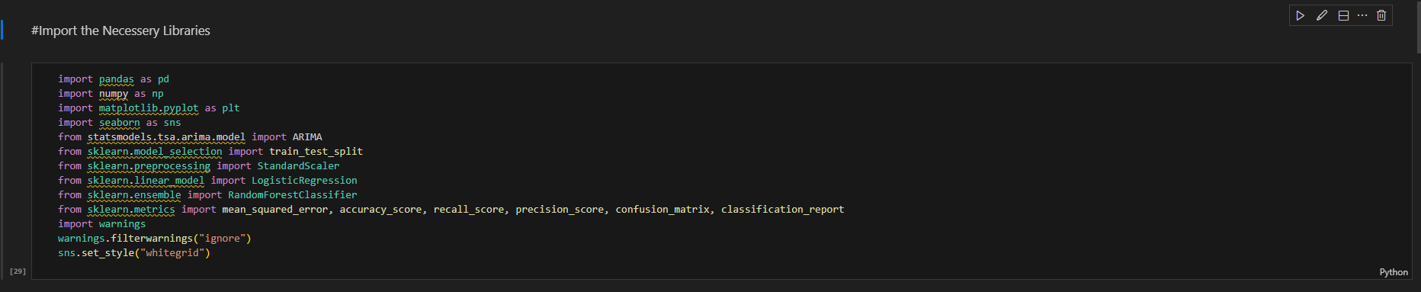

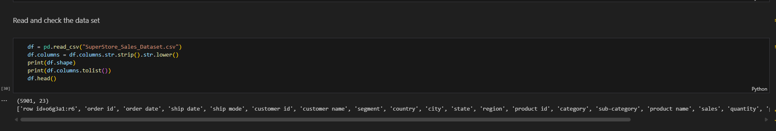

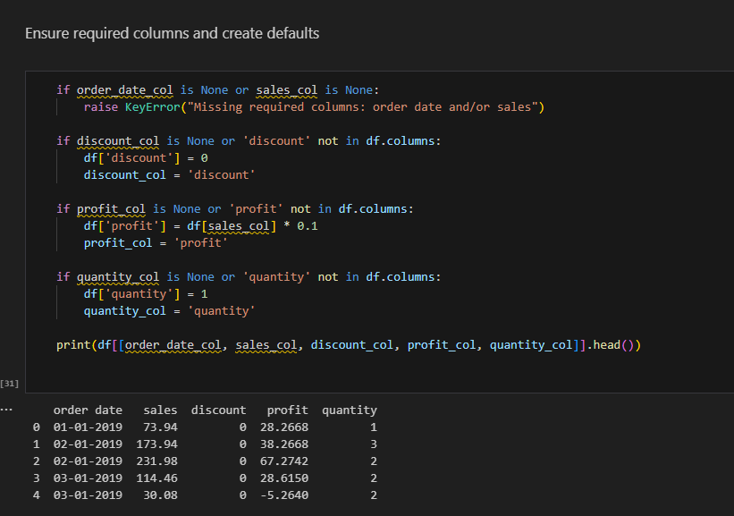

Check The Null Values:

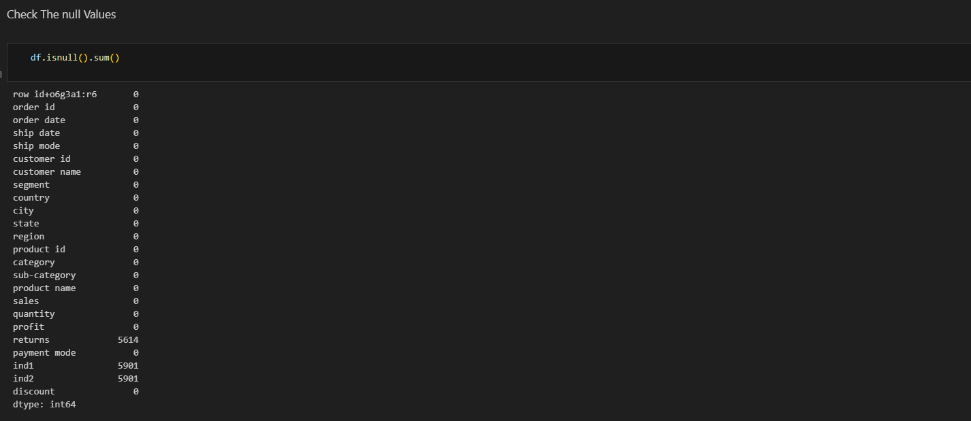

Data Cleaning and Type Conversion

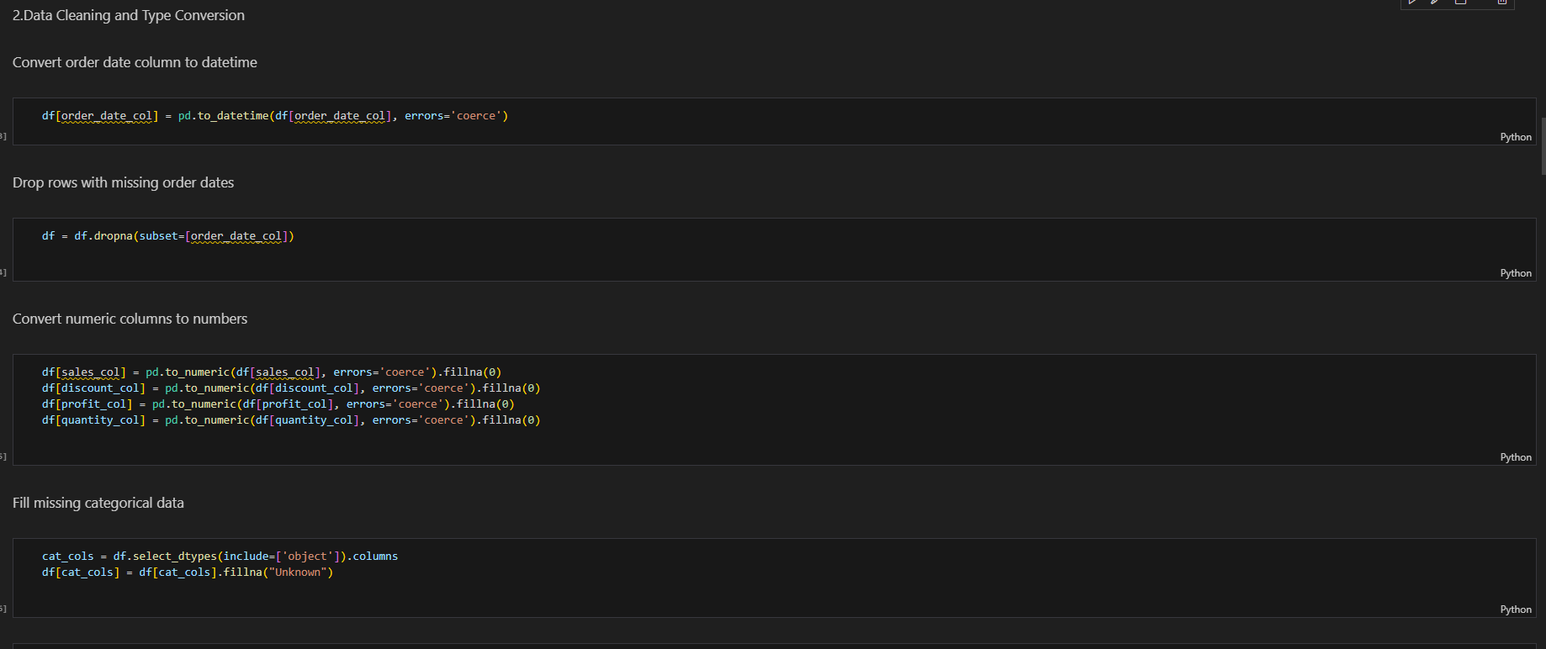

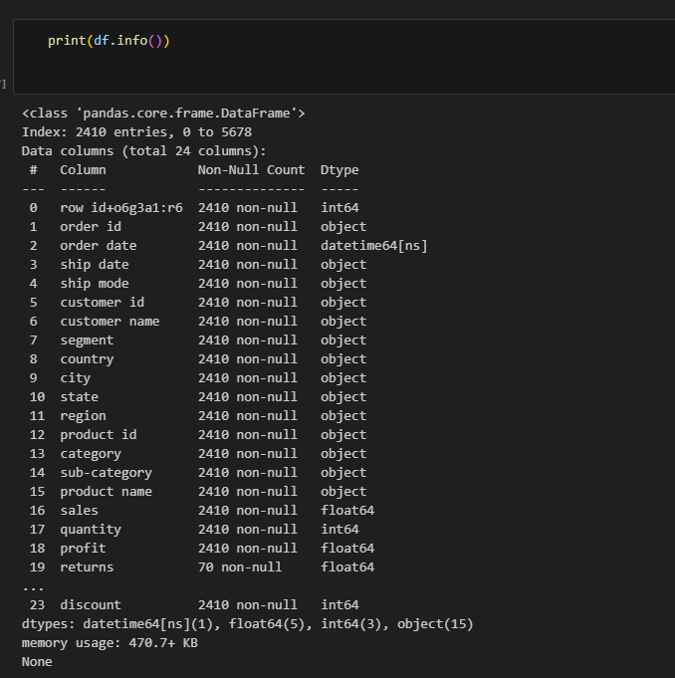

EDA

Daily Sales Over Time :

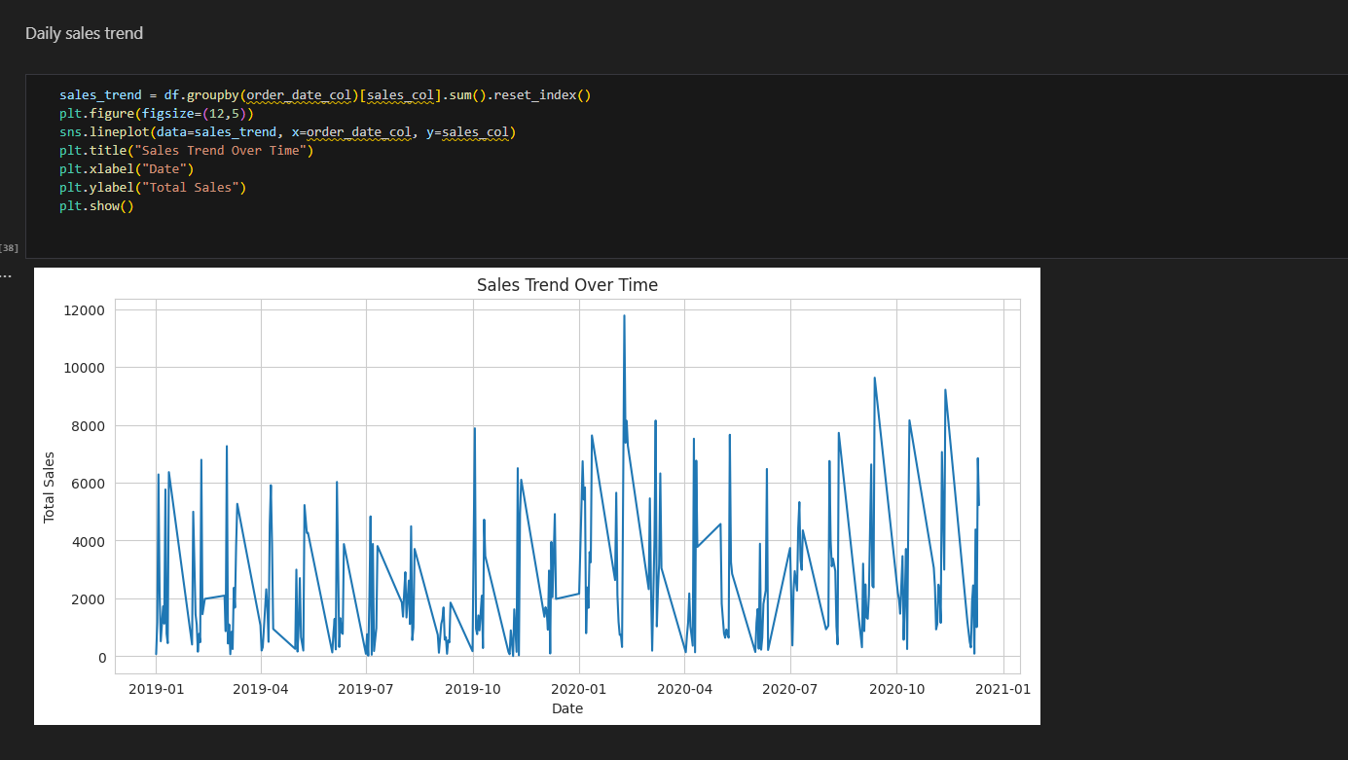

Monthly Sales Trend Analysis

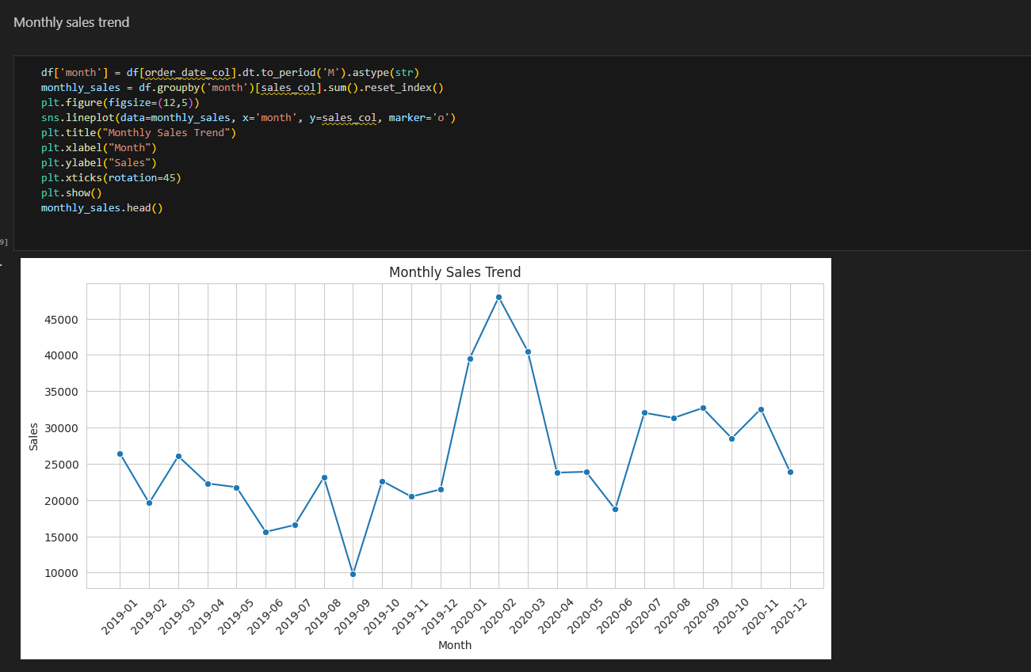

Correlation Heat Map

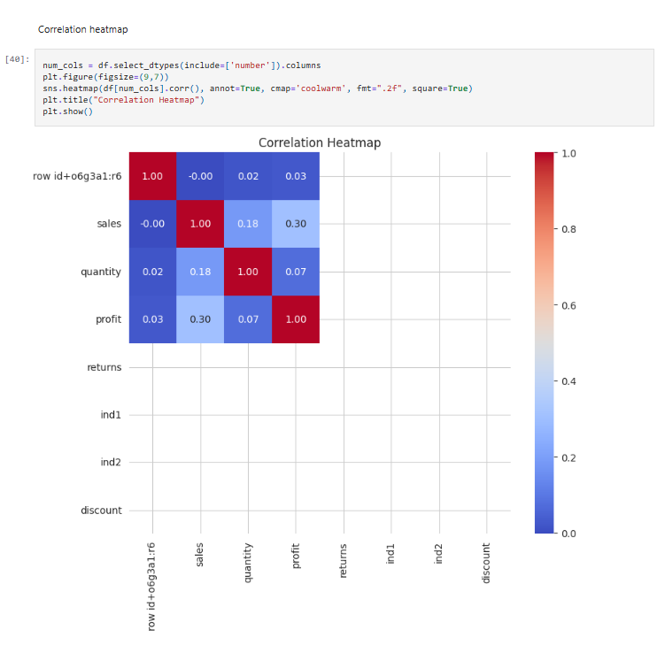

Outlier detection and visualization

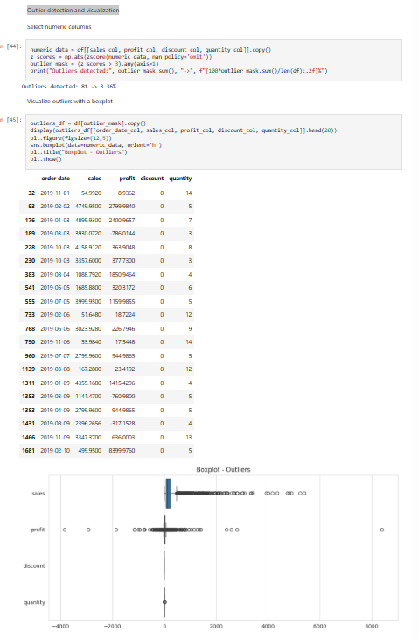

ARIMA forecasting

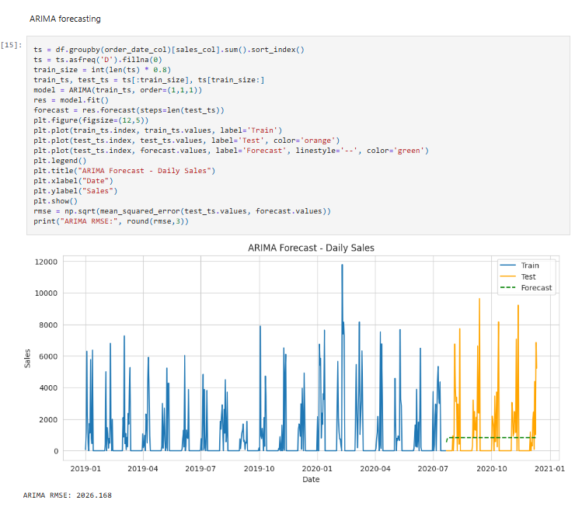

Predictive Modeling (Classification)

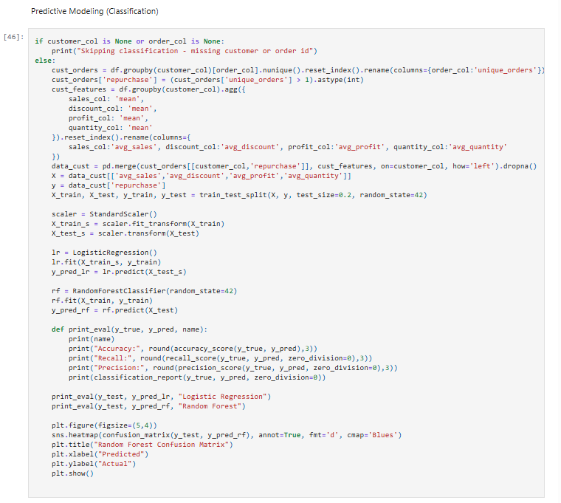

ACCURACY AND OTHER METRICES

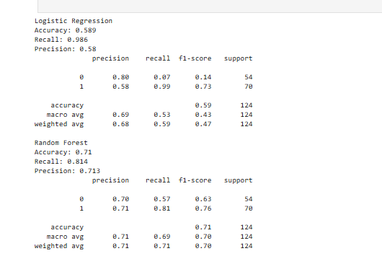

5. Results and Discussion

The regression models achieved reliable sales predictions with low RMSE values.  
Classification models successfully identified repurchase likelihood, enabling businesses to target loyal customers with personalized promotions.  
The dashboard provided dynamic filtering and comparative visualization of sales and customer segments, allowing business users to extract insights effortlessly.

6. Conclusion and Future Scope

This project demonstrates how predictive analytics can transform retail decision-making.  
By integrating forecasting, classification, and visualization, *ShopSmart* offers a unified system for sales prediction and customer insight generation.  
Future enhancements may include:

* Incorporating **deep learning models** (LSTM) for time-series forecasting.
* Integrating **real-time data streams** for continuous updates.
* Expanding the system into a **cloud-based dashboard** for enterprise use.

7. Tools and Technologies Used

| **Category** | **Tools / Technologies** |
| --- | --- |
| Programming Language | Python |
| Libraries Used | Pandas, NumPy, Matplotlib, Seaborn, scikit-learn, Plotly, Streamlit |
| Database | MySQL / CSV Files |
| Visualization | Tableau / Streamlit / Plotly Dash |
| Development Environment | Jupyter Notebook / VS Code |

8. References

1. Han, J., Kamber, M., & Pei, J. (2011). *Data Mining: Concepts and Techniques*. Elsevier.
2. Géron, A. (2019). *Hands-On Machine Learning with Scikit-Learn and TensorFlow*. O'Reilly Media.
3. Brownlee, J. (2020). *Machine Learning Mastery with Python*.
4. Kaggle Datasets – Retail Sales and Customer Analytics.
5. Tableau Documentation and Streamlit API References.

9.Output Screens

