**WiPhone**

(MOBILE AD HOC NETWORK IMPLEMENTATION FOR ANDROID SMARTPHONES)

**Data Flow Diagram**

**Level 0**

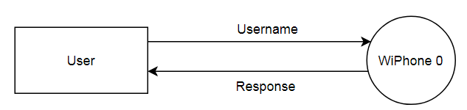

**Level 1**

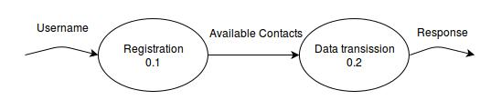

**Level 2**

**LEVEL 2.1** (REGISTRATION)

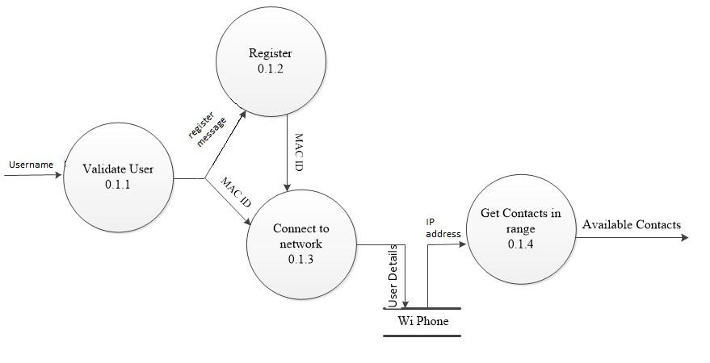

**LEVEL 2.2** (REGISTRATION)

