**WiPhone**

(MOBILE AD HOC NETWORK IMPLEMENTATION FOR ANDROID SMARTPHONES)

**User Interface Designs**

1. **Login User**

Username

**START**

1. **Register User / Enable service**

:

.

**Username: XXXXXXX**

Enable service to connect / visible to other devices

Enable service

1. **Searching Available Contacts**

**CONTACTS**

**SELECT A CONTACT**

Contact 1

Contact 2

Contact 3

Contact 4

Contact 5

Contact 6

**Username: XXXXXXX**

1. **Sending and receiving data**

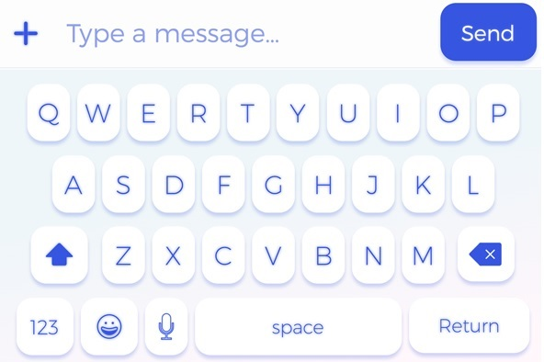

How are you?

Good Morning

Hi

XXXXXX

1. **History**

XXX_6c4d6d7f8c9x

: I’m fine

09/09/22

YYY_5c4d7d7f8c2w

: yes

10/09/22

ZZZ_8c4d6d7v8c9d

: I will be there

11/09/22

1. **Calling**

**Calling**

**xxxxxxxxxxx**

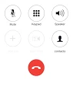

1. **Incoming Call**

Incoming

YYYYYYYYYYYYYY



1. **Disable service / Refresh contact**

Refresh

Disable service

bxs

:



Contact 1

Contact 2

Contact 3

Contact 4

Contact 5

Contact 6

**Username: XXXXXXX**