

St. JOSEPH'S INSTITUTE OF TECHNOLOGY
(St. Joseph's Group of Institutions)
DEPARTMENT OF INFORMATION TECHNOLOGY

MINI PROJECT REPORT

RESTAURANT MANAGEMENT SYSTEM

GUIDE | : MR. M.KARTHI.,M.TECH
STUDENTS | : 1. G.RATHI DEAVI  2. G.SONA

Signature of Guide Signature of HOD

ABSTRACT

The Online Restaurant Management System permits the clients globally to reserve the rooms,party halls,dinner tables in the hotel at any time. It will provide a unique search and book functionally for the customers anywhere in the world. This project can be used by the clients and the travel agencies who will help them to reserve the hotel of their choice. Sometimes people face problem in reserving the hotels in the places where they want to visit. In that situation, this project can be of great relief to them. The user interface must be simple and easy to understand even by the common man.

The purpose of Restaurant Website is to automate the existing manual system by the help of the computerized equipments and fully-fledged computer software,fulfilling their requirements,so that their valuable data/information cn be stored for a longer period with easy accessing and manipulation of the same.The required hardware and software are easily available and easy to work with.

Restaurant Website,as described above,can lead to error free,secure,reliable and fast management system.It will help in better organization in better utilization of resources.It can maintain computerized records for the betterment of the clients.It describes how to manage for good performance and better services for the clients.

TABLE CONTENTS

Chapter 1 - Introduction

1.1 Objective
1.2 Scope of the project

Chapter 2 - System Analysis

2.1 Present System
2.2 Proposed System

Chapter 3 - System Requirements

3.1 Software Requirements

Chapter 4 - System Design

4.1 Screens

Chapter 5 - Implementation

5.1 Source code

Chapter 6 - Conclusion

CHAPTER 1
INTRODUCTION

  - OBJECTIVE

The main objective of the project on Restaurant Website is to manage
the details of restaurant booking,tables,menu,facility.The project is totally built at administrative end and thus only the administrator is guaranteed the access.The purpose of the project is to build the website to reduce the manual work for managing the restaurant,booking,client.It tracks all the details about the menu,booking,facility

  - SCOPE OF THE PROJECT
It may help collecting perfect management in details.In a very short time,the collection will be simple and sensible.It will help a person to know the management of passed year perfectly and vividly.It also helps in current all works relative to restaurant websites.It will be also reduced the cost of collecting the management &collection procedure will go on smoothly.
Our project aims at Business process automation,i.e., we have tried to computarize various processess of restaurant websites.
In computer system the person has to fill the various forms & number of copies of the form can be easily generated at a time.
In computer system,it is not necessary to create the manifest but we can directly print it,which saves our time.
- To assist the size in capturing the effort spent on their respective working areas.
- To utilize resources in an efficient manner by increasing their productivity through automation.
- The system generates types of information that can be used for various purposes.
- It satisfy the user requirements.
- Be easy to understand by the user and operator.
- Be easy to operate.
- Have a good user interface.
- Be expandable.
- Delivered within the budget.

CHAPTER 2
SYSTEM ANALYSIS

2.1 PRESENT SYSTEM:
There are certain features limiting the process of the present system.
- The transactions are executed in off-line mode,hence on-line data for booking capture and modification is not possible.
- Off-line reports of restaurants,facility cannot be generated due to batch mode execution.

2.2 PROPOSED SYSTEM:
- System needs store information about new food items in restaurant.
- System needs to help the internal staff to keep information of table and find them as per various queries.
- System needs to maintain quantity record.
- System needs to keep the record of category.
- System also needs a search area.
- System needs to update and delete the record.

CHAPTER 3

SYSTEM REQUIREMENTS

3.1 SOFTWARE ENVIRONMENT:

Software Environment is a technical specification of requirement of software product. This specifies the environment for development, operation and maintenance of the product.

Requirements software and Hardware:
- HTML
- CSS
- PHP
- MYSQL
- JAVASCRIPT
- XAAMP

CHAPTER 4
SYSTEM DESIGN

4.1 SCREENS:

HOMEPAGE:
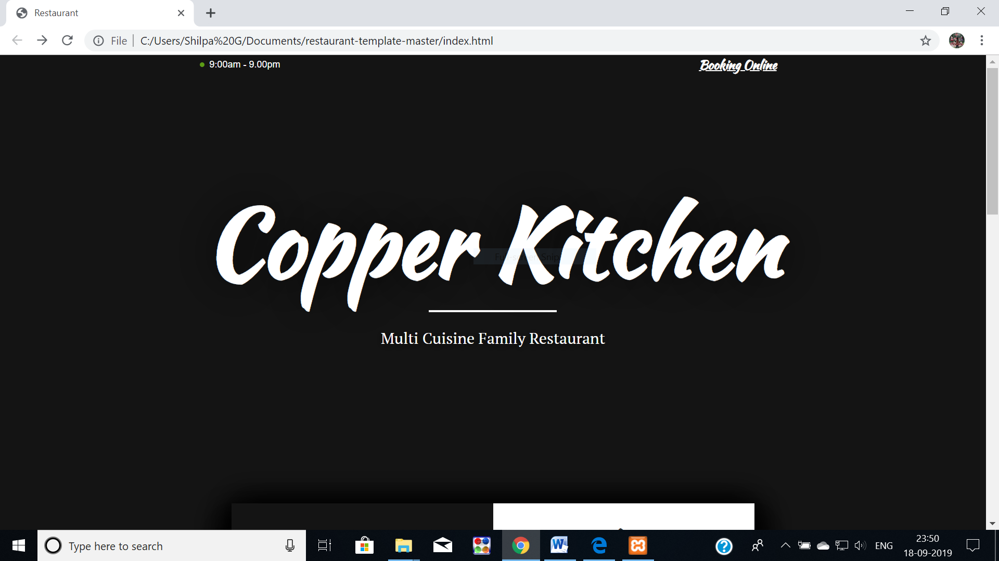

The above page is the frontend home design of the restaurant using html and css.
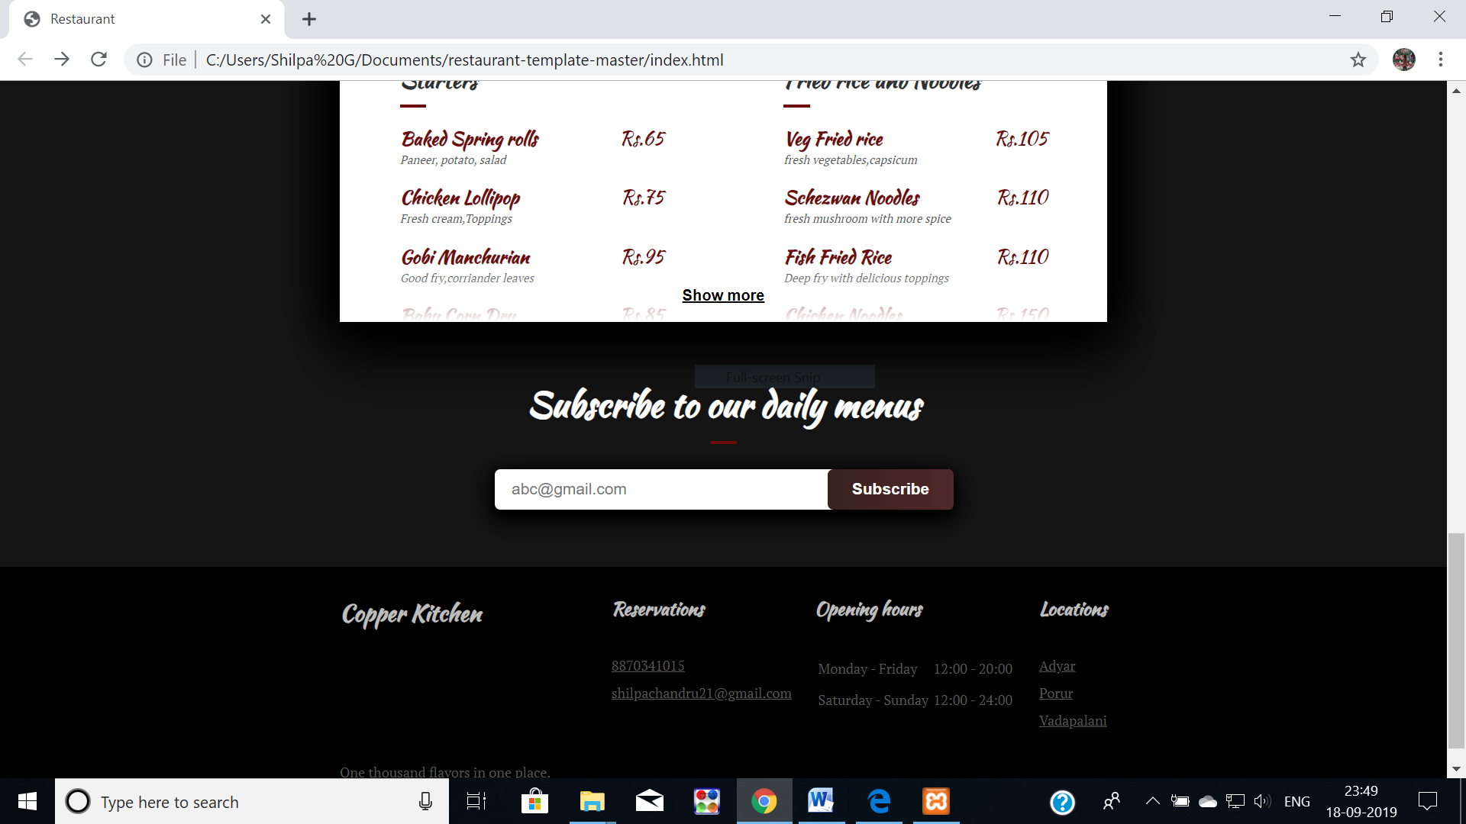

The above page is the further data included in the webpage like menu,cost of food items,footer.

RECORD UPDATION:

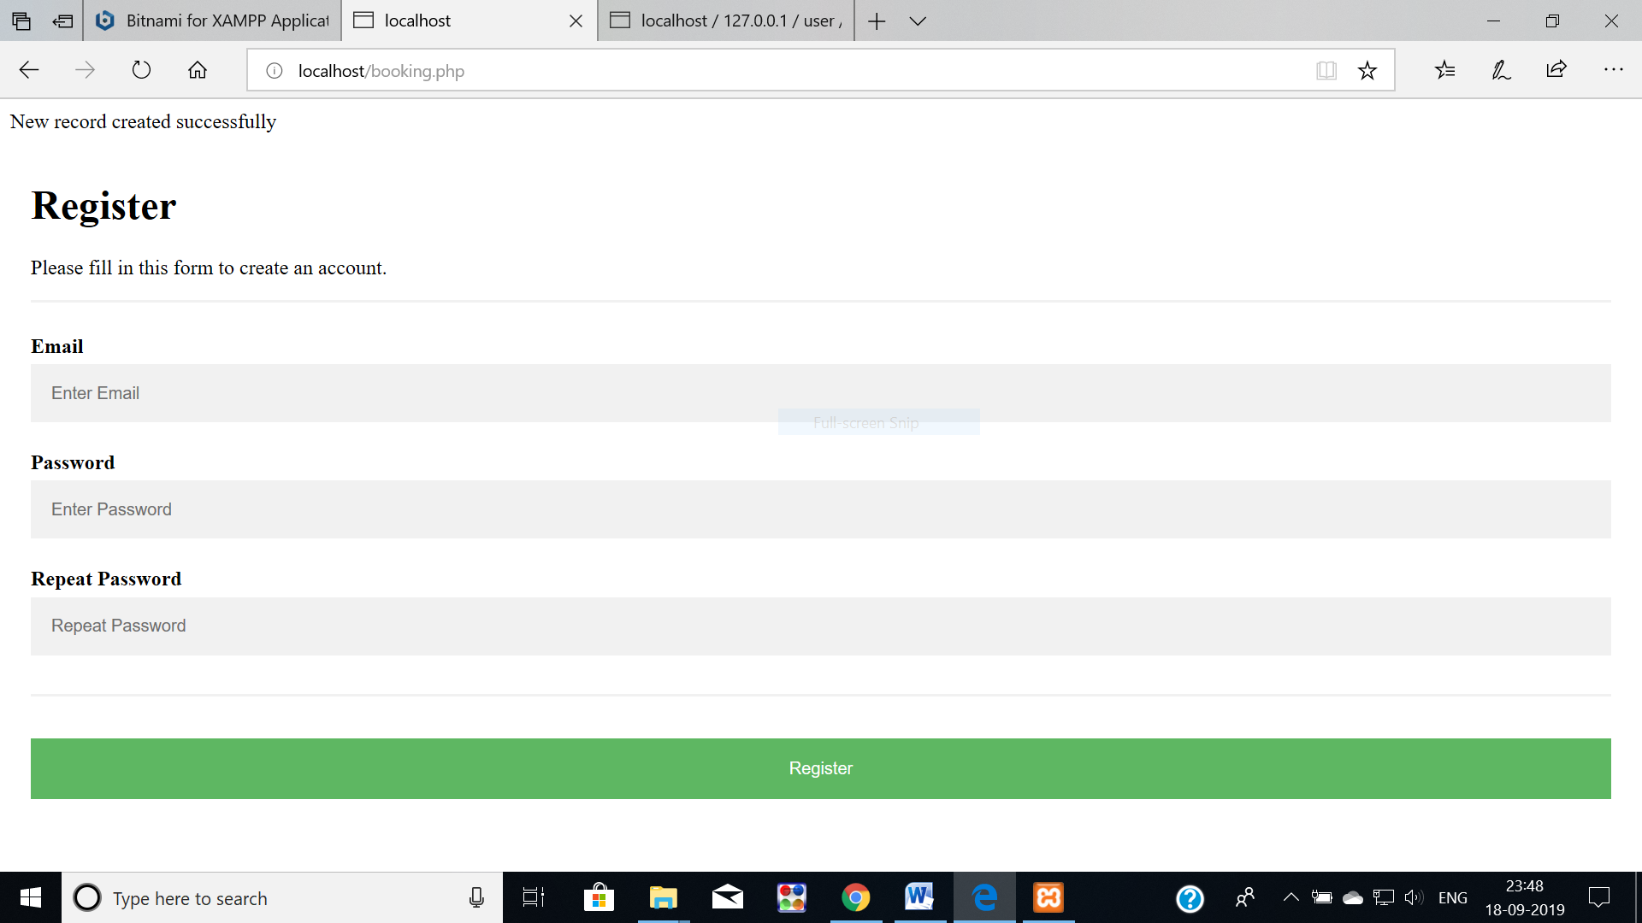

The above registration form helps the clients to get registered in our restaurant for booking tables,party halls etc.

UPDATE CONFIRMATION:

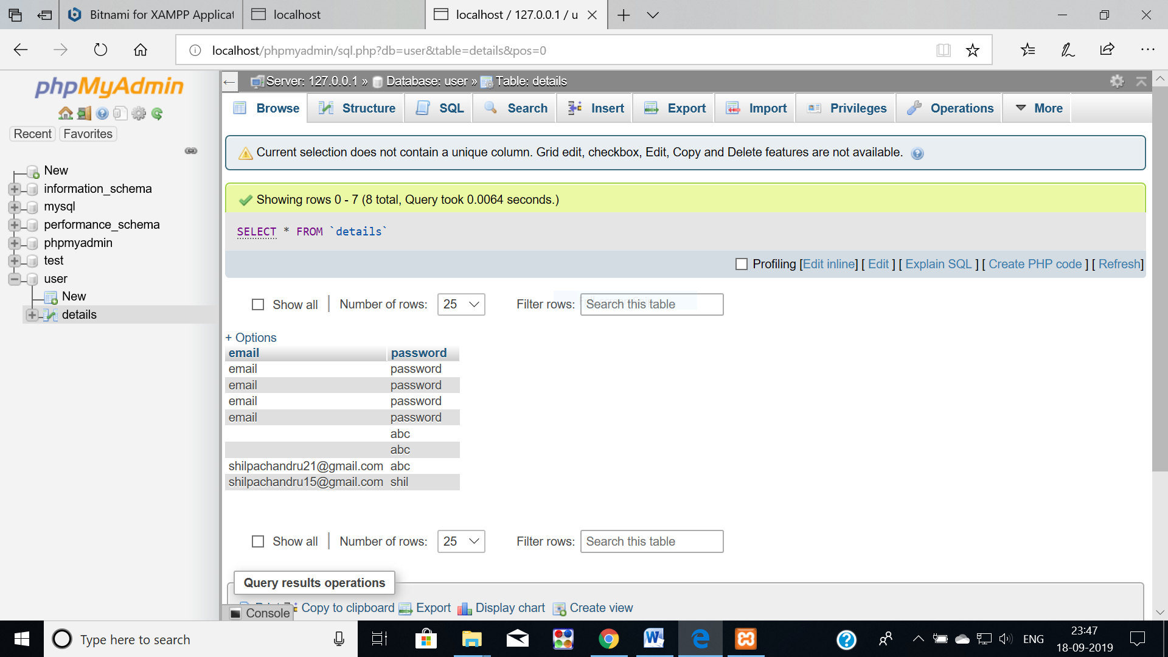

The email and the password being entered in the register form is successfully updated/stored in the database using php/xaamp.

CHAPTER 5

IMPLEMENTATION

5.1 SOURCECODE:
Index.html
<!DOCTYPE html>
<html lang="en">
<head><meta charset="utf-8">
<title>Restaurant</title>
<meta name="Copper Kitchen" content="Restaurant">
<link href="https://fonts.googleapis.com/css?family=Kaushan+Script|PT+Serif" rel="stylesheet">
<link rel="stylesheet" type="text/css" href="css/style.css">
<meta name="viewport" content="width=device-width, initial-scale=1">
<meta name="theme-color" content="#141414" />
<meta name="description" content="Copper Kitchen - Multi Cuisine Restaurant.Official website with menu, gallery and contacts">
</head>
<body>
<div class="top">
<p class="top__hours">9:00am - 9.00pm</p>
<a href="Booking.html"> <font color="white"><h4>Booking Online</h4></font> </a> </div><header class="intro"><h1 class="brand"> Copper Kitchen</h1>
<p class="intro__text">Multi Cuisine Family Restaurant</p></header>
<section class="degustation">
<img src="/restaurant-template/images/gourmet.jpg" alt="">
<div class="degustation__label gourmet"><h2 class="after--middle">About</h2>
<p class="degustation__text">COPPER KITCHEN,welcomes you to a splendid and memorable dining experience in the truest sense of the word with Great Food, Grand Ambience and an Unmatched Service. </p>
</div><div class="degustation__label bonjour">
<h2 class="after--middle">Speciality</h2>
<p class="degustation__text">Listed as one of the best Multi Cuisine Restaurant in Chennai COPPER KITCHEN offers wonderful Arabian, Chinese, Indian and Tandoor delicacies using only the finest, freshest ingredients.COPPER KITCHEN serves you Lunch and Dinner buffet with unmatched spreads in arabian barbeque starters and main course of veg, non veg and seafood.Our full fledged Home Delivery team brings our delicious food at your door step.</p>
</div> <img src="/restaurant-template/images/bonjour.jpg" alt="">
</section><section class="menu shaded">
<h2 class="menu__title">Menu</h2><div class="category">
<h3 class="category__title after--left">Starters</h3>
<div class="menu__item">
<strong class="item__title">Baked Spring rolls</strong>
<span class="price">Rs.65</span>
<p class="ingredients">Paneer, potato, salad</p></div>
<footer>
<div class="footer__block footer__locations"><h4>Locations</h4>
<a href="chennai.html">Adyar</a>
<a href="porur.html">Porur</a>
<a href="vadap.html">Vadapalani</a></div>
</div><p class="copyright">One thousand flavors in one place.</p>
</footer></body></html>

Style.css
html, body { padding: 0;
margin: 0; }
body {
font-family: "PT Serif", serif;
background-color: #141414;
}
h2, h3 {
font-family: "Kaushan Script";
color: #313131;
}
h2 {
font-size: 30px;
text-align: center;
}
h3 {
font-size: 20px;
}
h4 {
font-family: "Kaushan Script";
font-size: 16px;
}
input:focus {
outline: none !important;
}
button:focus {
outline: none; }
.after--middle {
position: relative;
}

BOOKING.PHP
<?php
$conn = mysqli_connect("localhost", "root", "", "user");
if (mysqli_connect_errno()) {
print_r(mysqli_connect_error());
exit();
}
if($_SERVER["REQUEST_METHOD"] == "POST") {
$email = mysqli_real_escape_string($conn,$_POST['email']);
$password = mysqli_real_escape_string($conn,$_POST['password']);
$sql = "INSERT INTO details (email, password) VALUES ('$email', '$password')";
if ($conn->query($sql) == TRUE) {
echo "New record created successfully";
} else {
echo "Error: " . $sql . "<br>" . $conn->error;
}}$conn->close();
?>

CHAPTER 6
CONCLUSION AND FUTURE SCOPE

This project has given me an ample opportunity to design, code, test and implements an application. This has helped in putting into practice of various Software Engineering principles and Database Management concepts like maintaining integrity and consistency of data records.Several user friendly coding have also adopted.

FUTURE SCOPE:
In a nutshell,it can be summarized that the future scope of the project circles around maintaining information regarding:
- We can give more advance software for restaurant website including more facilities.
- We will host the platforms on online servers to make it accessible worldwide.
- Integrate multiple balancers to distribute the loads of the system.
- Implement the backup mechanism for taking backup of codebase and database on regular basis on different servers.

