# Software Requirements

*Specification*

# –

**Document ID:** ASP-CMS-SRS-02.doc

**Author(s): SHATHYASHRI M K**

**Version:** 0.2

**Date:** November 10, 2022

**Confidential 1**



**Copyright notice:** Copyright © 1996-2004 Aspire Systems. All rights reserved. The contents on this document are not to be reproduced or duplicated in any form or kind, either in part or full, without written consent from Aspire Systems.

1. **Introduction 3**
   1. Objective and scope 3
   2. Module Requirements 3
2. **Functional requirements 4**
   1. Login 4
   2. User 4
   3. Attendance
   4. Event details
   5. Courses 4

1. **Diagrams 6**
   1. Flow diagram 6
   2. Use case 7
   3. Class diagram 8
   4. ER diagram
   5. Sequence diagram 9
2. **Reports 9**
3. **Introduction**

The world has become digital. The education system also has evolved digitally enabling distance education. There are so many portals that are available to students for their engagement in their academics, also to make education an enjoyable one. The only resource for learning and educating ourselves during the pandemic was online schooling. Many colleges educated their students using different forms of online learning. We have developed our website, "Student portal of College," to address problems with college-level online learning that may be brought on by a dearth of interaction between mentors and students.The term "student portal" is frequently used to refer to the login page where students enter their username and password to access the programs and other learning-related resources of an educational organization. Our website's main goal is to assist students in obtaining an education despite being in challenging circumstances and far-off locations.In a world where education is primarily computerized, a student portal is crucial. as it consolidates all announcements, data, and tools pertaining to colleges. Additionally, it allows students to handle fewer accounts because everything related to college can be taken care of in one place.

* 1. **Objective and Scope**

“Student attendance Management System” is software developed for maintaining the attendance of the student on a daily basis in the college/school. Here the staff, who are handling the subjects, will be responsible to mark the attendance of the students. Each staff member will be given a separate username and password based on the subject they handle. An accurate report based on the student attendance is generated here. This system will also help in evaluating attendance eligibility criteria of a student. Report of the student’s attendance on a weekly and monthly basis is generated.

* 1. **Module Requirements**
     + Admin
     + Staff
     + Student

1. **Functional requirements**
   1. **Login**

After registration one can log in to the system as the operator of the system on the behalf of the user. The user will get only those privileges that are given to the user for which one has registered. For example, if a user has registered as a student, then the user only has the privileges to view the data and cannot make any changes to the data.

* 1. **User**

The user can be anyone either a student or a teacher. If the user is a teacher, then the interface that is shown is different from the one that is shown to the students. Like teachers can mark attendance and can also rectify it but students can only view attendance. Teachers can detain a student if the fees are not paid on time but students can only view the detailed message and reason. Teachers can upload the result of the students but students cannot upload their results. Teachers can choose the sections they want to teach but students’ sections can only be selected by teachers based on their results.

* 1. **Attendance**

This module is only present in the teachers’ interface but not in the students’ interface. Teachers can mark the attendance by selecting the section they want to take attendance for. Teachers can also rectify the attendance of a student if it is marked incorrect by chance of any student. Students can only view their attendance if they are not detained for any reason. The marked attendance can only be rectified within a week, after that it cannot be rectified.

* 1. **Event Details**

Event details module provides various event details like conference,paper presentation.The module provides the details with accuracy based on the preferences chosen bu the user.This details could be accessed by Staff and students.

* 1. **Courses**

Courses being an important feature to the project,study materials like books,videos are displayed to the students in this section.

1. **Diagram**

**Flowchart**

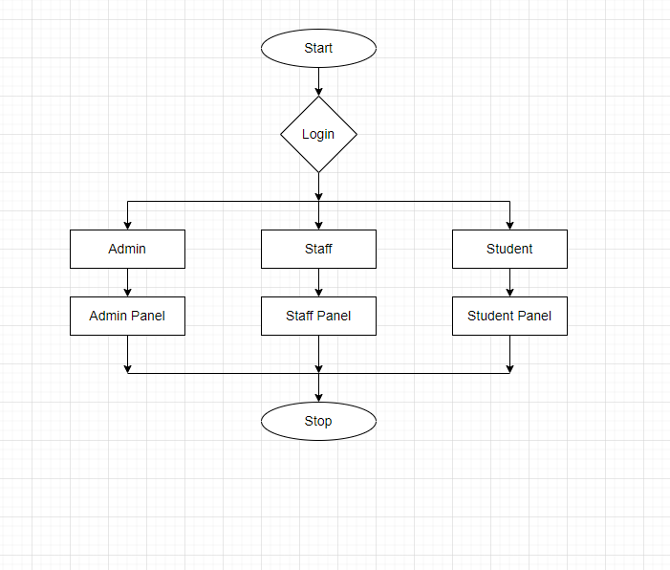

* 1. **Use case**

**Admin panel:**

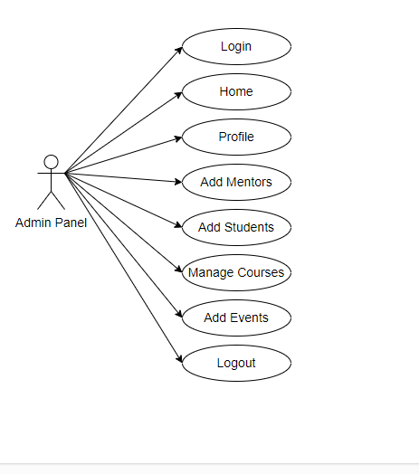

**Staff panel:**

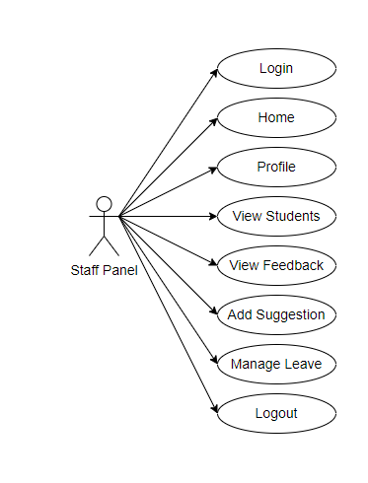

**Student panel:**

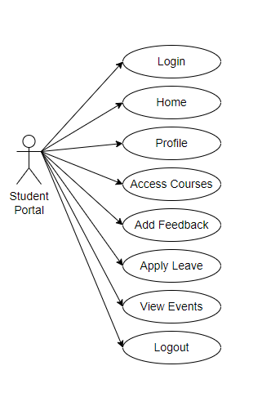

* 1. 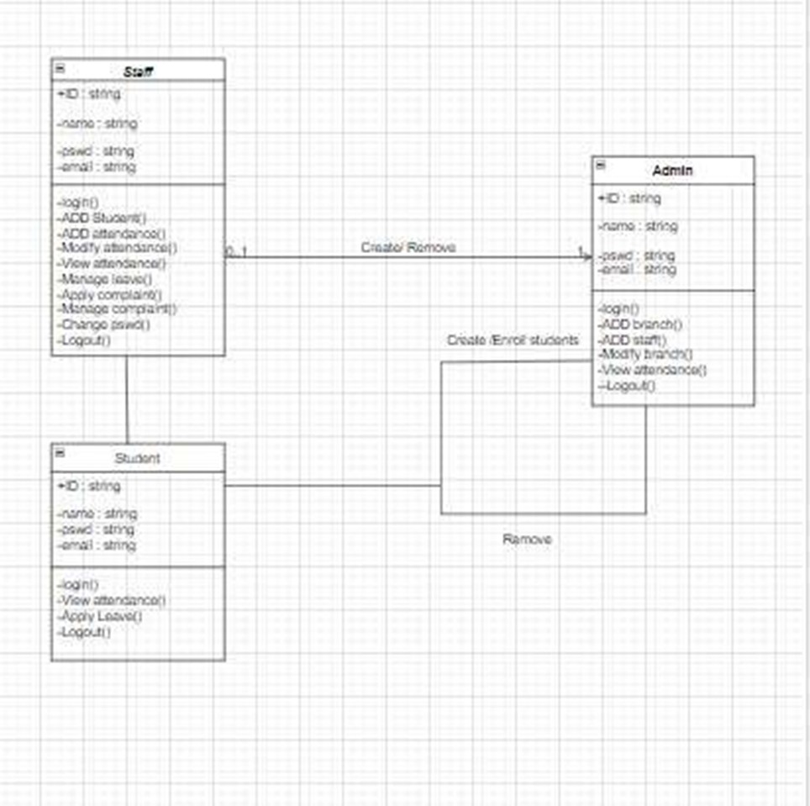**Class Diagram**
  2. **ER Diagram**

The major features of the employee management database system as shown in below

**entity–relationship model (ER model**).

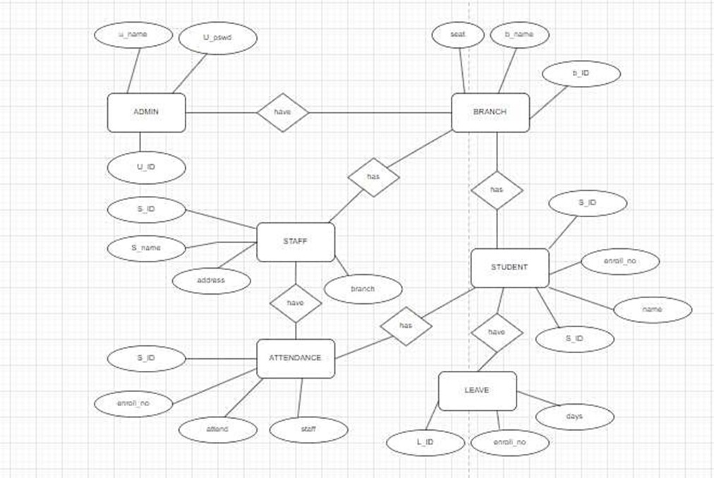

* 1. **Sequence Diagram**

The sequence of the Students’ portal’s attendance module is shown in the below diagram.

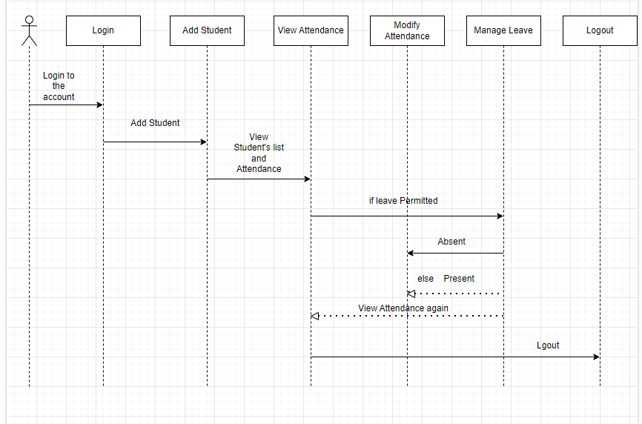

**4. Reports**

This system has reporting capabilities. It shows the students report of leave , students report of attendance , Adding a new student and removing the old student by the Admin . It also manages the leave system of students and the admin & helps in managing the whole students attendance system.