1. Write a query to display the name (first_name, last_name) and salary for all employees whose salary is not in the range $10,000 through $15,000.

+-------------+-------------+-------------+----------+--------------------+------------+------------+----------+----------------+------------+---------------+

| EMPLOYEE_ID | FIRST_NAME | LAST_NAME | EMAIL | PHONE_NUMBER | HIRE_DATE | JOB_ID | SALARY | COMMISSION_PCT | MANAGER_ID | DEPARTMENT_ID |

+-------------+-------------+-------------+----------+--------------------+------------+------------+----------+----------------+------------+---------------+

| 100 | Steven | King | SKING | 515.123.4567 | 1987-06-17 | AD_PRES | 24000.00 | 0.00 | 0 | 90 |

| 101 | Neena | Kochhar | NKOCHHAR | 515.123.4568 | 1987-06-18 | AD_VP | 17000.00 | 0.00 | 100 | 90 |

| 102 | Lex | De Haan | LDEHAAN | 515.123.4569 | 1987-06-19 | AD_VP | 17000.00 | 0.00 | 100 | 90 |

| 103 | Alexander | Hunold | AHUNOLD | 590.423.4567 | 1987-06-20 | IT_PROG | 9000.00 | 0.00 | 102 | 60 |

| 104 | Bruce | Ernst | BERNST | 590.423.4568 | 1987-06-21 | IT_PROG | 6000.00 | 0.00 | 103 | 60 |

| 105 | David | Austin | DAUSTIN | 590.423.4569 | 1987-06-22 | IT_PROG | 4800.00 | 0.00 | 103 | 60 |

| 106 | Valli | Pataballa | VPATABAL | 590.423.4560 | 1987-06-23 | IT_PROG | 4800.00 | 0.00 | 103 | 60 |

| 107 | Diana | Lorentz | DLORENTZ | 590.423.5567 | 1987-06-24 | IT_PROG | 4200.00 | 0.00 | 103 | 60 |

| 108 | Nancy | Greenberg | NGREENBE | 515.124.4569 | 1987-06-25 | FI_MGR | 12000.00 | 0.00 | 101 | 100 |

| 109 | Daniel | Faviet | DFAVIET | 515.124.4169 | 1987-06-26 | FI_ACCOUNT | 9000.00 | 0.00 | 108 | 100 |

| 110 | John | Chen | JCHEN | 515.124.4269 | 1987-06-27 | FI_ACCOUNT | 8200.00 | 0.00 | 108 | 100 |

| 111 | Ismael | Sciarra | ISCIARRA | 515.124.4369 | 1987-06-28 | FI_ACCOUNT | 7700.00 | 0.00 | 108 | 100 |

| 112 | Jose Manuel | Urman | JMURMAN | 515.124.4469 | 1987-06-29 | FI_ACCOUNT | 7800.00 | 0.00 | 108 | 100 |

| 113 | Luis | Popp | LPOPP | 515.124.4567 | 1987-06-30 | FI_ACCOUNT | 6900.00 | 0.00 | 108 | 100 |

| 114 | Den | Raphaely | DRAPHEAL | 515.127.4561 | 1987-07-01 | PU_MAN | 11000.00 | 0.00 | 100 | 30 |

| 115 | Alexander | Khoo | AKHOO | 515.127.4562 | 1987-07-02 | PU_CLERK | 3100.00 | 0.00 | 114 | 30 |

| 116 | Shelli | Baida | SBAIDA | 515.127.4563 | 1987-07-03 | PU_CLERK | 2900.00 | 0.00 | 114 | 30 |

| 117 | Sigal | Tobias | STOBIAS | 515.127.4564 | 1987-07-04 | PU_CLERK | 2800.00 | 0.00 | 114 | 30 |

| 118 | Guy | Himuro | GHIMURO | 515.127.4565 | 1987-07-05 | PU_CLERK | 2600.00 | 0.00 | 114 | 30 |

| 119 | Karen | Colmenares | KCOLMENA | 515.127.4566 | 1987-07-06 | PU_CLERK | 2500.00 | 0.00 | 114 | 30 |

| 120 | Matthew | Weiss | MWEISS | 650.123.1234 | 1987-07-07 | ST_MAN | 8000.00 | 0.00 | 100 | 50 |

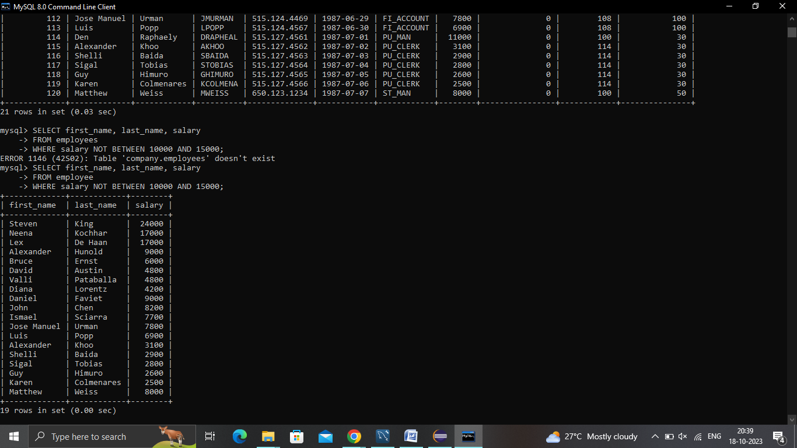

2.Write a query to display the name (first_name, last_name) and hire date for all employees who were hired in 1987.

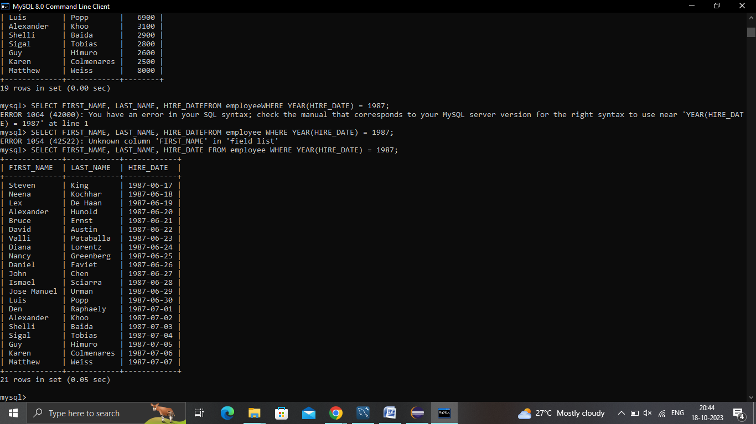

1. Write a query to list the number of jobs available in the employees table.

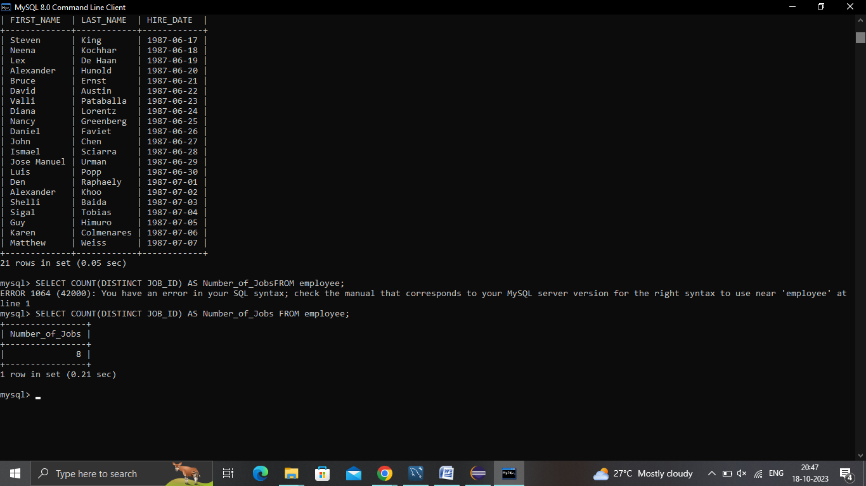

1. Write a query to get the total salaries payable to employees.

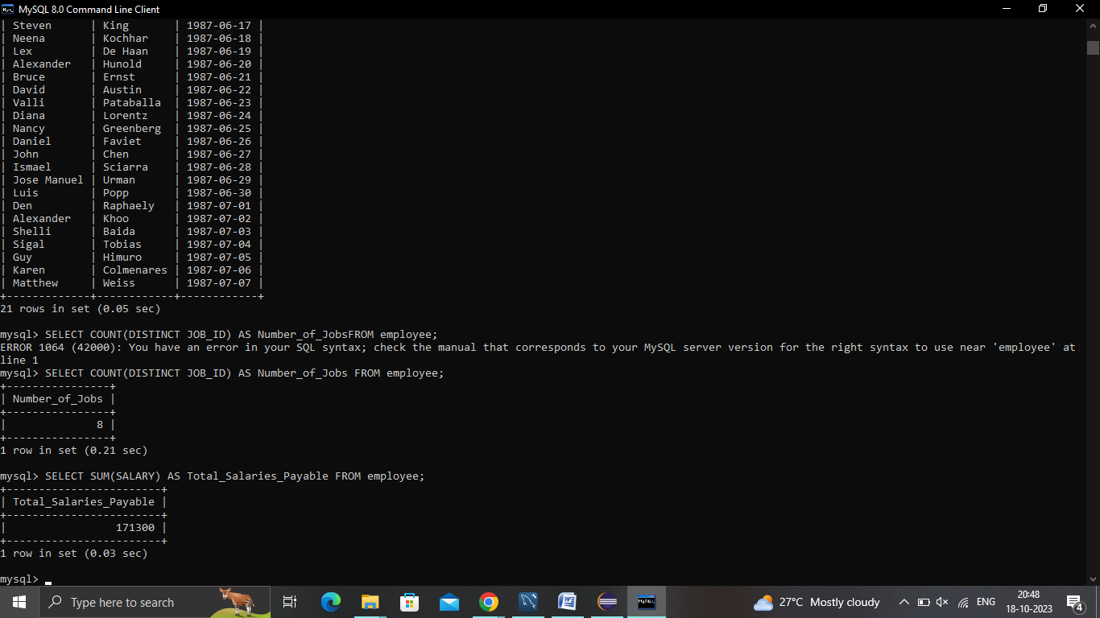

1. Write a query to get the minimum salary from employees table.

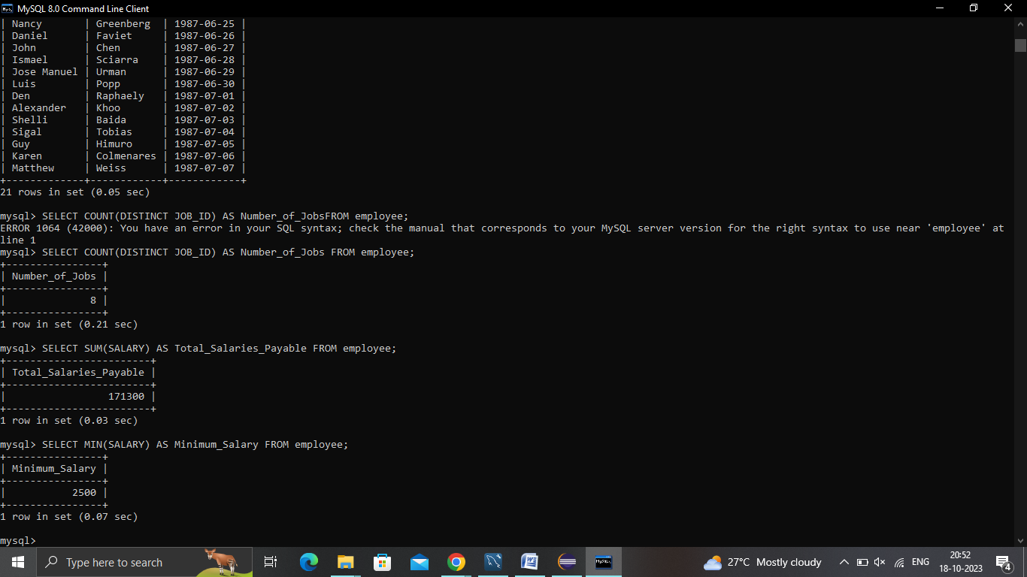

1. Write a query to get the maximum salary of an employee working as a Programmer.

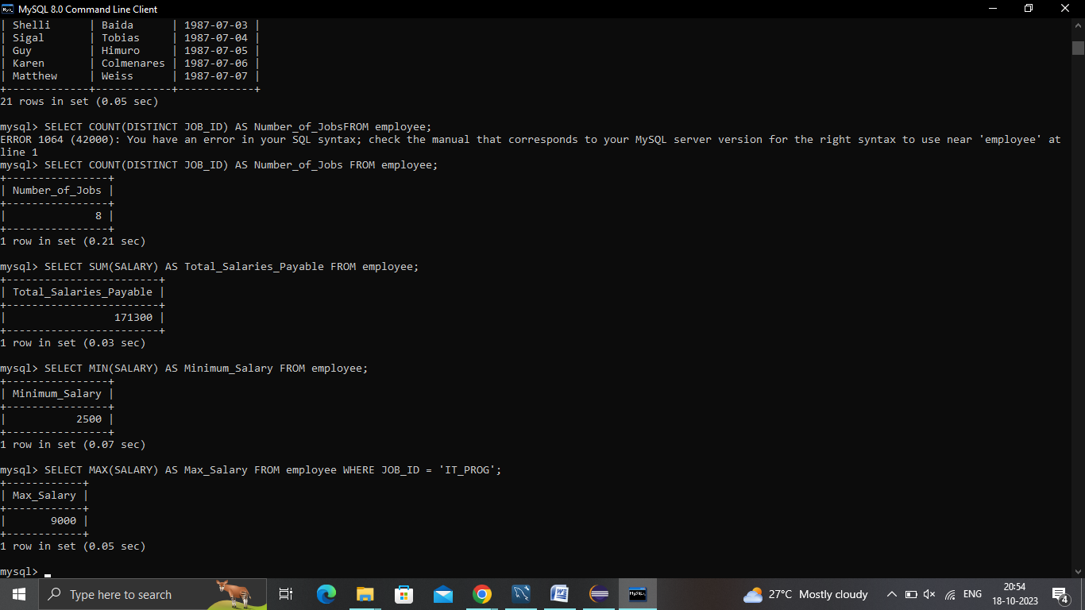

1. Write a query to get the average salary and number of employees working the department 90

