FitTrack AI
Intelligent Exercise Logging & Coaching API
Project Documentation & Build Manual
Node.js • Express • MongoDB • JWT • Gemini AI

FitTrack AI
Intelligent Exercise Logging & Coaching API
Project Documentation & Build Manual
Node.js • Express • MongoDB • JWT • Gemini AI

Executive Summary
FitTrack AI is a server-side application that lets people record their exercise sessions in one safe place and receive smart coaching based on what they have done. It is written in Node.js with the Express framework and stores its data in MongoDB through the Mongoose library. The service publishes REST endpoints covering sign-up and sign-in, exercise log management, log lookup, and AI-driven advice.
Internally, the code is divided using the Model-View-Controller approach so every part can be changed or extended without disturbing the others. Access control relies on JSON Web Tokens: after login the client receives a token, and a middleware checks it on every private route. Passwords are never saved in plain form; they are hashed with bcrypt.js first.
Coaching is powered by Google Gemini. When given a person's age, target and training experience, it drafts a suitable plan. When given overall statistics such as session count, mean duration and calories spent, it writes a short performance review.
Every response uses the same JSON format, so web pages, phone apps and other services can plug in easily. Validation checks, guarded routes, reusable services and central error handling keep the system stable and easy to grow.

Problem Statement & Motivating Scenario

Scenario Background
Consider Rahul, who works out several times a week and writes each session in a notebook or spreadsheet. He is disciplined, yet his records are scattered, he cannot easily see whether he is improving, and he is unsure if his current routine matches what he wants to achieve. Nobody is around to tell him which exercises fit his ability

Pain Points Identified
- Exercise records are spread across different notebooks and files.
- Hand-written logs contain mistakes, so history cannot be trusted.
- Nothing protects private fitness data with a login.
- Finding an older session takes too long.
- There is no advice tailored to the individual.
- There is no summary of overall progress.
- Working out calories and time totals by hand is tedious.

Functional Walkthrough

Client-Side Operations
A visitor first creates an account and afterwards logs in using an email and password. Successful login returns a JWT that unlocks the private endpoints.
With that token, the person can:
- Create a new exercise entry.
- List every session completed so far.
- Open one session by its unique ID.
- Edit the details of a saved session.
- Delete entries that are not needed.
- Look up sessions by title, type or date.
- Ask the AI for a suggested training plan.
- Ask the AI to review their activity numbers.

Intelligent Assistance Workflow
A separate service layer connects the application to Gemini. To get a training plan, the person provides:
- Their age
- Their main fitness target
- Their training experience
The AI answers with:
- A plan built around the individual
- Exercise ideas spread across the week
- Advice matched to beginner, intermediate or advanced ability
- Encouraging remarks
- Precautions to stay safe
To get a performance review, the person sends their totals:
- Number of sessions completed
- Mean session length
- Overall calories spent
The AI studies the numbers and replies with a personal assessment

Benefits & Roadmap
The platform ends paper-based logging and adds coaching that reflects each person's real activity. Login protection means workout data can only be seen by its owner, and the AI helps people refine what they do.

Tools, Platforms & Infrastructure Needs

Software Environment
The tools below are needed for building and running the project. It works the same on Windows 10/11, macOS and Linux.
Tool / Technology | Role in the Project
Node.js (v16+) | Runs the JavaScript code on the server.
npm (v8+) | Installs and manages libraries the project depends on.
Express.js | Minimal framework used to define the REST endpoints.
MongoDB | Document database holding accounts and exercise logs.
Postman | Client for sending test requests and checking responses, including private routes.
Code editor | Visual Studio Code or a similar development environment.

Recommended Machine Configuration
- CPU: Intel Core i5 (8th gen or higher), AMD Ryzen 5 or an equivalent chip.
- Memory: 8 GB at minimum, with 16 GB preferred if MongoDB, the server and other tools run together.

Module 1: Solution Blueprint

High-Level Design
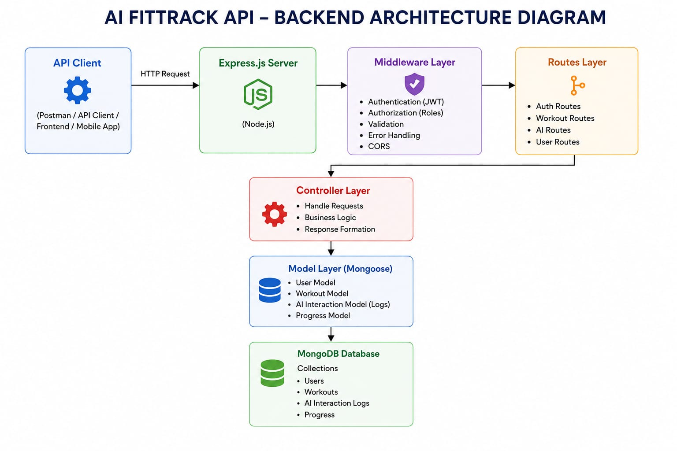

The system is arranged in layers following the MVC pattern. Routing, logic, data access, middleware and AI integration each sit in their own module, which makes the code simpler to look after and expand.
A request begins at the client and lands on the Express server, which passes it to the correct route. On private routes the token-verification middleware runs first. Next, a controller takes over and, when needed, calls a service or the AI layer. Mongoose models perform all reads and writes, and Gemini is contacted through its own service. The controller finally sends back a uniform JSON reply.
Because each piece has a single job, the design is easier to secure, test and evolve.

Building Blocks
- Consumer application (React, mobile app or Postman)
- Express server
- API routes
- Token-verification middleware
- Controllers
- Services
- Gemini AI service
- MongoDB database
- Mongoose models
The blocks talk to each other through clear interfaces, so one can be replaced or upgraded without breaking the rest.

Layer-wise Responsibilities
Each layer is responsible for one concern. A request moves through them in order before touching the database or the AI service, which keeps handling secure and orderly.

1. Presentation / Consumer Tier
This is where every request starts. It can be a React site, a phone app or a testing utility like Postman. It sends HTTP calls and reads the JSON that comes back.
Duties:
- Issue API calls
- Show workout information
- Keep the JWT after sign-in
- Trigger the AI coaching and review endpoints
- Present results and error messages
Endpoints it uses: login and sign-up, exercise log operations, AI plan generation and AI review generation.

2. Application Server Entry Point
The Express server is the front door of the backend. It accepts incoming traffic, loads middleware, reads request bodies, allows cross-origin access and directs each call to its controller.
Duties:
- Launch the HTTP server
- Read JSON bodies
- Turn on CORS
- Mount the routes
- Plug in middleware
- Catch and format errors
In practice it receives the call, checks its shape, hands it to the router and finally returns JSON.

3. Token Verification Middleware
This component protects all private endpoints by checking the JWT. Any protected call has to include a valid Authorization header.
Duties:
- Read the Authorization header
- Pull out the token
- Check the token signature
- Decode the identity inside it
- Attach that identity to the request
- Turn away invalid callers
Why it matters:
- Stops anonymous access
- Keeps exercise data private
- Restricts private APIs to logged-in people
- Removes duplicate login checks from controllers

4. Endpoint Mapping
The routing layer lists the API paths and ties each HTTP call to the controller function that should answer it.
Module | Exposed Operations
Account access | Sign up, sign in, fetch profile
Exercise logs | Create entry, list entries, search entries, fetch by ID, edit entry, delete entry
AI coaching | Training plan suggestion, activity review

5. Request Handlers
Handlers (controllers) contain the working logic. They take what the router gives them, check the input, use services or the database, and shape a consistent JSON answer.
Handler | Scope of Work
Account Handler | Sign-up, sign-in and profile lookup
Exercise Handler | Creating, reading, editing, deleting and searching logs
AI Handler | Passing prompts to Gemini, collecting its answers and returning them to the caller

6. Shared Utilities
Utilities hold reusable logic that several handlers depend on.
Utility Service | Key Functions
Gemini Service | Compose prompts, send them to Gemini, receive replies and tidy the output
Token Service | Issue tokens, set their lifetime and confirm who is calling
Credential Service | Hash new passwords and compare them during sign-in

7. Persistence Tier
MongoDB keeps all long-term data. Mongoose, an Object Data Modelling (ODM) library, makes it easy for Node.js to read and write MongoDB.
Collections: accounts and exercise logs.
Strengths: adaptable schema, strong speed, simple querying and easy scaling.

Database Design & Entity Links
Two principal collections make up the data model, connected by a one-to-many link.
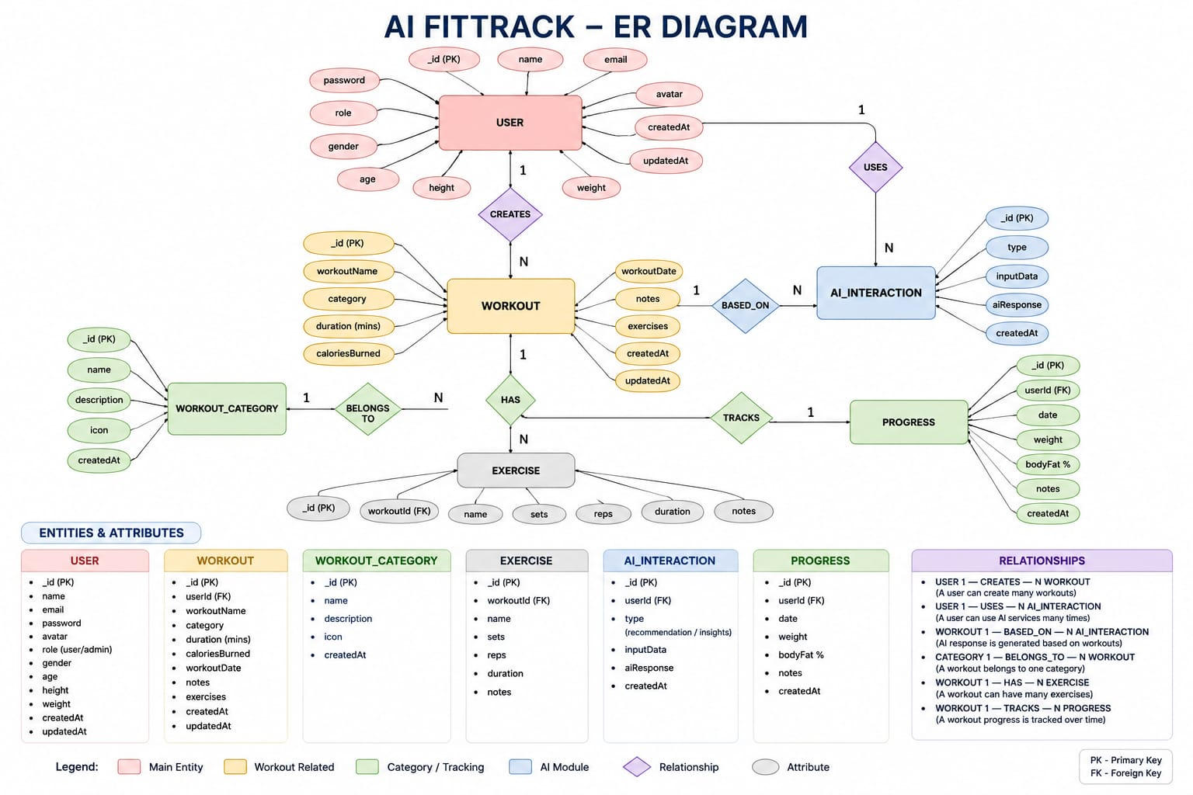

Account Entity
Holds sign-in and profile information.
Attribute | Data Format | Purpose
_id | ObjectId | Primary identifier
name | String | Display name of the person
email | String | Distinct email used to sign in
password | String | Hashed password
createdAt | Date | When the account was made
updatedAt | Date | When it was last changed

Rules:
- No two accounts may share an email.
- Passwords are hashed with bcrypt.
- A name must be provided.
- A JWT is issued once login succeeds.

Exercise Log Entity
Holds the sessions recorded by each logged-in person.
Attribute | Data Format | Purpose
_id | ObjectId | Primary identifier
user | ObjectId | Points to the owning account
workoutName | String | Title of the session
category | String | Type of exercise
duration | Number | Length in minutes
caloriesBurned | Number | Energy spent in calories
workoutDate | Date | Day the session took place
createdAt | Date | When the entry was saved
updatedAt | Date | When the entry was last edited

Account–Exercise Association
Cardinality: One-to-Many. A single account can own numerous exercise entries, but each entry has just one owner. For instance, "John Doe" might have Morning Running, Evening Jogging, Upper Body Strength and Cycling Session entries. The link is kept in the "user" attribute of the exercise schema, which stores the owner's ObjectId.

Functional Highlights
FitTrack AI delivers a full backend for logging workouts and receiving AI coaching.

1. Protected Sign-In
Token-based security that includes sign-up, sign-in, password hashing, token issuing and guarded endpoints.

2. Exercise Log Handling
Complete create, read, update and delete operations. Every entry is tied to the account that made it.

3. Log Lookup
Entries can be found by title, type or date, so older sessions are quick to retrieve.

4. Gemini-Powered Coaching
The backend asks Google Gemini for tailored training advice.
- Inputs: age, target, experience
- Outputs: weekly plan, exercise ideas, coaching tips, safety notes

5. AI Performance Review
The AI evaluates the person's activity totals.
- Inputs: session count, mean duration, calories spent
- Outputs: assessment, areas to improve, encouragement, progress recap

6. Unified Error Reporting
Readable JSON errors are sent for wrong credentials, absent tokens, failed validation, database faults and unexpected server problems.

7. REST-Style Interface
The API respects REST conventions, using GET, POST, PUT and DELETE, and answers in JSON.

8. Separated Code Structure
Code is split into models, controllers, routes, middleware, services and configuration for easier upkeep and growth.

Stakeholders & Permissions
The system currently recognises a single stakeholder: the logged-in person.

Logged-In Person: Duties
- Create an account
- Log in safely
- Look at profile details
- Add exercise entries
- Review past sessions
- Look up sessions
- Edit sessions
- Delete sessions
- Request AI training plans
- Request AI activity reviews

Permission Matrix
Action | Access Status
Sign up | Permitted
Sign in | Permitted
View profile | Permitted
Create entry | Permitted
List entries | Permitted
Search entries | Permitted
Edit entry | Permitted
Delete entry | Permitted
AI training plan | Permitted
AI activity review | Permitted

End-to-End Flow
The person signs up, logs in and gets a JWT. This token is sent with every later request, and the middleware confirms it. Approved requests move on to the exercise or AI handlers, which use the database or Gemini and send JSON back to the caller.

MVC-Based Structure
The application is built on the Model-View-Controller pattern. Dividing the logic into separate parts makes the code cleaner, easier to maintain and simpler to scale.
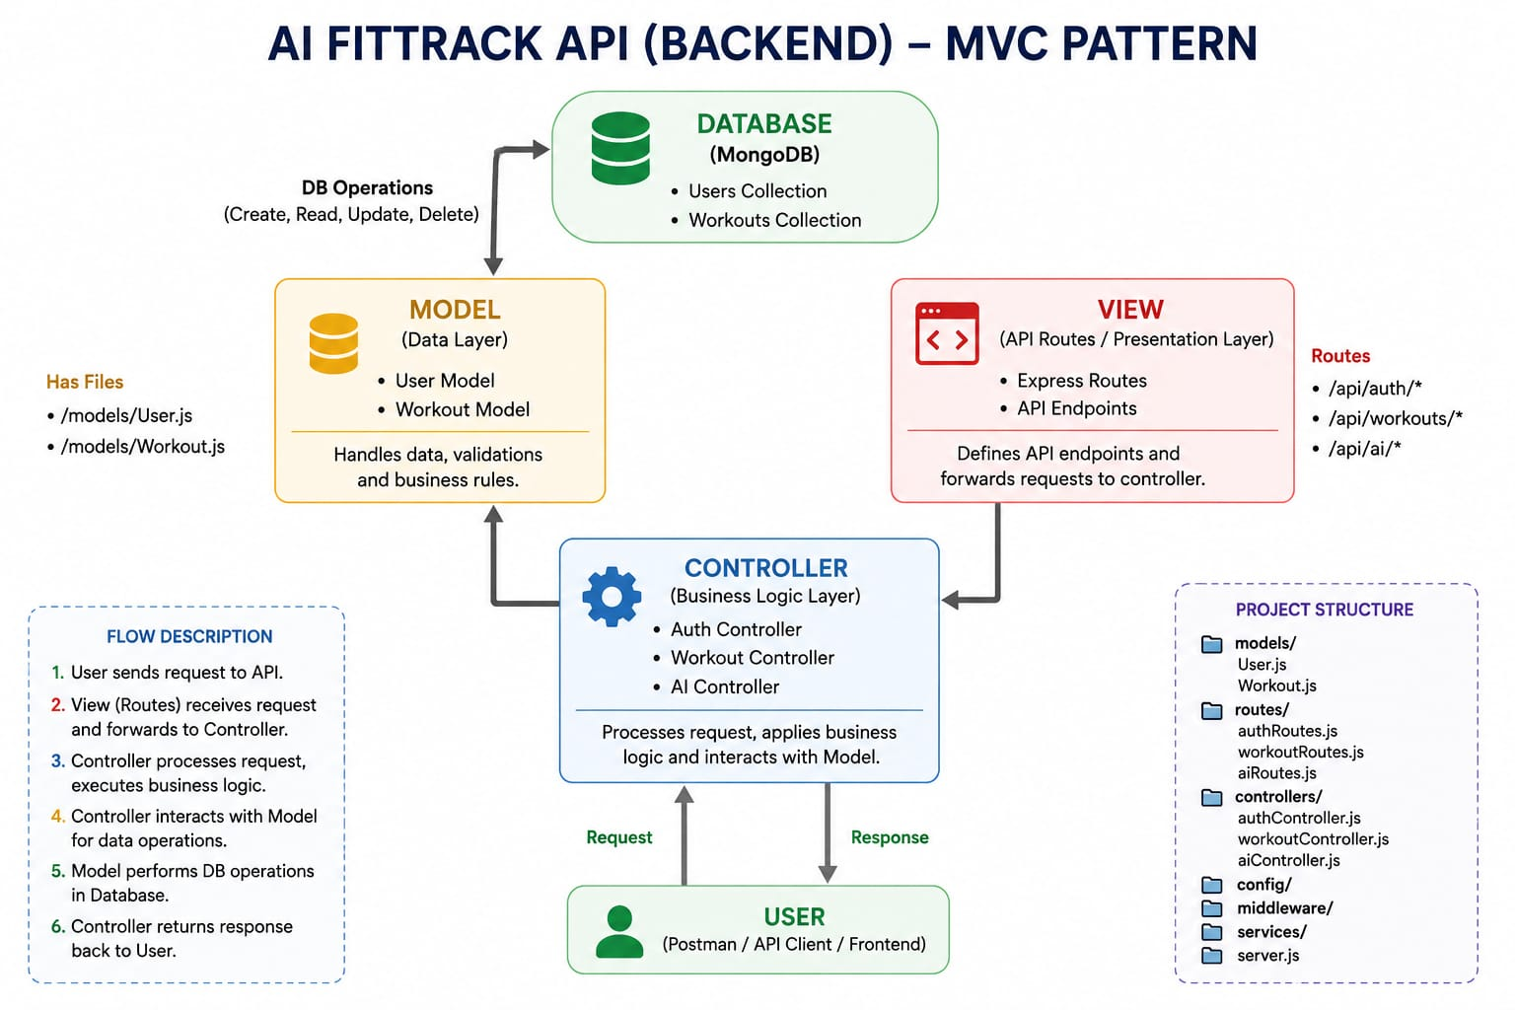

Model (Data Tier)
Models describe how data looks using Mongoose schemas and work directly with MongoDB. The project has an Account model and an Exercise Log model.
- Defining schemas
- Checking data validity
- Create/read/update/delete operations
- Mapping to collections

View (API Consumers)
As a pure REST backend, FitTrack AI has no page templates. Its "view" is whichever client calls it — a React site, a mobile app or Postman — which sends HTTP requests and reads JSON.
- Sending requests
- Reading JSON replies
- Showing data
- Managing client interaction

Controller (Logic Tier)
The controller stands between the view and the model. It receives requests, checks input, uses services and models, and returns structured JSON.
- Validating requests
- Running the business logic
- Working with the database
- Calling the AI service
- Building responses
Keeping these three tiers apart results in loose coupling, easier testing, clearer code and simple feature additions.

Module 2: Setup & Configuration
The project is laid out so that logic, routes, database work, middleware and AI services each have their own module. This helps readability, upkeep and growth, and makes troubleshooting easier.
It is built with Node.js and Express, uses MongoDB as the main database and depends on Google Gemini AI for coaching.

Workspace Preparation

Step 1: Make the main folder
Create a folder with this name:
AI-FitTrack-API

Step 2: Load it in the editor
Open that folder in Visual Studio Code.

Step 3: Add the server directory
Within the main folder, add a directory called "server". All backend code lives here.
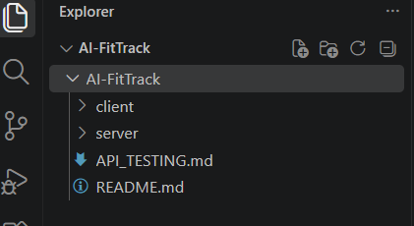

Step 4: Start the Node project
Open a terminal in the server directory and type:
npm init -y
This produces package.json, which records project details and dependencies.

Step 5: Add the libraries
npm install express mongoose dotenv bcryptjs jsonwebtoken cors
Then add Nodemon for development use only:
npm install --save-dev nodemon

Secure Environment Settings
Private values are placed in a .env file. Sample:
PORT=5000
MONGO_URI=mongodb://localhost:27017/aifittrack
JWT_SECRET=your_secret_key
GEMINI_API_KEY=your_google_gemini_api_key
Storing these in environment variables keeps secrets out of the source code.

Module 3: Server-Side Development
This stage builds the REST endpoints that allow logged-in people to manage their exercise entries and use Google Gemini AI. The work is divided into modules that together cover login, exercise handling, AI connection and database access.
Key modules:
- Server setup
- Database setup
- Login and sign-up
- Exercise log management
- AI coaching
- Middleware
- Error handling
Video walkthrough: https://drive.google.com/file/d/1KswrctSaPI0eOYyJ3GkbbVHvHsU3EfZJ/view?usp=sharing

Module 4: Persistence Layer Setup
FitTrack AI stores account credentials and exercise logs in MongoDB, a NoSQL database. Mongoose links the app to MongoDB and adds schema checks, middleware hooks, relationships and easier CRUD operations.
This layer protects data accuracy, checks incoming data and stores personal details securely.

Database Overview
MongoDB organises data into collections rather than relational tables. FitTrack AI uses one collection for accounts and one for exercise logs. Each holds JSON-style documents (BSON), which gives a flexible structure and quick retrieval.

Adding Mongoose
npm install mongoose
Mongoose links Node.js to MongoDB, providing schema definitions, validation and query methods.

Connecting to the Database
The link is set up in config/db.js, which joins the application to the MongoDB server as it starts.
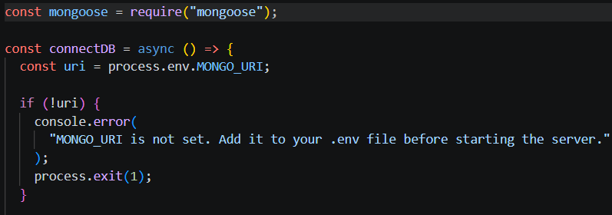

Duties: open the MongoDB connection, deal with connection failures, report connection status and export the connection.
Benefits: one central configuration, a reusable module, managed connections and simple error handling.

Schema Definitions
Two Mongoose schemas exist: the Account schema and the Exercise Log schema. They set the structure, rules and links of the stored documents.

1. Account Schema (models/User.js)
Keeps sign-in details for registered people.
Rules:
- The name cannot be blank.
- The email has to be unique.
- A password is compulsory.
- Passwords are hashed with bcrypt.js before saving.
- Timestamps are added automatically.
Highlights: unique-email check, password hashing, automatic timestamps, secure login support and JWT compatibility.

2. Exercise Log Schema (models/Workout.js)
Keeps the entries created by logged-in people.
Rules:
- A workout name is compulsory.
- A category is compulsory.
- Duration must exceed zero.
- Calories burned cannot be negative.
- A workout date is compulsory.
- Every entry belongs to one logged-in account.
Highlights: schema-level checks, automatic timestamps, link to the owner, easy searching and efficient CRUD.

Module 5: Running & Verifying the APIs
- Install Postman, or the ThunderClient extension for VS Code.
Launch the server with:
npm start

Endpoint Verification
Verification confirms that each endpoint responds correctly. FitTrack AI is checked with Postman to test request handling, login, database actions and the AI connection.
Order of testing:
- Account APIs
- Exercise log APIs
- AI APIs

Account API Checks
Sign Up
Sign In
Fetch Profile
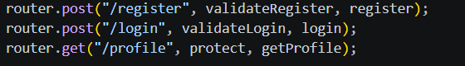

Exercise Log API Checks
Create Entry

List All Entries
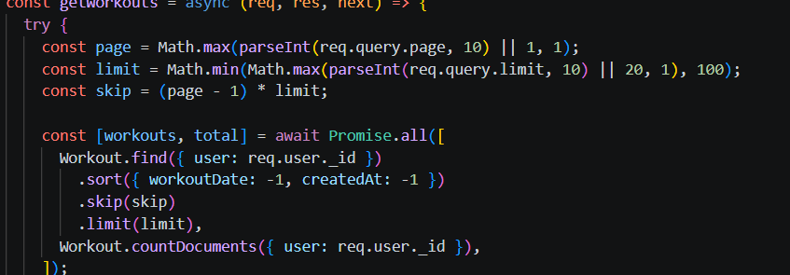

Fetch Entry by ID
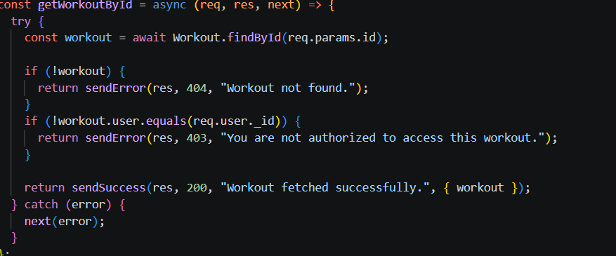

Edit Entry
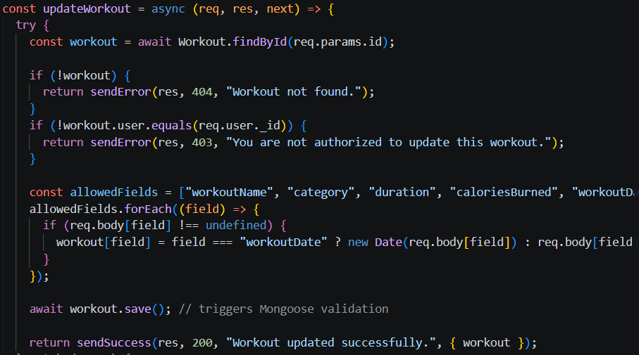

Delete Entry
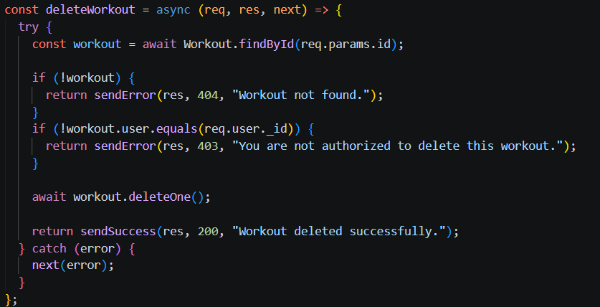

AI API Checks
Training Plan Suggestion
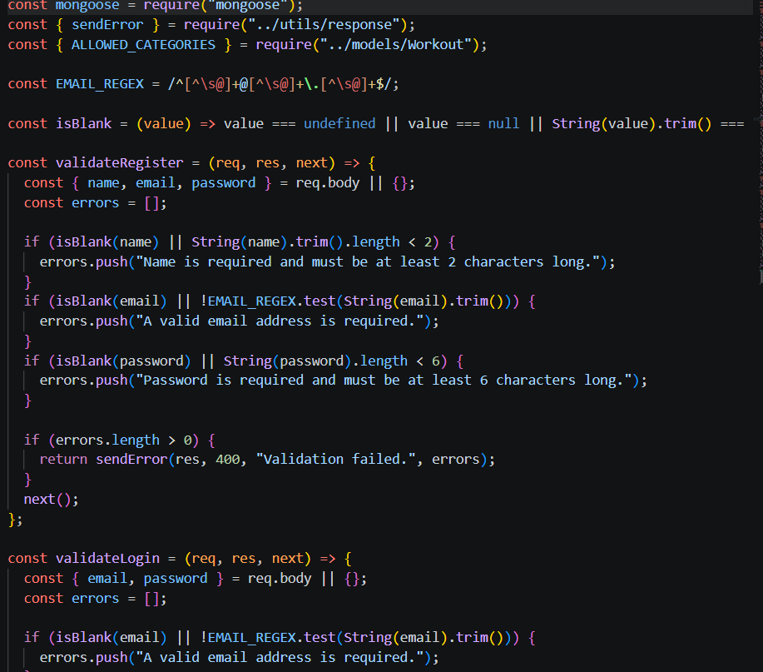

Activity Review

Reference Links
Demo video: https://drive.google.com/file/d/1sYDYL2JX7ikGFn5MvP99zhOvzlZGMgDG/view?usp=sharing
API testing video: https://drive.google.com/file/d/1V1MvWF6sJOc7VqNn0H_dQAeX8e58gUJO/view?usp=sharing
Source code: https://drive.google.com/drive/folders/1KA4hCJ1oAr8fRcS_Au8W9SEG9MxI33Bn?usp=sharing

