**Coronavirus (COVID-19)**

In [7]:

confirmed.keys()

Out[7]:

Index(['1/22/20', '1/23/20', '1/24/20', '1/25/20', '1/26/20', '1/27/20',

'1/28/20', '1/29/20', '1/30/20', '1/31/20',

...

'1/6/23', '1/7/23', '1/8/23', '1/9/23', '1/10/23', '1/11/23', '1/12/23',

'1/13/23', '1/14/23', '1/15/23'],

dtype='object', length=1090)

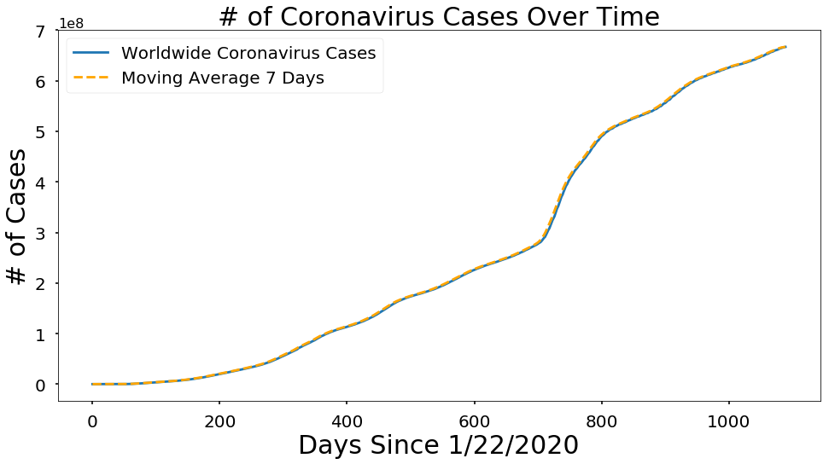

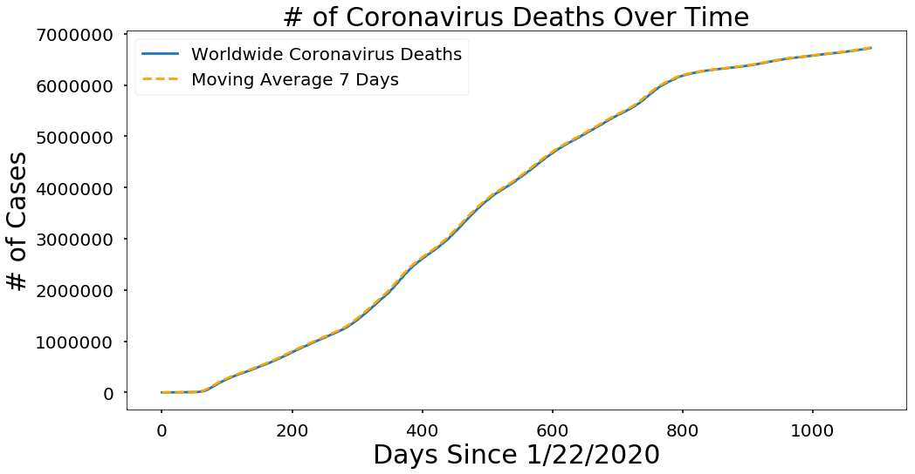

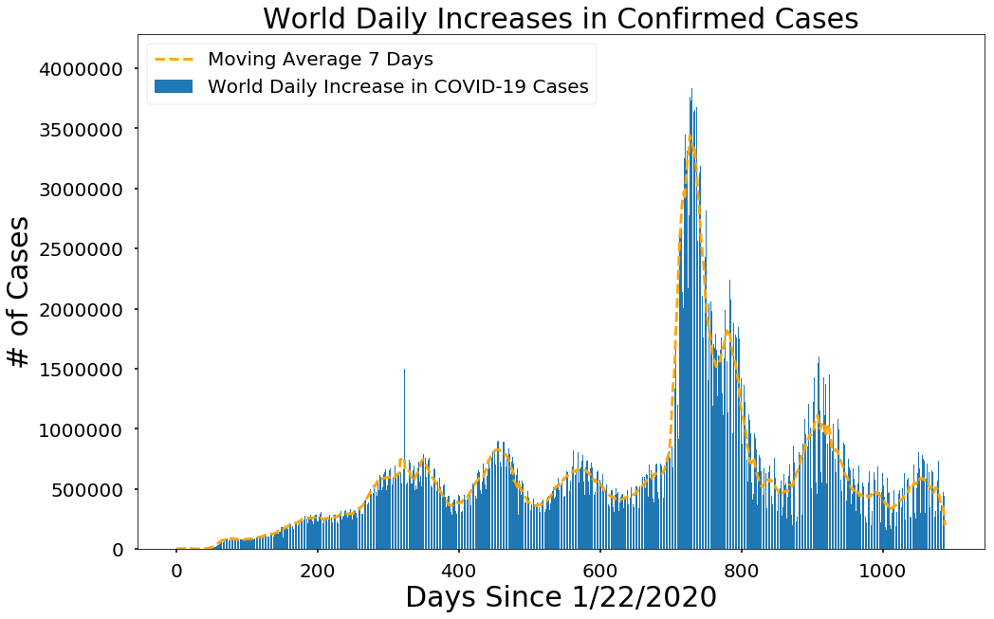

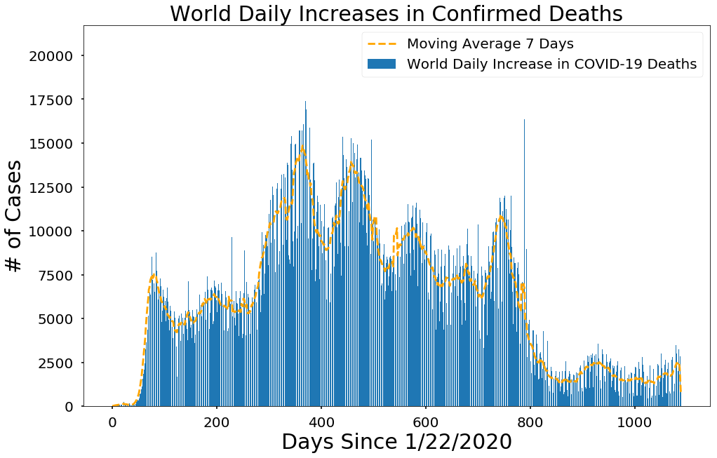

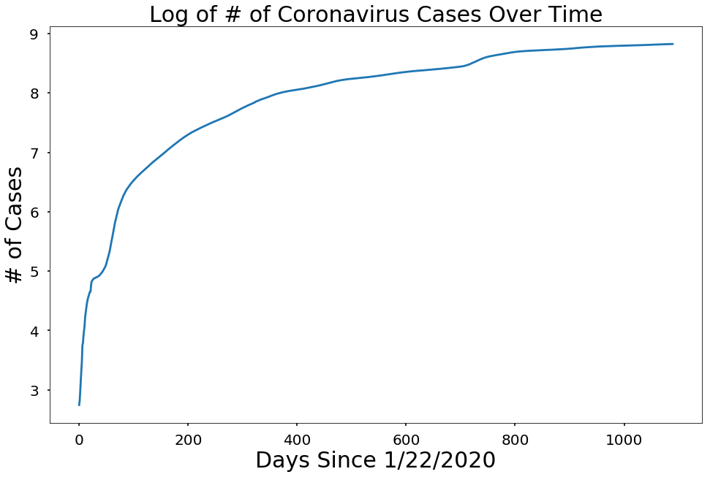

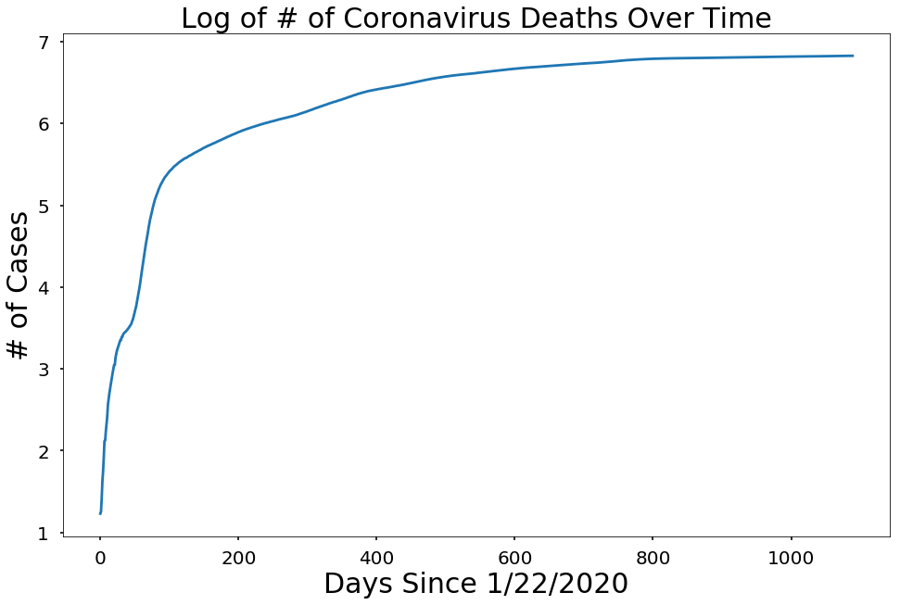

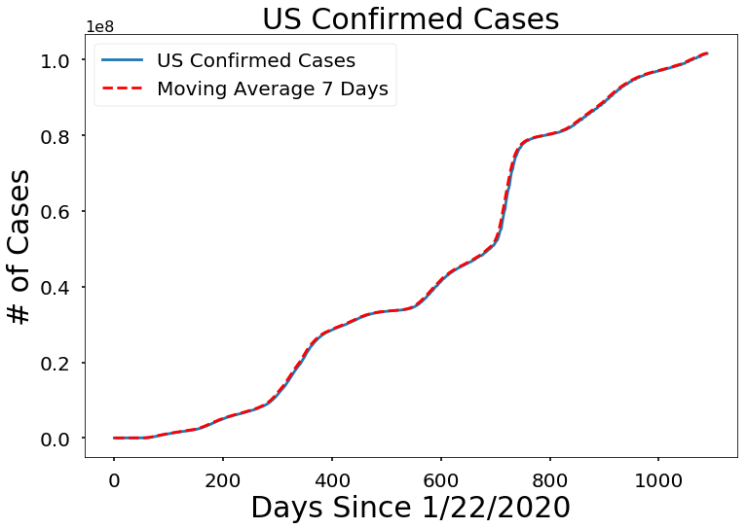

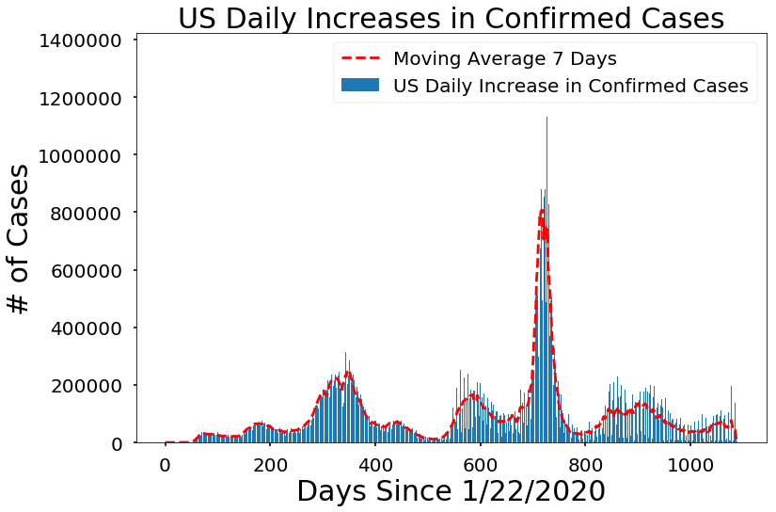

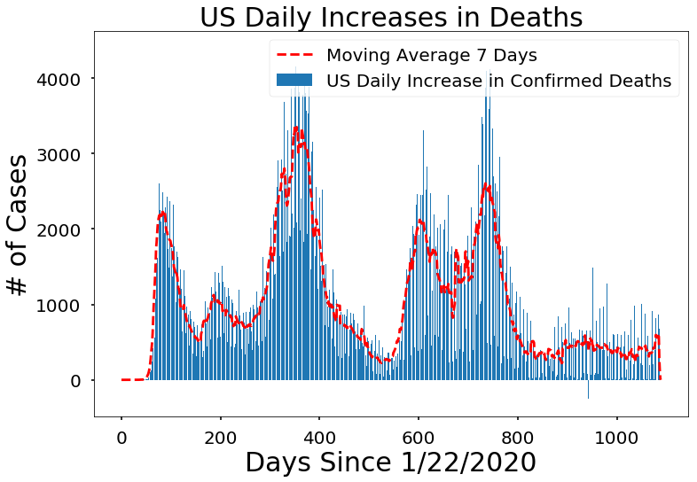

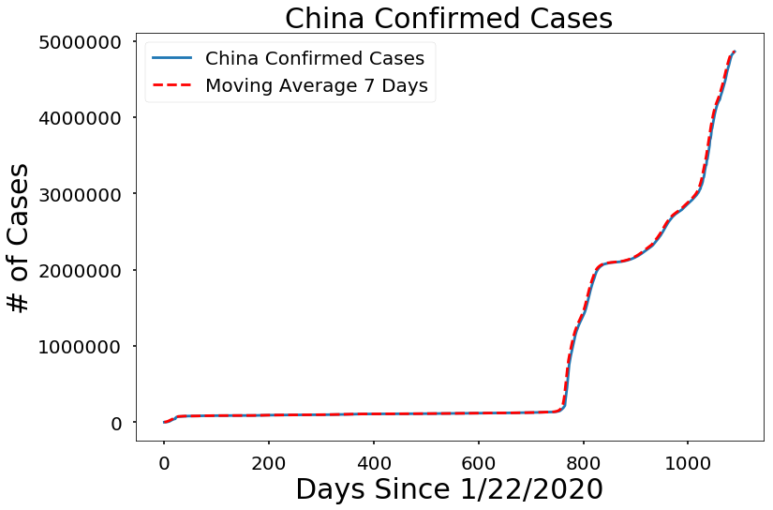

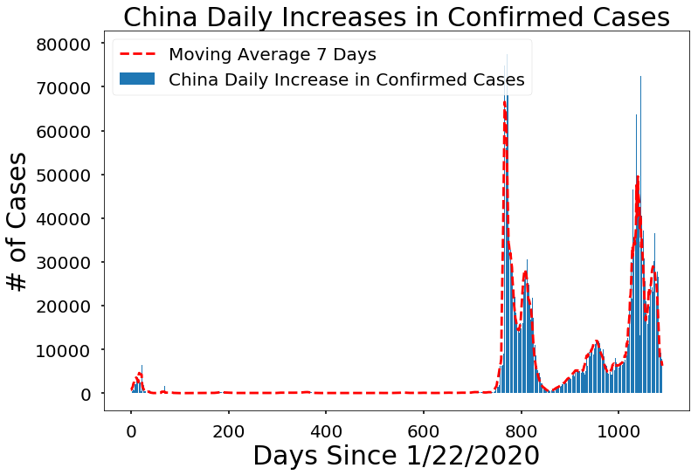

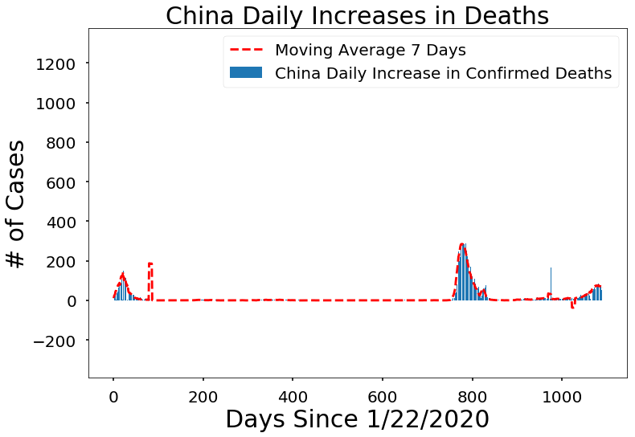

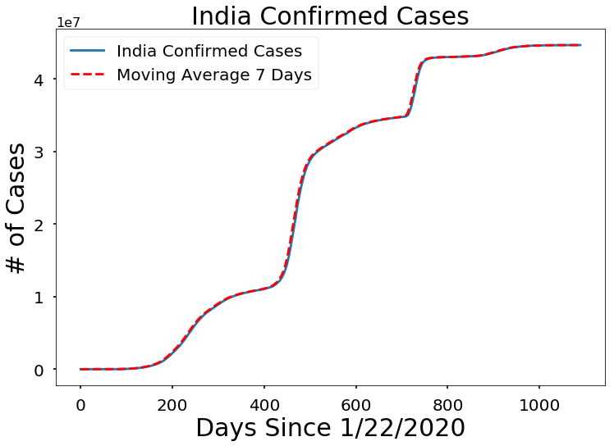

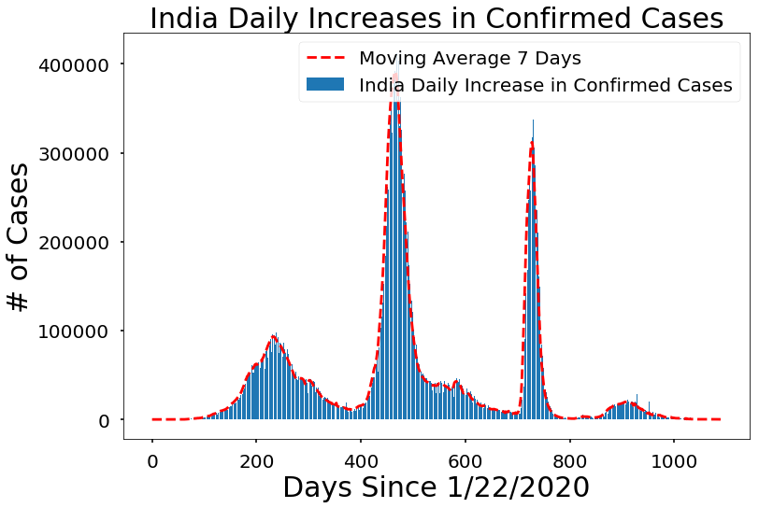

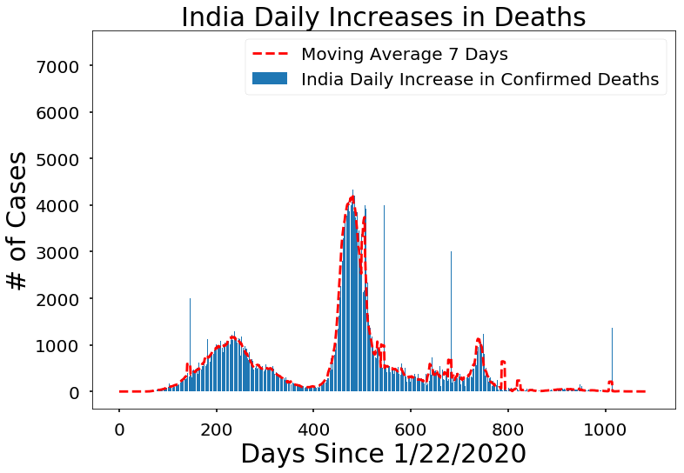

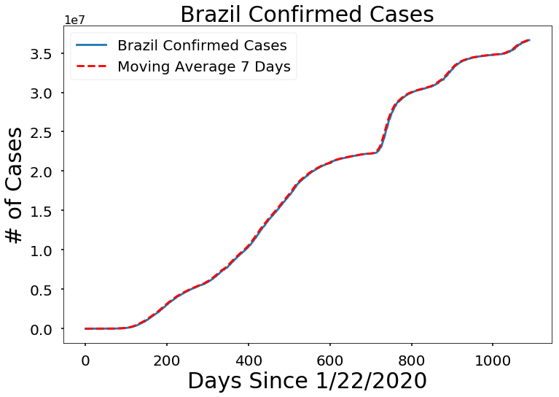

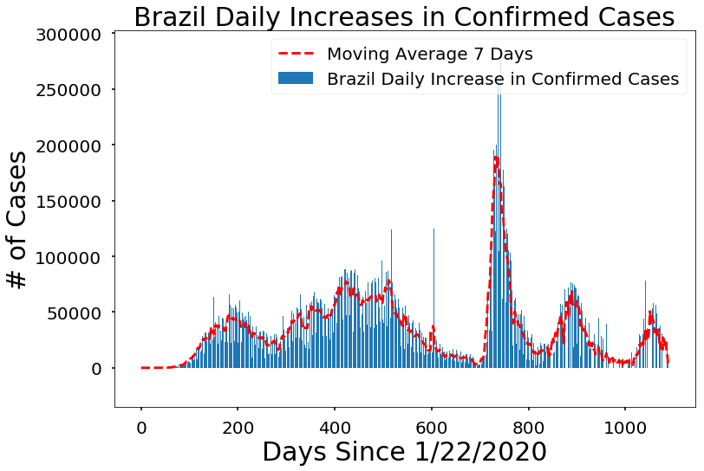

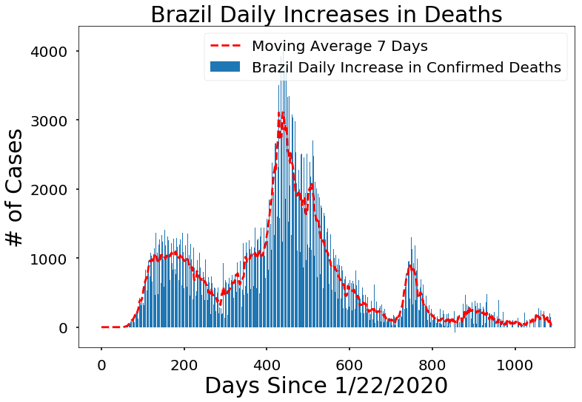

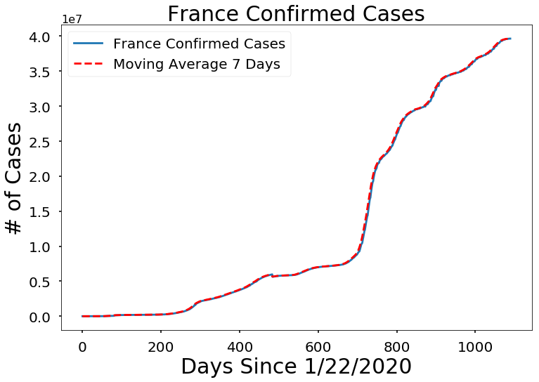

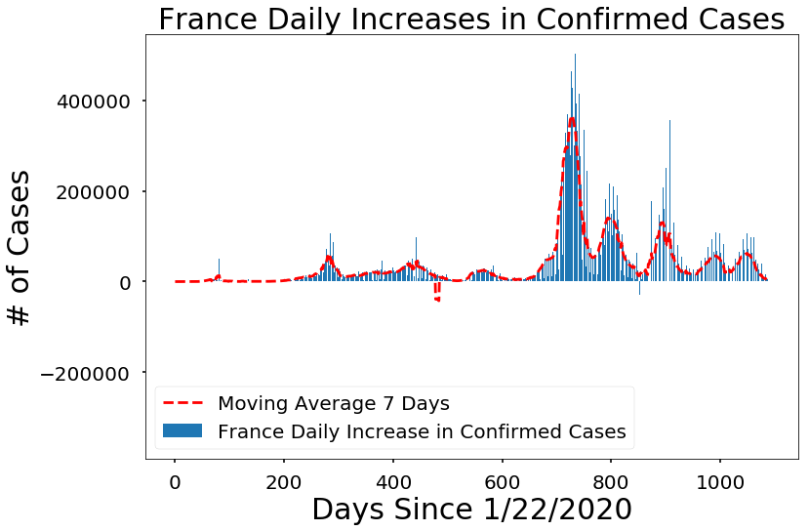

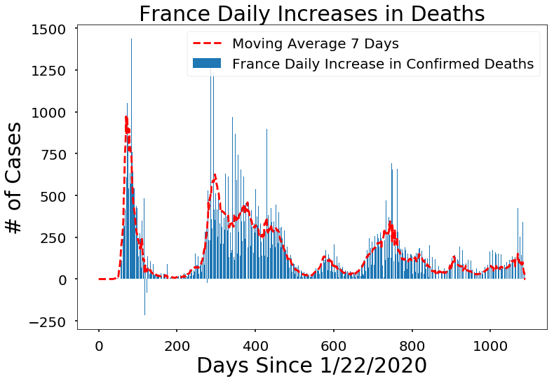

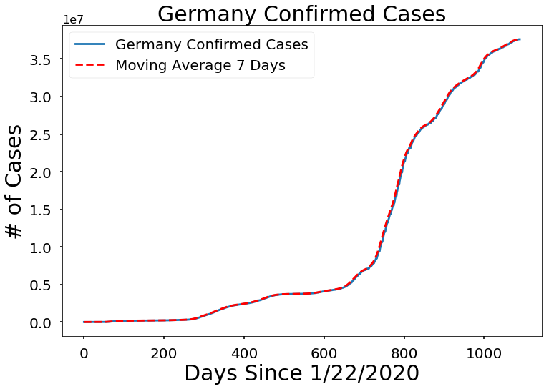

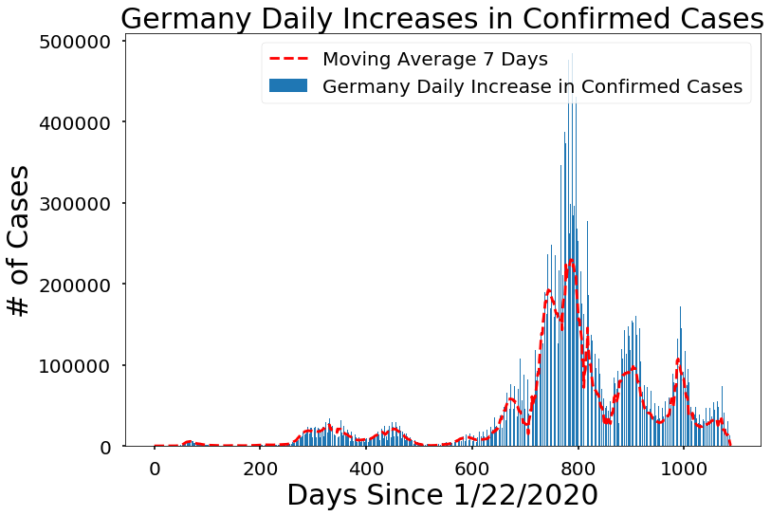

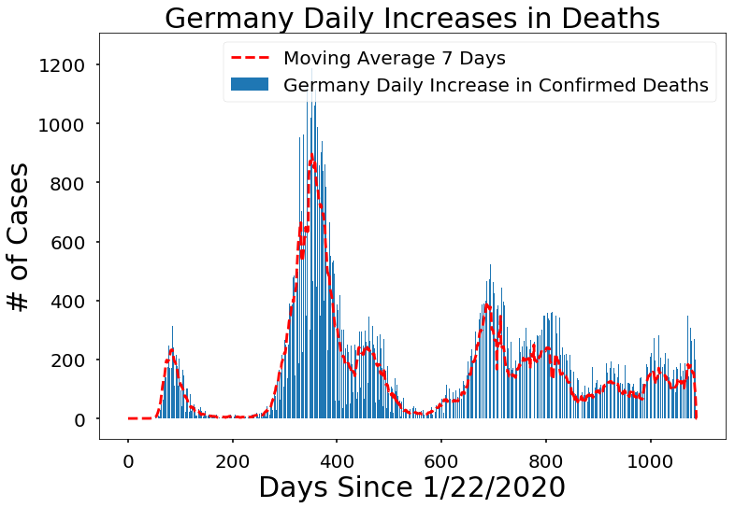

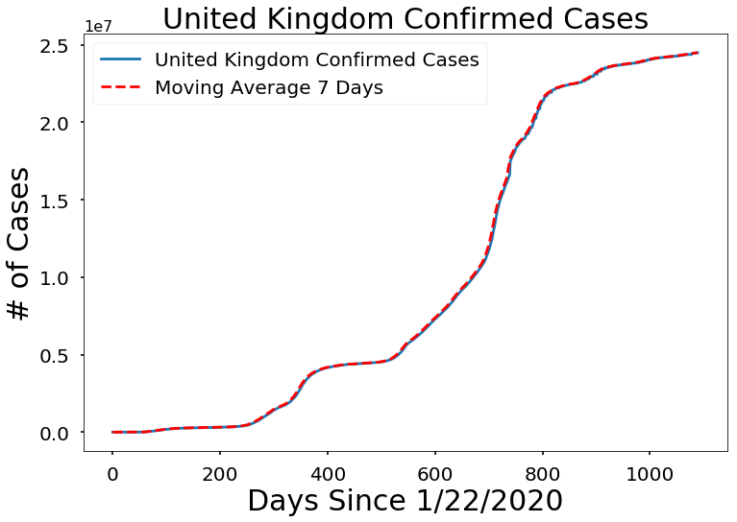

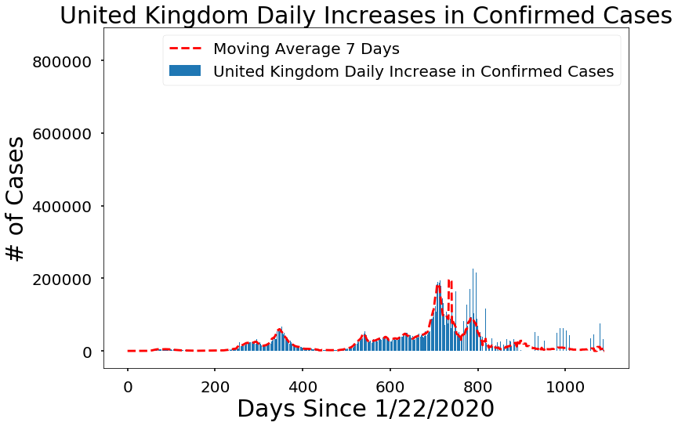

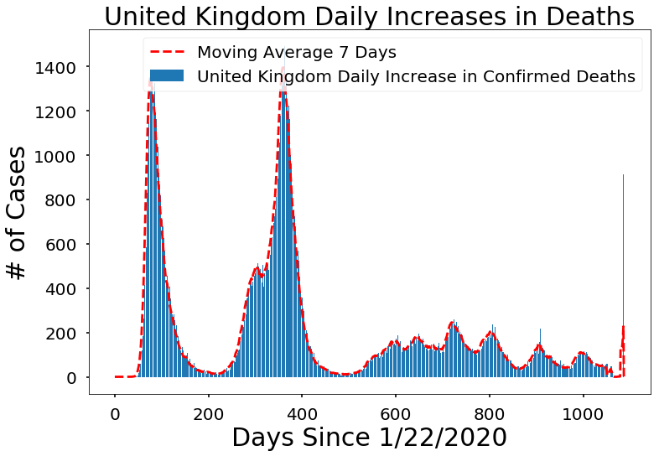

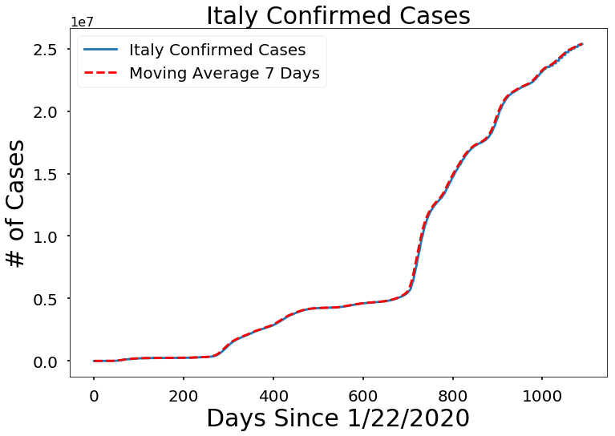

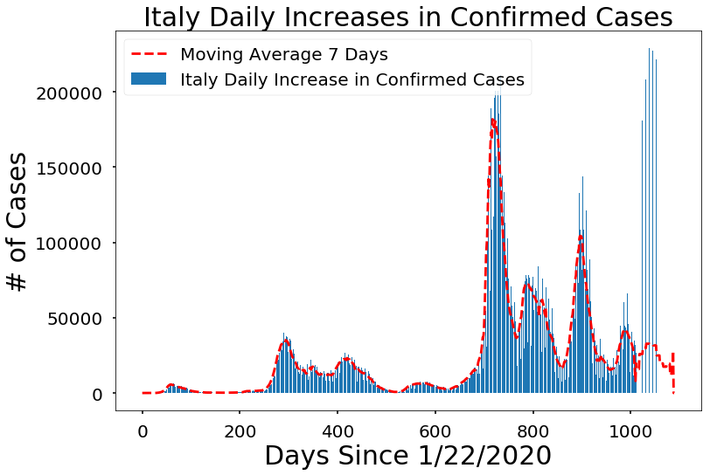

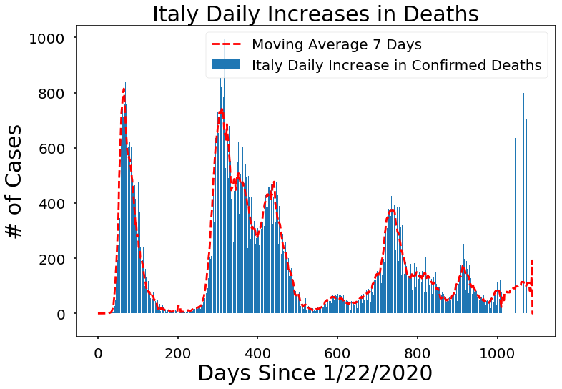

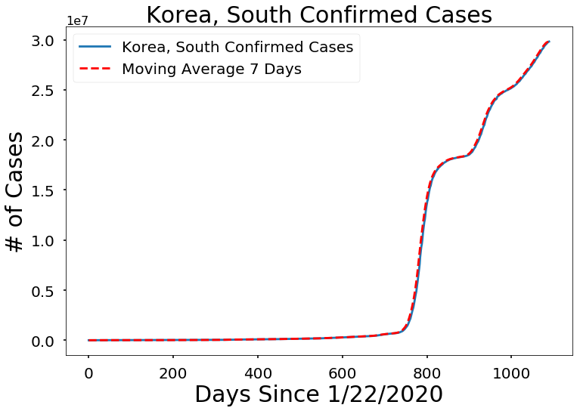

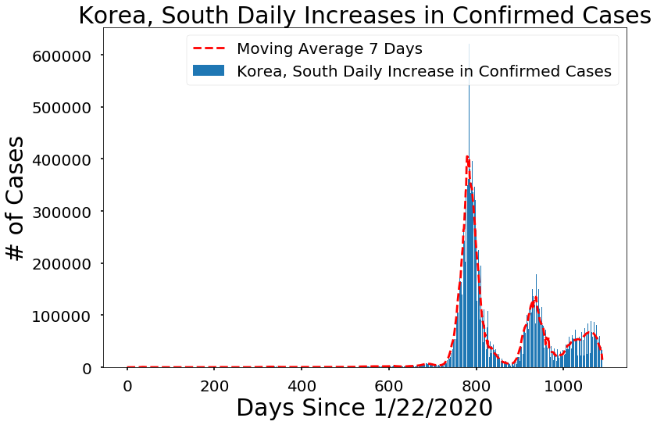

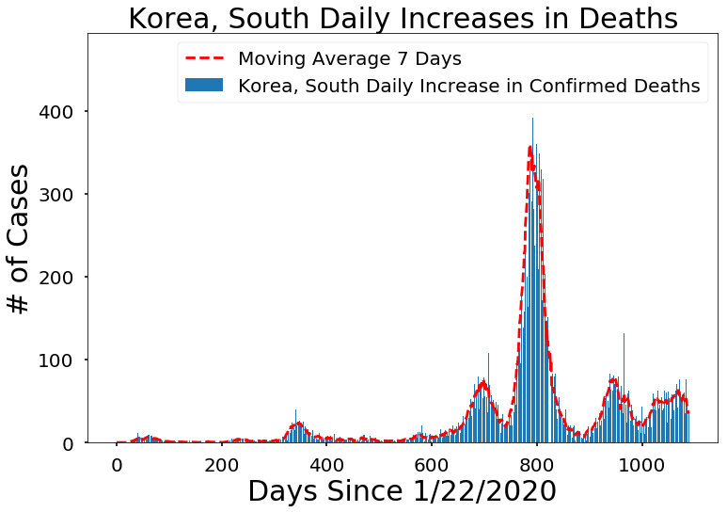

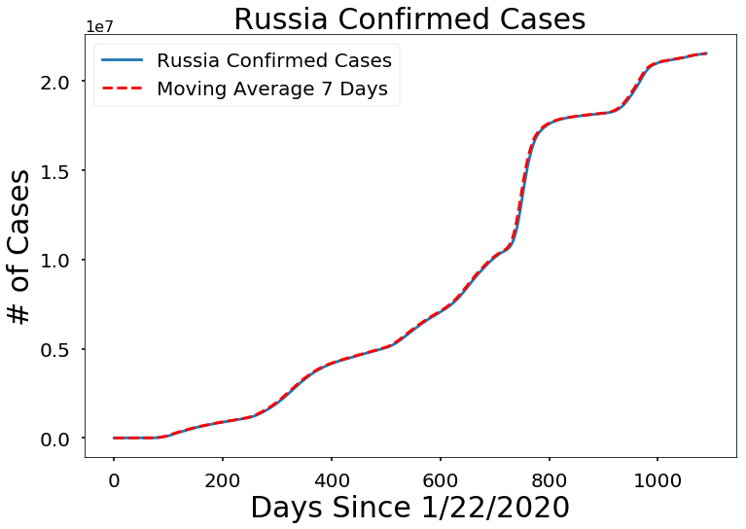

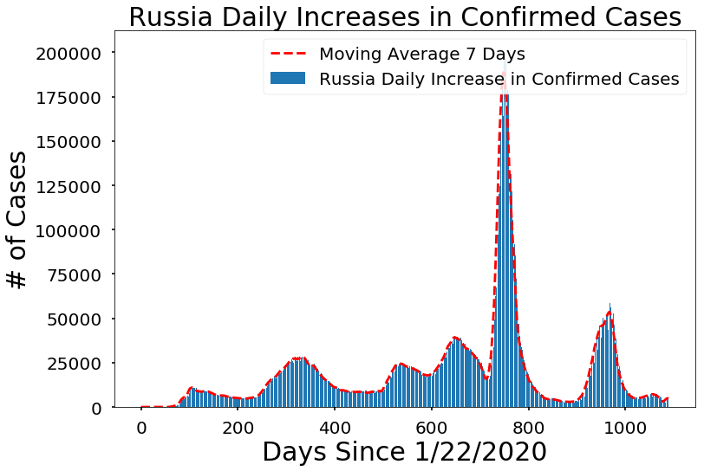

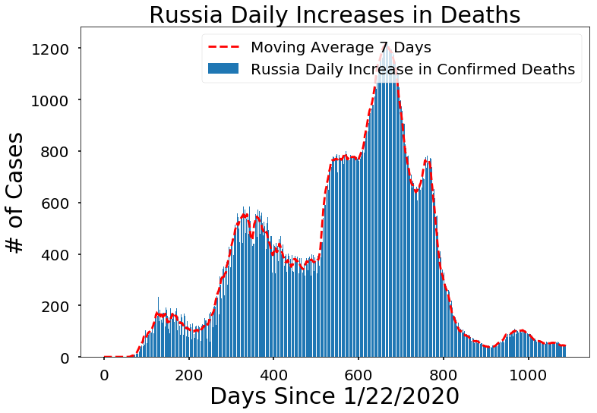

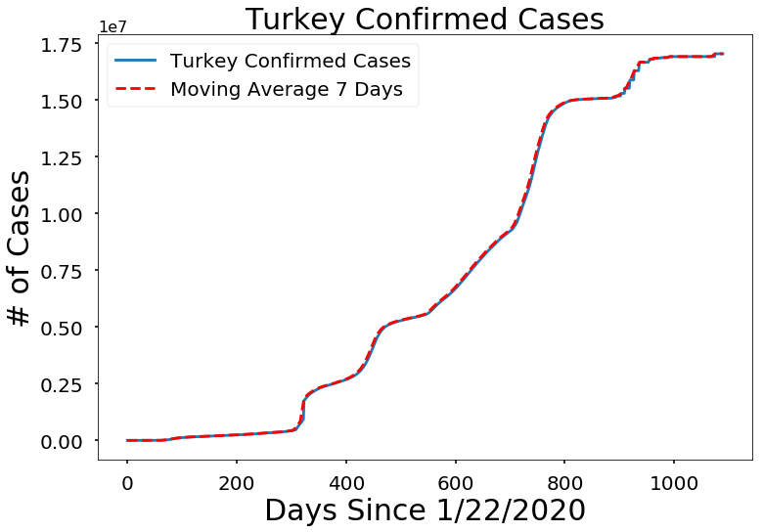

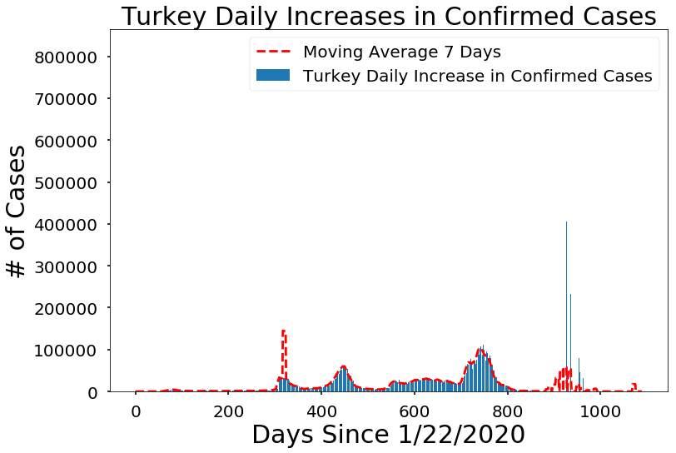

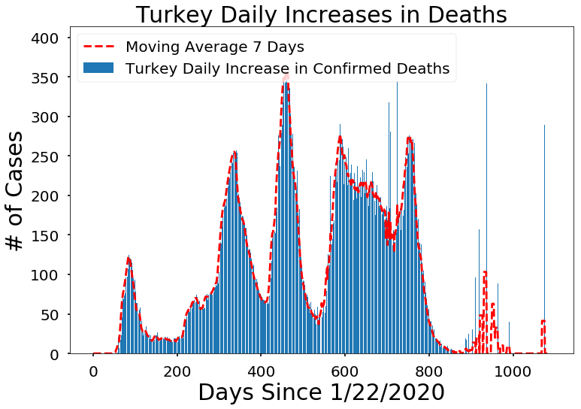

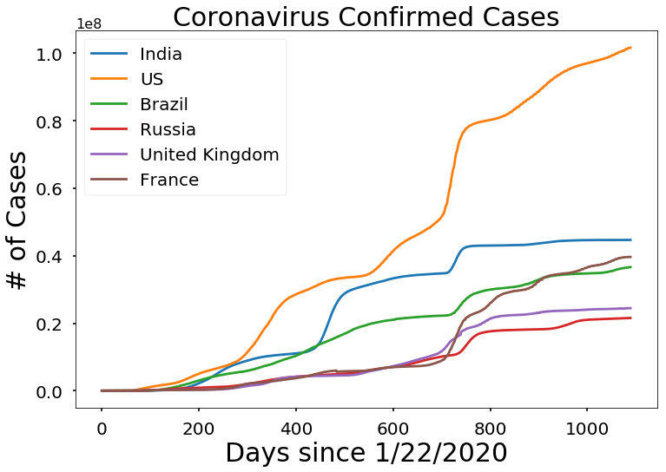

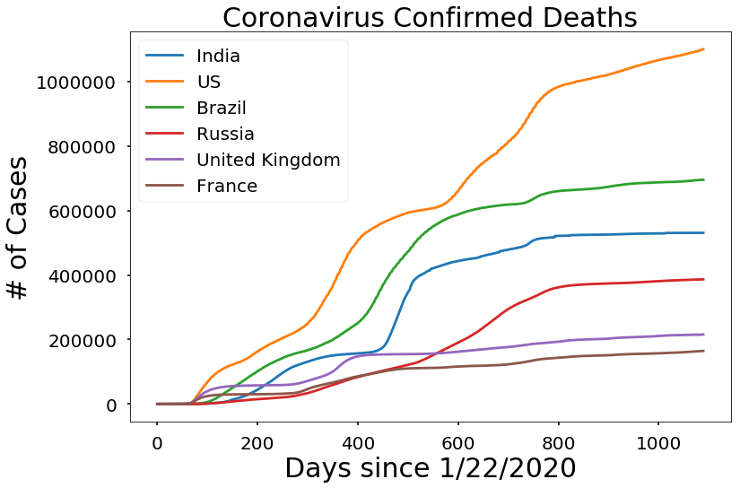

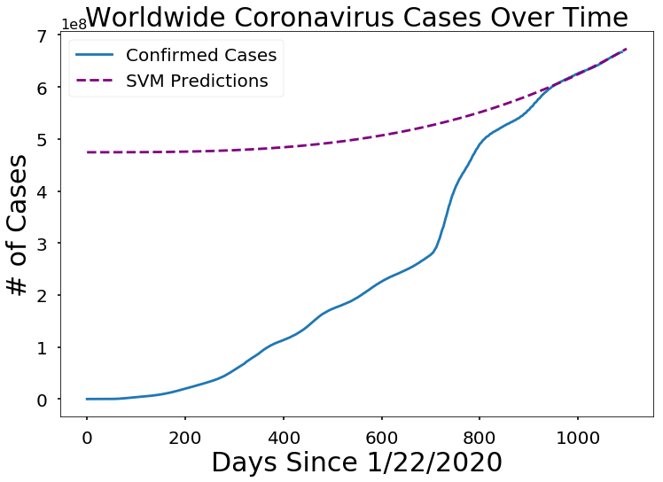

unfold_moreShow hidden code

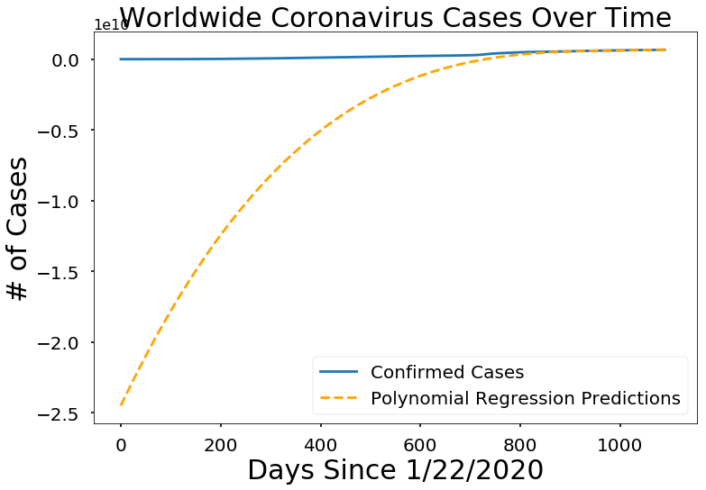

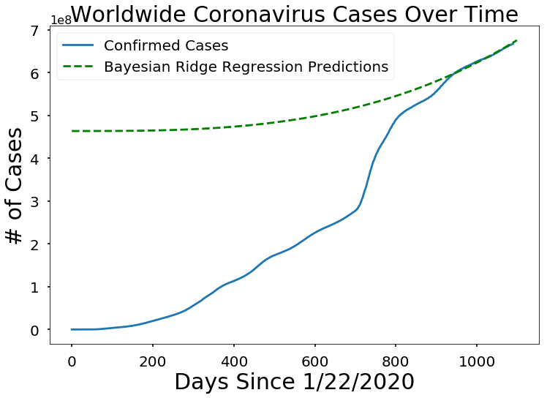

Out[37]:

|  | Date | SVM Predicted # of Confirmed Cases Worldwide |
| --- | --- | --- |
| 0 | 01/16/2023 | 6.68638e+08 |
| 1 | 01/17/2023 | 6.69173e+08 |
| 2 | 01/18/2023 | 6.69709e+08 |
| 3 | 01/19/2023 | 6.70246e+08 |
| 4 | 01/20/2023 | 6.70784e+08 |
| 5 | 01/21/2023 | 6.71323e+08 |
| 6 | 01/22/2023 | 6.71863e+08 |
| 7 | 01/23/2023 | 6.72404e+08 |
| 8 | 01/24/2023 | 6.72946e+08 |
| 9 | 01/25/2023 | 6.73489e+08 |

Out[38]:

|  | Date | Polynomial Predicted # of Confirmed Cases Worldwide |
| --- | --- | --- |
| 0 | 01/16/2023 | 6.73526e+08 |
| 1 | 01/17/2023 | 6.74395e+08 |
| 2 | 01/18/2023 | 6.75277e+08 |
| 3 | 01/19/2023 | 6.7617e+08 |
| 4 | 01/20/2023 | 6.77076e+08 |
| 5 | 01/21/2023 | 6.77994e+08 |
| 6 | 01/22/2023 | 6.78924e+08 |
| 7 | 01/23/2023 | 6.79867e+08 |
| 8 | 01/24/2023 | 6.80822e+08 |
| 9 | 01/25/2023 | 6.81791e+08 |

Out[39]:

|  | Date | Bayesian Ridge Predicted # of Confirmed Cases Worldwide |
| --- | --- | --- |
| 0 | 01/16/2023 | 6.70622e+08 |
| 1 | 01/17/2023 | 6.71192e+08 |
| 2 | 01/18/2023 | 6.71763e+08 |
| 3 | 01/19/2023 | 6.72335e+08 |
| 4 | 01/20/2023 | 6.72909e+08 |
| 5 | 01/21/2023 | 6.73483e+08 |
| 6 | 01/22/2023 | 6.74059e+08 |
| 7 | 01/23/2023 | 6.74635e+08 |
| 8 | 01/24/2023 | 6.75213e+08 |
| 9 | 01/25/2023 | 6.75791e+08 |

Mortality Rate (worldwide) **susceptible to change**

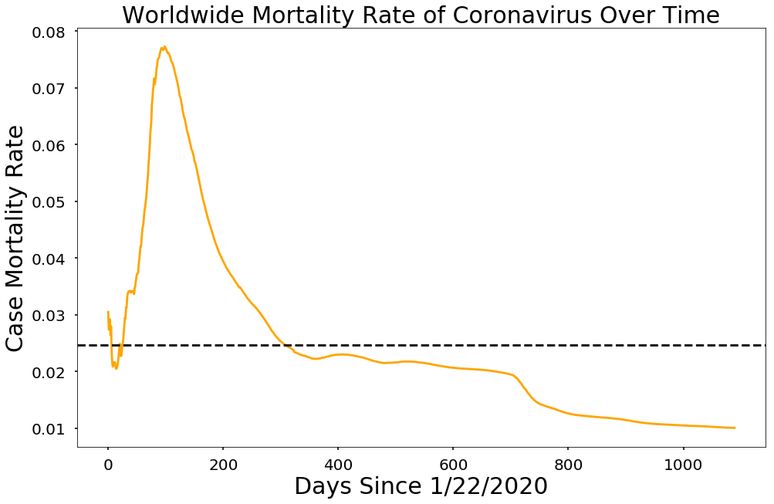

Data table

This shows covid data for several countries. The table includes the number of confirmed cases, deaths, incidence rate, and mortality rate.

Out[43]:

|  | Country Name | Number of Confirmed Cases | Number of Deaths | Incidence Rate | Mortality Rate |
| --- | --- | --- | --- | --- | --- |
| 0 | US | 101,648,826 | 1,099,860 | 9.61432e+07 | 0.0108202 |
| 1 | India | 44,682,378 | 530,726 | 202138 | 0.0118777 |
| 2 | France | 39,646,833 | 164,388 | 495669 | 0.00414631 |
| 3 | Germany | 37,605,135 | 163,775 | 709346 | 0.00435512 |
| 4 | Brazil | 36,628,099 | 695,343 | 526869 | 0.0189839 |
| 5 | Japan | 31,438,775 | 62,687 | 1.1149e+06 | 0.00199394 |
| 6 | Korea, South | 29,821,035 | 32,984 | 58165.6 | 0.00110606 |
| 7 | Italy | 25,363,742 | 185,993 | 885981 | 0.00733303 |
| 8 | United Kingdom | 24,475,895 | 215,633 | 635466 | 0.00881001 |
| 9 | Russia | 21,548,111 | 386,460 | 1.21278e+06 | 0.0179348 |
| 10 | Turkey | 17,042,722 | 101,492 | 20207.4 | 0.00595515 |
| 11 | Spain | 13,711,251 | 117,759 | 575875 | 0.00858849 |
| 12 | Vietnam | 11,526,140 | 43,186 | 11841.3 | 0.00374679 |
| 13 | Australia | 11,247,412 | 17,712 | 372093 | 0.00157476 |
| 14 | Argentina | 10,004,679 | 130,249 | 22136.3 | 0.0130188 |
| 15 | Taiwan* | 9,209,474 | 15,833 | 38668 | 0.00171921 |
| 16 | Netherlands | 8,690,420 | 23,702 | 719329 | 0.00272737 |
| 17 | Iran | 7,562,610 | 144,727 | 9003.86 | 0.0191372 |
| 18 | Mexico | 7,314,891 | 331,595 | 190149 | 0.0453315 |
| 19 | Indonesia | 6,726,086 | 160,727 | 2459.05 | 0.0238961 |
| 20 | Poland | 6,373,315 | 118,651 | 16839.9 | 0.0186168 |
| 21 | Colombia | 6,343,059 | 141,959 | 320596 | 0.0223802 |
| 22 | Austria | 5,742,055 | 21,564 | 63755.3 | 0.00375545 |
| 23 | Ukraine | 5,672,824 | 118,858 | 327445 | 0.0209522 |
| 24 | Portugal | 5,557,941 | 25,805 | 54507.2 | 0.00464291 |
| 25 | Greece | 5,548,487 | 34,779 | 53232.8 | 0.0062682 |
| 26 | Chile | 5,087,555 | 63,509 | 510691 | 0.0124832 |
| 27 | Malaysia | 5,032,677 | 36,908 | 256091 | 0.00733367 |
| 28 | China | 4,859,037 | 18,192 | 39696.6 | 0.00374395 |
| 29 | Israel | 4,775,990 | 12,111 | 55178.4 | 0.00253581 |
| 30 | Thailand | 4,752,782 | 34,668 | 6809.15 | 0.00729425 |
| 31 | Belgium | 4,686,147 | 33,478 | 447894 | 0.00714404 |
| 32 | Czechia | 4,584,920 | 42,254 | 42813.8 | 0.00921586 |
| 33 | Canada | 4,538,048 | 49,969 | 189142 | 0.0110111 |
| 34 | Peru | 4,475,426 | 218,530 | 300986 | 0.0488289 |
| 35 | Switzerland | 4,404,980 | 14,234 | 50897.5 | 0.00323134 |
| 36 | Philippines | 4,070,287 | 65,590 | 3714.41 | 0.0161143 |
| 37 | South Africa | 4,051,787 | 102,568 | 6831.69 | 0.0253143 |
| 38 | Denmark | 3,443,287 | 8,031 | 150654 | 0.00233236 |
| 39 | Romania | 3,316,192 | 67,460 | 17238 | 0.0203426 |
| 40 | Sweden | 2,687,840 | 22,645 | 539984 | 0.00842498 |
| 41 | Slovakia | 2,659,236 | 20,875 | 48930.6 | 0.00785 |
| 42 | Iraq | 2,465,545 | 25,375 | 6129.77 | 0.0102918 |
| 43 | Serbia | 2,459,432 | 17,606 | 28148.4 | 0.00715856 |
| 44 | Singapore | 2,211,855 | 1,717 | 37807.3 | 0.000776272 |
| 45 | Hungary | 2,190,334 | 48,578 | 22673.4 | 0.0221784 |
| 46 | New Zealand | 2,165,599 | 2,438 | 127841 | 0.00112579 |
| 47 | Bangladesh | 2,037,368 | 29,441 | 1237.1 | 0.0144505 |
| 48 | Georgia | 1,811,015 | 16,909 | 45398.2 | 0.00933675 |
| 49 | Jordan | 1,746,997 | 14,122 | 17122.2 | 0.00808359 |
| 50 | Ireland | 1,697,775 | 8,388 | 34383.3 | 0.00494058 |
| 51 | Pakistan | 1,576,080 | 30,640 | 11998.7 | 0.0194406 |
| 52 | Kazakhstan | 1,488,306 | 19,063 | 7926.34 | 0.0128085 |
| 53 | Norway | 1,476,947 | 4,963 | 27243.7 | 0.00336031 |
| 54 | Finland | 1,448,656 | 8,431 | 26145.6 | 0.00581988 |
| 55 | Slovenia | 1,317,469 | 7,036 | 63372.4 | 0.00534054 |
| 56 | Bulgaria | 1,294,152 | 38,139 | 18625.1 | 0.0294703 |
| 57 | Lithuania | 1,292,560 | 9,514 | 47480.6 | 0.00736059 |
| 58 | Morocco | 1,272,050 | 16,295 | 3446.3 | 0.01281 |
| 59 | Croatia | 1,266,483 | 17,765 | 30850.2 | 0.014027 |
| 60 | Lebanon | 1,225,400 | 10,761 | 17953.4 | 0.00878162 |
| 61 | Guatemala | 1,218,471 | 20,054 | 6801.19 | 0.0164583 |
| 62 | Bolivia | 1,179,195 | 22,333 | 10101.9 | 0.0189392 |
| 63 | Costa Rica | 1,171,802 | 9,104 | 23003.1 | 0.00776923 |
| 64 | Tunisia | 1,147,729 | 29,288 | 9711.19 | 0.0255182 |
| 65 | Cuba | 1,112,280 | 8,530 | 9820.06 | 0.00766893 |
| 66 | United Arab Emirates | 1,048,098 | 2,348 | 10597.1 | 0.00224025 |
| 67 | Ecuador | 1,040,463 | 35,940 | 5897.29 | 0.0345423 |
| 68 | Panama | 1,027,247 | 8,584 | 23807.7 | 0.00835632 |
| 69 | Uruguay | 1,025,810 | 7,586 | 29530.5 | 0.00739513 |
| 70 | Mongolia | 1,007,821 | 2,136 | 30742.3 | 0.00211942 |
| 71 | Nepal | 1,001,051 | 12,020 | 3435.69 | 0.0120074 |
| 72 | Belarus | 994,037 | 7,118 | 10519.7 | 0.0071607 |
| 73 | Latvia | 974,872 | 6,195 | 51684.4 | 0.00635468 |
| 74 | Saudi Arabia | 827,391 | 9,544 | 2376.61 | 0.0115351 |
| 75 | Azerbaijan | 827,377 | 10,049 | 8160.2 | 0.0121456 |
| 76 | Paraguay | 800,163 | 19,746 | 11218.5 | 0.0246775 |
| 77 | West Bank and Gaza | 703,228 | 5,708 | 13785 | 0.00811686 |
| 78 | Bahrain | 699,581 | 1,540 | 41113.5 | 0.00220132 |
| 79 | Sri Lanka | 671,964 | 16,823 | 3138.08 | 0.0250356 |
| 80 | Kuwait | 662,747 | 2,570 | 15519 | 0.0038778 |
| 81 | Dominican Republic | 659,606 | 4,384 | 6080.49 | 0.00664639 |
| 82 | Cyprus | 638,062 | 1,270 | 52847.7 | 0.0019904 |
| 83 | Burma | 633,750 | 19,490 | 1164.77 | 0.0307535 |
| 84 | Estonia | 612,843 | 2,885 | 46198.6 | 0.00470757 |
| 85 | Moldova | 597,216 | 11,940 | 14827.8 | 0.0199928 |
| 86 | Venezuela | 550,997 | 5,837 | 1937.68 | 0.0105935 |
| 87 | Egypt | 515,645 | 24,803 | 503.882 | 0.0481009 |
| 88 | Libya | 507,154 | 6,437 | 7380.77 | 0.0126924 |
| 89 | Ethiopia | 499,111 | 7,572 | 434.147 | 0.015171 |
| 90 | Qatar | 491,400 | 685 | 17056.2 | 0.00139398 |
| 91 | Honduras | 469,230 | 11,095 | 4737.49 | 0.0236451 |
| 92 | Armenia | 445,976 | 8,716 | 15050.3 | 0.0195437 |
| 93 | Bosnia and Herzegovina | 401,187 | 16,241 | 12228.3 | 0.0404824 |
| 94 | Oman | 399,154 | 4,628 | 7816.4 | 0.0115945 |
| 95 | North Macedonia | 346,095 | 9,623 | 16612.2 | 0.0278045 |
| 96 | Kenya | 342,703 | 5,688 | 637.334 | 0.0165975 |
| 97 | Zambia | 337,303 | 4,036 | 1834.77 | 0.0119655 |
| 98 | Albania | 334,037 | 3,596 | 11607.4 | 0.0107653 |
| 99 | Botswana | 328,230 | 2,795 | 13957.6 | 0.00851537 |
| 100 | Luxembourg | 313,952 | 1,200 | 50154 | 0.00382224 |
| 101 | Mauritius | 293,386 | 1,042 | 23069.2 | 0.00355164 |
| 102 | Montenegro | 285,535 | 2,794 | 45462.9 | 0.00978514 |
| 103 | Brunei | 272,646 | 225 | 62321.5 | 0.000825246 |
| 104 | Kosovo | 272,400 | 3,202 | 15046.7 | 0.0117548 |
| 105 | Algeria | 271,287 | 6,881 | 618.656 | 0.0253643 |
| 106 | Nigeria | 266,463 | 3,155 | 129.263 | 0.0118403 |
| 107 | Zimbabwe | 259,981 | 5,637 | 1749.19 | 0.0216824 |
| 108 | Uzbekistan | 250,137 | 1,637 | 747.365 | 0.00654441 |
| 109 | Mozambique | 231,219 | 2,232 | 739.772 | 0.00965319 |
| 110 | Laos | 217,927 | 758 | 2995.33 | 0.00347823 |
| 111 | Iceland | 208,459 | 229 | 61086.9 | 0.00109854 |
| 112 | Afghanistan | 207,900 | 7,854 | 534.058 | 0.0377778 |
| 113 | Kyrgyzstan | 206,586 | 2,991 | 3166.46 | 0.0144782 |
| 114 | El Salvador | 201,785 | 4,230 | 3110.99 | 0.0209629 |
| 115 | Trinidad and Tobago | 186,685 | 4,297 | 13339.5 | 0.0230174 |
| 116 | Maldives | 185,702 | 311 | 34354.8 | 0.00167473 |
| 117 | Ghana | 171,089 | 1,462 | 550.604 | 0.00854526 |
| 118 | Namibia | 170,369 | 4,082 | 6705.02 | 0.0239598 |
| 119 | Uganda | 170,279 | 3,630 | 372.268 | 0.021318 |
| 120 | Jamaica | 152,968 | 3,465 | 5165.81 | 0.0226518 |
| 121 | Cambodia | 138,662 | 3,056 | 829.369 | 0.0220392 |
| 122 | Rwanda | 133,063 | 1,468 | 1027.34 | 0.0110324 |
| 123 | Cameroon | 123,993 | 1,965 | 467.09 | 0.0158477 |
| 124 | Malta | 116,820 | 822 | 26457.5 | 0.00703647 |
| 125 | Barbados | 105,905 | 569 | 36853.1 | 0.00537274 |
| 126 | Angola | 105,095 | 1,930 | 319.766 | 0.0183643 |
| 127 | Congo (Kinshasa) | 95,173 | 1,462 | 106.266 | 0.0153615 |
| 128 | Senegal | 88,900 | 1,968 | 530.939 | 0.0221372 |
| 129 | Malawi | 88,220 | 2,685 | 461.162 | 0.0304353 |
| 130 | Cote d'Ivoire | 87,960 | 833 | 333.456 | 0.00947021 |
| 131 | Suriname | 82,020 | 1,398 | 13981.5 | 0.0170446 |
| 132 | Eswatini | 74,053 | 1,422 | 6382.98 | 0.0192025 |
| 133 | Guyana | 72,638 | 1,293 | 9234.91 | 0.0178006 |
| 134 | Belize | 70,397 | 688 | 17704.5 | 0.00977314 |
| 135 | Fiji | 68,793 | 883 | 7673.99 | 0.0128356 |
| 136 | Madagascar | 67,788 | 1,418 | 244.801 | 0.0209182 |
| 137 | Sudan | 63,702 | 4,995 | 145.275 | 0.078412 |
| 138 | Mauritania | 63,435 | 997 | 1364.29 | 0.0157169 |
| 139 | Cabo Verde | 63,220 | 412 | 11370.7 | 0.00651693 |
| 140 | Bhutan | 62,551 | 21 | 8106.54 | 0.000335726 |
| 141 | Syria | 57,441 | 3,164 | 328.222 | 0.0550826 |
| 142 | Burundi | 52,380 | 38 | 440.509 | 0.000725468 |
| 143 | Seychelles | 50,355 | 172 | 51205 | 0.00341575 |
| 144 | Gabon | 48,980 | 306 | 2200.63 | 0.00624745 |
| 145 | Andorra | 47,781 | 165 | 61840.4 | 0.00345326 |
| 146 | Papua New Guinea | 46,663 | 669 | 521.548 | 0.0143368 |
| 147 | Tanzania | 42,467 | 846 | 71.0933 | 0.0199214 |
| 148 | Togo | 39,351 | 290 | 475.326 | 0.00736957 |
| 149 | Guinea | 38,210 | 466 | 290.951 | 0.0121958 |
| 150 | Bahamas | 37,491 | 833 | 9533.68 | 0.0222187 |
| 151 | Lesotho | 34,790 | 723 | 1623.99 | 0.0207818 |
| 152 | Haiti | 33,969 | 860 | 297.907 | 0.0253172 |
| 153 | Mali | 32,772 | 743 | 161.83 | 0.0226718 |
| 154 | Saint Lucia | 29,759 | 409 | 16206 | 0.0137437 |
| 155 | Benin | 27,982 | 163 | 230.814 | 0.00582517 |
| 156 | Somalia | 27,310 | 1,361 | 171.834 | 0.0498352 |
| 157 | Congo (Brazzaville) | 25,375 | 386 | 459.851 | 0.0152118 |
| 158 | Solomon Islands | 24,575 | 153 | 3764.22 | 0.00622584 |
| 159 | Timor-Leste | 23,405 | 138 | 1775.2 | 0.00589618 |
| 160 | San Marino | 23,290 | 121 | 68625.1 | 0.00519536 |
| 161 | Micronesia | 22,247 | 58 | 19546.6 | 0.00260709 |
| 162 | Burkina Faso | 22,025 | 396 | 105.366 | 0.0179796 |
| 163 | Liechtenstein | 21,329 | 88 | 55927.3 | 0.00412584 |
| 164 | Grenada | 19,680 | 238 | 17490.4 | 0.0120935 |
| 165 | South Sudan | 18,368 | 138 | 164.092 | 0.00751307 |
| 166 | Tajikistan | 17,786 | 125 | 186.482 | 0.007028 |
| 167 | Equatorial Guinea | 17,186 | 183 | 1224.96 | 0.0106482 |
| 168 | Tonga | 16,590 | 13 | 15695.8 | 0.000783605 |
| 169 | Monaco | 16,021 | 65 | 40824.1 | 0.00405717 |
| 170 | Samoa | 16,008 | 29 | 8161.93 | 0.00181159 |
| 171 | Dominica | 15,760 | 74 | 21891.6 | 0.00469543 |
| 172 | Djibouti | 15,690 | 189 | 1588.05 | 0.0120459 |
| 173 | Marshall Islands | 15,554 | 17 | 26627.6 | 0.00109297 |
| 174 | Nicaragua | 15,507 | 245 | 234.084 | 0.0157993 |
| 175 | Central African Republic | 15,351 | 113 | 317.842 | 0.00736108 |
| 176 | Gambia | 12,586 | 372 | 520.801 | 0.0295567 |
| 177 | Vanuatu | 12,014 | 14 | 4104.82 | 0.00116531 |
| 178 | Yemen | 11,945 | 2,159 | 40.049 | 0.180745 |
| 179 | Eritrea | 10,189 | 103 | 287.303 | 0.0101089 |
| 180 | Saint Vincent and the Grenadines | 9,563 | 121 | 8619.43 | 0.0126529 |
| 181 | Niger | 9,506 | 315 | 39.2702 | 0.033137 |
| 182 | Antigua and Barbuda | 9,106 | 146 | 9298.67 | 0.0160334 |
| 183 | Comoros | 8,986 | 161 | 1033.35 | 0.0179168 |
| 184 | Guinea-Bissau | 8,947 | 176 | 454.624 | 0.0196714 |
| 185 | Liberia | 8,043 | 294 | 159.026 | 0.0365535 |
| 186 | Sierra Leone | 7,760 | 126 | 97.2799 | 0.0162371 |
| 187 | Chad | 7,651 | 194 | 46.579 | 0.0253562 |
| 188 | Saint Kitts and Nevis | 6,578 | 46 | 12366.5 | 0.00699301 |
| 189 | Sao Tome and Principe | 6,279 | 77 | 2865.02 | 0.0122631 |
| 190 | Palau | 5,980 | 9 | 33207.5 | 0.00150502 |
| 191 | Kiribati | 4,921 | 17 | 4184.31 | 0.00345458 |
| 192 | Nauru | 4,621 | 1 | 42652.8 | 0.000216403 |
| 193 | Tuvalu | 2,805 | 0 | 23787.3 | 0 |
| 194 | Summer Olympics 2020 | 865 | 0 | 0 | 0 |
| 195 | Diamond Princess | 712 | 13 | 0 | 0.0182584 |
| 196 | Winter Olympics 2022 | 535 | 0 | 0 | 0 |
| 197 | Holy See | 29 | 0 | 3584.67 | 0 |
| 198 | Antarctica | 11 | 0 | 0 | 0 |
| 199 | MS Zaandam | 9 | 2 | 0 | 0.222222 |
| 200 | Korea, North | 1 | 6 | 0.00387915 | 6 |

Out[47]:

|  | Province/State Name | Country | Number of Confirmed Cases | Number of Deaths | Incidence Rate | Mortality Rate |
| --- | --- | --- | --- | --- | --- | --- |
| 0 | England | United Kingdom | 20,489,558 | 182,239 | 36603.4 | 0.00889424 |
| 1 | California | US | 11,929,677 | 99,319 | 1.55502e+06 | 0.00832537 |
| 2 | Texas | US | 8,302,540 | 92,097 | 7.16585e+06 | 0.0110926 |
| 3 | Maharashtra | India | 8,136,935 | 148,419 | 6607.65 | 0.0182402 |
| 4 | Nordrhein-Westfalen | Germany | 7,859,099 | 30,377 | 43825.6 | 0.0038652 |
| 5 | Florida | US | 7,393,712 | 84,176 | 2.09157e+06 | 0.0113848 |
| 6 | Kerala | India | 6,829,217 | 71,570 | 19129.8 | 0.01048 |
| 7 | New York | US | 6,649,934 | 75,751 | 1.73098e+06 | 0.0113912 |
| 8 | Bayern | Germany | 6,635,394 | 27,799 | 50742 | 0.0041895 |
| 9 | Sao Paulo | Brazil | 6,367,148 | 177,740 | 13866 | 0.0279152 |
| 10 | Baden-Wurttemberg | Germany | 4,989,503 | 18,745 | 45074.2 | 0.00375689 |
| 11 | Tokyo | Japan | 4,178,605 | 7,184 | 30017.3 | 0.00171923 |
| 12 | Minas Gerais | Brazil | 4,114,182 | 64,687 | 19435.1 | 0.0157229 |
| 13 | Lombardia | Italy | 4,085,002 | 45,040 | 40604.1 | 0.0110257 |
| 14 | Karnataka | India | 4,072,512 | 40,308 | 6027.75 | 0.00989758 |
| 15 | Illinois | US | 3,981,275 | 40,747 | 3.59397e+06 | 0.0102347 |
| 16 | New South Wales | Australia | 3,858,737 | 5,993 | 47533.1 | 0.0015531 |
| 17 | Niedersachsen | Germany | 3,789,258 | 12,746 | 47469.9 | 0.00336372 |
| 18 | Tamil Nadu | India | 3,594,566 | 38,049 | 4617.82 | 0.0105851 |
| 19 | Pennsylvania | US | 3,447,091 | 49,263 | 1.84971e+06 | 0.0142912 |
| 20 | North Carolina | US | 3,382,420 | 27,908 | 3.15177e+06 | 0.0082509 |
| 21 | Ohio | US | 3,331,651 | 41,139 | 2.5677e+06 | 0.0123479 |
| 22 | Moscow | Russia | 3,317,982 | 47,699 | 26530.1 | 0.0143759 |
| 23 | Georgia | US | 3,011,842 | 41,648 | 4.33877e+06 | 0.0138281 |
| 24 | Michigan | US | 3,008,317 | 41,001 | 2.25163e+06 | 0.0136292 |
| 25 | New Jersey | US | 2,967,500 | 35,670 | 681167 | 0.0120202 |
| 26 | Rio Grande do Sul | Brazil | 2,931,576 | 41,664 | 25767 | 0.0142122 |
| 27 | Parana | Brazil | 2,897,623 | 45,874 | 25342.3 | 0.0158316 |
| 28 | Hessen | Germany | 2,870,188 | 12,036 | 45807.1 | 0.00419345 |
| 29 | Victoria | Australia | 2,853,876 | 6,638 | 43045.5 | 0.00232596 |
| 30 | Hong Kong | China | 2,831,717 | 12,813 | 37771.4 | 0.00452482 |
| 31 | Rio de Janeiro | Brazil | 2,715,649 | 76,605 | 15729.3 | 0.0282087 |
| 32 | Osaka | Japan | 2,693,113 | 7,548 | 30571 | 0.0028027 |
| 33 | Catalonia | Spain | 2,677,599 | 20,978 | 35387.9 | 0.00783463 |
| 34 | Veneto | Italy | 2,664,353 | 16,440 | 54309.7 | 0.00617035 |
| 35 | Tennessee | US | 2,451,618 | 28,669 | 3.4601e+06 | 0.0116939 |
| 36 | Campania | Italy | 2,426,364 | 11,626 | 41821.7 | 0.00479153 |
| 37 | Arizona | US | 2,391,895 | 32,503 | 518734 | 0.0135888 |
| 38 | Lazio | Italy | 2,347,969 | 12,611 | 39937.7 | 0.00537102 |
| 39 | Andhra Pradesh | India | 2,339,078 | 14,733 | 4339.39 | 0.00629864 |
| 40 | Virginia | US | 2,229,877 | 22,822 | 3.68158e+06 | 0.0102346 |
| 41 | Massachusetts | US | 2,178,027 | 23,259 | 362666 | 0.0106789 |
| 42 | Scotland | United Kingdom | 2,145,484 | 16,379 | 39270.8 | 0.00763417 |
| 43 | Unknown | Belgium | 2,145,432 | 39,040 | 0 | 0.0181968 |
| 44 | Uttar Pradesh | India | 2,128,154 | 23,634 | 894.623 | 0.0111054 |
| 45 | Emilia-Romagna | Italy | 2,119,845 | 19,088 | 47535.7 | 0.00900443 |
| 46 | West Bengal | India | 2,118,695 | 21,532 | 2127.01 | 0.0101629 |
| 47 | Kanagawa | Japan | 2,104,135 | 3,774 | 22875.3 | 0.00179361 |
| 48 | Lima | Peru | 2,103,038 | 96,347 | 19786.8 | 0.0458132 |
| 49 | Indiana | US | 2,017,978 | 25,722 | 2.81028e+06 | 0.0127464 |
| 50 | Delhi | India | 2,007,313 | 26,522 | 10728 | 0.0132127 |
| 51 | Aichi | Japan | 1,979,622 | 3,759 | 26212.4 | 0.00189885 |
| 52 | Madrid | Spain | 1,979,342 | 20,424 | 29802 | 0.0103186 |
| 53 | Wisconsin | US | 1,972,701 | 15,961 | 2.34859e+06 | 0.00809094 |
| 54 | Santa Catarina | Brazil | 1,968,058 | 22,615 | 27468.5 | 0.011491 |
| 55 | Sachsen | Germany | 1,939,279 | 16,664 | 47555.4 | 0.00859288 |
| 56 | Metropolitana | Chile | 1,926,222 | 30,597 | 27081 | 0.0158845 |
| 57 | Washington | US | 1,894,796 | 15,225 | 915333 | 0.00803517 |
| 58 | Capital District | Colombia | 1,868,271 | 29,965 | 25204.1 | 0.0160389 |
| 59 | Goias | Brazil | 1,854,646 | 27,858 | 26425.7 | 0.0150207 |
| 60 | Saint Petersburg | Russia | 1,833,943 | 36,765 | 34266.9 | 0.020047 |
| 61 | Ciudad de Mexico | Mexico | 1,811,539 | 43,804 | 20086.6 | 0.0241805 |
| 62 | Zuid-Holland | Netherlands | 1,799,128 | 5,299 | 48511.1 | 0.00294532 |
| 63 | Sicilia | Italy | 1,798,715 | 12,511 | 35975.1 | 0.00695552 |
| 64 | South Carolina | US | 1,791,933 | 18,983 | 1.5256e+06 | 0.0105936 |
| 65 | Bahia | Brazil | 1,780,446 | 31,318 | 11970.9 | 0.01759 |
| 66 | Queensland | Australia | 1,771,741 | 2,526 | 34634.8 | 0.00142572 |
| 67 | Minnesota | US | 1,745,105 | 14,421 | 2.66611e+06 | 0.00826369 |
| 68 | Missouri | US | 1,744,978 | 22,421 | 3.16483e+06 | 0.0128489 |
| 69 | Colorado | US | 1,741,972 | 13,940 | 1.85348e+06 | 0.00800242 |
| 70 | Rheinland-Pfalz | Germany | 1,733,618 | 6,753 | 42440.2 | 0.00389532 |
| 71 | Piemonte | Italy | 1,709,597 | 13,809 | 39243.3 | 0.00807734 |
| 72 | Saitama | Japan | 1,707,604 | 3,221 | 23233.7 | 0.00188627 |
| 73 | Kentucky | US | 1,675,363 | 17,734 | 4.57614e+06 | 0.0105852 |
| 74 | Andalusia | Spain | 1,618,728 | 15,042 | 19207.9 | 0.00929248 |
| 75 | Puglia | Italy | 1,612,588 | 9,488 | 40024 | 0.00588371 |
| 76 | Alabama | US | 1,596,149 | 20,820 | 2.13655e+06 | 0.0130439 |
| 77 | C. Valenciana | Spain | 1,582,081 | 10,293 | 31800.8 | 0.00650599 |
| 78 | Toscana | Italy | 1,576,963 | 11,430 | 42281.9 | 0.00724811 |
| 79 | Ontario | Canada | 1,567,467 | 15,717 | 10654.5 | 0.010027 |
| 80 | Selangor | Malaysia | 1,547,001 | 10,967 | 23647.6 | 0.0070892 |
| 81 | Louisiana | US | 1,528,052 | 18,436 | 2.13246e+06 | 0.012065 |
| 82 | Fukuoka | Japan | 1,494,346 | 2,651 | 29279.8 | 0.00177402 |
| 83 | Ceara | Brazil | 1,444,852 | 28,082 | 15821.7 | 0.0194359 |
| 84 | Berlin | Germany | 1,412,104 | 5,373 | 38742.7 | 0.00380496 |
| 85 | Noord-Holland | Netherlands | 1,410,856 | 3,508 | 48996.1 | 0.00248643 |
| 86 | Chiba | Japan | 1,377,222 | 3,226 | 22002.5 | 0.0023424 |
| 87 | Hyogo | Japan | 1,374,699 | 3,401 | 25149.1 | 0.002474 |
| 88 | Odisha | India | 1,336,594 | 9,205 | 2883.3 | 0.00688691 |
| 89 | Maryland | US | 1,333,095 | 16,103 | 524674 | 0.0120794 |
| 90 | Espirito Santo | Brazil | 1,316,663 | 14,992 | 32763.8 | 0.0113864 |
| 91 | Rajasthan | India | 1,315,563 | 9,653 | 1623.5 | 0.00733754 |
| 92 | Punjab | India | 1,308,933 | 32,907 | 3081.87 | 0.0251403 |
| 93 | Noord-Brabant | Netherlands | 1,301,670 | 3,783 | 50787.9 | 0.00290627 |
| 94 | Quebec | Canada | 1,294,652 | 17,810 | 15164 | 0.0137566 |
| 95 | Hokkaido | Japan | 1,281,839 | 4,236 | 24415.8 | 0.00330463 |
| 96 | Gujarat | India | 1,277,615 | 11,043 | 2000.26 | 0.00864345 |
| 97 | Western Australia | Australia | 1,276,129 | 880 | 48510.9 | 0.000689585 |
| 98 | Oklahoma | US | 1,261,310 | 17,502 | 2.42277e+06 | 0.013876 |
| 99 | Chhattisgarh | India | 1,177,767 | 14,146 | 4001.08 | 0.0120109 |

Out[49]:

|  | State Name | Number of Confirmed Cases | Number of Deaths | Incidence Rate | Mortality Rate |
| --- | --- | --- | --- | --- | --- |
| 0 | California | 11,929,677 | 99,319 | 1.55502e+06 | 0.00832537 |
| 1 | Texas | 8,302,540 | 92,097 | 7.16585e+06 | 0.0110926 |
| 2 | Florida | 7,393,712 | 84,176 | 2.09157e+06 | 0.0113848 |
| 3 | New York | 6,649,934 | 75,751 | 1.73098e+06 | 0.01  13912 |
| 4 | Illinois | 3,981,275 | 40,747 | 3.59397e+06 | 0.0102347 |
| 5 | Pennsylvania | 3,447,091 | 49,263 | 1.84971e+06 | 0.0142912 |
| 6 | North Carolina | 3,382,420 | 27,908 | 3.15177e+06 | 0.0082509 |
| 7 | Ohio | 3,331,651 | 41,139 | 2.5677e+06 | 0.0123479 |
| 8 | Georgia | 3,011,842 | 41,648 | 4.33877e+06 | 0.0138281 |
| 9 | Michigan | 3,008,317 | 41,001 | 2.25163e+06 | 0.0136292 |
| 10 | New Jersey | 2,967,500 | 35,670 | 681167 | 0.0120202 |
| 11 | Tennessee | 2,451,618 | 28,669 | 3.4601e+06 | 0.0116939 |
| 12 | Arizona | 2,391,895 | 32,503 | 518734 | 0.0135888 |
| 13 | Virginia | 2,229,877 | 22,822 | 3.68158e+06 | 0.0102346 |
| 14 | Massachusetts | 2,178,027 | 23,259 | 362666 | 0.0106789 |
| 15 | Indiana | 2,017,978 | 25,722 | 2.81028e+06 | 0.0127464 |
| 16 | Wisconsin | 1,972,701 | 15,961 | 2.34859e+06 | 0.00809094 |
| 17 | Washington | 1,894,796 | 15,225 | 915333 | 0.00803517 |
| 18 | South Carolina | 1,791,933 | 18,983 | 1.5256e+06 | 0.0105936 |
| 19 | Minnesota | 1,745,105 | 14,421 | 2.66611e+06 | 0.00826369 |
| 20 | Missouri | 1,744,978 | 22,421 | 3.16483e+06 | 0.0128489 |
| 21 | Colorado | 1,741,972 | 13,940 | 1.85348e+06 | 0.00800242 |
| 22 | Kentucky | 1,675,363 | 17,734 | 4.57614e+06 | 0.0105852 |
| 23 | Alabama | 1,596,149 | 20,820 | 2.13655e+06 | 0.0130439 |
| 24 | Louisiana | 1,528,052 | 18,436 | 2.13246e+06 | 0.012065 |
| 25 | Maryland | 1,333,095 | 16,103 | 524674 | 0.0120794 |
| 26 | Oklahoma | 1,261,310 | 17,502 | 2.42277e+06 | 0.013876 |
| 27 | Utah | 1,079,001 | 5,222 | 419567 | 0.00483966 |
| 28 | Puerto Rico | 1,069,735 | 5,611 | 2.52306e+06 | 0.00524522 |
| 29 | Arkansas | 991,814 | 12,759 | 2.36134e+06 | 0.0128643 |
| 30 | Mississippi | 960,923 | 13,112 | 2.67626e+06 | 0.0136452 |
| 31 | Connecticut | 959,305 | 11,864 | 201548 | 0.0123673 |
| 32 | Oregon | 944,622 | 9,078 | 850756 | 0.00961019 |
| 33 | Kansas | 922,249 | 9,834 | 3.3513e+06 | 0.0106631 |
| 34 | Iowa | 890,871 | 10,509 | 2.6912e+06 | 0.0117963 |
| 35 | Nevada | 880,235 | 11,823 | 367745 | 0.0134316 |
| 36 | New Mexico | 662,301 | 8,891 | 981651 | 0.0134244 |
| 37 | West Virginia | 629,923 | 7,778 | 1.92851e+06 | 0.0123475 |
| 38 | Nebraska | 558,003 | 4,730 | 2.14849e+06 | 0.00847666 |
| 39 | Idaho | 513,667 | 5,339 | 1.06894e+06 | 0.0103939 |
| 40 | Rhode Island | 450,559 | 3,798 | 181977 | 0.00842953 |
| 41 | Hawaii | 374,857 | 1,770 | 100322 | 0.0047218 |
| 42 | New Hampshire | 370,929 | 2,899 | 264916 | 0.00781551 |
| 43 | Montana | 324,726 | 3,630 | 1.51952e+06 | 0.0111787 |
| 44 | Delaware | 324,137 | 3,220 | 100355 | 0.00993407 |
| 45 | Maine | 309,233 | 2,853 | 356378 | 0.00922605 |
| 46 | Alaska | 302,272 | 1,455 | 1.25391e+06 | 0.00481355 |
| 47 | North Dakota | 281,704 | 2,428 | 1.67679e+06 | 0.00861898 |
| 48 | South Dakota | 272,890 | 3,133 | 1.8898e+06 | 0.0114808 |
| 49 | Wyoming | 183,385 | 1,967 | 709669 | 0.0107261 |
| 50 | District of Columbia | 175,014 | 1,415 | 24798.3 | 0.00808507 |
| 51 | Vermont | 149,298 | 881 | 317853 | 0.00590095 |
| 52 | Guam | 60,442 | 415 | 36803.5 | 0.00686609 |
| 53 | Virgin Islands | 24,032 | 128 | 22403.7 | 0.00532623 |
| 54 | Northern Mariana Islands | 13,430 | 41 | 24354.4 | 0.00305287 |
| 55 | American Samoa | 8,309 | 34 | 14933.2 | 0.00409195 |
| 56 | Grand Princess | 116 | 3 | 0 | 0.0258621 |
| 57 | Diamond Princess | 49 | 1 | 0 | 0.0204082 |

Data table for **India**

Out[50]:

|  | State Name | Number of Confirmed Cases | Number of Deaths | Incidence Rate | Mortality Rate |
| --- | --- | --- | --- | --- | --- |
| 0 | Maharashtra | 8,136,935 | 148,419 | 6607.65 | 0.0182402 |
| 1 | Kerala | 6,829,217 | 71,570 | 19129.8 | 0.01048 |
| 2 | Karnataka | 4,072,512 | 40,308 | 6027.75 | 0.00989758 |
| 3 | Tamil Nadu | 3,594,566 | 38,049 | 4617.82 | 0.0105851 |
| 4 | Andhra Pradesh | 2,339,078 | 14,733 | 4339.39 | 0.00629864 |
| 5 | Unknown | 2,145,432 | 39,040 | 0 | 0.0181968 |
| 6 | Uttar Pradesh | 2,128,154 | 23,634 | 894.623 | 0.0111054 |
| 7 | West Bengal | 2,118,695 | 21,532 | 2127.01 | 0.0101629 |
| 8 | Delhi | 2,007,313 | 26,522 | 10728 | 0.0132127 |
| 9 | Odisha | 1,336,594 | 9,205 | 2883.3 | 0.00688691 |
| 10 | Rajasthan | 1,315,563 | 9,653 | 1623.5 | 0.00733754 |
| 11 | Punjab | 1,308,933 | 32,907 | 3081.87 | 0.0251403 |
| 12 | Gujarat | 1,277,615 | 11,043 | 2000.26 | 0.00864345 |
| 13 | Chhattisgarh | 1,177,767 | 14,146 | 4001.08 | 0.0120109 |
| 14 | Haryana | 1,056,653 | 10,714 | 3746.37 | 0.0101396 |
| 15 | Madhya Pradesh | 1,054,934 | 10,777 | 1235.88 | 0.0102158 |
| 16 | Bihar | 851,404 | 12,303 | 682.215 | 0.0144502 |
| 17 | Telangana | 841,452 | 4,111 | 2137.69 | 0.0048856 |
| 18 | Assam | 746,100 | 8,035 | 2095.37 | 0.0107693 |
| 19 | Jammu and Kashmir | 479,444 | 4,785 | 3523.69 | 0.00998031 |
| 20 | Uttarakhand | 449,429 | 7,753 | 3994.62 | 0.0172508 |
| 21 | Jharkhand | 442,574 | 5,331 | 1146.74 | 0.0120454 |
| 22 | Himachal Pradesh | 312,692 | 4,213 | 4196.11 | 0.0134733 |
| 23 | Goa | 259,107 | 4,013 | 16334.6 | 0.0154878 |
| 24 | Mizoram | 238,964 | 726 | 19283 | 0.00303811 |
| 25 | Puducherry | 175,636 | 1,975 | 12425.2 | 0.0112448 |
| 26 | Manipur | 139,924 | 2,149 | 4526.02 | 0.0153583 |
| 27 | Tripura | 108,034 | 940 | 2590.87 | 0.00870096 |
| 28 | Chandigarh | 99,358 | 1,181 | 8576.63 | 0.0118863 |
| 29 | Meghalaya | 96,786 | 1,624 | 2874.79 | 0.0167793 |
| 30 | Arunachal Pradesh | 66,891 | 296 | 4259.33 | 0.00442511 |
| 31 | Sikkim | 44,321 | 499 | 6421 | 0.0112588 |
| 32 | Nagaland | 35,986 | 782 | 1599.59 | 0.0217307 |
| 33 | Ladakh | 29,417 | 231 | 10724.8 | 0.0078526 |
| 34 | Dadra and Nagar Haveli and Daman and Diu | 11,591 | 4 | 1882.5 | 0.000345095 |
| 35 | Lakshadweep | 11,415 | 52 | 17717.2 | 0.00455541 |
| 36 | Andaman and Nicobar Islands | 10,747 | 129 | 2577 | 0.0120033 |

Data table for **Brazil**

Out[51]:

|  | State Name | Number of Confirmed Cases | Number of Deaths | Incidence Rate | Mortality Rate |
| --- | --- | --- | --- | --- | --- |
| 0 | Sao Paulo | 6,367,148 | 177,740 | 13866 | 0.0279152 |
| 1 | Minas Gerais | 4,114,182 | 64,687 | 19435.1 | 0.0157229 |
| 2 | Rio Grande do Sul | 2,931,576 | 41,664 | 25767 | 0.0142122 |
| 3 | Parana | 2,897,623 | 45,874 | 25342.3 | 0.0158316 |
| 4 | Rio de Janeiro | 2,715,649 | 76,605 | 15729.3 | 0.0282087 |
| 5 | Santa Catarina | 1,968,058 | 22,615 | 27468.5 | 0.011491 |
| 6 | Goias | 1,854,646 | 27,858 | 26425.7 | 0.0150207 |
| 7 | Bahia | 1,780,446 | 31,318 | 11970.9 | 0.01759 |
| 8 | Ceara | 1,444,852 | 28,082 | 15821.7 | 0.0194359 |
| 9 | Espirito Santo | 1,316,663 | 14,992 | 32763.8 | 0.0113864 |
| 10 | Pernambuco | 1,133,169 | 22,606 | 11856.9 | 0.0199494 |
| 11 | Distrito Federal | 892,073 | 11,838 | 29585.2 | 0.0132702 |
| 12 | Mato Grosso | 870,049 | 15,050 | 24969.4 | 0.0172979 |
| 13 | Para | 863,170 | 18,989 | 10033.5 | 0.0219991 |
| 14 | Paraiba | 703,259 | 10,537 | 17502.2 | 0.0149831 |
| 15 | Amazonas | 684,045 | 16,071 | 37284.1 | 0.0234941 |
| 16 | Mato Grosso do Sul | 599,285 | 10,944 | 21564.9 | 0.0182618 |
| 17 | Rio Grande do Norte | 583,765 | 8,695 | 16646.4 | 0.0148947 |
| 18 | Maranhao | 490,349 | 11,041 | 6930.55 | 0.0225166 |
| 19 | Rondonia | 477,135 | 7,415 | 26847.2 | 0.0155407 |
| 20 | Piaui | 417,383 | 8,045 | 12751.4 | 0.0192749 |
| 21 | Tocantins | 362,364 | 4,216 | 23038.5 | 0.0116347 |
| 22 | Sergipe | 359,074 | 6,495 | 15620.8 | 0.0180882 |
| 23 | Alagoas | 336,328 | 7,229 | 10077.7 | 0.0214939 |
| 24 | Amapa | 183,306 | 2,166 | 21674.3 | 0.0118163 |
| 25 | Roraima | 181,541 | 2,180 | 29969.1 | 0.0120083 |
| 26 | Acre | 159,880 | 2,041 | 18128.3 | 0.0127658 |

Data table for **Russia**

Out[52]:

|  | State Name | Number of Confirmed Cases | Number of Deaths | Incidence Rate | Mortality Rate |
| --- | --- | --- | --- | --- | --- |
| 0 | Moscow | 3,317,982 | 47,699 | 26530.1 | 0.0143759 |
| 1 | Saint Petersburg | 1,833,943 | 36,765 | 34266.9 | 0.020047 |
| 2 | Moscow Oblast | 1,129,864 | 15,463 | 15058.1 | 0.0136857 |
| 3 | Sverdlovsk Oblast | 565,446 | 10,910 | 13073.1 | 0.0192945 |
| 4 | Nizhny Novgorod Oblast | 501,724 | 11,811 | 15510.4 | 0.0235408 |
| 5 | Samara Oblast | 493,582 | 8,201 | 15455.8 | 0.0166153 |
| 6 | Voronezh Oblast | 471,180 | 8,602 | 20189.7 | 0.0182563 |
| 7 | Perm Krai | 456,557 | 9,195 | 17405.1 | 0.0201399 |
| 8 | Rostov Oblast | 438,834 | 11,081 | 10397.8 | 0.025251 |
| 9 | Krasnoyarsk Krai | 427,305 | 11,230 | 14855 | 0.026281 |
| 10 | Chelyabinsk Oblast | 395,691 | 8,204 | 11328 | 0.0207334 |
| 11 | Irkutsk Oblast | 358,575 | 8,689 | 14914.6 | 0.024232 |
| 12 | Bashkortostan Republic | 346,875 | 5,968 | 8536.8 | 0.017205 |
| 13 | Krasnodar Krai | 344,319 | 11,138 | 6144.8 | 0.0323479 |
| 14 | Altai Krai | 316,523 | 8,853 | 13468.6 | 0.0279695 |
| 15 | Novosibirsk Oblast | 310,835 | 5,749 | 11145.6 | 0.0184953 |
| 16 | Saratov Oblast | 302,480 | 6,001 | 12281.2 | 0.0198393 |
| 17 | Arkhangelsk Oblast | 272,387 | 1,795 | 23582.7 | 0.00658989 |
| 18 | Volgograd Oblast | 264,814 | 6,912 | 10503.2 | 0.0261013 |
| 19 | Khanty-Mansi Autonomous Okrug | 254,244 | 2,602 | 16592.9 | 0.0102343 |
| 20 | Tyumen Oblast | 254,123 | 4,363 | 6882.33 | 0.0171689 |
| 21 | Stavropol Krai | 245,313 | 7,127 | 8759.07 | 0.0290527 |
| 22 | Leningrad Oblast | 241,106 | 3,508 | 13292.7 | 0.0145496 |
| 23 | Orenburg Oblast | 241,097 | 4,030 | 12190.7 | 0.0167153 |
| 24 | Udmurt Republic | 233,842 | 3,961 | 15455.1 | 0.0169388 |
| 25 | Omsk Oblast | 231,813 | 4,570 | 11826.7 | 0.0197142 |
| 26 | Ulyanovsk Oblast | 226,770 | 4,808 | 18190.8 | 0.0212021 |
| 27 | Khabarovsk Krai | 226,589 | 1,565 | 17058.5 | 0.00690678 |
| 28 | Penza Oblast | 222,324 | 6,200 | 16695.3 | 0.0278872 |
| 29 | Sakha (Yakutiya) Republic | 217,585 | 2,141 | 22563.3 | 0.00983983 |
| 30 | Vologda Oblast | 216,826 | 3,892 | 18426.8 | 0.0179499 |
| 31 | Kemerovo Oblast | 213,391 | 2,864 | 7918.39 | 0.0134214 |
| 32 | Primorsky Krai | 209,456 | 1,966 | 10948.9 | 0.00938622 |
| 33 | Tatarstan Republic | 194,148 | 2,009 | 4985.46 | 0.0103478 |
| 34 | Kaliningrad Oblast | 194,144 | 2,041 | 19519.8 | 0.0105128 |
| 35 | Komi Republic | 192,687 | 3,254 | 22915.1 | 0.0168875 |
| 36 | Zabaykalsky Krai | 190,804 | 2,374 | 17785.5 | 0.0124421 |
| 37 | Yaroslavl Oblast | 189,653 | 2,886 | 14984.2 | 0.0152173 |
| 38 | Tula Oblast | 188,138 | 5,359 | 12611 | 0.0284844 |
| 39 | Bryansk Oblast | 184,621 | 4,136 | 15245.6 | 0.0224027 |
| 40 | Tver Oblast | 179,735 | 2,771 | 13999.4 | 0.0154171 |
| 41 | Vladimir Oblast | 178,882 | 3,581 | 12978.1 | 0.0200188 |
| 42 | Lipetsk Oblast | 176,390 | 3,945 | 15335.6 | 0.0223652 |
| 43 | Kirov Oblast | 165,849 | 1,097 | 12924.3 | 0.00661445 |
| 44 | Belgorod Oblast | 164,816 | 2,331 | 10634.1 | 0.014143 |
| 45 | Karelia Republic | 162,888 | 1,526 | 26167.4 | 0.0093684 |
| 46 | Tomsk Oblast | 158,851 | 963 | 14731.9 | 0.00606228 |
| 47 | Buryatia Republic | 154,109 | 3,105 | 15653.4 | 0.0201481 |
| 48 | Yamalo-Nenets Autonomous Okrug | 150,346 | 1,055 | 27917 | 0.00701715 |
| 49 | Kursk Oblast | 150,209 | 2,536 | 13468.8 | 0.0168831 |
| 50 | Ryazan Oblast | 149,648 | 3,491 | 13343.9 | 0.0233281 |
| 51 | Smolensk Oblast | 146,107 | 3,180 | 15390.2 | 0.0217649 |
| 52 | Murmansk Oblast | 145,755 | 3,402 | 19342.3 | 0.0233405 |
| 53 | Tambov Oblast | 137,634 | 2,523 | 13316.6 | 0.0183312 |
| 54 | Orel Oblast | 134,919 | 1,977 | 18055.5 | 0.0146532 |
| 55 | Astrakhan Oblast | 132,931 | 3,113 | 13064.3 | 0.0234182 |
| 56 | Ivanovo Oblast | 131,618 | 3,228 | 12971.8 | 0.0245255 |
| 57 | Amur Oblast | 127,199 | 766 | 15931.3 | 0.00602206 |
| 58 | Pskov Oblast | 125,984 | 1,961 | 19791.8 | 0.0155655 |
| 59 | Kurgan Oblast | 123,899 | 1,533 | 14653.3 | 0.012373 |
| 60 | Kaluga Oblast | 122,550 | 1,453 | 12109 | 0.0118564 |
| 61 | Novgorod Oblast | 116,770 | 1,071 | 19253.9 | 0.00917188 |
| 62 | Chuvashia Republic | 108,290 | 4,700 | 8796.08 | 0.043402 |
| 63 | Khakassia Republic | 103,251 | 2,427 | 19209 | 0.0235058 |
| 64 | Kostroma Oblast | 102,831 | 1,467 | 15984.3 | 0.0142661 |
| 65 | Dagestan Republic | 102,594 | 3,623 | 3348.49 | 0.035314 |
| 66 | Mordovia Republic | 83,204 | 1,396 | 10335.2 | 0.016778 |
| 67 | Kabardino-Balkarian Republic | 73,699 | 1,925 | 8511.97 | 0.0261198 |
| 68 | Sakhalin Oblast | 69,659 | 831 | 14210.9 | 0.0119295 |
| 69 | Kalmykia Republic | 59,400 | 843 | 21567.6 | 0.0141919 |
| 70 | Adygea Republic | 54,494 | 1,027 | 12019.6 | 0.0188461 |
| 71 | Tyva Republic | 52,389 | 358 | 16283.9 | 0.0068335 |
| 72 | Mari El Republic | 51,733 | 1,087 | 7581.78 | 0.0210117 |
| 73 | Karachay-Cherkess Republic | 51,103 | 991 | 10959.1 | 0.0193922 |
| 74 | Chechen Republic | 46,943 | 1,076 | 3266.78 | 0.0229214 |
| 75 | North Ossetia - Alania Republic | 45,901 | 1,267 | 6540.79 | 0.0276029 |
| 76 | Kamchatka Krai | 44,641 | 625 | 14146.7 | 0.0140006 |
| 77 | Ingushetia Republic | 43,431 | 553 | 8899.01 | 0.0127328 |
| 78 | Altai Republic | 40,071 | 630 | 18375.9 | 0.0157221 |
| 79 | Jewish Autonomous Okrug | 22,307 | 562 | 13768.6 | 0.0251939 |
| 80 | Magadan Oblast | 22,209 | 394 | 15413.2 | 0.0177406 |
| 81 | Nenets Autonomous Okrug | 8,358 | 103 | 18996.7 | 0.0123235 |
| 82 | Chukotka Autonomous Okrug | 6,924 | 45 | 14031 | 0.00649913 |

Data table for **United Kingdom**

Out[53]:

|  | State Name | Number of Confirmed Cases | Number of Deaths | Incidence Rate | Mortality Rate |
| --- | --- | --- | --- | --- | --- |
| 0 | England | 20,489,558 | 182,239 | 36603.4 | 0.00889424 |
| 1 | Scotland | 2,145,484 | 16,379 | 39270.8 | 0.00763417 |
| 2 | Unknown | 2,145,432 | 39,040 | 0 | 0.0181968 |
| 3 | Wales | 895,053 | 11,237 | 28517.6 | 0.0125546 |
| 4 | Northern Ireland | 713,294 | 5,023 | 37908.9 | 0.00704198 |
| 5 | Jersey | 66,174 | 154 | 60543.5 | 0.0023272 |
| 6 | Isle of Man | 38,008 | 116 | 44698.5 | 0.00305199 |
| 7 | Guernsey | 34,564 | 62 | 54863.5 | 0.00179377 |
| 8 | Cayman Islands | 31,472 | 37 | 47888 | 0.00117565 |
| 9 | Gibraltar | 20,379 | 111 | 60488 | 0.00544678 |
| 10 | Bermuda | 18,718 | 155 | 30058 | 0.0082808 |
| 11 | British Virgin Islands | 7,305 | 64 | 24159.1 | 0.00876112 |
| 12 | Turks and Caicos Islands | 6,479 | 36 | 16733.8 | 0.00555641 |
| 13 | Anguilla | 3,904 | 12 | 26023.2 | 0.00307377 |
| 14 | Saint Helena, Ascension and Tristan da Cunha | 2,166 | 0 | 38261.8 | 0 |
| 15 | Falkland Islands (Malvinas) | 1,930 | 0 | 55412 | 0 |
| 16 | Montserrat | 1,403 | 8 | 28065.6 | 0.00570207 |
| 17 | Pitcairn Islands | 4 | 0 | 5970.15 | 0 |

Data table for **France**

Out[54]:

|  | State Name | Number of Confirmed Cases | Number of Deaths | Incidence Rate | Mortality Rate |
| --- | --- | --- | --- | --- | --- |
| 0 | Reunion | 491,825 | 915 | 54933.6 | 0.00186042 |
| 1 | Martinique | 228,171 | 1,085 | 60802.6 | 0.00475521 |
| 2 | Guadeloupe | 200,965 | 1,003 | 50225.3 | 0.00499092 |
| 3 | French Guiana | 97,946 | 413 | 32792.7 | 0.00421661 |
| 4 | New Caledonia | 79,860 | 314 | 27972.9 | 0.00393188 |
| 5 | French Polynesia | 77,957 | 649 | 27752.2 | 0.0083251 |
| 6 | Mayotte | 42,002 | 187 | 15395.9 | 0.00445217 |
| 7 | St Martin | 12,222 | 63 | 31614.9 | 0.00515464 |
| 8 | Saint Barthelemy | 5,418 | 6 | 54810.3 | 0.00110742 |
| 9 | Wallis and Futuna | 3,427 | 7 | 22414.8 | 0.0020426 |
| 10 | Saint Pierre and Miquelon | 3,368 | 2 | 58119.1 | 0.000593824 |

Data table for **Italy**

Out[55]:

|  | State Name | Number of Confirmed Cases | Number of Deaths | Incidence Rate | Mortality Rate |
| --- | --- | --- | --- | --- | --- |
| 0 | Lombardia | 4,085,002 | 45,040 | 40604.1 | 0.0110257 |
| 1 | Veneto | 2,664,353 | 16,440 | 54309.7 | 0.00617035 |
| 2 | Campania | 2,426,364 | 11,626 | 41821.7 | 0.00479153 |
| 3 | Lazio | 2,347,969 | 12,611 | 39937.7 | 0.00537102 |
| 4 | Emilia-Romagna | 2,119,845 | 19,088 | 47535.7 | 0.00900443 |
| 5 | Sicilia | 1,798,715 | 12,511 | 35975.1 | 0.00695552 |
| 6 | Piemonte | 1,709,597 | 13,809 | 39243.3 | 0.00807734 |
| 7 | Puglia | 1,612,588 | 9,488 | 40024 | 0.00588371 |
| 8 | Toscana | 1,576,963 | 11,430 | 42281.9 | 0.00724811 |
| 9 | Marche | 709,075 | 4,331 | 46488.5 | 0.00610796 |
| 10 | Liguria | 656,929 | 5,827 | 42365 | 0.00887006 |
| 11 | Abruzzo | 642,940 | 3,861 | 49020.3 | 0.00600523 |
| 12 | Calabria | 624,191 | 3,257 | 32057 | 0.00521795 |
| 13 | Friuli Venezia Giulia | 569,956 | 5,895 | 46901.5 | 0.0103429 |
| 14 | Sardegna | 503,903 | 2,879 | 30733.5 | 0.0057134 |
| 15 | Umbria | 432,777 | 2,372 | 49066.9 | 0.00548088 |
| 16 | P.A. Bolzano | 290,950 | 1,606 | 54657.2 | 0.00551985 |
| 17 | P.A. Trento | 242,050 | 1,636 | 44706.7 | 0.00675893 |
| 18 | Basilicata | 198,357 | 1,012 | 35240.3 | 0.00510191 |
| 19 | Molise | 100,997 | 709 | 33046.9 | 0.00702001 |
| 20 | Valle d'Aosta | 50,221 | 565 | 39963.9 | 0.0112503 |

Data table for **Germany**

Out[56]:

|  | State Name | Number of Confirmed Cases | Number of Deaths | Incidence Rate | Mortality Rate |
| --- | --- | --- | --- | --- | --- |
| 0 | Nordrhein-Westfalen | 7,859,099 | 30,377 | 43825.6 | 0.0038652 |
| 1 | Bayern | 6,635,394 | 27,799 | 50742 | 0.0041895 |
| 2 | Baden-Wurttemberg | 4,989,503 | 18,745 | 45074.2 | 0.00375689 |
| 3 | Niedersachsen | 3,789,258 | 12,746 | 47469.9 | 0.00336372 |
| 4 | Hessen | 2,870,188 | 12,036 | 45807.1 | 0.00419345 |
| 5 | Unknown | 2,145,432 | 39,040 | 0 | 0.0181968 |
| 6 | Sachsen | 1,939,279 | 16,664 | 47555.4 | 0.00859288 |
| 7 | Rheinland-Pfalz | 1,733,618 | 6,753 | 42440.2 | 0.00389532 |
| 8 | Berlin | 1,412,104 | 5,373 | 38742.7 | 0.00380496 |
| 9 | Schleswig-Holstein | 1,163,502 | 3,390 | 40166.3 | 0.00291362 |
| 10 | Brandenburg | 1,100,064 | 6,381 | 43793.8 | 0.00580057 |
| 11 | Sachsen-Anhalt | 950,573 | 6,189 | 43045.1 | 0.00651081 |
| 12 | Thuringen | 876,344 | 8,170 | 40890.6 | 0.00932282 |
| 13 | Hamburg | 800,425 | 3,457 | 43473.5 | 0.00431896 |
| 14 | Mecklenburg-Vorpommern | 703,484 | 2,711 | 43703.5 | 0.00385368 |
| 15 | Saarland | 482,311 | 2,042 | 48693.2 | 0.00423378 |
| 16 | Bremen | 299,989 | 942 | 43923.2 | 0.00314012 |

Data table for **Spain**

Out[57]:

|  | State Name | Number of Confirmed Cases | Number of Deaths | Incidence Rate | Mortality Rate |
| --- | --- | --- | --- | --- | --- |
| 0 | Catalonia | 2,677,599 | 20,978 | 35387.9 | 0.00783463 |
| 1 | Unknown | 2,145,432 | 39,040 | 0 | 0.0181968 |
| 2 | Madrid | 1,979,342 | 20,424 | 29802 | 0.0103186 |
| 3 | Andalusia | 1,618,728 | 15,042 | 19207.9 | 0.00929248 |
| 4 | C. Valenciana | 1,582,081 | 10,293 | 31800.8 | 0.00650599 |
| 5 | Castilla y Leon | 844,206 | 9,351 | 35062.3 | 0.0110767 |
| 6 | Pais Vasco | 794,221 | 7,679 | 36467.6 | 0.00966859 |
| 7 | Galicia | 748,205 | 4,023 | 27706.8 | 0.00537687 |
| 8 | Castilla - La Mancha | 606,688 | 8,035 | 29814.5 | 0.013244 |
| 9 | Aragon | 464,551 | 5,423 | 35177.6 | 0.0116736 |
| 10 | Murcia | 464,219 | 2,517 | 31204.6 | 0.00542201 |
| 11 | Canarias | 462,123 | 2,203 | 20939.9 | 0.00476713 |
| 12 | Baleares | 313,971 | 1,619 | 26423.6 | 0.00515653 |
| 13 | Extremadura | 309,312 | 2,689 | 29031.8 | 0.00869349 |
| 14 | Asturias | 264,862 | 3,423 | 25910.8 | 0.0129237 |
| 15 | Navarra | 257,630 | 1,750 | 39638.7 | 0.00679269 |
| 16 | Cantabria | 162,544 | 982 | 27945.8 | 0.00604144 |
| 17 | La Rioja | 111,001 | 962 | 35399 | 0.00866659 |
| 18 | Melilla | 25,342 | 173 | 29923.6 | 0.00682661 |
| 19 | Ceuta | 24,626 | 193 | 29030.2 | 0.00783725 |

Data table for **China**

Out[58]:

|  | State Name | Number of Confirmed Cases | Number of Deaths | Incidence Rate | Mortality Rate |
| --- | --- | --- | --- | --- | --- |
| 0 | Hong Kong | 2,831,717 | 12,813 | 37771.4 | 0.00452482 |
| 1 | Unknown | 2,145,432 | 39,040 | 0 | 0.0181968 |
| 2 | Guangdong | 103,248 | 10 | 90.9995 | 9.68542e-05 |
| 3 | Hubei | 72,131 | 4,515 | 121.905 | 0.0625944 |
| 4 | Shanghai | 67,040 | 595 | 276.568 | 0.0088753 |
| 5 | Beijing | 40,774 | 20 | 189.294 | 0.000490509 |
| 6 | Jilin | 40,764 | 5 | 150.754 | 0.000122657 |
| 7 | Fujian | 17,122 | 2 | 43.4458 | 0.000116809 |
| 8 | Chongqing | 14,715 | 11 | 47.4371 | 0.000747537 |
| 9 | Sichuan | 14,567 | 12 | 17.4643 | 0.00082378 |
| 10 | Guangxi | 13,371 | 2 | 27.1437 | 0.000149577 |
| 11 | Zhejiang | 11,848 | 1 | 20.6519 | 8.44024e-05 |
| 12 | Hainan | 10,483 | 6 | 112.238 | 0.000572355 |
| 13 | Henan | 9,948 | 23 | 10.3571 | 0.00231202 |
| 14 | Yunnan | 9,743 | 4 | 20.1718 | 0.000410551 |
| 15 | Inner Mongolia | 8,847 | 1 | 34.9132 | 0.000113033 |
| 16 | Hunan | 7,437 | 4 | 10.7798 | 0.000537851 |
| 17 | Shaanxi | 7,326 | 5 | 18.9596 | 0.000682501 |
| 18 | Shanxi | 7,167 | 1 | 19.2765 | 0.000139528 |
| 19 | Heilongjiang | 6,603 | 18 | 17.5007 | 0.00272603 |
| 20 | Shandong | 5,880 | 10 | 5.85249 | 0.00170068 |
| 21 | Jiangsu | 5,075 | 0 | 6.30356 | 0 |
| 22 | Tianjin | 4,392 | 3 | 28.1538 | 0.00068306 |
| 23 | Liaoning | 3,547 | 2 | 8.13719 | 0.000563857 |
| 24 | Jiangxi | 3,423 | 2 | 7.36446 | 0.000584283 |
| 25 | Macau | 3,416 | 106 | 526.071 | 0.0310304 |
| 26 | Hebei | 3,292 | 7 | 4.3568 | 0.00212637 |
| 27 | Xinjiang | 3,089 | 3 | 12.4206 | 0.000971188 |
| 28 | Guizhou | 2,534 | 2 | 7.03889 | 0.000789266 |
| 29 | Anhui | 2,275 | 7 | 3.59741 | 0.00307692 |
| 30 | Gansu | 1,742 | 2 | 6.60599 | 0.00114811 |
| 31 | Tibet | 1,647 | 0 | 47.8779 | 0 |
| 32 | Ningxia | 1,276 | 0 | 18.5465 | 0 |
| 33 | Qinghai | 782 | 0 | 12.9685 | 0 |

Data table for **Mexico**

Out[59]:

|  | State Name | Number of Confirmed Cases | Number of Deaths | Incidence Rate | Mortality Rate |
| --- | --- | --- | --- | --- | --- |
| 0 | Unknown | 2,145,432 | 39,040 | 0 | 0.0181968 |
| 1 | Ciudad de Mexico | 1,811,539 | 43,804 | 20086.6 | 0.0241805 |
| 2 | Mexico | 724,394 | 48,028 | 4156.55 | 0.0663009 |
| 3 | Nuevo Leon | 408,040 | 15,416 | 7273.24 | 0.0377806 |
| 4 | Guanajuato | 359,097 | 15,147 | 5765.69 | 0.0421808 |
| 5 | Jalisco | 290,689 | 20,050 | 3456.59 | 0.0689741 |
| 6 | San Luis Potosi | 248,341 | 7,629 | 8664.64 | 0.0307199 |
| 7 | Veracruz | 231,024 | 17,083 | 2705.24 | 0.0739447 |
| 8 | Tabasco | 221,046 | 6,161 | 8593.36 | 0.027872 |
| 9 | Puebla | 213,982 | 16,678 | 3239.97 | 0.0779411 |
| 10 | Sonora | 199,611 | 10,329 | 6491.95 | 0.0517456 |
| 11 | Coahuila | 183,537 | 8,994 | 5702.17 | 0.0490037 |
| 12 | Queretaro | 181,608 | 6,371 | 7966.53 | 0.0350811 |
| 13 | Tamaulipas | 181,305 | 8,242 | 4966.44 | 0.0454593 |
| 14 | Sinaloa | 179,843 | 9,944 | 5697.23 | 0.0552927 |
| 15 | Baja California | 171,293 | 12,468 | 4712.5 | 0.0727876 |
| 16 | Chihuahua | 171,143 | 10,200 | 4502 | 0.0595993 |
| 17 | Oaxaca | 153,244 | 6,374 | 3698.34 | 0.0415938 |
| 18 | Yucatan | 142,155 | 6,998 | 6292.56 | 0.049228 |
| 19 | Baja California Sur | 126,657 | 2,771 | 15739.5 | 0.021878 |
| 20 | Hidalgo | 123,444 | 8,585 | 3999.59 | 0.0695457 |
| 21 | Guerrero | 117,930 | 6,868 | 3224.73 | 0.0582379 |
| 22 | Quintana Roo | 117,918 | 4,450 | 6842.73 | 0.0377381 |
| 23 | Michoacan | 111,930 | 8,988 | 2319.6 | 0.0803002 |
| 24 | Morelos | 95,437 | 5,419 | 4669 | 0.0567809 |
| 25 | Aguascalientes | 87,570 | 3,597 | 6103.99 | 0.0410757 |
| 26 | Zacatecas | 81,594 | 3,952 | 4896.35 | 0.0484349 |
| 27 | Durango | 80,559 | 3,683 | 4310.28 | 0.045718 |
| 28 | Nayarit | 73,939 | 3,255 | 5738.06 | 0.0440228 |
| 29 | Colima | 68,818 | 2,247 | 8764.92 | 0.0326513 |
| 30 | Tlaxcala | 57,960 | 3,127 | 4199.97 | 0.053951 |
| 31 | Chiapas | 55,157 | 2,444 | 962.539 | 0.0443099 |
| 32 | Campeche | 44,087 | 2,293 | 4405.98 | 0.0520108 |

Bar Chart Visualizations for COVID-19

This offers us some insights for how different countries/regions compare in terms of covid cases.

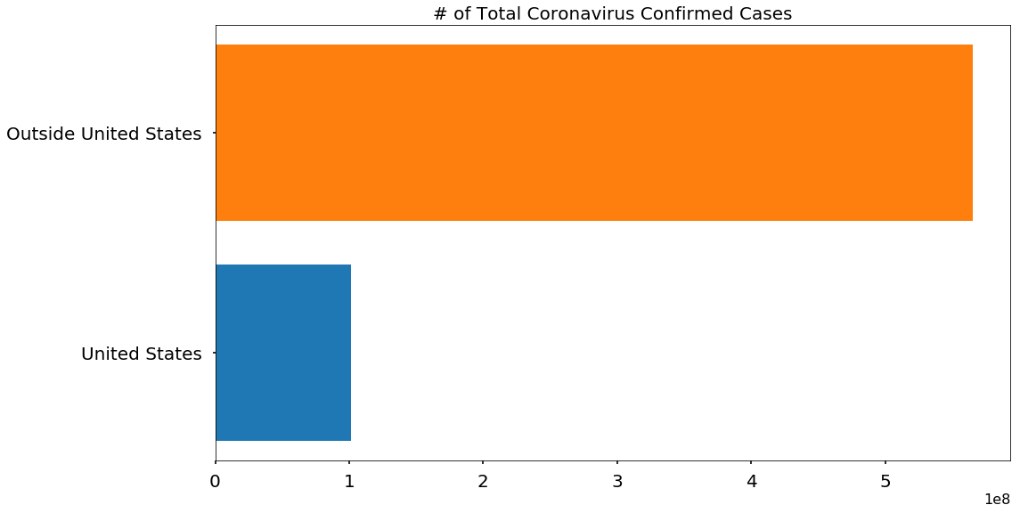

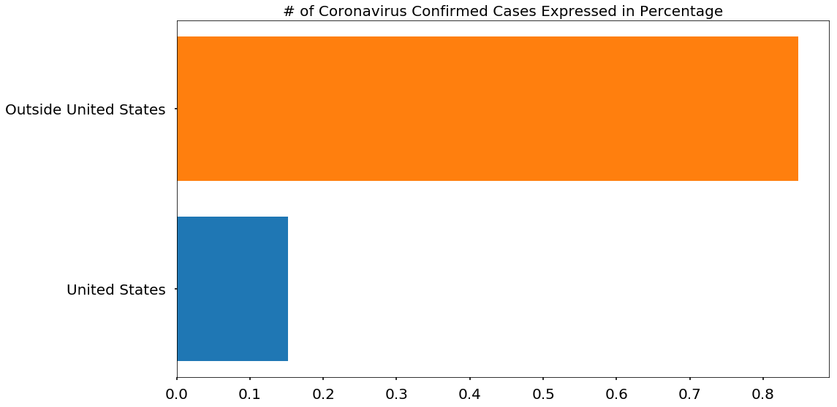

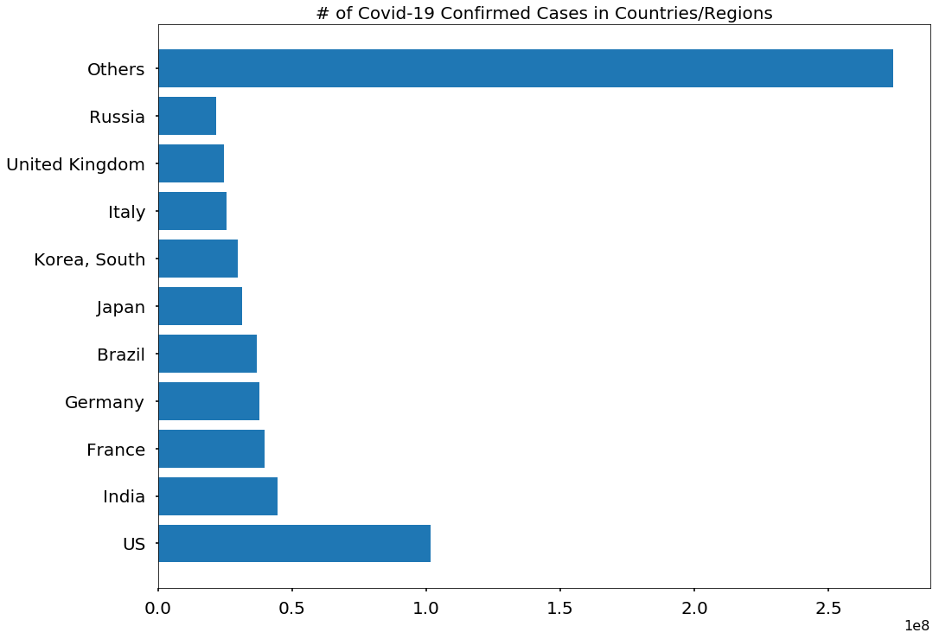

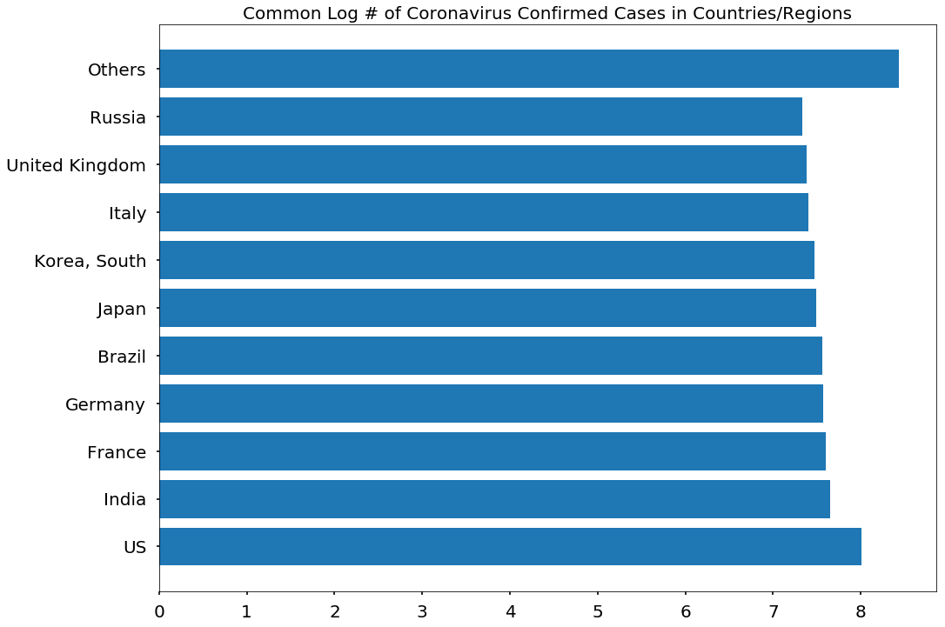

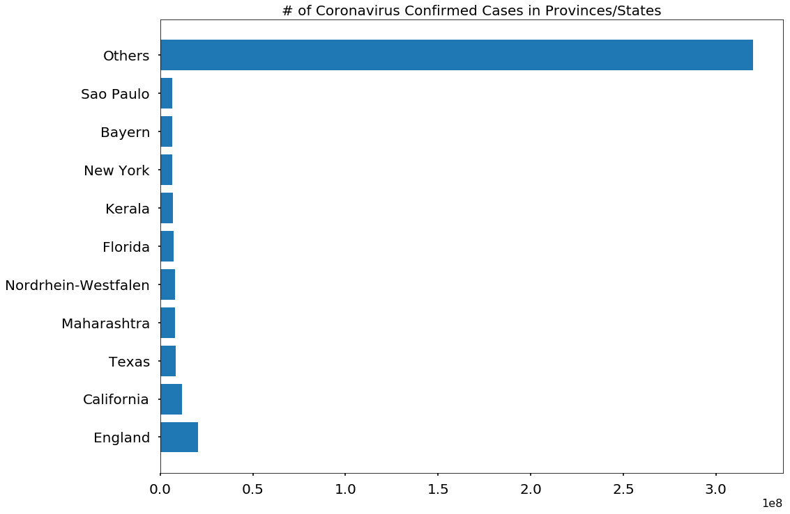

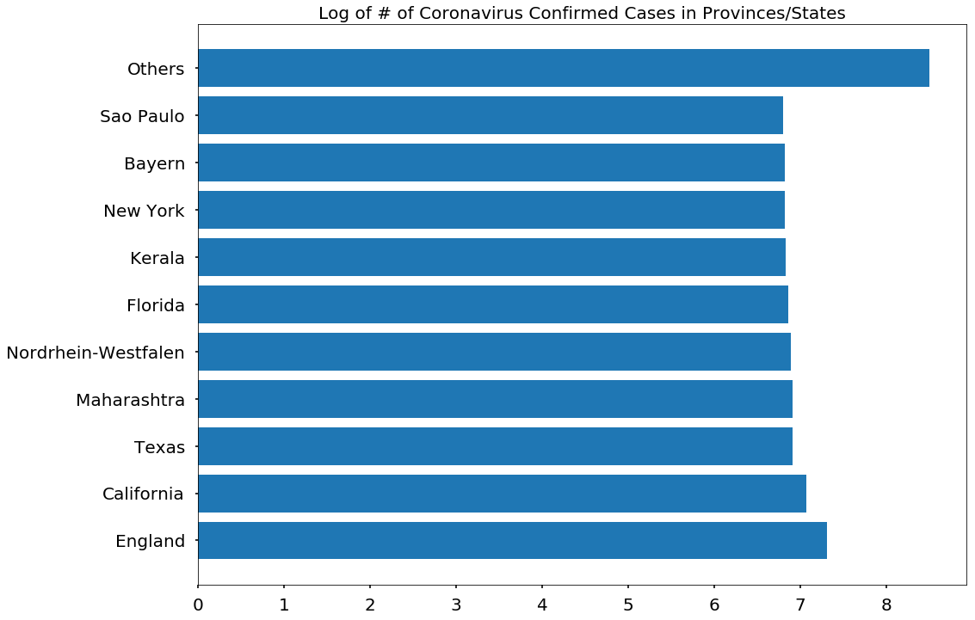

Pie Chart Visualizations for COVID-19

Although pie charts are not necessarily the most informative visualizations, I added them to increase some variety for the visualizations.

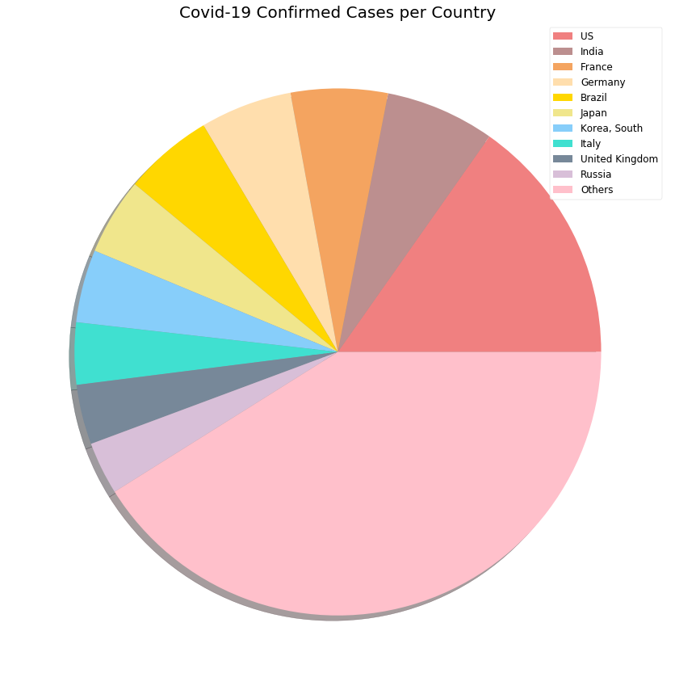

unfold_moreShow hidden code

