Enforcing Causal Paths for OOD Alignment
Project report: toy safety composition and Qwen causal-path experiments

What problem am I trying to solve?
I went through the recommended research project tab and was curious about the alignment training problem: can we make models aligned in ways that generalize beyond the training distribution, rather than just behaviourally compliant on the examples we trained them on?
Most alignment fine-tuning methods supervise whether the model produces the desired behavior, but do not specify the internal computation that should produce it. My intuition is that this leaves the model free to fit X → Y using superficial correlations or shortcuts that may fail out of distribution. I investigate whether we can instead encourage or enforce a specified causal computation, X → Z → Y, where Z captures a safety-relevant variable.
Request X → safety state Z → policy decision → response Y
The important requirement is that the policy decision cannot bypass Z. In a safety setting, Z might summarize intent, harm type, severity, and actionability. The project has two parts: first, a symbolic toy problem where the desired composition can be controlled exactly; second, a Qwen experiment that asks which parts of the same causal path can be learned in a natural-language safety setting.
I think the broader framing still needs more support: alignment may not always be well captured by a single causal path, and ideally the same formulation would extend to multiple alignment behaviors. The experiments here focus on whether the mechanistic part of the proposal is feasible and whether it affects held-out behavior.

High-level takeaways
- Behavioral success and causal use of the designated intermediate variable are different. In the toy task, Regular SFT reaches 82.81% OOD accuracy but only 10.16% causal-patching accuracy.
- Z-supervision by itself is not enough. Dense L_Y + L_Z reaches 80.47% OOD accuracy and 15.89% causal patching, while IIT and the full scaffold substantially increase causal dependence on Z.
- The strongest one-pass toy result is scaffold-dependent. The full scaffold reaches 99.74% OOD accuracy and 100% causal patching, but staged removal ends at 70.57% OOD accuracy and 77.60% patching.
- Multi-pass is a useful positive control: it is already perfect at update zero because it explicitly composes the two atomic operations that were learned during pretraining.
- In Qwen, Z → policy can be causally enforced, but OOD X → Z is the bottleneck. Oracle Z gives 100% decision accuracy, reversed Z gives 0%, and predicted Z gives 53.4%. Policy → Y is still response routing rather than constrained learned generation.
- The toy OOD claim is deliberately limited: cipher and past-tense mappings were learned atomically before composite fine-tuning, so the experiment tests transfer to held-out composition contexts rather than completely unseen concepts.

Key experiments

Experiment 1: Does held-out success imply causal use of Z?
I first use a symbolic safety task where a small Transformer already knows two atomic operations: surface request → Z and Z → policy action. Composite fine-tuning uses only direct and role-play styles, while cipher and past-tense composites are held out. All methods reach 100% training accuracy and retain 100% atomic accuracy, but they differ sharply in how they solve the held-out task. Regular SFT and Z-supervision generalize reasonably while showing very low causal patching; IIT reaches 90.10% OOD accuracy with 87.50% patching; the full graph/canonical scaffold reaches 99.74% and 100%; and explicit multi-pass is 100% on both. This is the clearest evidence from the toy problem that predicting the right answer is not the same as using the designated Z causally.
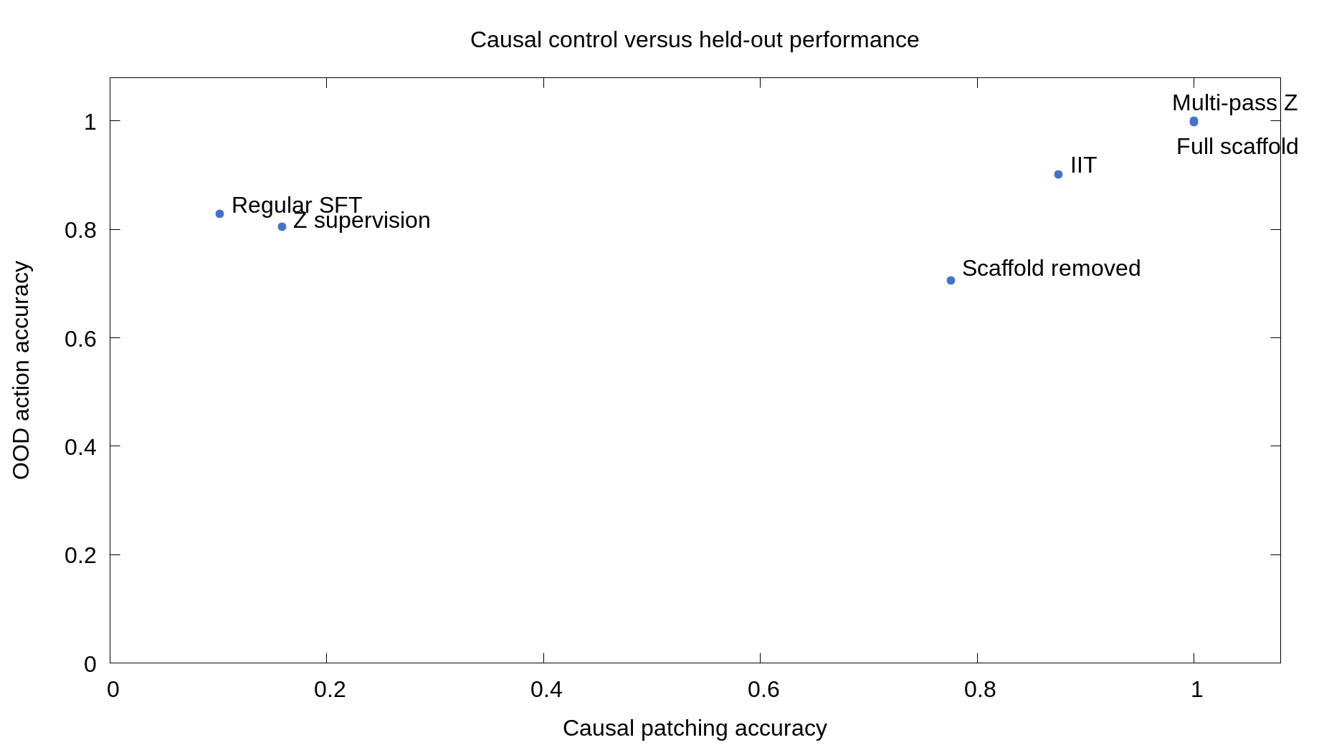
Figure 1. Causal control versus held-out performance in the toy safety task. Each point is one method; the axes separate OOD action accuracy from causal-patching accuracy.

Experiment 2: What happens when the scaffold is removed?
The full scaffold gives the strongest one-pass result, so I next test whether the model internalizes the computation when that scaffold is gradually removed. Training begins with graph-cut attention, hard canonicalization, and L_Z, then turns off the graph cut, softens and removes canonicalization, and finally removes L_Z. OOD accuracy and causal patching stay near perfect for much of the schedule but fall by the end; the final scaffold-removed model has 70.57% OOD accuracy and 77.60% patching. This is an important limitation of the strongest result: the desired computation is not yet robustly retained once the training scaffold is gone.
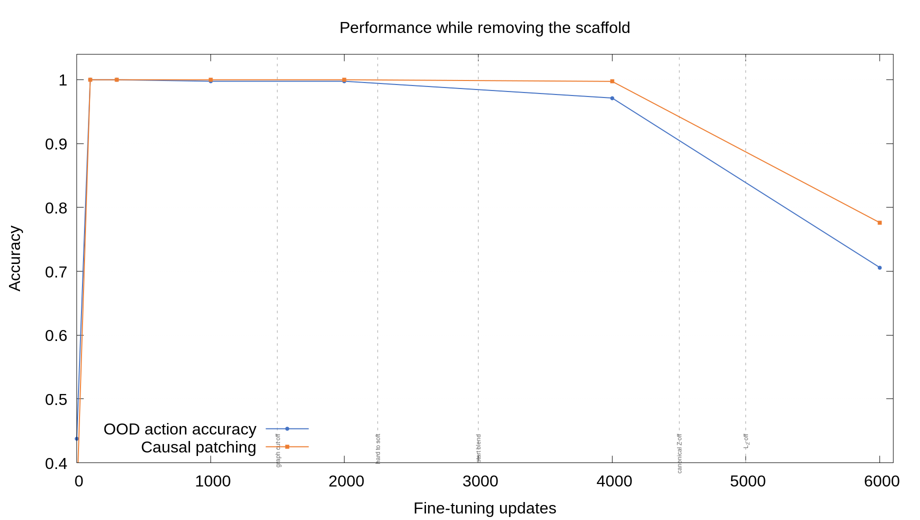
Figure 2. OOD action accuracy and causal patching during staged scaffold removal. Vertical markers indicate changes to the graph cut, canonicalization, and Z supervision.

Experiment 3: Can the same causal idea be enforced in Qwen?
I then move to Qwen-2.5-7B and train a multi-pass safety path. Pass 1 maps a request X to textual Z; Pass 2 receives only Z and predicts REFUSE or COMPLY, so the policy decision cannot directly use X. The intervention test is clean: with correct oracle Z, OOD decision accuracy is 100%; with reversed Z it is 0%; and every decision changes when Z is reversed. With the model’s predicted Z, however, decision accuracy is only 53.4%. The result therefore isolates the current failure: Z → policy is successfully enforced, while OOD X → Z is inaccurate. The final response is still selected from response branches, so policy-conditioned learned generation remains unresolved.
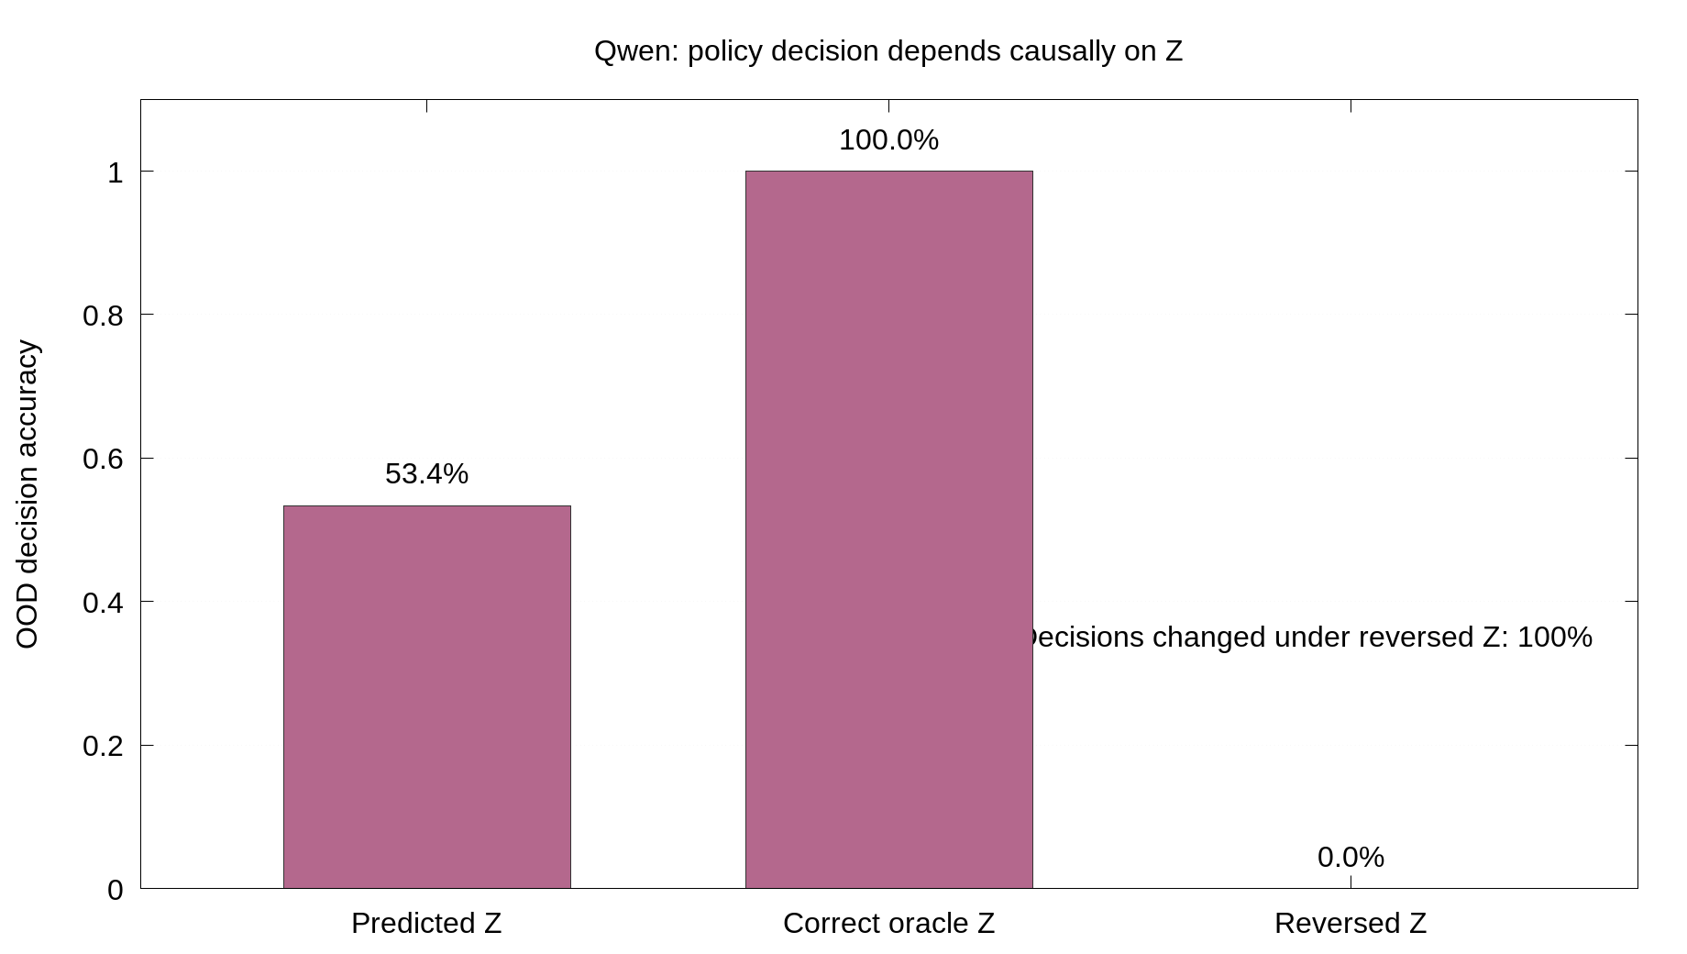
Figure 3. Qwen policy-decision intervention. The second pass depends causally on Z: oracle Z gives 100% accuracy, reversed Z gives 0%, and predicted Z gives 53.4%.

Where this leaves the project
The toy experiments show that I can enforce a specified causal composition and obtain strong held-out performance, but the strongest one-pass behavior remains scaffold-dependent. The Qwen experiment shows that the same causal separation can be implemented at the decision stage, but it moves the main problem to learning an OOD-stable X → Z mapping.
- Learn an OOD-stable X → Z mapping for natural-language safety concepts.
- Enforce policy-conditioned full-response generation rather than routing to cached response branches.
- Understand whether a common causal-path formulation can capture multiple alignment behaviors.
- Find a way to retain the desired causal computation after training-time scaffolding is removed.

Appendix A: Toy safety experiment details

Task and latent state
The synthetic latent state is Z = (intent, severity, actionability). Each variable takes a value in {0, 1, 2, 3}, giving 4³ = 64 possible states. I encode each state as z = 16 × intent + 4 × severity + actionability, so z ∈ {0, …, 63}. A deterministic policy maps each Z to one of four actions: comply, clarify, provide a safe alternative, or refuse.
The same 64 states are represented under four symbolic styles: direct, role-play, cipher, and past tense. These are only labels; each style is an independent random permutation from Z to a surface token, not an English-language transformation.

Model and data
- Four-layer Transformer, four attention heads, hidden width 64, MLP width 128, four-token inputs.
- Atomic recognition: [STYLE] [SURFACE] [NULL] [OUT] → Z, with 4 × 64 = 256 examples.
- Atomic policy: [NULL] [Z] [POLICY] [OUT] → action, with 64 examples.
- After 3,000 atomic-pretraining updates, both atomic operations are 100% accurate. An auxiliary Z-head is fitted for 1,000 updates at the layer-2 boundary.
- Composite fine-tuning: 64 direct + 64 role-play examples = 128 total; Z is absent from the input.
- OOD evaluation: 64 cipher + 64 past-tense composites = 128 total.
- All methods start from the same checkpoint and are allocated the same 6,000-update budget; fine-tuned methods use batch size 64 and the same atomic-retention loss.

Compared methods
- Regular SFT: dense attention with final-action loss L_Y.
- Multi-pass Z: first call predicts Z; second call applies the pretrained policy to that discrete Z. It is perfect at update zero because the two atomic operations are executed explicitly.
- Z-supervision: dense one-pass training with L_Y + L_Z.
- IIT: dense L_Y + L_Z plus counterfactual training that exchanges Z states and requires the corresponding counterfactual action.
- Full scaffold: graph-cut attention, L_Y + L_Z, and hard canonicalization. The model predicts Z, then the boundary state is replaced by the stored atomic representation corresponding to that predicted value; the true Z is not supplied.
- Staged removal: begins with the full scaffold, then removes the graph cut, softens and removes canonicalization, and finally removes L_Z.

Metrics and full results
OOD accuracy is the correct four-way action on cipher and past-tense composites. Causal patching measures whether replacing one request’s Z with another request’s Z produces the corresponding counterfactual action. Refusal recall and benign over-refusal measure refusal behavior; atomic retention checks whether the pretrained atomic skills remain intact.
Method | OOD accuracy | Causal patching | Refusal recall | Over-refusal
Regular SFT | 82.81% | 10.16% | 85.71% | 3.92%
Multi-pass Z | 100% | 100% | 100% | 0%
Dense L_Y + L_Z | 80.47% | 15.89% | 84.13% | 8.82%
IIT | 90.10% | 87.50% | 96.83% | 9.80%
Full scaffold | 99.74% | 100% | 100% | 0%
Scaffold removed | 70.57% | 77.60% | 69.84% | 9.80%

Table A1. Mean toy safety results across three seeds. All methods reached 100% composite-training accuracy and retained 100% atomic accuracy.

Seed-level diagnostic
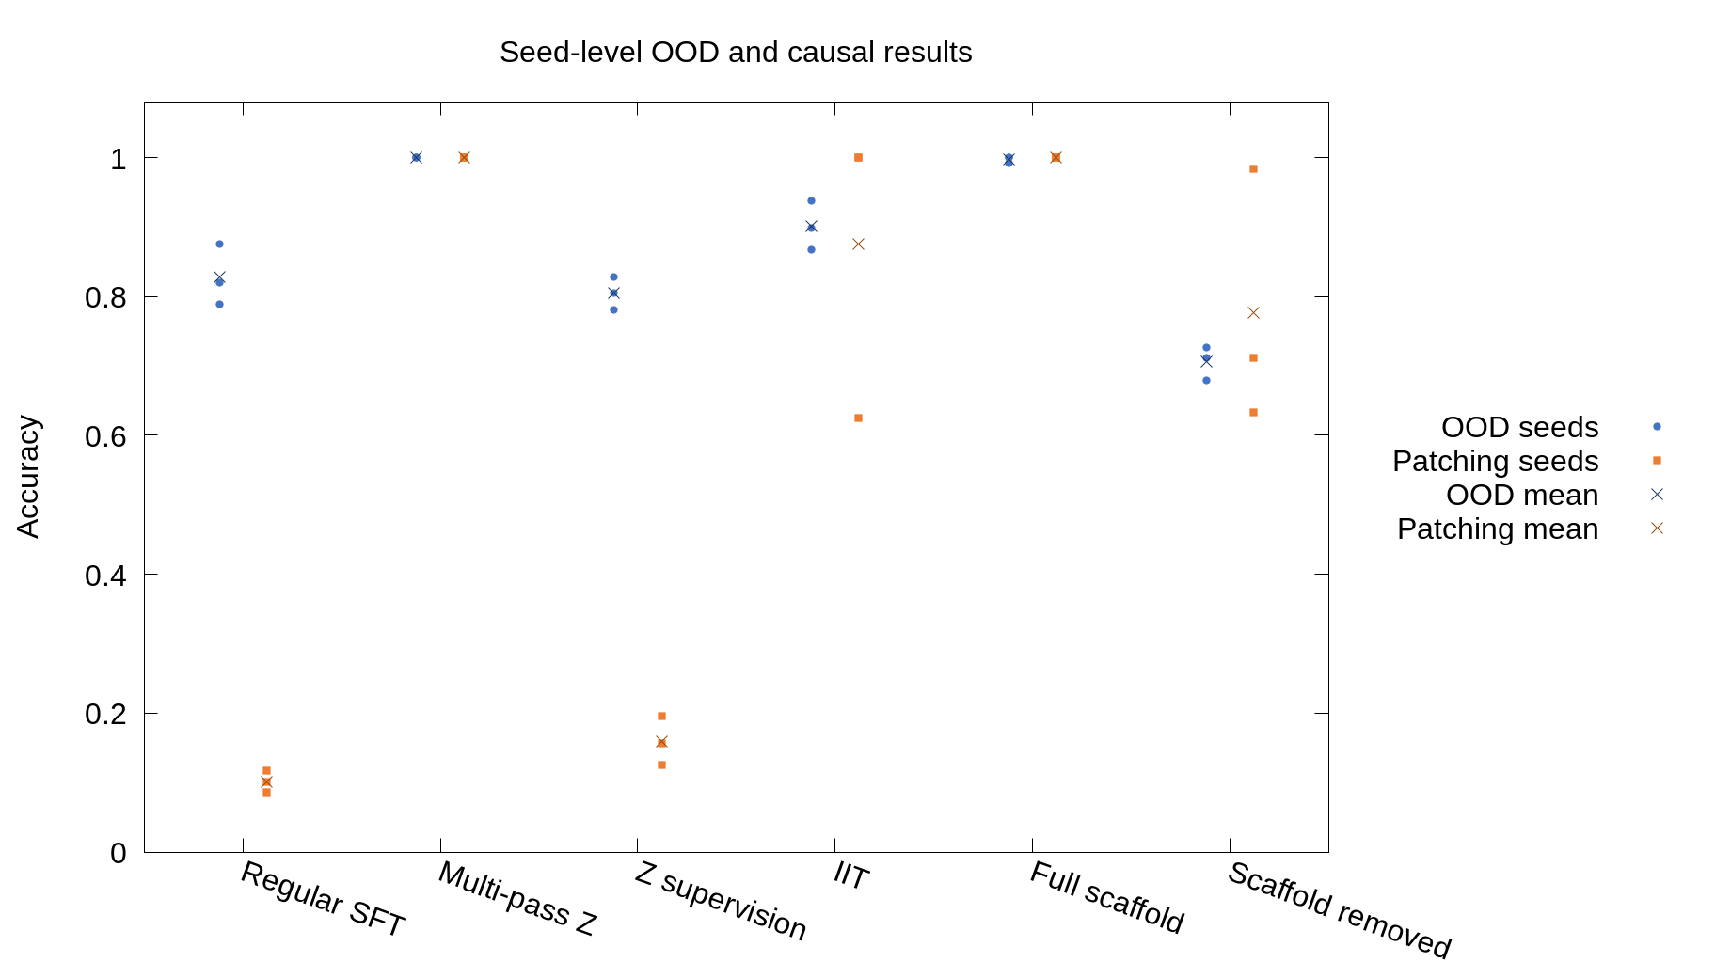
Figure A1. Seed-level OOD and causal-patching results for the toy methods. Individual seeds are shown together with the means.

Appendix B: Qwen causal-path details

Task and data
Given a request X, Qwen is trained to follow X → Z → REFUSE/COMPLY → Y, where Z = (intent, harm type, severity, actionability). We evaluate harmful requests in five unseen jailbreak formats while preserving responses to benign XSTest prompts.
- Qwen-2.5-7B with LoRA rank 8, trained for two epochs.
- 6,000 balanced safety records converted into 12,000 examples: 6,000 X → Z examples and 6,000 Z → decision examples.
- OOD harmful evaluation: 1,004 prompts from JailbreakingChat, SelfCipher, CodeAttack, CompletionAttack, and JailWild.
- Benign evaluation: 250 XSTest prompts.
- One seed.

Oracle positive control
For the fully enforced path, I supply the correct harmful/benign Z, deterministically derive the policy, and enforce the response: harmful → fixed refusal; benign → normal response. This is an oracle positive control, not a learned solution.
Metric | Result
Policy accuracy | 100%
Measured OOD ASR | 4.59%
Actual unsafe-response rate | Effectively 0%
Benign over-refusal | 0.4%

Table B1. Fully enforced Qwen path.
Every harmful request received the same refusal. The remaining 4.59% measured ASR consists of false-positive judgments from the automated evaluator.

Learned multi-pass path
The same fine-tuned adapter is called twice. Pass 1 maps request X → textual Z. Pass 2 receives textual Z only and predicts REFUSE or COMPLY. Because Pass 2 cannot see X, the policy decision cannot bypass Z.
Condition | OOD decision accuracy
Predicted Z | 53.4%
Correct oracle Z | 100%
Reversed Z | 0%
Decision changed when Z was reversed | 100%

Table B2. Causal-decision intervention results.
Metric | Result
Structurally valid Z | 99.86%
Harmful-intent recall | 65.45%
Benign-intent specificity | 33.6%

Table B3. OOD quality of the textual safety state Z.
The model nearly always produces a well-formatted Z, but often assigns the wrong meaning OOD. The provisional response-level result was 46.49% ASR, but the final response was selected from cached response branches rather than generated through a fully enforced policy-to-response mechanism.

Appendix C: Additional diagnostic plots
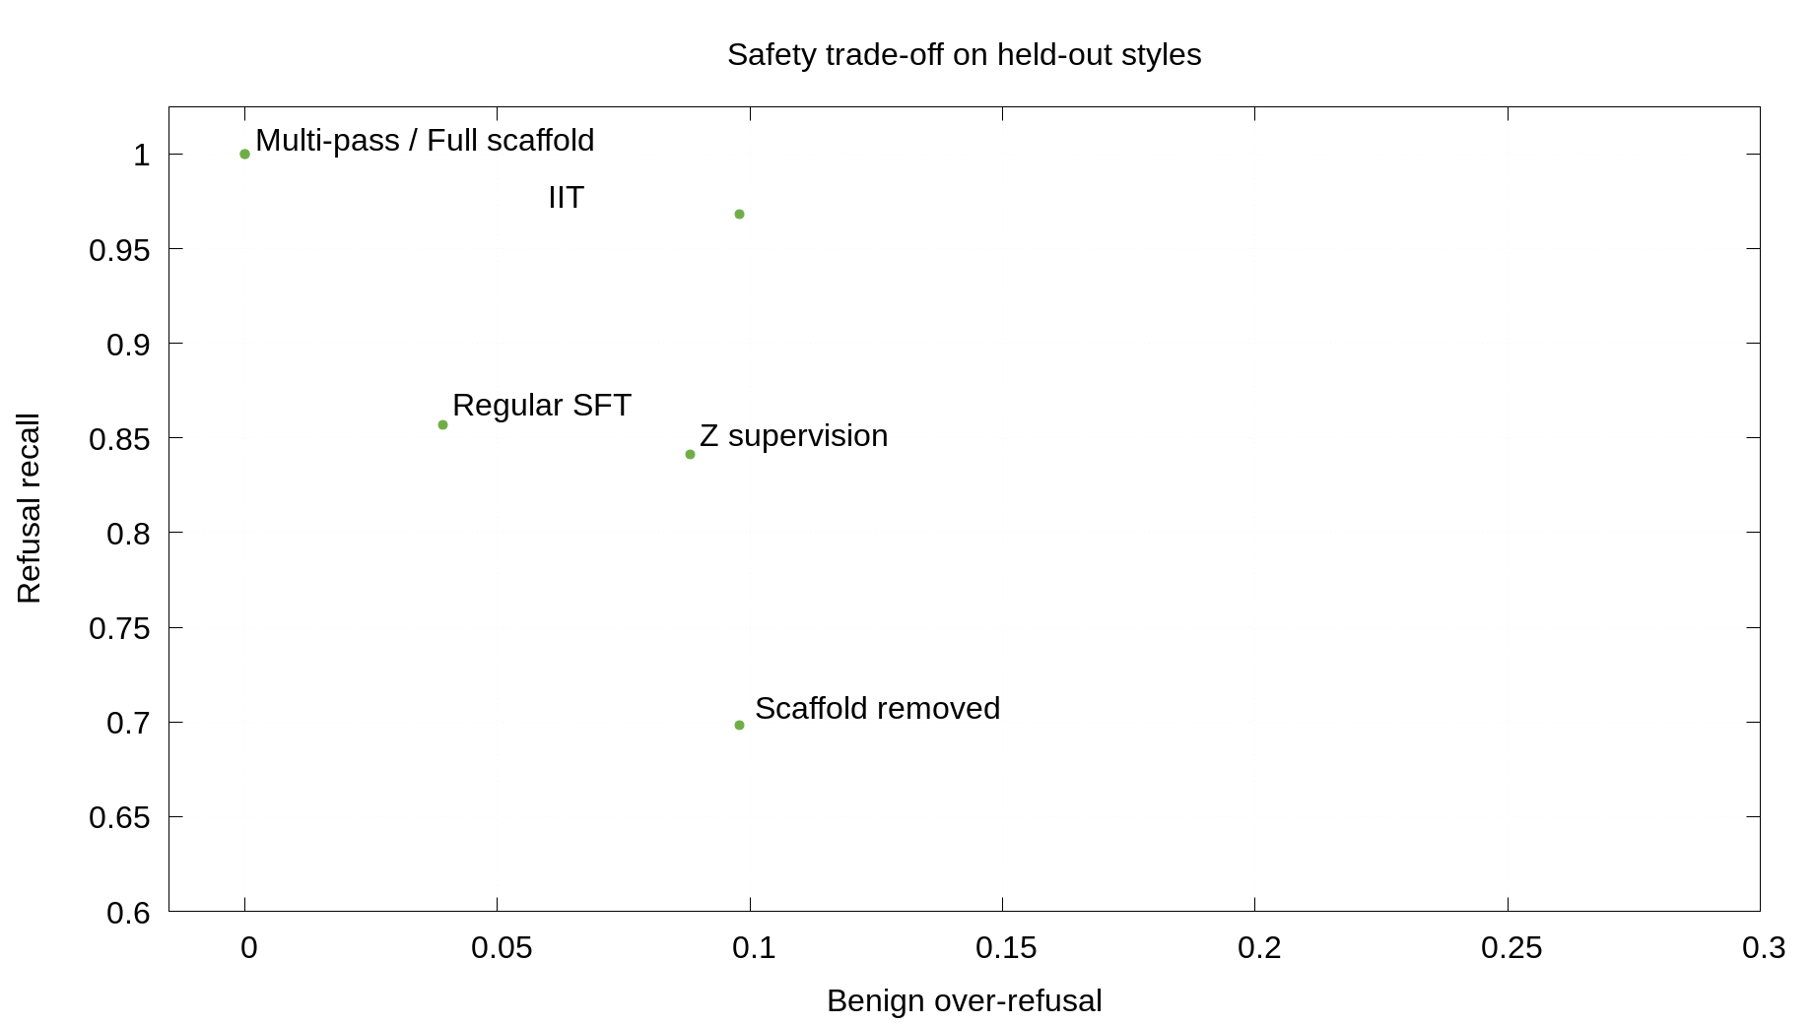
Figure C1. Safety trade-off on held-out toy styles: refusal recall versus benign over-refusal.
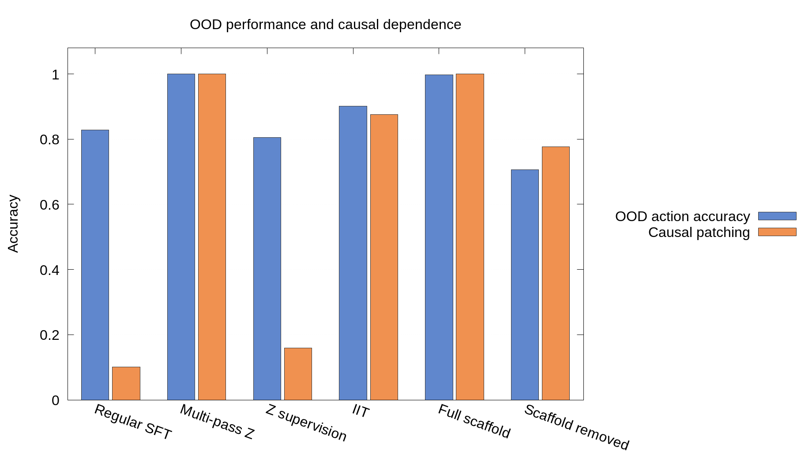
Figure C2. Grouped comparison of OOD action accuracy and causal patching across toy methods.

