Demo Title: Event-Related Potential Extraction System Development and Applications.

Event Type: Brain, Computation, and Learning (BCL-2023) Workshop,

Date: January 09-13, 2023

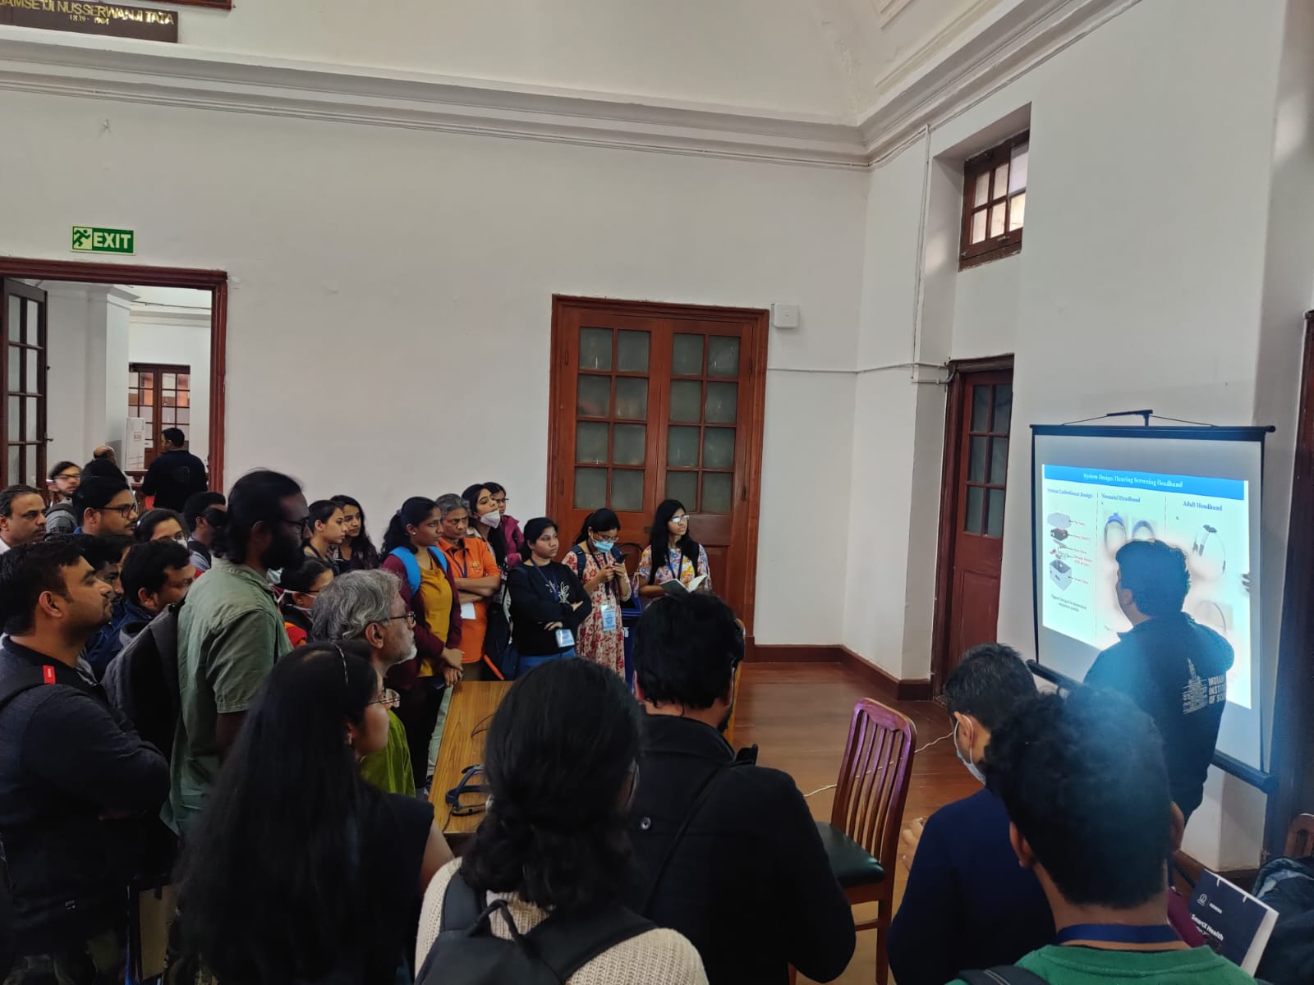Venue: Faculty Hall, Indian Institute of Science, Bangalore.