|  |  |
| --- | --- |
| **Ex. No. 4** | **Sign-In and Sign-Up Webpage with Navigation Bar using CSS** |
| **Date of Exercise** | 02/08/2023 |

**Aim:**

To create a sign-in and sign-up form, including a horizontal navigation bar, for any industry using HTML and CSS.

**Description:**

CSS (Cascading Style Sheets) is used to style and layout web pages - for example, to alter the font, color, size, and spacing of your content, split it into multiple columns, or add animations and other decorative features.

**CSS Position:**

CSS (Cascading Style Sheets) is a language used for styling and formatting web documents, particularly HTML pages. The `position` property in CSS determines how an element is positioned within its containing element or the viewport. It has several possible values:

* **static:** This is the default value. Elements with `position: static` are positioned according to the normal flow of the document. They cannot be moved using properties like `top`, `bottom`, `left`, or `right`.
* **relative**: Elements with `position: relative` are positioned relative to their normal position in the document flow. You can use properties like `top`, `bottom`, `left`, or `right` to move the element from its original position.
* **absolute**: Elements with `position: absolute` are positioned relative to their closest positioned ancestor (or the containing element if there's none). They are taken out of the normal document flow, so they can overlap other elements. This positioning is often used for creating overlays or tooltips.
* **fixed**: Elements with `position: fixed` are positioned relative to the viewport (browser window). They remain fixed in place even when the user scrolls. This is often used for creating persistent headers, footers, or navigation bars.
* **sticky**: Elements with `position: sticky` are initially positioned according to the normal flow of the document, but they become "stuck" or "fixed" as the user scrolls. They behave similarly to `position: relative` until a certain scroll threshold is reached, at which point they become fixed in place.

**CSS Forms:**

The look of an HTML form can be greatly improved with CSS. Styling Input Fields, Use the width property to determine the width of the input field:

input {

width: 100%; }

input[type=text] - will only select text fields

input[type=password] - will only select password fields

**Padded Inputs:**

Use the padding property to add space inside the text field.

input[type=text] {

width: 100%;

padding: 12px 20px;

margin: 8px 0;

box-sizing: border-box;

}

**Bordered Inputs:**

Use the border property to change the border size and color, and use the border-radius property to add rounded corners.

input[type=text] {

border: 2px solid red;

border-radius: 4px;}

**Program:**

**HTML**

<!DOCTYPE html>

<html>

<head>

<title>Shop cart</title>

<meta name="viewpoint" content="width=device-width,initial-scale=1.0">

<link rel="stylesheet" href="style.css">

</head>

<body>

<ul style="font-size:180%;color: white;">

<li><a href="#home">Home</a></li>

<li><a href="#about">About</a></li>

<li><a href="#contact">Contact</a></li>

<li><a href="#Products">Products</a></li>

<li><a href="#cart">Cart</a></li>

</ul>

<div class="bg">

<div>

<h3 style="padding-left: 65%;padding-top: 5%;font-size: xx-large;font-family: Verdana, Geneva, Tahoma, sans-serif;"><b>Shop Cart</b></h3>

</div>

<div class="Signin">

<h1 style="text-align: center; font-size: 180%;">Sign-In</h1>

<form>

<label for="signinphno">Phone Number</label>

<input type="tel" id="signinphno" name="signinnum" value="Eg.9876543210"><br>

<label for="password">Password</label>

<input type="password" id="signinpass" name="signinapassc">

<button>Sign-In</button>

</form>

<div class="Signup">

<h1 style="text-align: center; font-size: 180%;">Sign-Up</h1>

<form>

<label for="signupname">Name</label>

<input type="name" id="signupname" name="signupname" value="Eg: Kumar">

<label for="phno1">Phone Number</label>

<input type="tel" id="signupph" name="signupnum" value="Eg:9876543210">

<label for="signuppass">Password</label>

<input type="password" id="signuppass" name="signuppass1">

<button>Sign-Up</button>

</form>

</div>

<p>❝Welcome to our online shopping site, where incredible deals await you! Shop from the comfort of your home and enjoy the convenience of doorstep delivery. Check out our latest promotions and offers on products session.❞</p>

</div>

</body>

</html>

**CSS**

*{

margin: 0;

}

html,body{

height: 100%;

}

.bg{

width: 100%;

height: 100%;

background-image: url(bg.jpeg);

background-repeat: no-repeat;

background-size:cover;

position: relative;

}

ul{

overflow: hidden;

list-style-type: none;

background-color: #000002cb;

}

li{

width: 20%;

float: left;

}

li a{

color: white;

display: block;

text-decoration: none;

text-align: center;

}

li a:hover{

background-color: rgba(103, 97, 97, 0.451);

}

.Signin{

width: 330px;

height: 225px;

background-color: white;

position: absolute;

left: 700px;

top: 150px;

padding: 20px;

box-sizing: border-box;

border-radius: 10px;

}

.Signin input{

background-color: antiquewhite;

padding: 8px ;

width: 90%;

border-radius: 8px;

}

.Signin button{

background-color: aqua;

position: absolute;

padding-top: 2%;

padding-bottom: 2%;

top: 180px;

left: 100px;

right: 100px;

box-sizing: border-box;

border-radius: 8px;

}

.Signup{

width: 400px;

height: 285px;

background-color: white;

position: absolute;

margin-left: 98%;

margin-top: -50%;

padding-top: 6%;

padding-left: 10%;

padding-right: 10%;

box-sizing: border-box;

border-radius: 10px;

}

.Signup button{

background-color: aqua;

position: absolute;

padding-top: 2%;

padding-bottom: 2%;

padding-left: 3%;

top: 235px;

left: 130px;

right: 130px;

box-sizing:content-box;

border-radius: 8px;

}

p{

padding: 80px;

padding-left: 1%;

padding-right: 8%;

font-family: Cambria, Cochin, Georgia, Times, 'Times New Roman', serif;font-size: 140%;

}

**Output:**

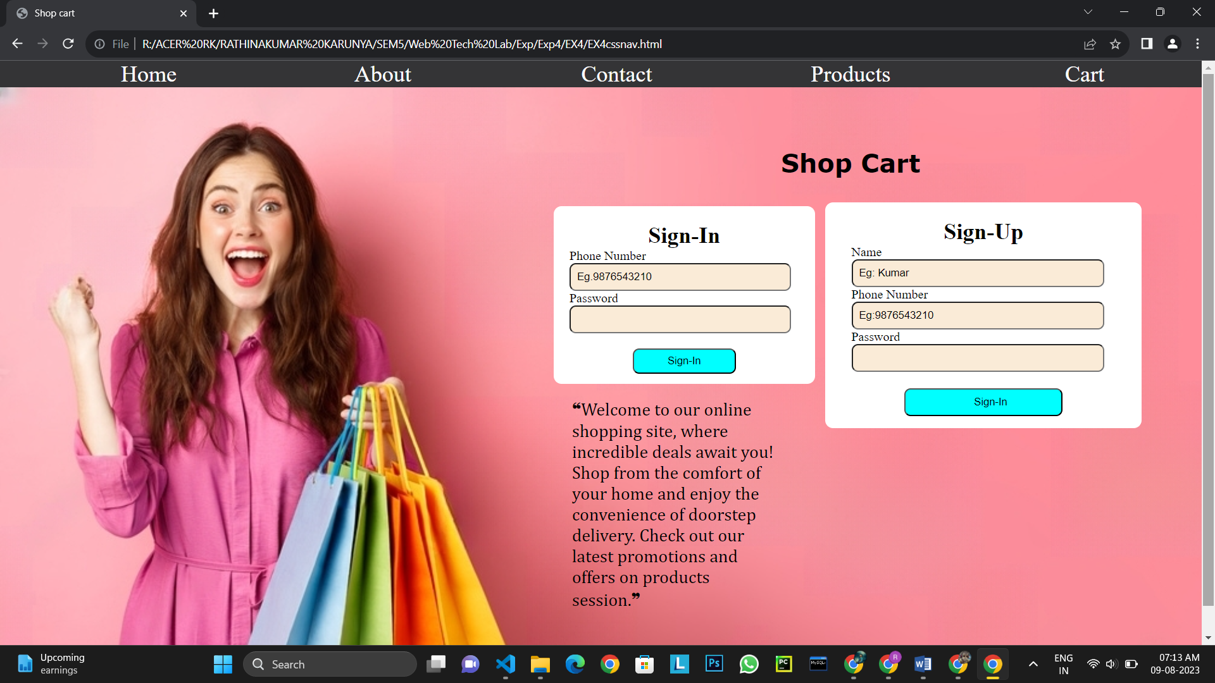

**Result:**

The program is executed successfully and the program output is displayed in the web browser.