
RAJALAKSHMI INSTITUTE OF TECHNOLOGY
(An Autonomous Institution, Affiliated to Anna University, Chennai)

DEPARTMENT OF ARTIFICIAL INTELLIGENCE AND DATA SCIENCE
ACADEMIC YEAR 2025 - 2026
SEMESTER III
ARTIFICIAL INTELLIGENCE LABORATORY
MINI PROJECT REPORT

REGISTER NUMBER | 2117240070252
NAME | P.N.Rathish
PROJECT TITLE | Rock-Paper-Scissors AI (Random + Learning)
DATE OF SUBMISSION
FACULTY IN-CHARGE | Ms. M. Bhavani

Signature of Faculty In-charge

INTRODUCTION
Artificial Intelligence (AI) is a branch of computer science that enables machines to perform tasks that normally require human intelligence. It includes problem solving, learning, reasoning, and adaptation. In modern computing, AI has been integrated into various applications such as recommendation systems, autonomous vehicles, speech recognition, and games. The Rock-Paper-Scissors game provides an excellent platform to study AI decision-making because it is a simple, zero-sum game involving probabilistic reasoning and behavioral adaptation.
This project focuses on developing an AI agent that plays Rock-Paper-Scissors intelligently using a combination of randomness and learning. Initially, the AI behaves randomly, but as the player continues to make moves, the AI begins to recognize recurring patterns in the player’s decisions. Over time, it adjusts its strategy by predicting the most likely next move. This type of adaptive learning demonstrates how AI can mimic cognitive processes such as pattern recognition and decision optimization. The implementation of this project uses Python and the Tkinter library for the graphical interface, allowing real-time interaction between the human player and the AI system.

PROBLEM STATEMENT
The Rock-Paper-Scissors game, though simple, presents a challenge for AI design because of the unpredictable nature of human behavior. Traditional game implementations rely on random move generation, which makes the AI non-intelligent and easy to beat in the long run. Humans tend to develop subconscious habits or move patterns, which can be exploited by a learning AI. The problem, therefore, is to design an AI system that can observe the player’s past moves, identify patterns, and make predictions about future choices. Such a model must maintain a balance between randomness (to remain unpredictable) and learning (to adapt strategically). The project aims to create a self-improving AI agent that challenges human intuition while showcasing fundamental principles of machine learning and pattern recognition.

GOAL
The main objective of this mini project is to implement a Rock-Paper-Scissors AI game that can adaptively learn and improve against the player over time. The AI should be able to record previous moves, analyze them to detect recurring patterns, and use this knowledge to predict and counter the player’s next move. Expected results include a system that gradually increases its win rate as it gathers more gameplay data. Additionally, the project aims to provide a visually interactive and engaging experience using a Graphical User Interface (GUI). This experiment also demonstrates practical applications of AI concepts like heuristic reasoning, pattern recognition, and adaptive systems.

THEORETICAL BACKGROUND
The theoretical basis for this project lies in the domain of learning agents and pattern recognition. A learning agent is an AI system that improves its performance based on experience. In this project, the AI acts as a model-based learning agent that stores and analyzes the player’s historical data. The AI uses a simple frequency-based prediction model: for every sequence of recent moves, it records the frequency of subsequent moves. When the same sequence appears again, the AI predicts the player’s most probable next move and chooses the counter move to it.
The model resembles a low-order Markov chain, where the next state (move) depends on a small number of previous states. Although more complex models like reinforcement learning or neural networks could be used, they are computationally intensive and unnecessary for this small-scale problem. The chosen approach is lightweight, interpretable, and effective for demonstrating fundamental AI learning behavior. It reflects real-world AI principles of pattern detection, adaptive reasoning, and bounded rationality — making decisions using limited historical information.

ALGORITHM EXPLANATION WITH EXAMPLE
Step 1: The player selects Rock, Paper, or Scissors.
Step 2: The AI checks if it has enough historical data (a predefined pattern length of 3 moves).
Step 3: If sufficient data exists, the AI identifies the most recent move sequence and looks it up in its pattern dictionary.
Step 4: The AI predicts the player’s next likely move using frequency analysis.
Step 5: The AI selects the counter move (Rock beats Scissors, Paper beats Rock, Scissors beats Paper).
Step 6: The result (Win, Lose, or Tie) is displayed in the GUI, and both the AI’s and player’s stats are updated.
Step 7: The AI then updates its internal memory (pattern dictionary) based on the new round result.
Example: If the player often follows 'RPS' with 'R', the AI will learn to counter this by playing 'P' when it detects the 'RPS' pattern again.

IMPLEMENTATION AND CODE
Below is the Python implementation of the Rock-Paper-Scissors AI with a Tkinter-based GUI:
import tkinter as tk
from tkinter import ttk, scrolledtext
import random
from collections import defaultdict, deque
class RPSLearningAI:
"""
Rock-Paper-Scissors AI that learns player patterns over time.
Uses pattern recognition to predict next move based on history.
"""
def __init__(self, pattern_length=3):
self.pattern_length = pattern_length
self.player_history = deque(maxlen=100)
self.pattern_dict = defaultdict(lambda: {'R': 0, 'P': 0, 'S': 0})
self.moves = ['R', 'P', 'S']
self.counter_move = {'R': 'P', 'P': 'S', 'S': 'R'}
self.wins = 0
self.losses = 0
self.ties = 0
def get_ai_move(self):
"""Generate AI move based on learned patterns or random if insufficient data."""
if len(self.player_history) < self.pattern_length:
return random.choice(self.moves)
recent_pattern = ''.join(list(self.player_history)[-self.pattern_length:])
if recent_pattern in self.pattern_dict:
pattern_data = self.pattern_dict[recent_pattern]
if sum(pattern_data.values()) >= 2:
predicted_player_move = max(pattern_data, key=pattern_data.get)
return self.counter_move[predicted_player_move]
return random.choice(self.moves)
def learn_pattern(self, player_move):
"""Update pattern dictionary with the player's move."""
if len(self.player_history) >= self.pattern_length:
pattern = ''.join(list(self.player_history)[-self.pattern_length:])
self.pattern_dict[pattern][player_move] += 1
self.player_history.append(player_move)
def determine_winner(self, player_move, ai_move):
"""Determine the winner of the round."""
if player_move == ai_move:
self.ties += 1
return 'tie'
elif (player_move == 'R' and ai_move == 'S') or \
(player_move == 'P' and ai_move == 'R') or \
(player_move == 'S' and ai_move == 'P'):
self.losses += 1
return 'player'
else:
self.wins += 1
return 'ai'
def reset_stats(self):
"""Reset game statistics but keep learned patterns."""
self.wins = 0
self.losses = 0
self.ties = 0
class RPSGameGUI:
def __init__(self, root):
self.root = root
self.root.title("Rock-Paper-Scissors AI")
self.root.geometry("700x600")
self.root.resizable(False, False)
self.ai = RPSLearningAI(pattern_length=3)
self.round_number = 0
self.setup_ui()
def setup_ui(self):
"""Setup the GUI interface."""
# Title
title_frame = tk.Frame(self.root, bg="#2c3e50", height=80)
title_frame.pack(fill=tk.X)
title_frame.pack_propagate(False)
title_label = tk.Label(
title_frame,
text="🎮 Rock-Paper-Scissors AI 🤖",
font=("Arial", 20, "bold"),
bg="#2c3e50",
fg="white"
)
title_label.pack(pady=20)
# Main content frame
content_frame = tk.Frame(self.root, bg="#ecf0f1")
content_frame.pack(fill=tk.BOTH, expand=True, padx=20, pady=10)
# Info label
info_label = tk.Label(
content_frame,
text="The AI learns your patterns over time. Try to beat it!",
font=("Arial", 11),
bg="#ecf0f1",
fg="#34495e"
)
info_label.pack(pady=10)
# Round counter
self.round_label = tk.Label(
content_frame,
text="Round: 0",
font=("Arial", 14, "bold"),
bg="#ecf0f1",
fg="#2c3e50"
)
self.round_label.pack(pady=5)
# Button frame
button_frame = tk.Frame(content_frame, bg="#ecf0f1")
button_frame.pack(pady=20)
# Rock button
self.rock_btn = tk.Button(
button_frame,
text="✊\nROCK",
font=("Arial", 14, "bold"),
width=10,
height=4,
bg="#e74c3c",
fg="white",
activebackground="#c0392b",
command=lambda: self.play_round('R')
)
self.rock_btn.grid(row=0, column=0, padx=10)
# Paper button
self.paper_btn = tk.Button(
button_frame,
text="✋\nPAPER",
font=("Arial", 14, "bold"),
width=10,
height=4,
bg="#3498db",
fg="white",
activebackground="#2980b9",
command=lambda: self.play_round('P')
)
self.paper_btn.grid(row=0, column=1, padx=10)
# Scissors button
self.scissors_btn = tk.Button(
button_frame,
text="✌\nSCISSORS",
font=("Arial", 14, "bold"),
width=10,
height=4,
bg="#2ecc71",
fg="white",
activebackground="#27ae60",
command=lambda: self.play_round('S')
)
self.scissors_btn.grid(row=0, column=2, padx=10)
# Result display
self.result_text = scrolledtext.ScrolledText(
content_frame,
height=10,
width=70,
font=("Courier", 10),
bg="#34495e",
fg="#ecf0f1",
state=tk.DISABLED
)
self.result_text.pack(pady=10)
# Stats frame
stats_frame = tk.Frame(content_frame, bg="#ecf0f1")
stats_frame.pack(pady=10)
self.stats_label = tk.Label(
stats_frame,
text="AI: 0 | Player: 0 | Ties: 0 | Win Rate: 0.0%",
font=("Arial", 12, "bold"),
bg="#ecf0f1",
fg="#2c3e50"
)
self.stats_label.pack()
# Control buttons
control_frame = tk.Frame(content_frame, bg="#ecf0f1")
control_frame.pack(pady=10)
reset_btn = tk.Button(
control_frame,
text="Reset Stats",
font=("Arial", 10),
bg="#95a5a6",
fg="white",
command=self.reset_game
)
reset_btn.pack(side=tk.LEFT, padx=5)
self.pattern_label = tk.Label(
control_frame,
text="Patterns Learned: 0",
font=("Arial", 10),
bg="#ecf0f1",
fg="#7f8c8d"
)
self.pattern_label.pack(side=tk.LEFT, padx=20)
# Initial message
self.add_message("Welcome! Make your first move to start playing.\n")
def add_message(self, message):
"""Add a message to the result text area."""
self.result_text.config(state=tk.NORMAL)
self.result_text.insert(tk.END, message)
self.result_text.see(tk.END)
self.result_text.config(state=tk.DISABLED)
def get_move_name(self, move):
"""Convert move letter to full name."""
names = {'R': 'Rock', 'P': 'Paper', 'S': 'Scissors'}
return names.get(move, move)
def play_round(self, player_move):
"""Play a round of the game."""
self.round_number += 1
# Get AI move
ai_move = self.ai.get_ai_move()
# Determine winner
result = self.ai.determine_winner(player_move, ai_move)
# Display round info
self.add_message(f"\n{'='*60}\n")
self.add_message(f"Round {self.round_number}\n")
self.add_message(f"{'='*60}\n")
self.add_message(f"You chose: {self.get_move_name(player_move)} ({player_move})\n")
self.add_message(f"AI chose: {self.get_move_name(ai_move)} ({ai_move})\n")
# Display result
if result == 'player':
self.add_message(">> YOU WIN THIS ROUND! 🎉\n")
elif result == 'ai':
self.add_message(">> AI WINS THIS ROUND! 🤖\n")
else:
self.add_message(">> IT'S A TIE! 🤝\n")
# Learn from player's move
self.ai.learn_pattern(player_move)
# Update displays
self.update_stats()
self.round_label.config(text=f"Round: {self.round_number}")
self.pattern_label.config(text=f"Patterns Learned: {len(self.ai.pattern_dict)}")
# Show learning progress
if self.round_number > 0 and self.round_number % 10 == 0:
self.add_message(f"\n[INFO] AI has learned {len(self.ai.pattern_dict)} patterns!\n")
def update_stats(self):
"""Update the statistics display."""
total = self.ai.wins + self.ai.losses + self.ai.ties
win_rate = (self.ai.wins / total * 100) if total > 0 else 0
self.stats_label.config(
text=f"AI: {self.ai.wins} | Player: {self.ai.losses} | Ties: {self.ai.ties} | AI Win Rate: {win_rate:.1f}%"
)
def reset_game(self):
"""Reset the game statistics."""
self.ai.reset_stats()
self.round_number = 0
self.round_label.config(text="Round: 0")
self.update_stats()
self.add_message("\n[RESET] Statistics reset! (Learned patterns retained)\n")
def main():
root = tk.Tk()
app = RPSGameGUI(root)
root.mainloop()
if __name__ == "__main__":
main()

OUTPUT
When the program is executed, a GUI window appears with buttons for Rock, Paper, and Scissors. Each round displays the choices made by the player and AI, followed by the round’s outcome. Statistics such as AI wins, player wins, ties, and AI win rate are shown dynamically. Over multiple rounds, the AI’s learning patterns and win rate improve as it adapts to the player’s strategy.
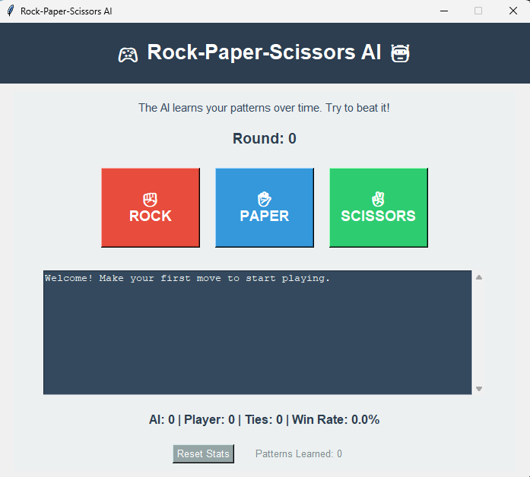
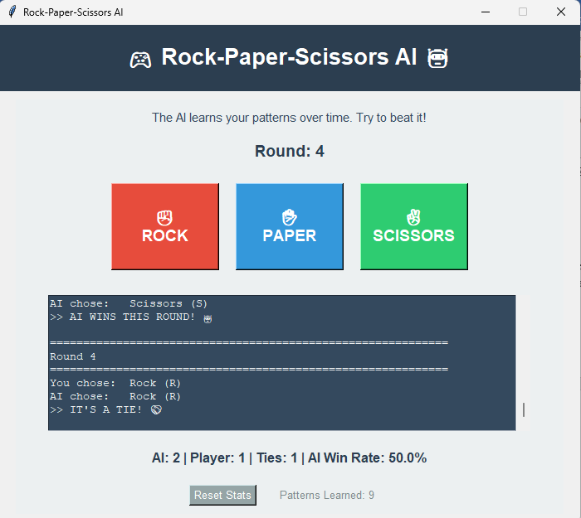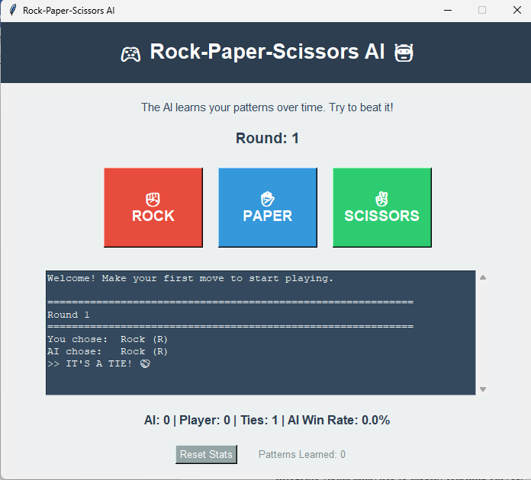

RESULTS AND FUTURE ENHANCEMENT
The Rock-Paper-Scissors AI was successfully developed and demonstrated adaptive learning capabilities. The AI’s win rate improved as it accumulated player data and learned repetitive patterns. This project proved that even simple frequency-based learning models can simulate intelligent behavior in games.
Future Enhancements:
- Implement reinforcement learning for reward-based training.
- Add difficulty levels (easy, medium, hard).
- Integrate visual analytics to display learning curves.
- Create a web-based version of the game for multi-user play.
- Expand the move set (e.g., Rock-Paper-Scissors-Lizard-Spock variant).

GIT HUB LINK OF THE PROJECT
https://github.com/Rathish-1112/rock-paper-scissors-Ai-mini-project/blob/main/rock_paper_scissors_ai_gui.py

REFERENCES
1. Russell, S., & Norvig, P. (2021). Artificial Intelligence: A Modern Approach (4th Edition). Pearson.
2. GeeksforGeeks – Rock Paper Scissors Python Implementation.
3. RealPython – Building Tkinter GUIs in Python.
4. Analytics Vidhya – Pattern Recognition and Machine Learning Simplified.
5. Medium Blog – Designing AI Opponents in Games Using Simple Heuristics

