**COMP 3123 – Full Stack Development – Lab 1**

**Exercise 1:**

***Write a JavaScript program to capitalize the first letter of each word of a given string.***

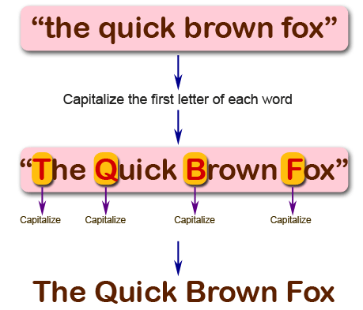

**Exercise 2:**

***Write a JavaScript program to find the largest of three given integers.***

**

**Exercise 3:**

*Write a JavaScript program to move last three character to the start of a given string. The string length must be greater or equal to three****.***

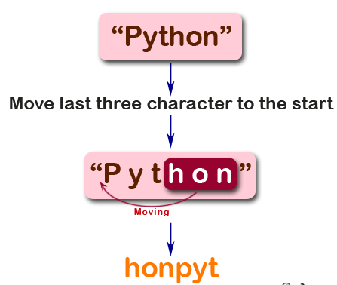

**Exercise 4:**

*Write a JavaScript program to find the types of a given angle.*

Types of angles:  
• Acute angle: An angle between 0 and 90 degrees.  
• Right angle: An 90 degree angle.  
• Obtuse angle: An angle between 90 and 180 degrees.  
• Straight angle: A 180 degree angle.



