MODEL 0
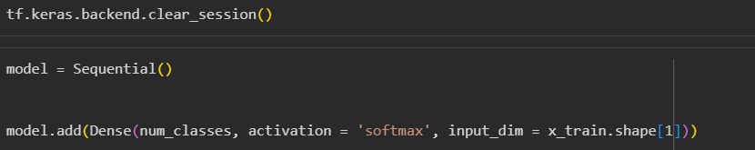

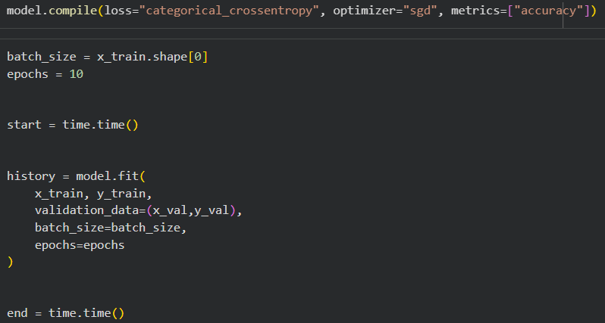

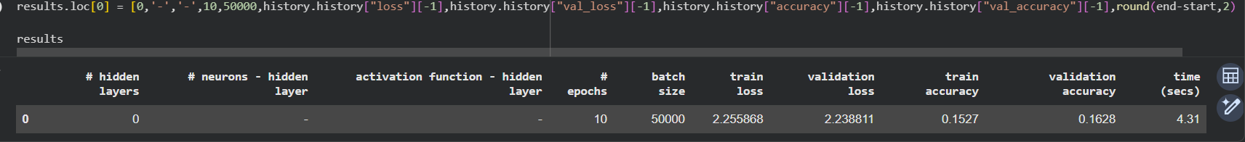

MODEL 1
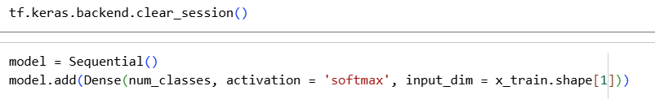

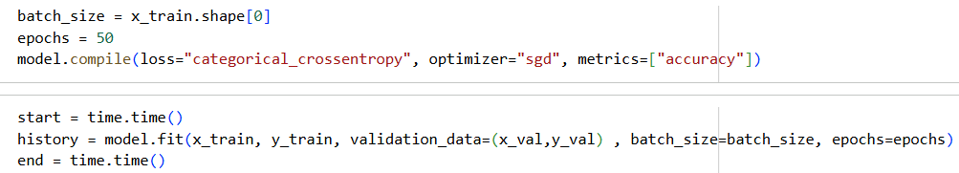

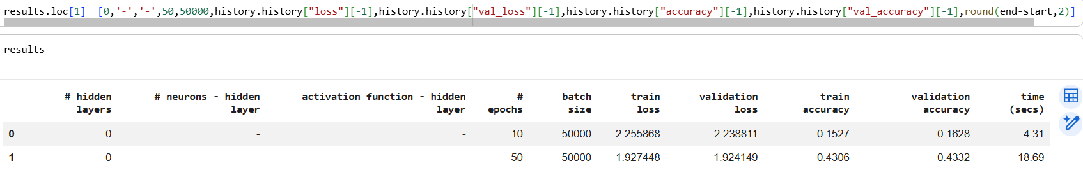

MODEL 2
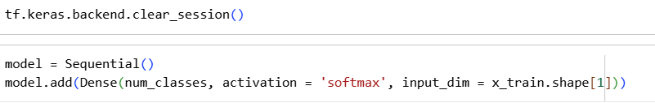

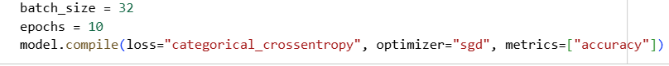

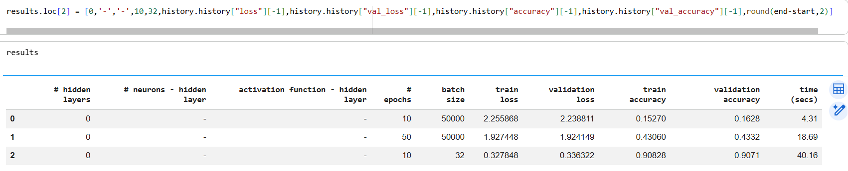

MODEL 3
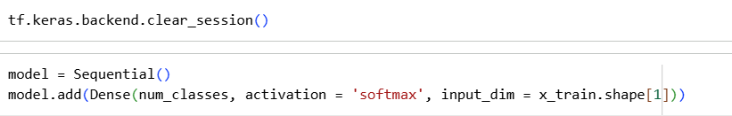

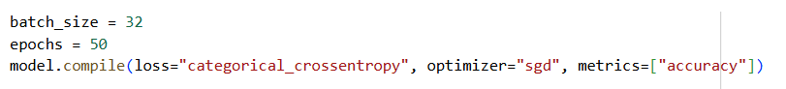

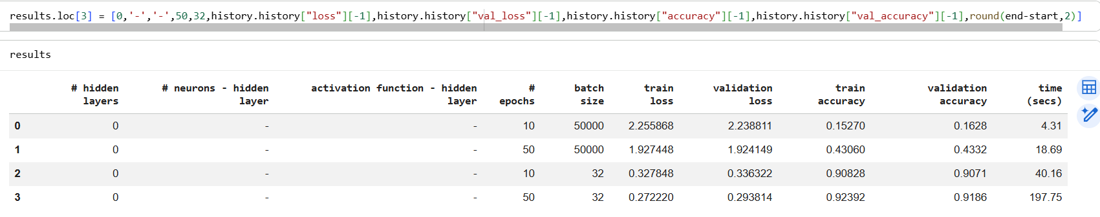

MODEL 4
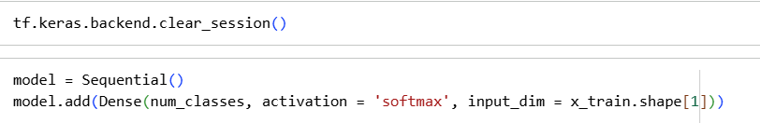

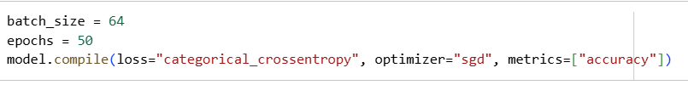

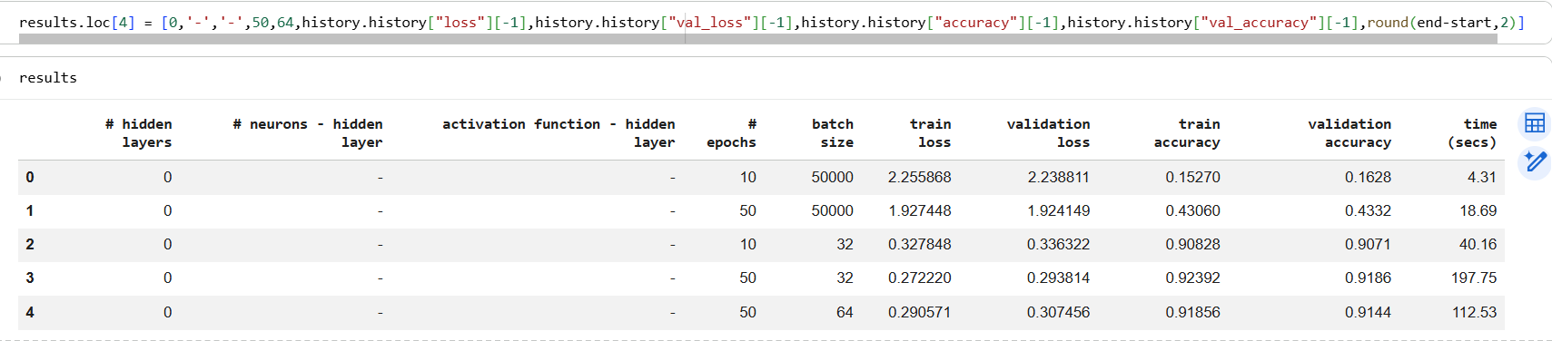

MODEL 5
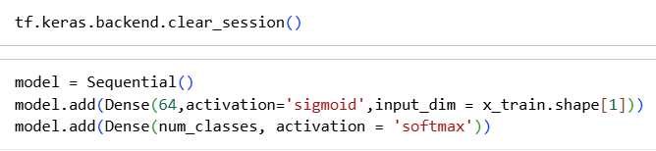

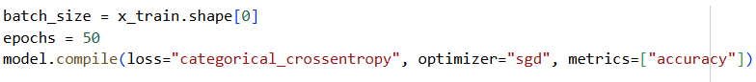

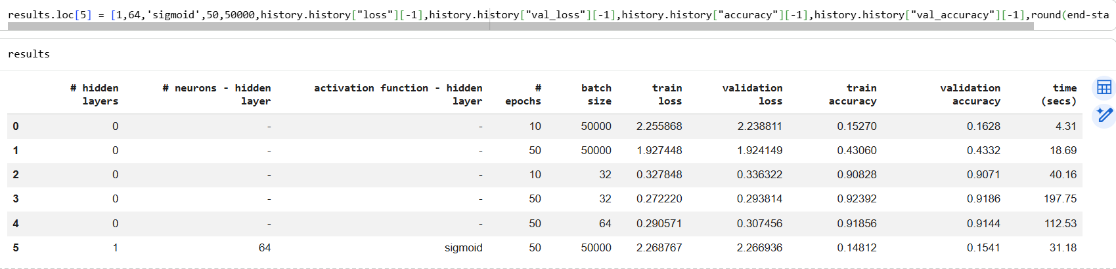

MODEL 6
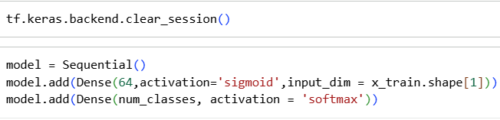

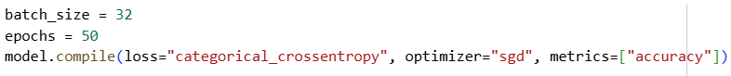

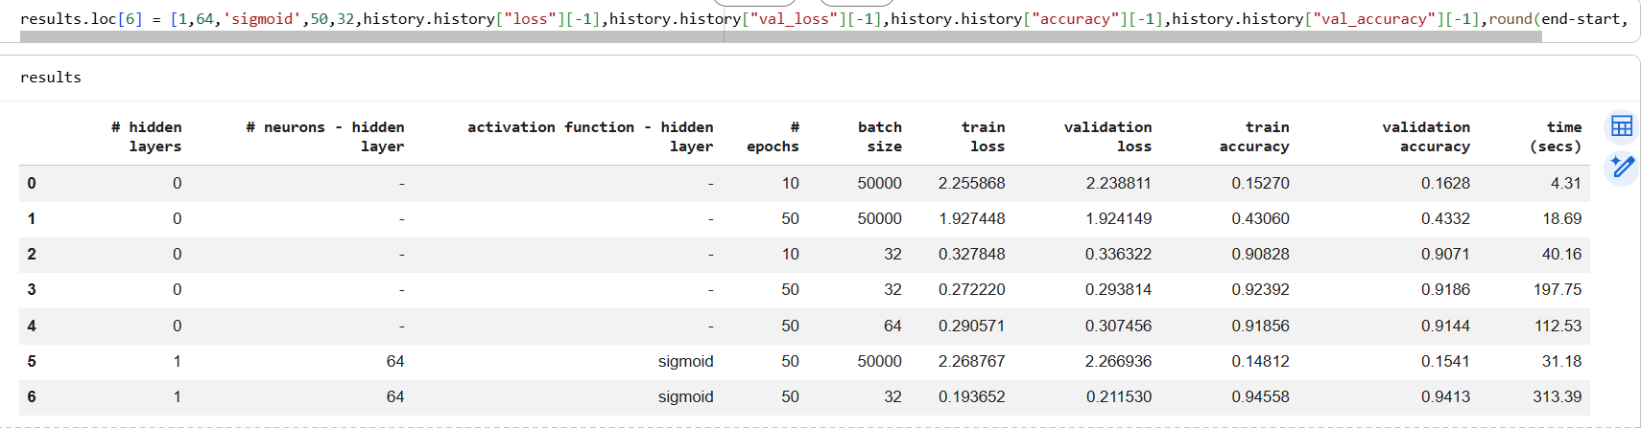

MODEL 7
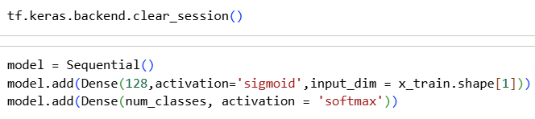

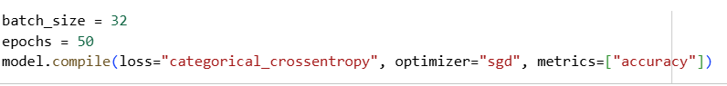

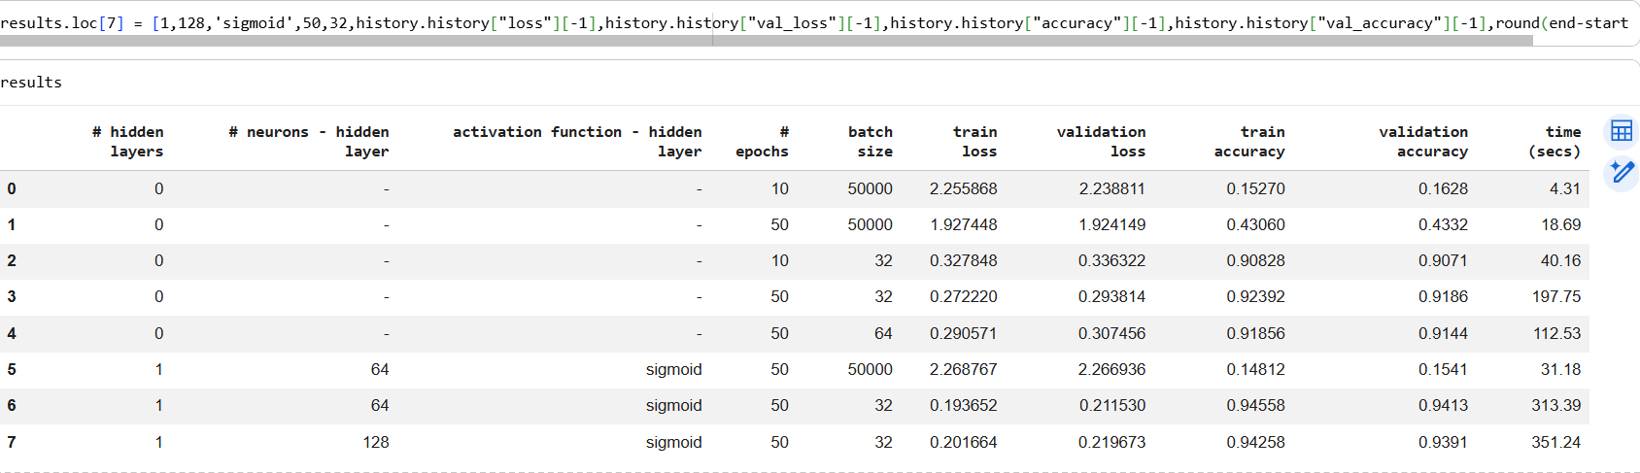

MODEL 8
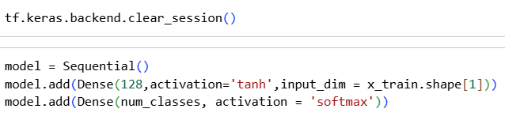

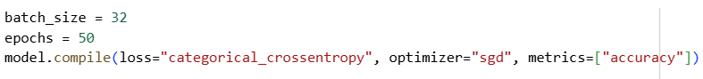

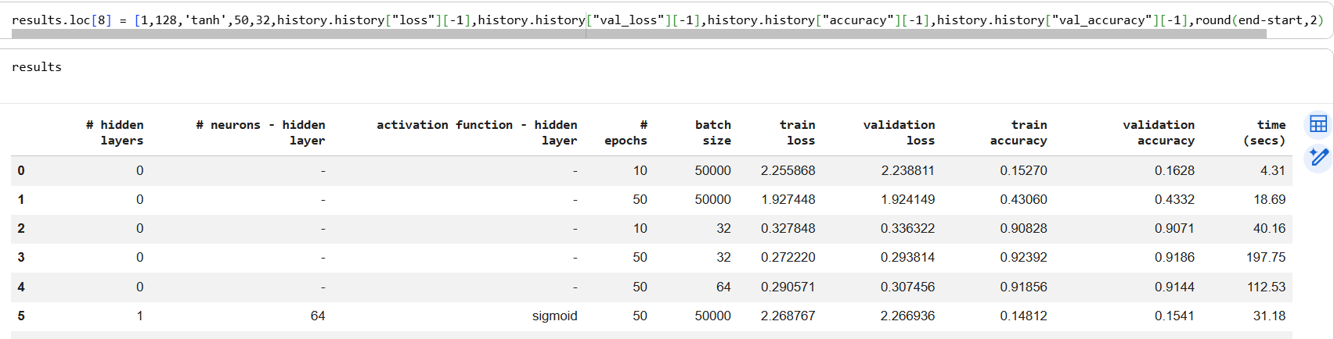

MODEL 9

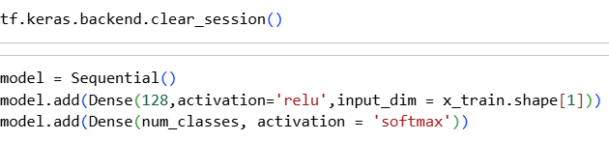

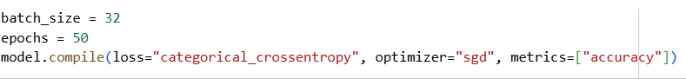

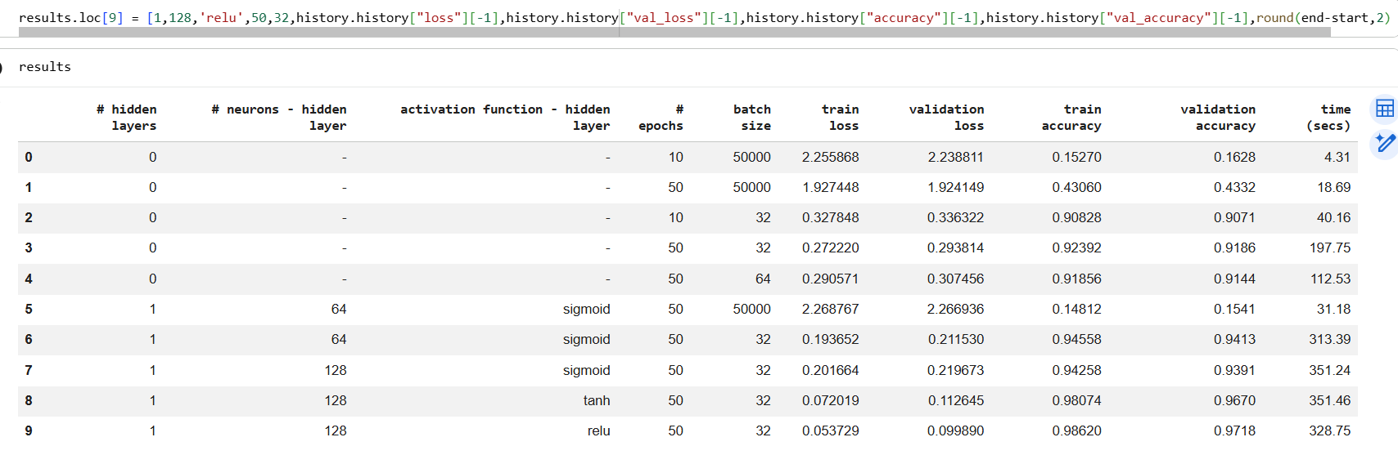

MODEL 10
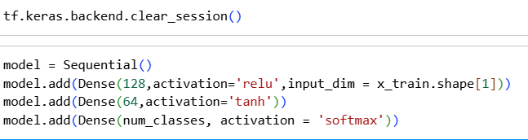

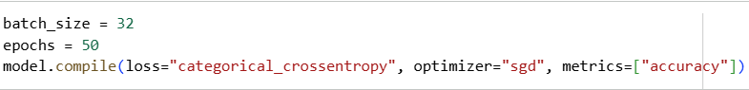

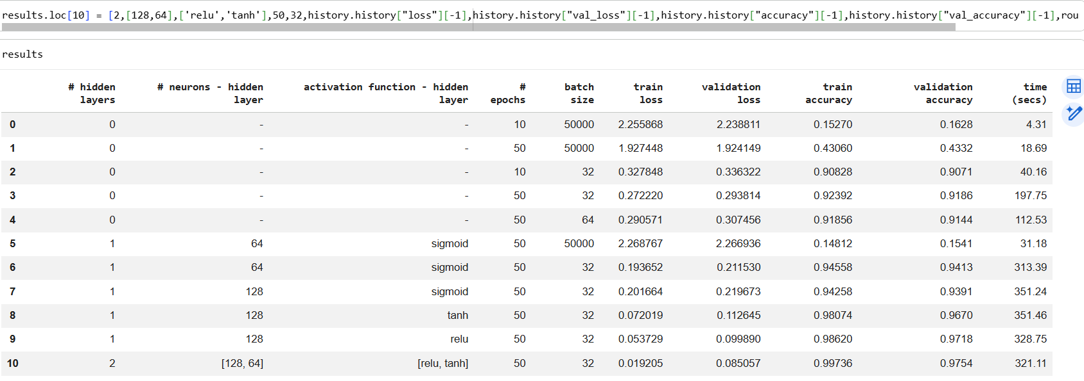

MODEL 11
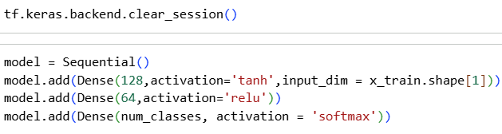

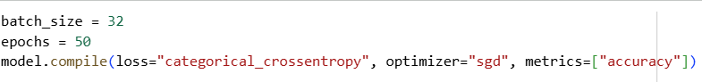

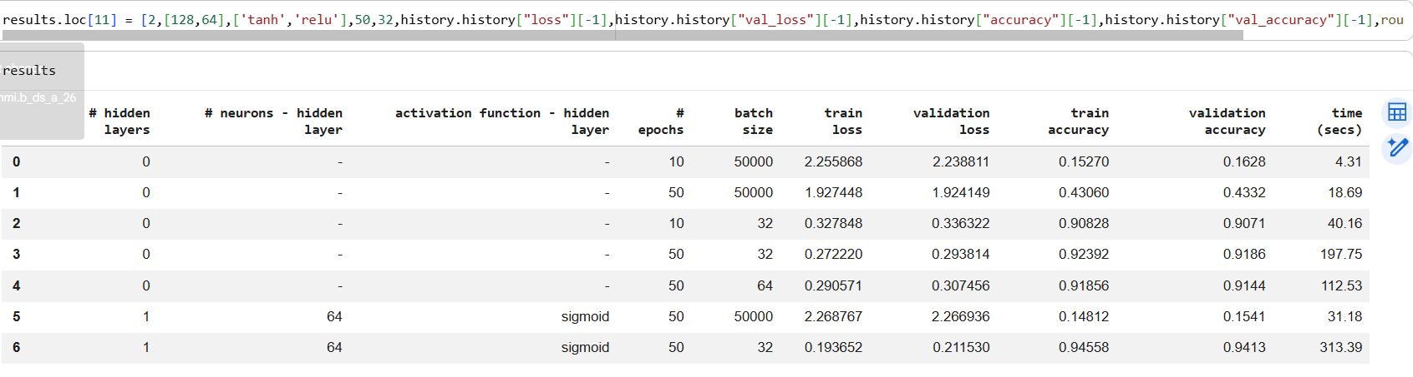

MODEL 12
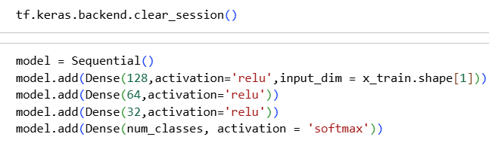

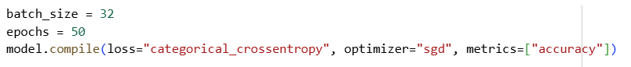

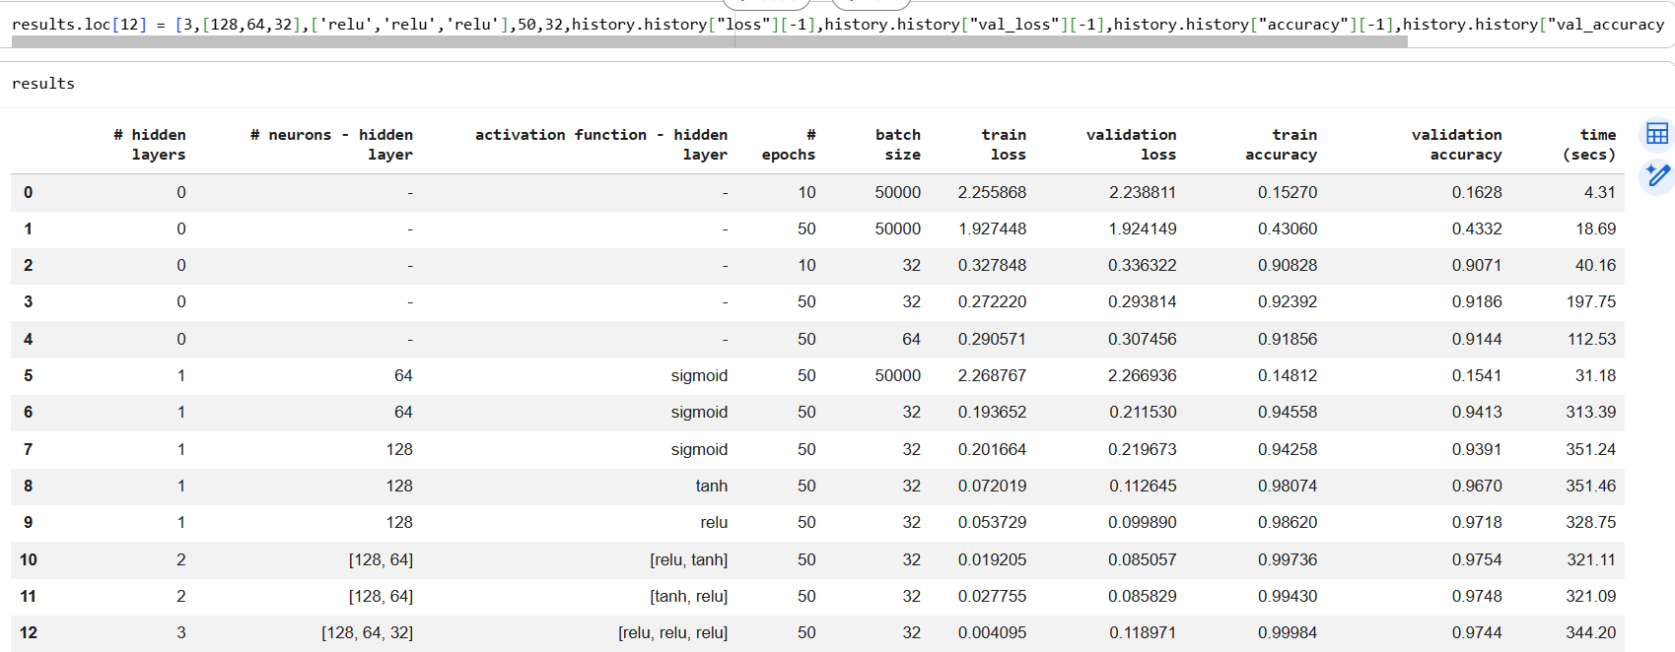

MODEL 13
