Mnist

Model 0

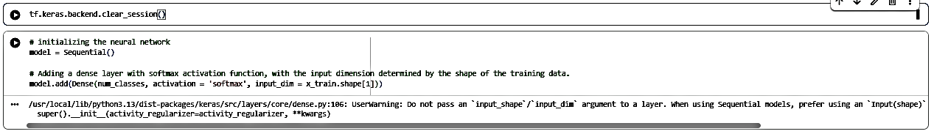

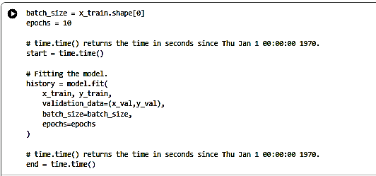

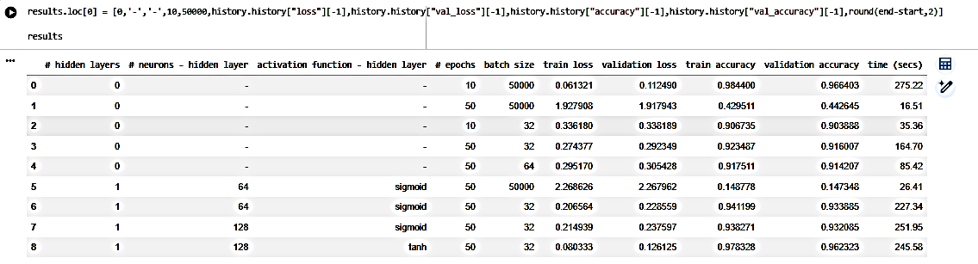
Model 1
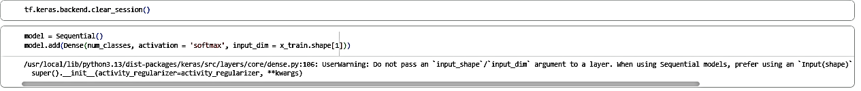
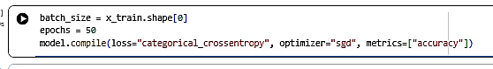

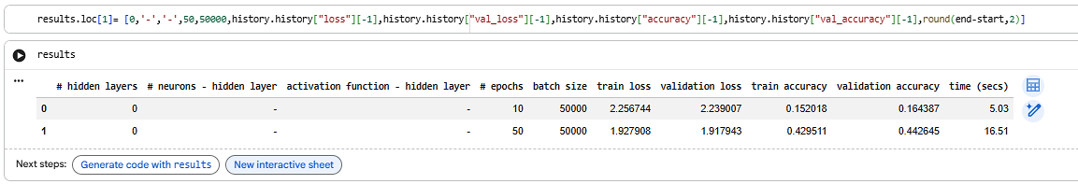

Model 2

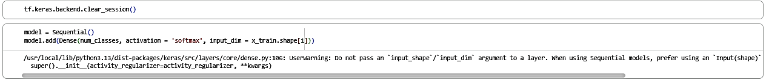

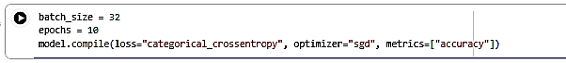

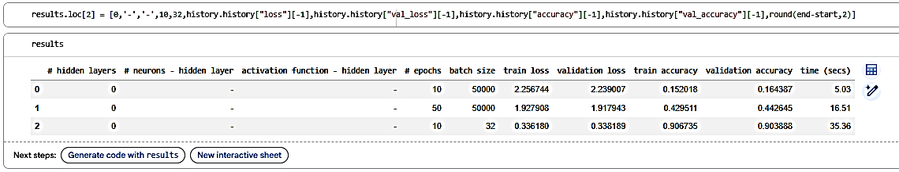

Model 3

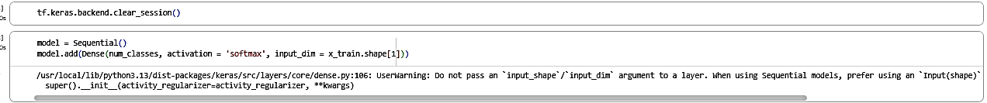
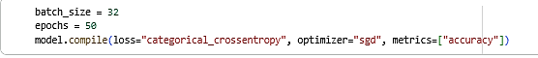

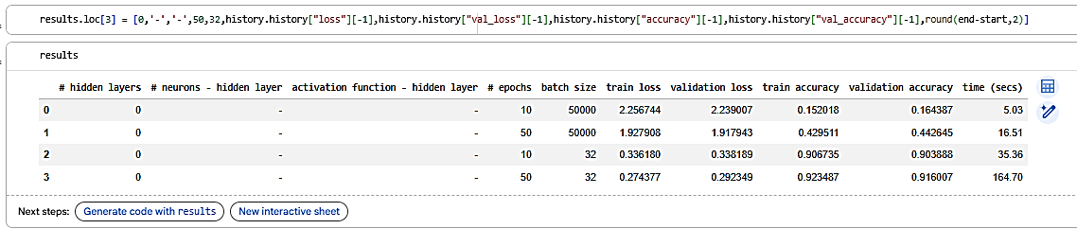

Model 4

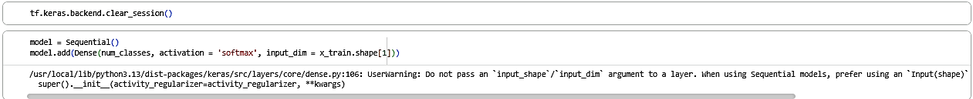

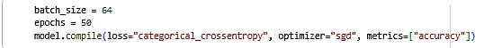

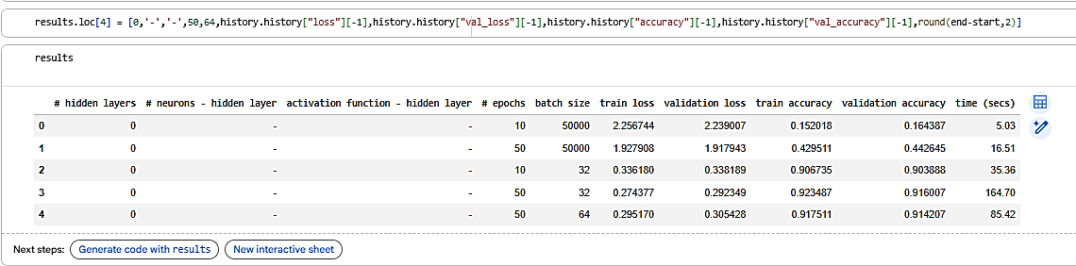

Model 5

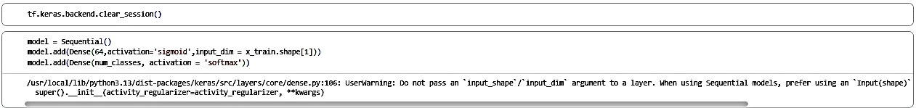

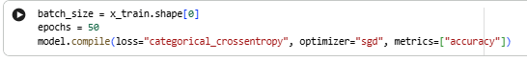

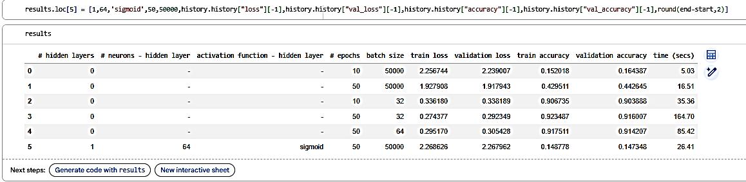

Model 6

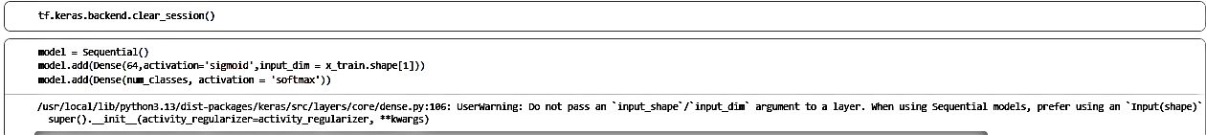

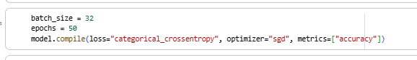

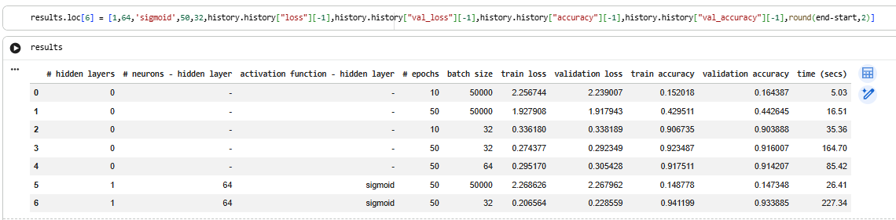

Model 7

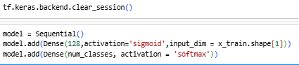

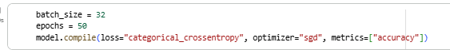

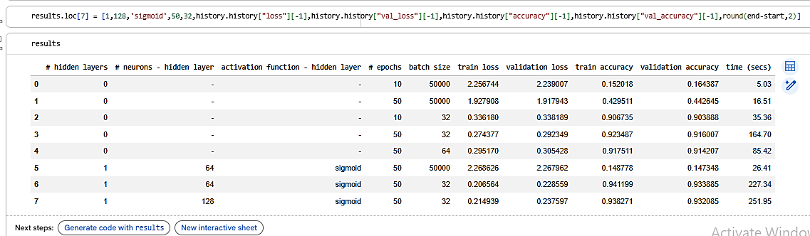

MODEL 8
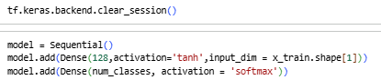
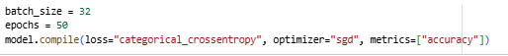

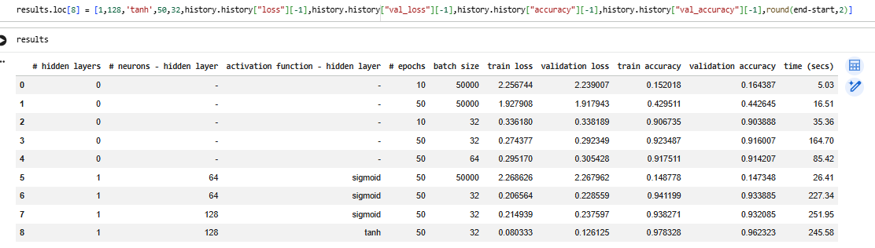

MODEL 9
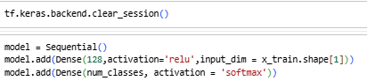

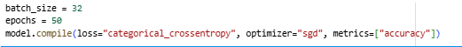

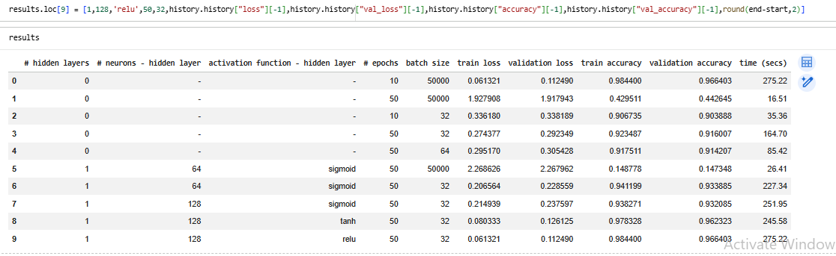

MODEL 10
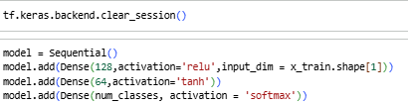

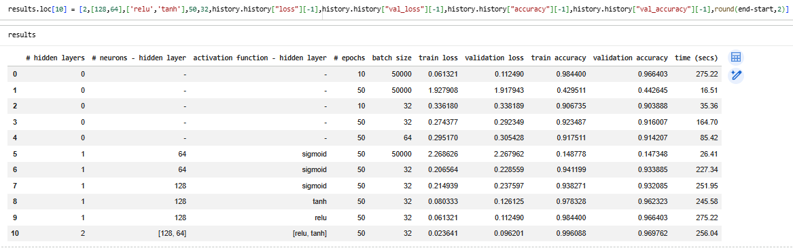

MODEL 11
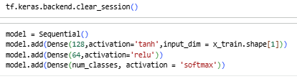

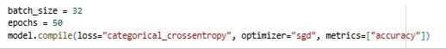

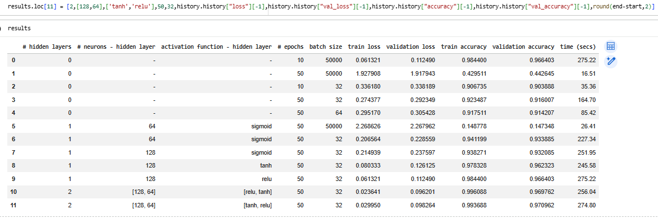

MODEL 12
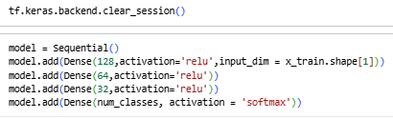

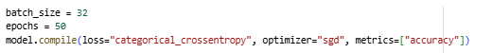

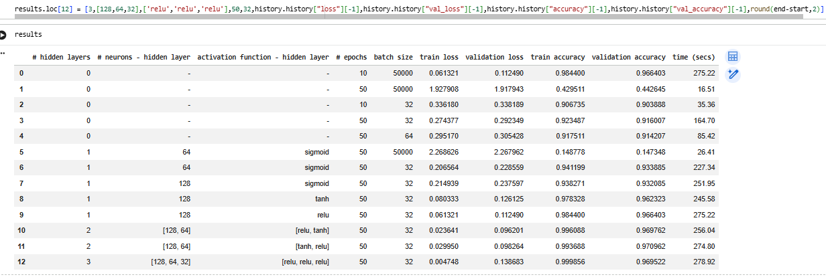

MODEL 13
