MNIST DATASET

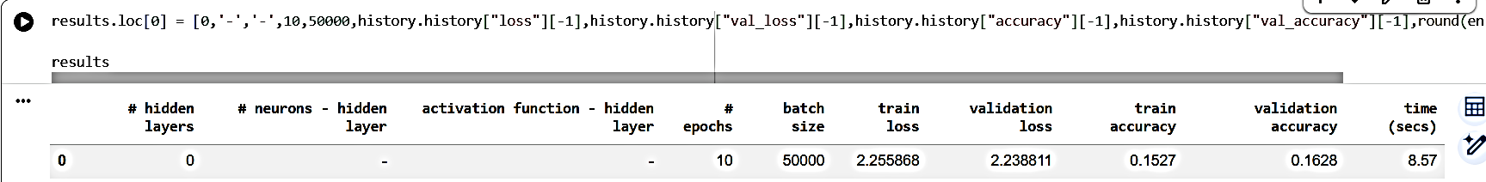
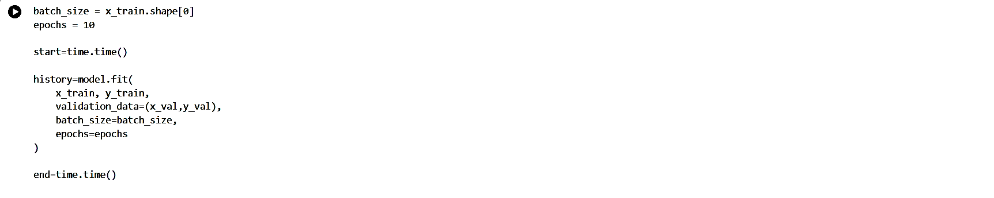
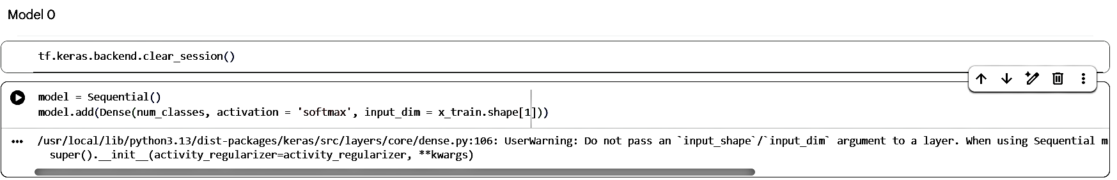
Model 0:

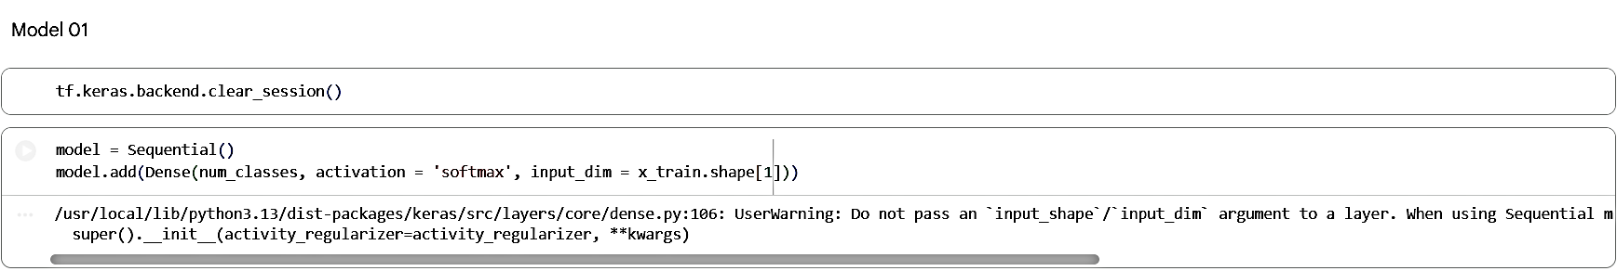
Model 1:
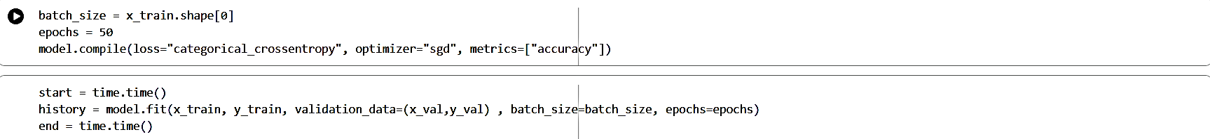
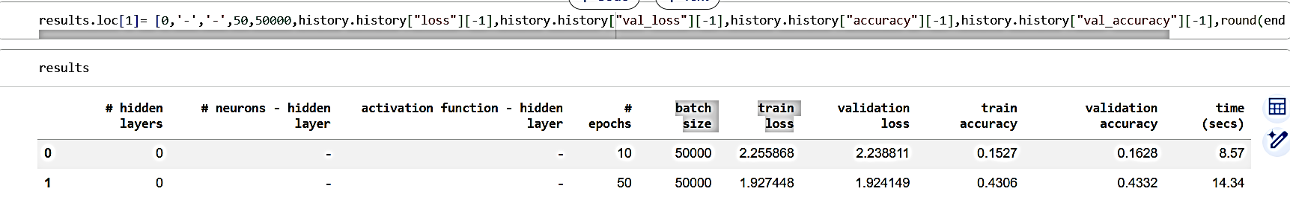

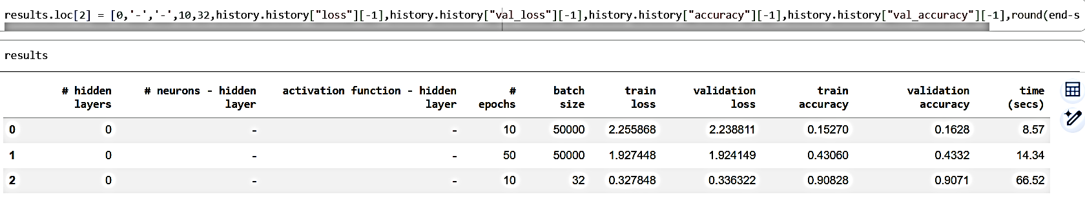
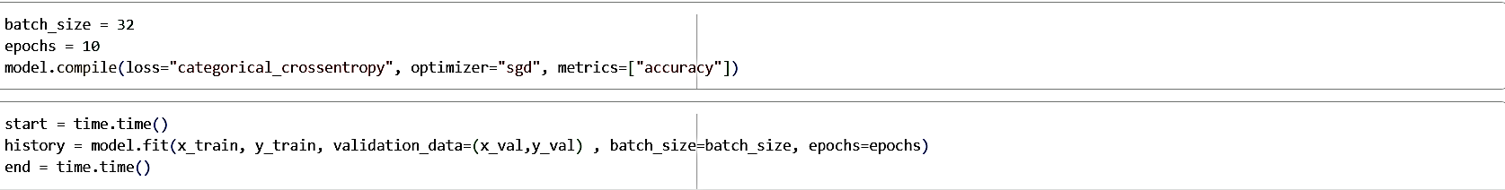
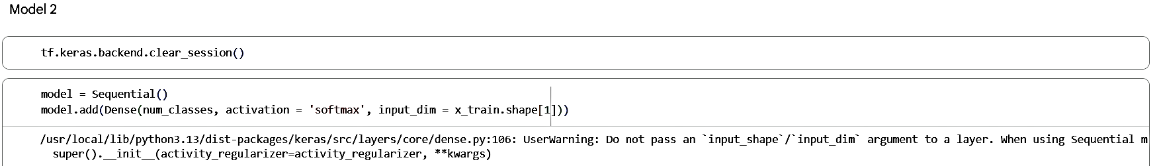
Model 2:

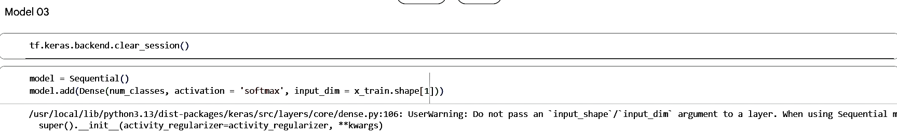
Model 3:
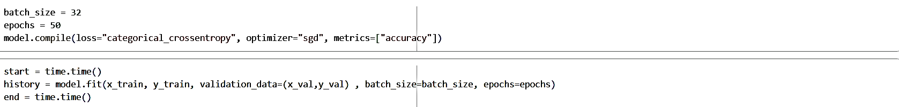
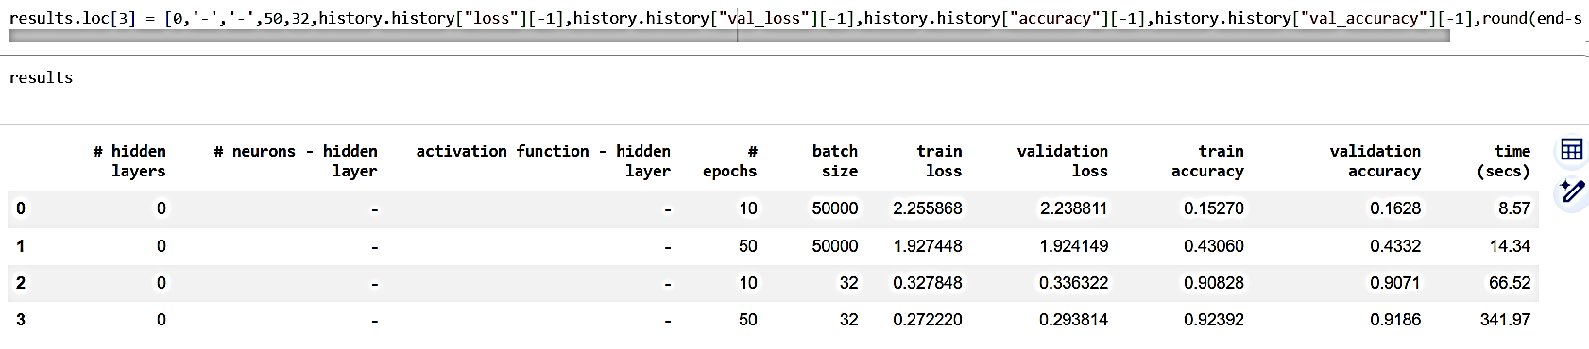

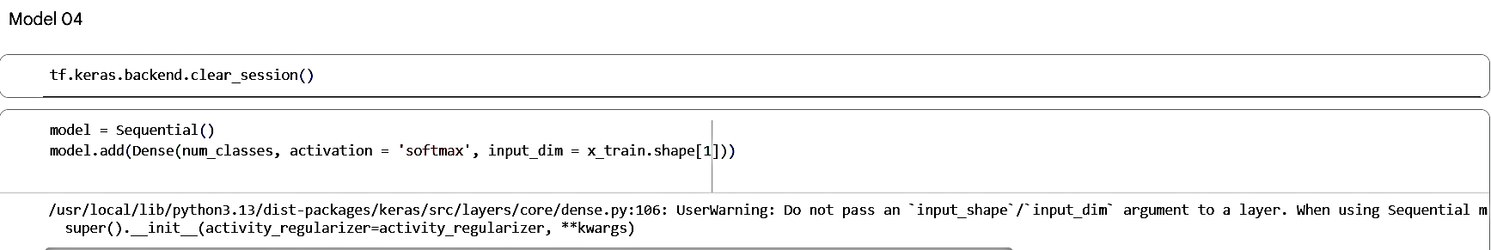
Model 4:
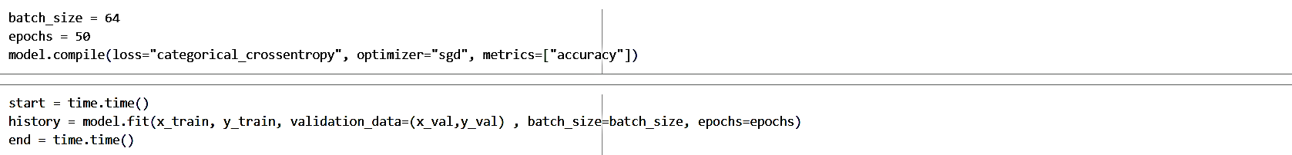
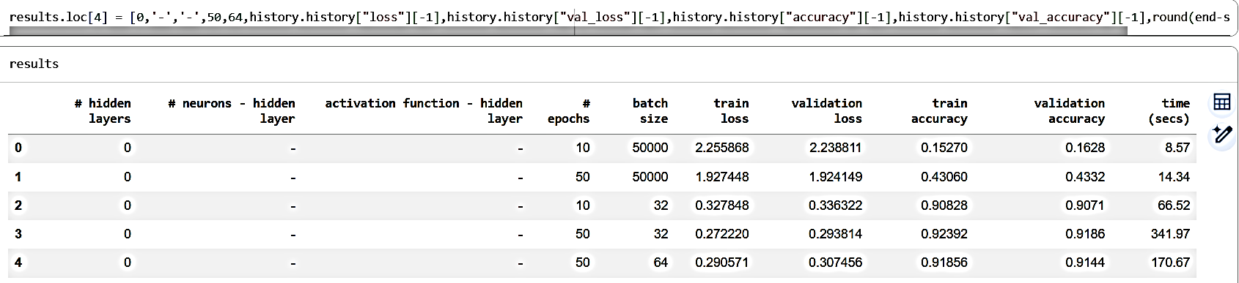

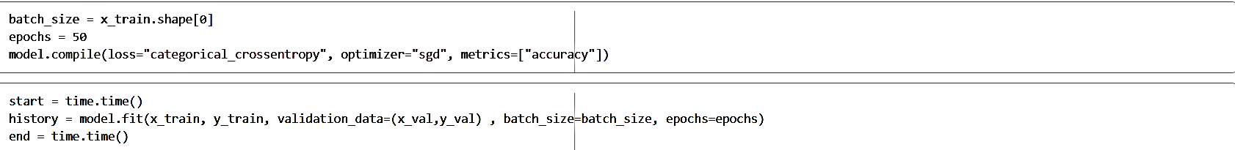
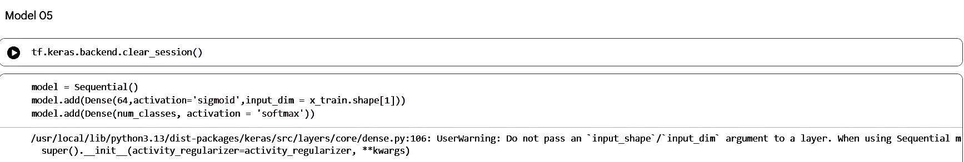
Model 5:

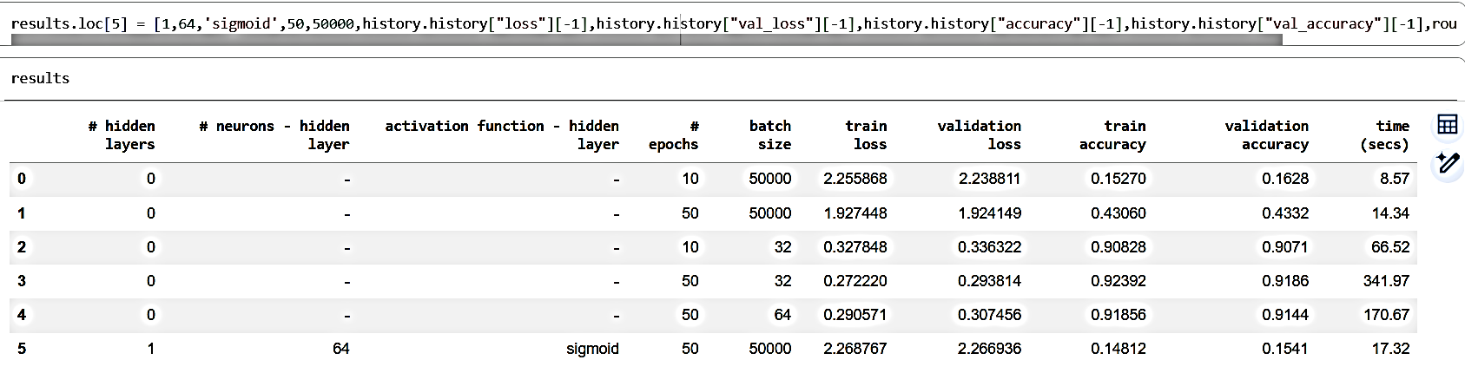
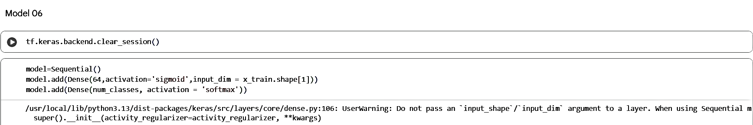
Model 6:
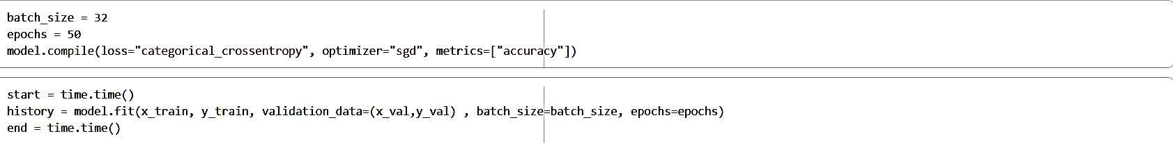
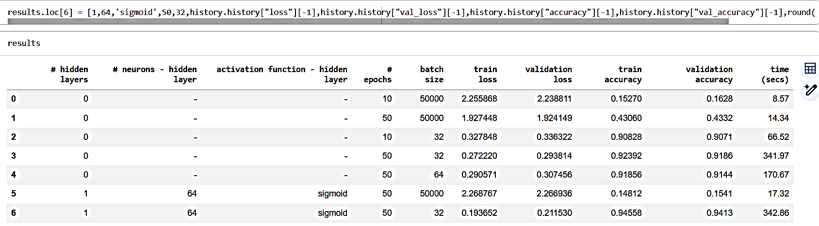

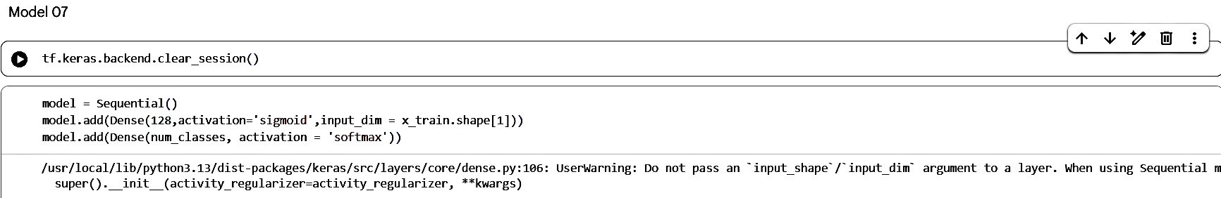
Model 7:
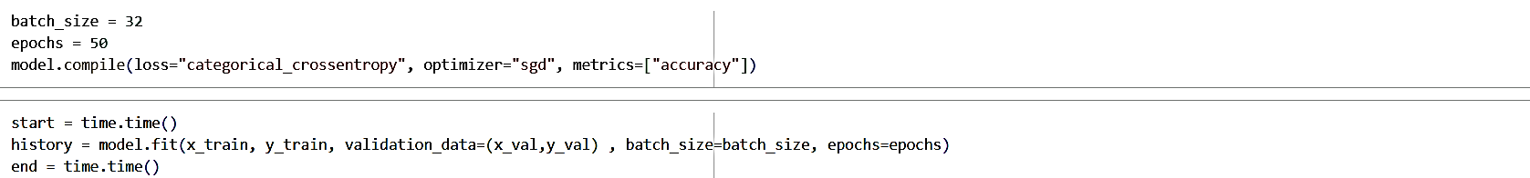
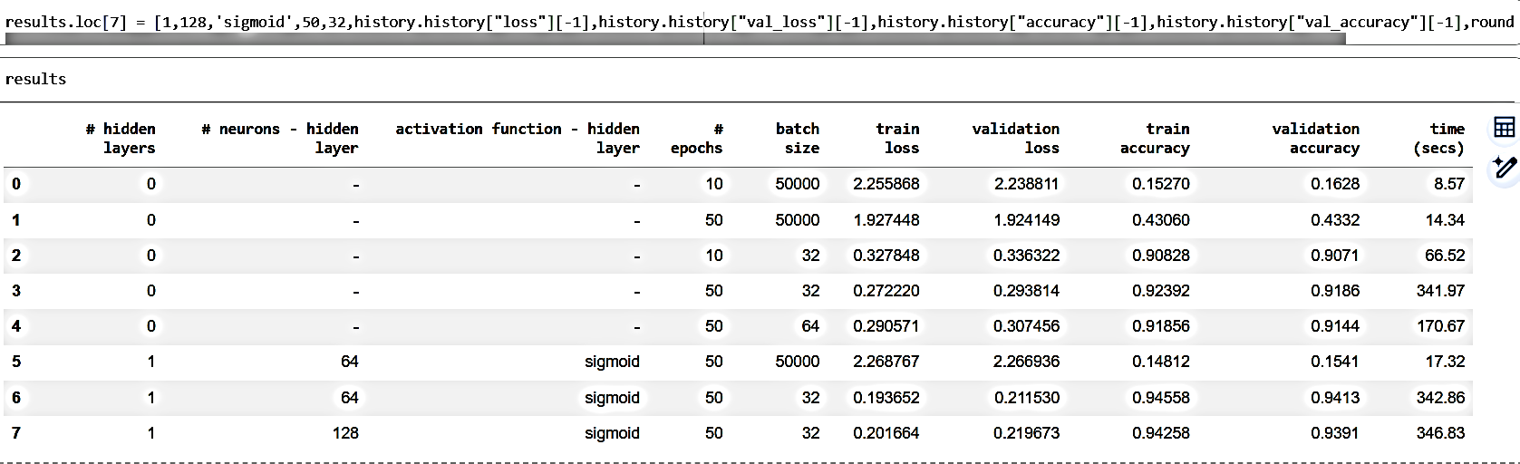
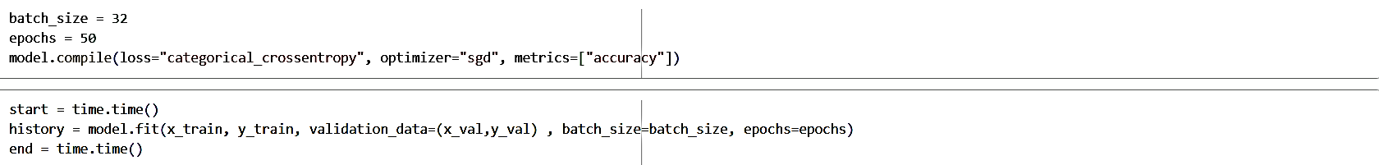
Model 8:
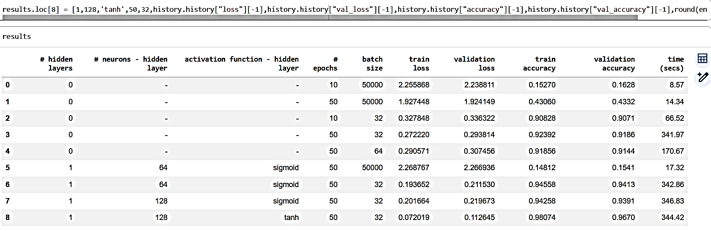
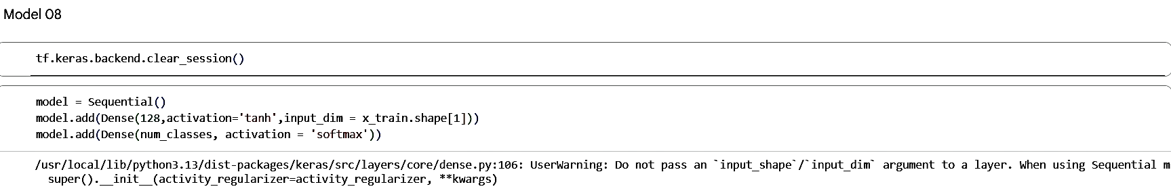
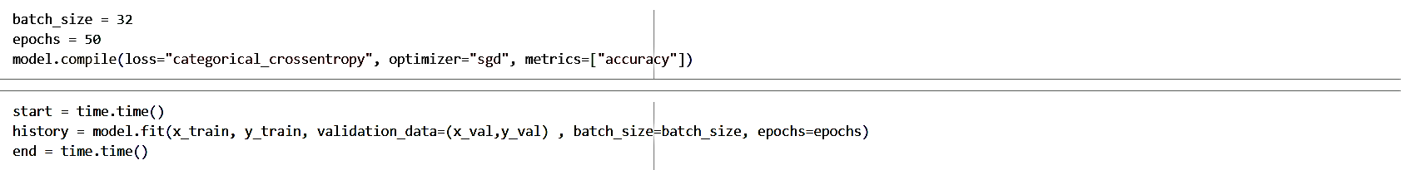
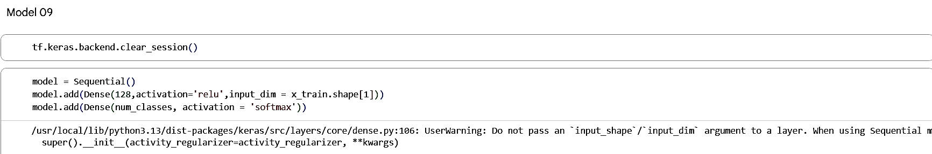
Model 9:
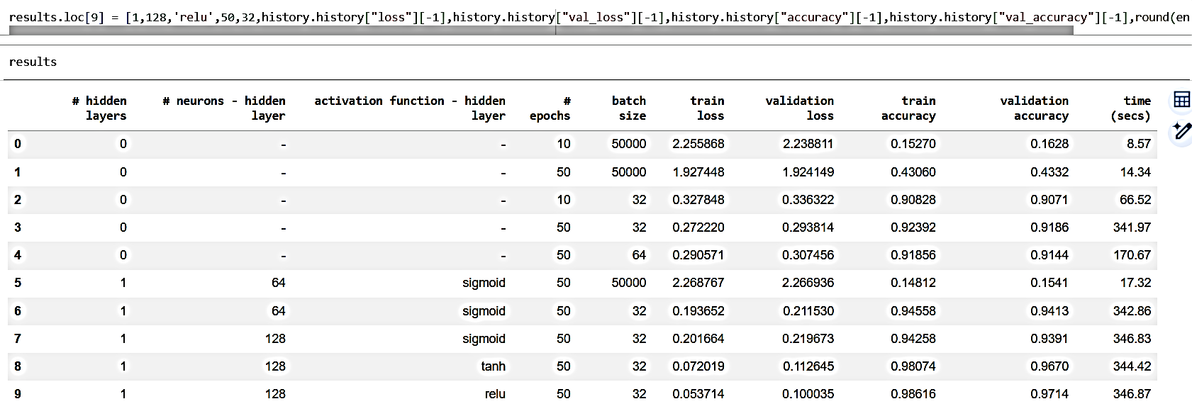
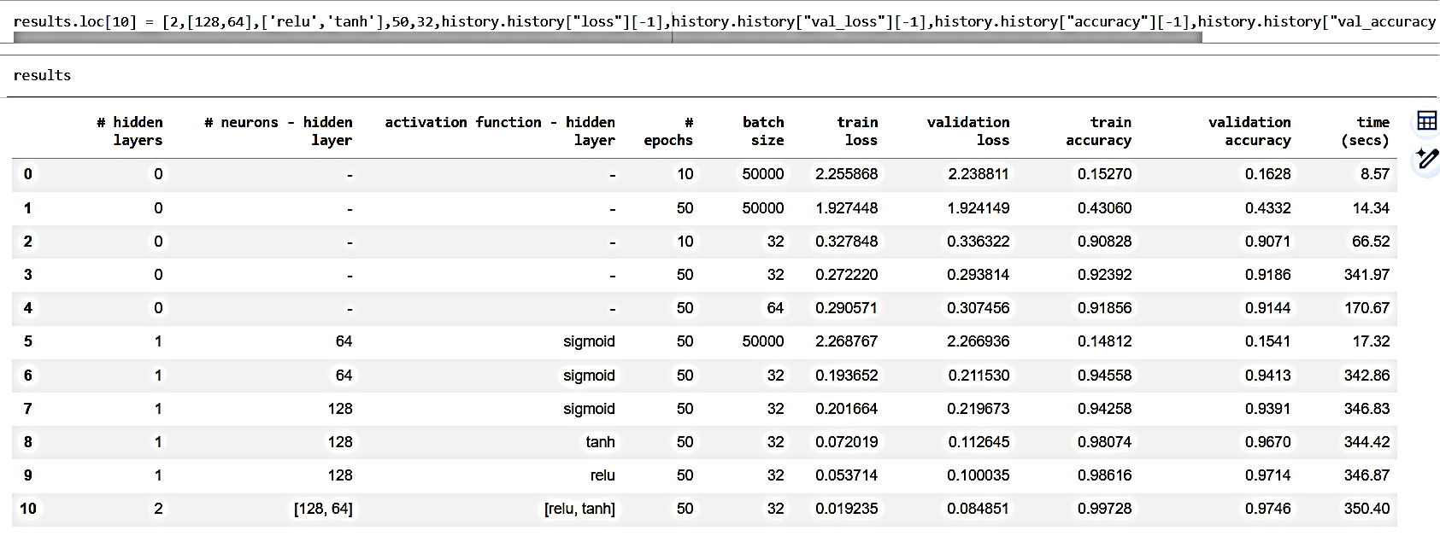
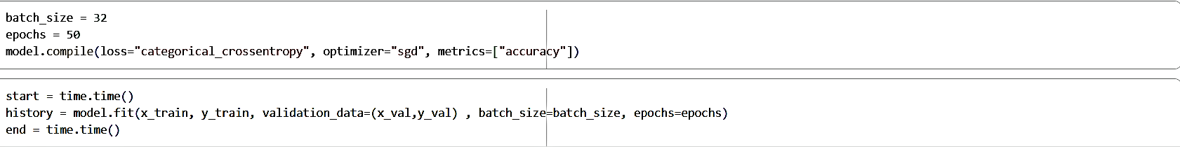
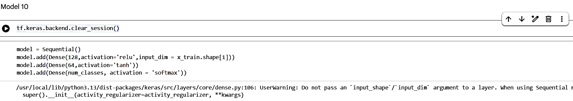
Model 10:

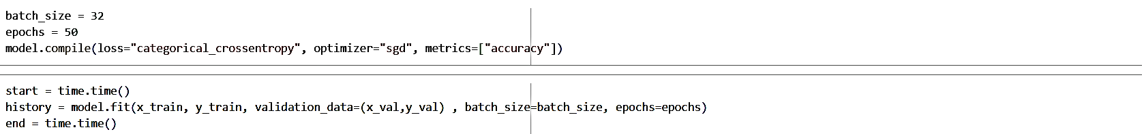
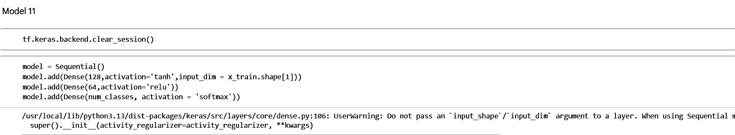
Model 11:
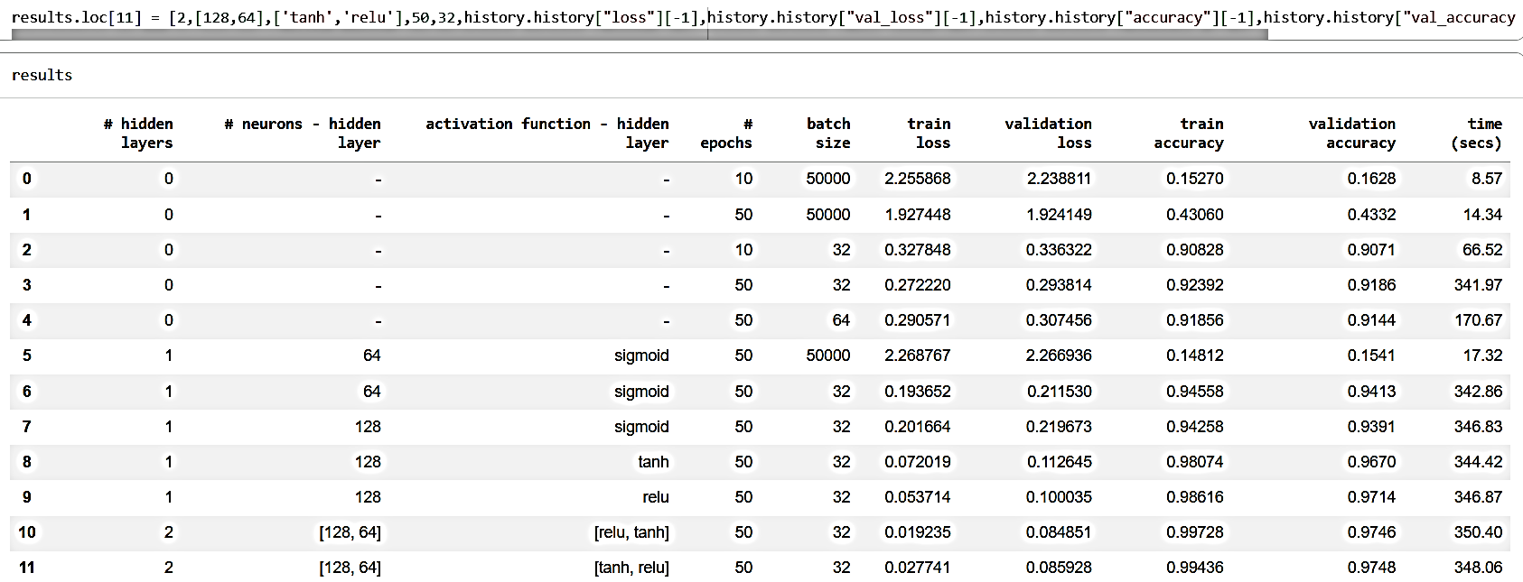
Model 12:
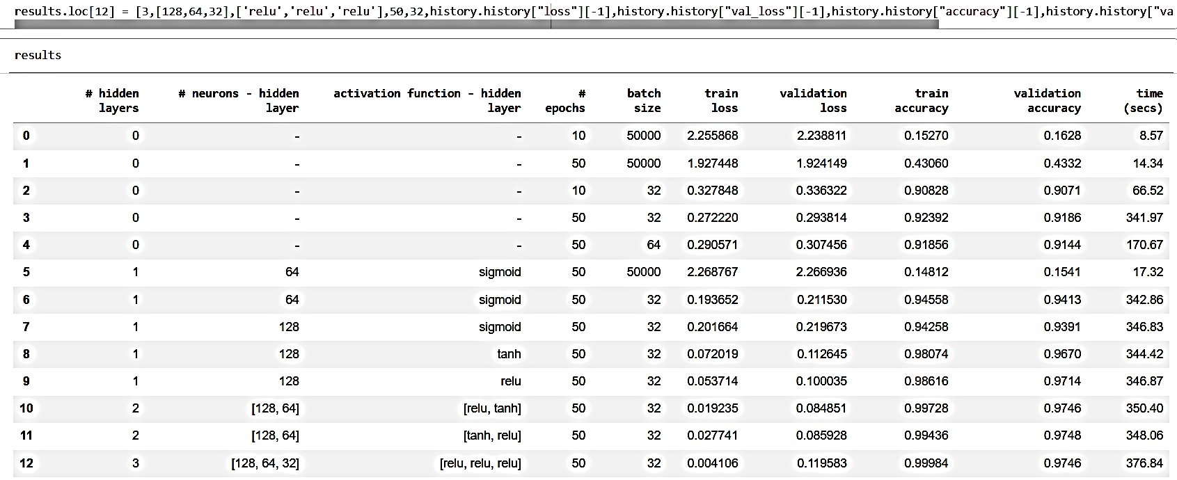
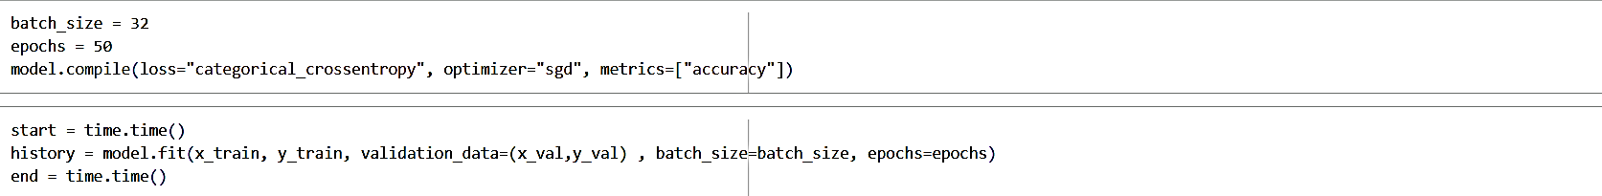
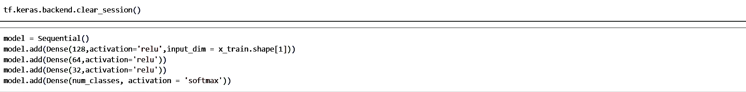
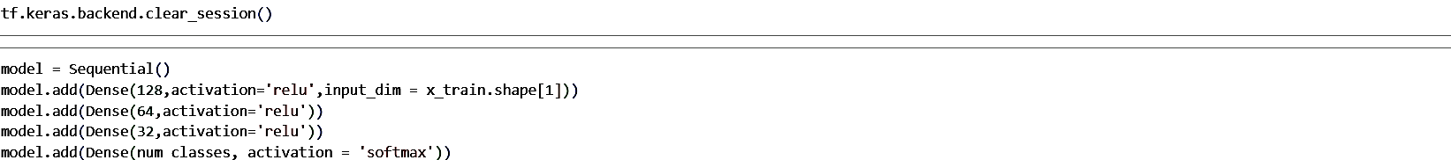
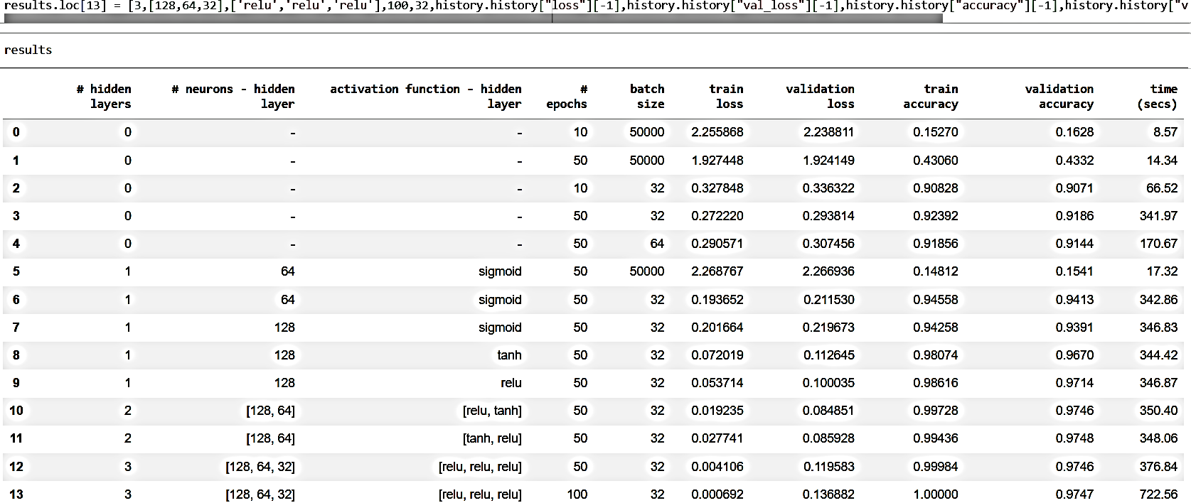
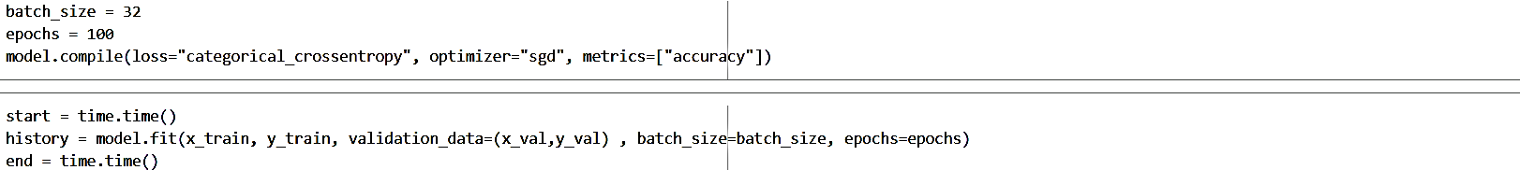
Model 13:

