MNIST DATASET

MODEL 0
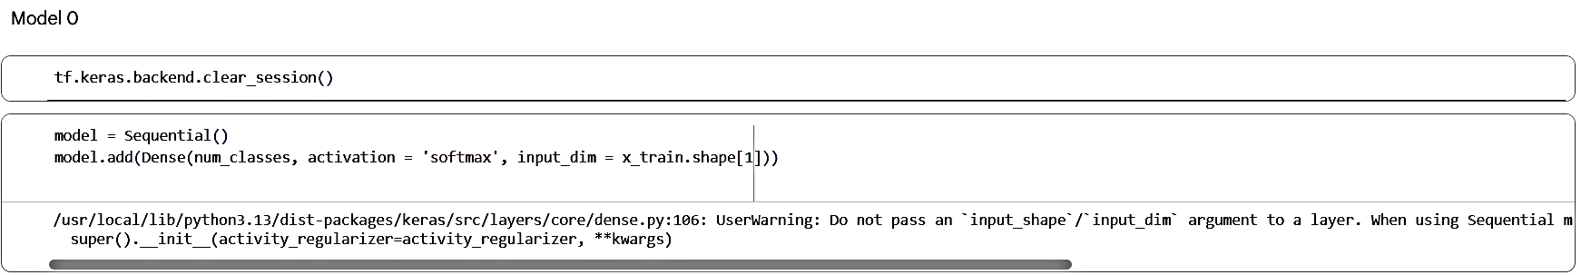
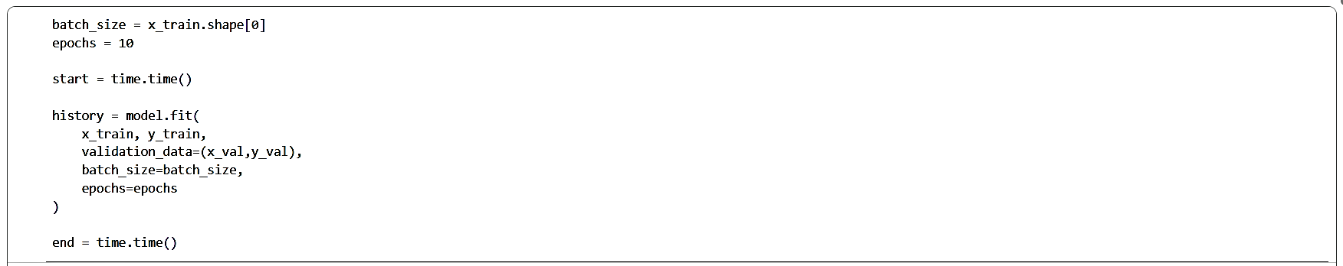
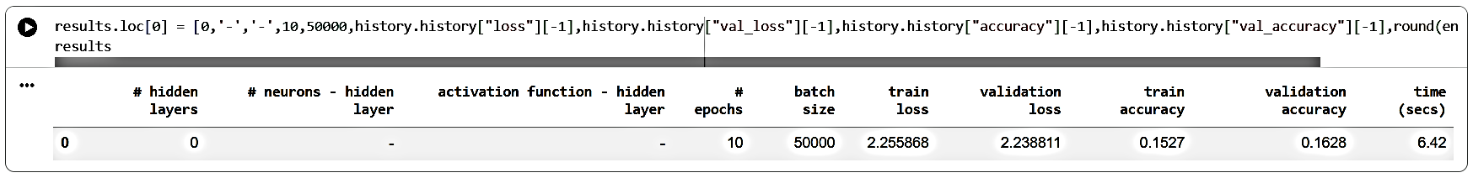
MODEL 1
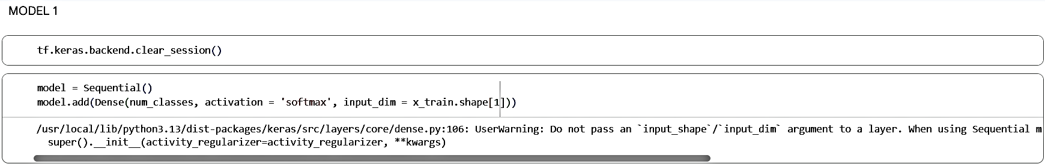
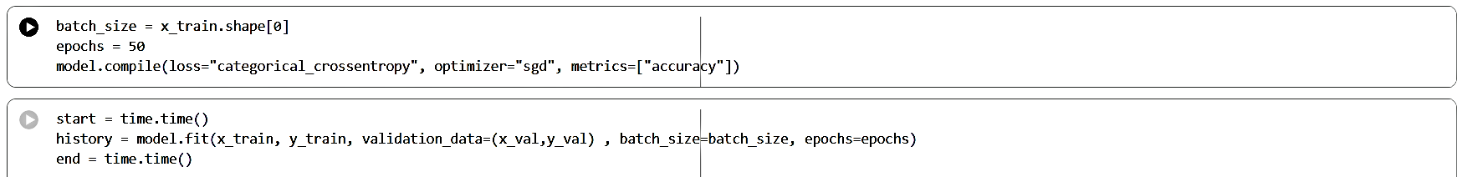
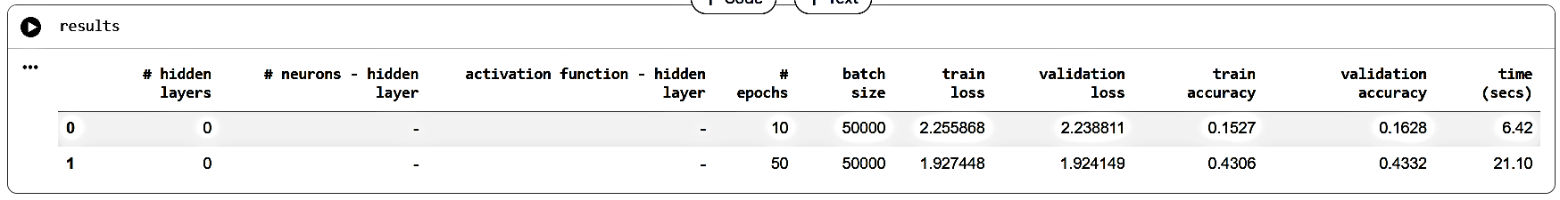
MODEL 2
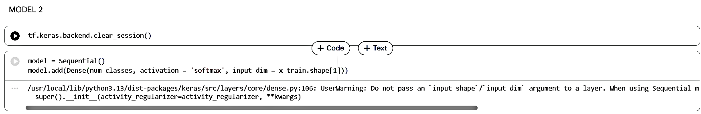
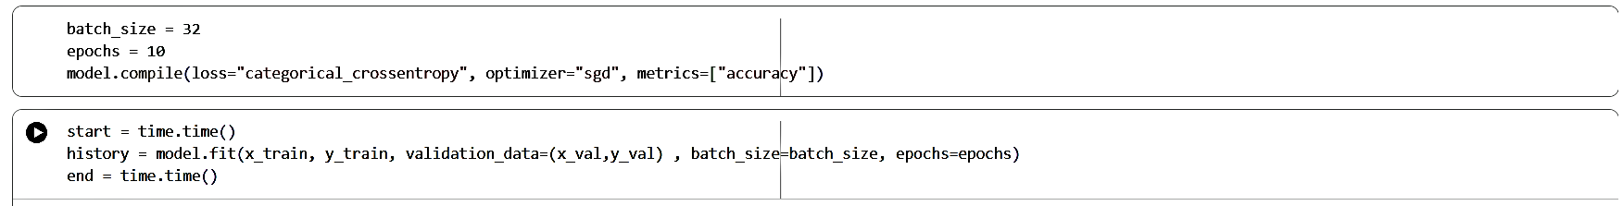
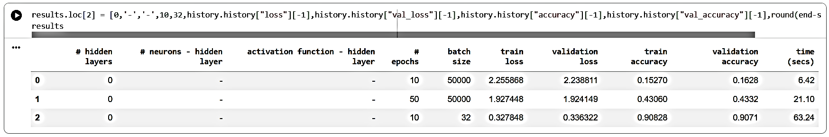

MODEL 3
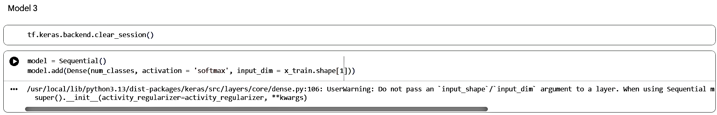
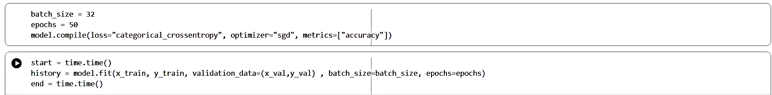
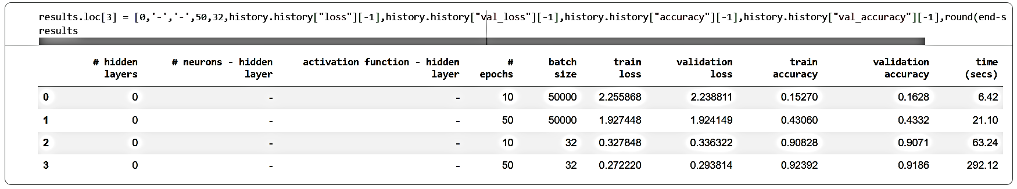

MODEL 4
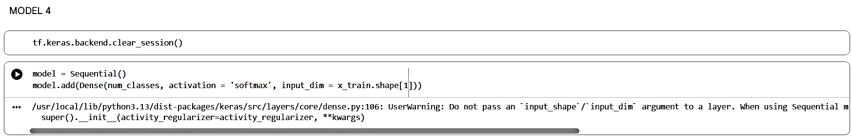
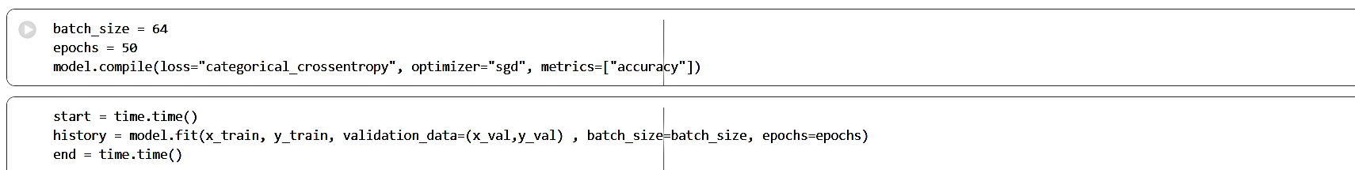
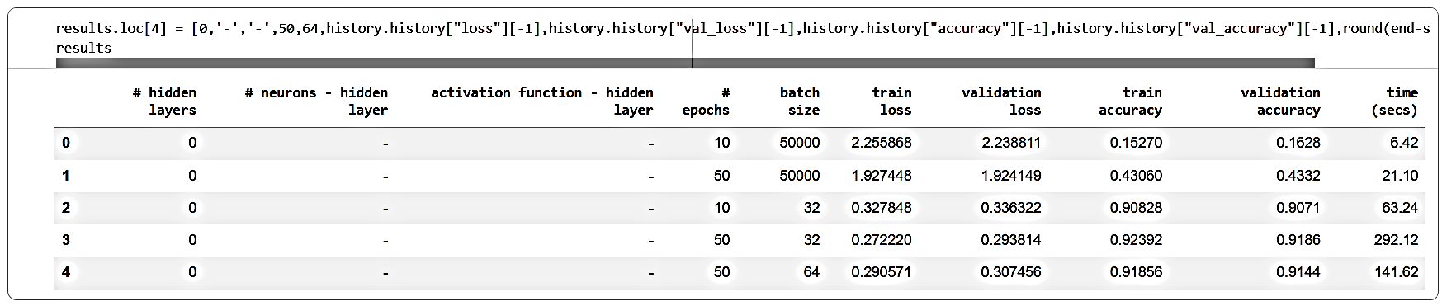

MODEL 5
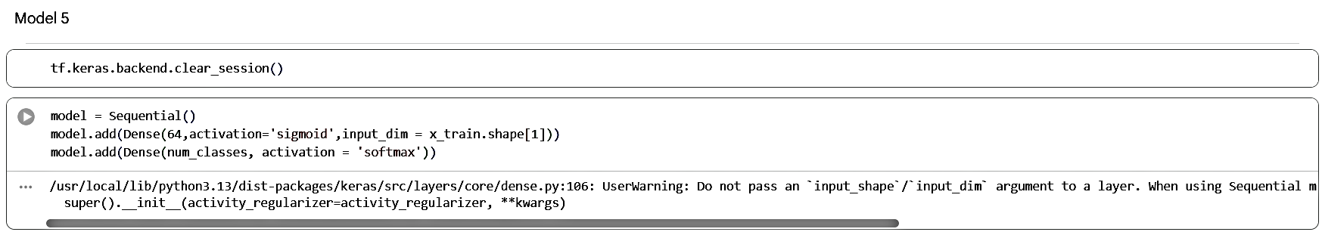
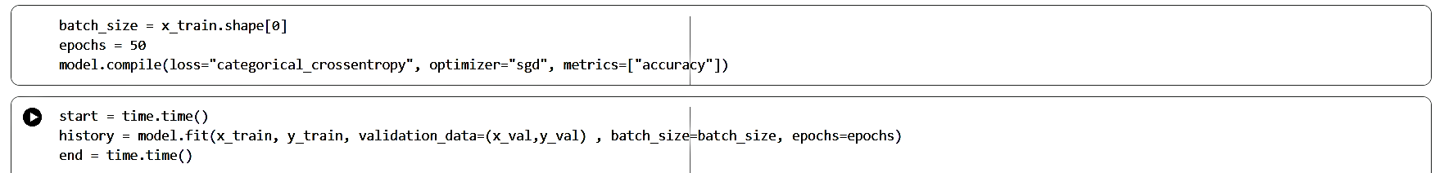
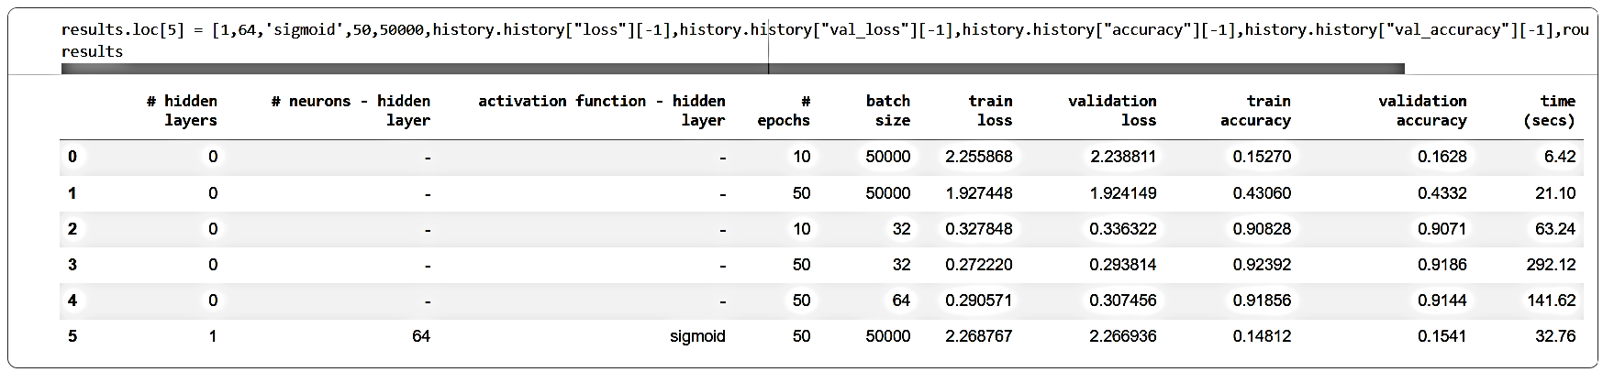

MODEL 6
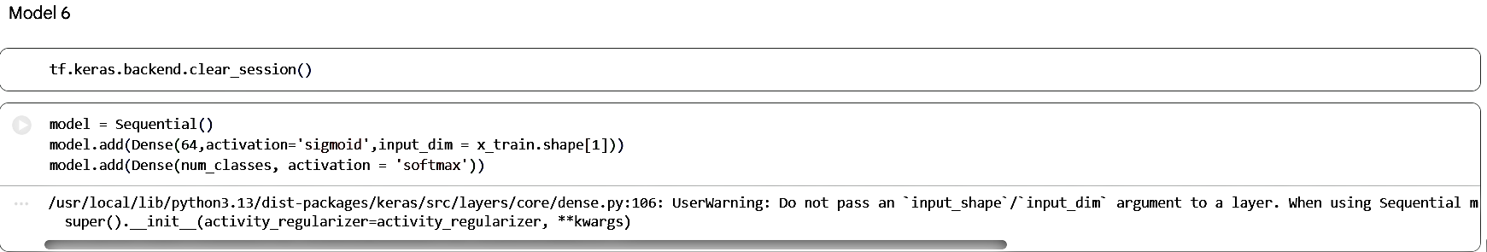
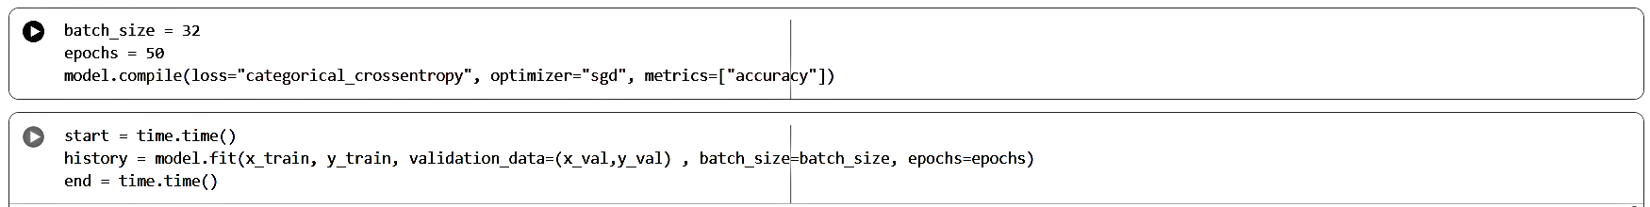
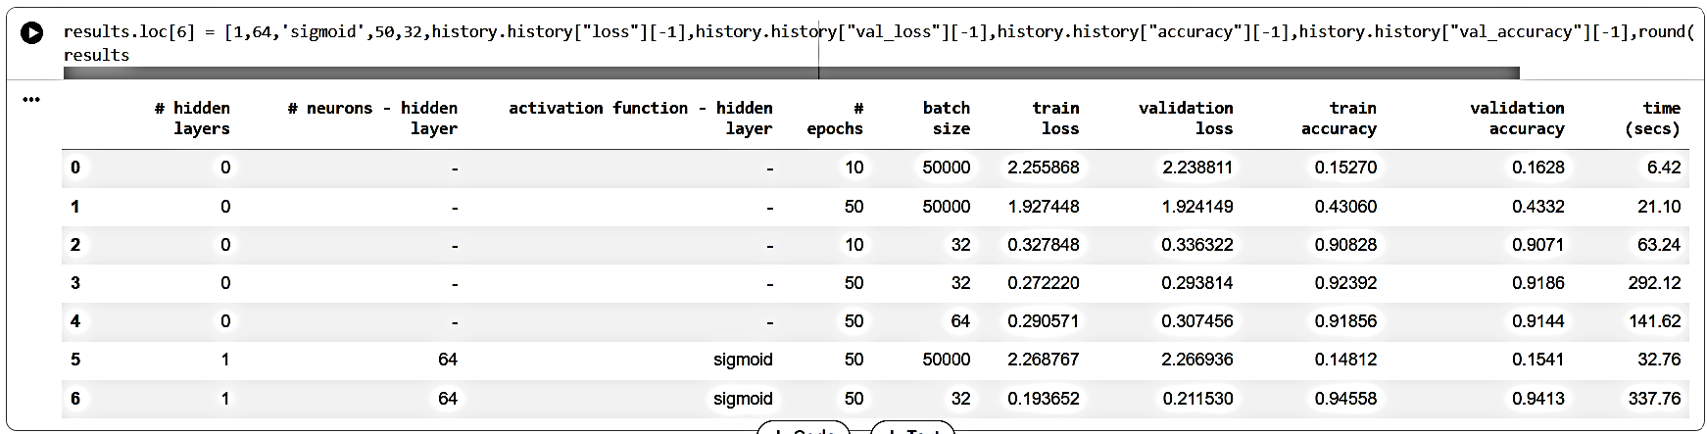

MODEL 7
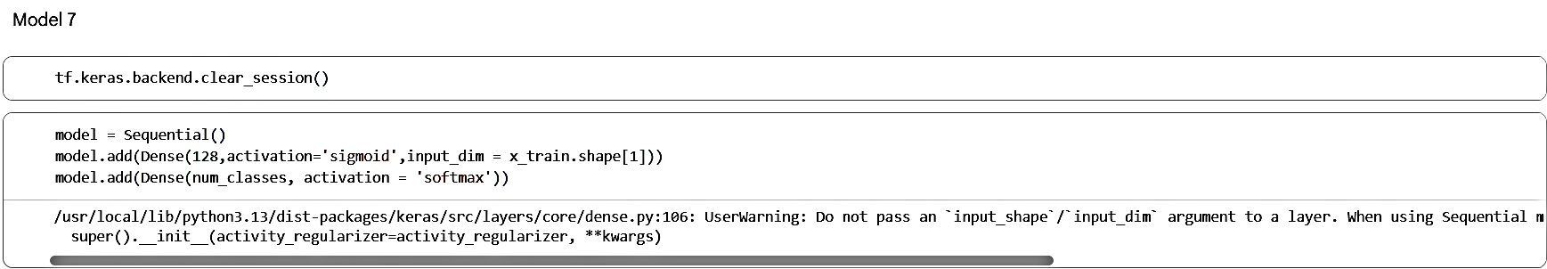
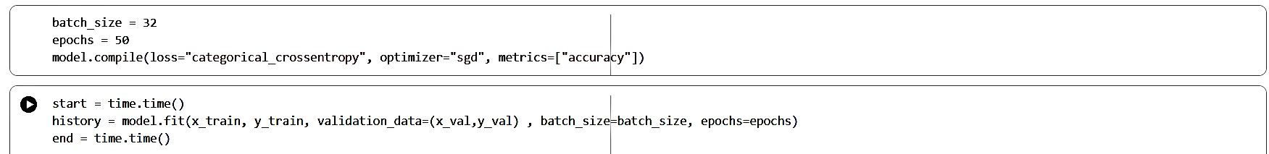
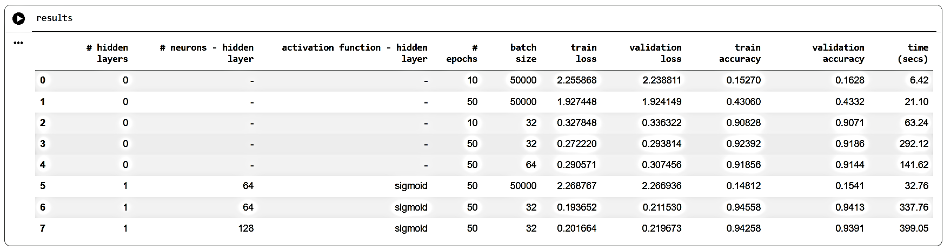

MODEL 8
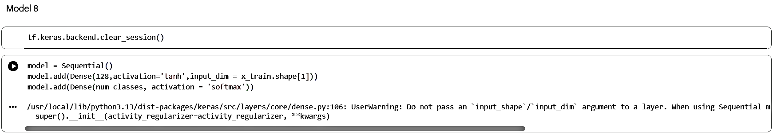
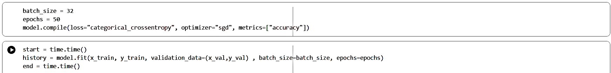
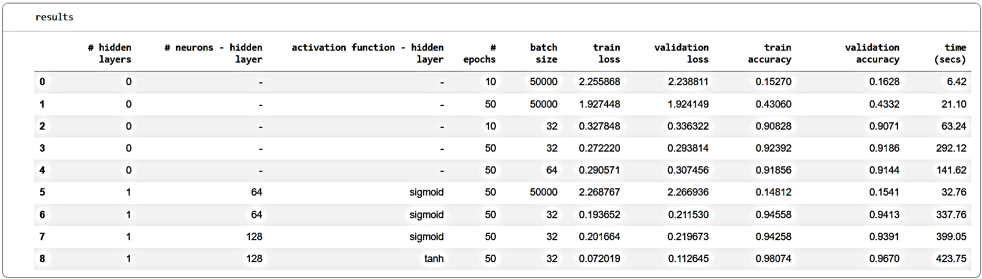

MODEL 9
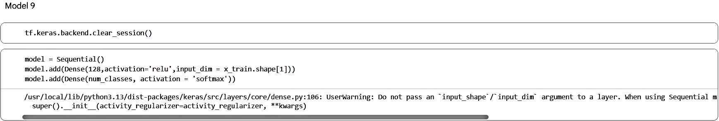
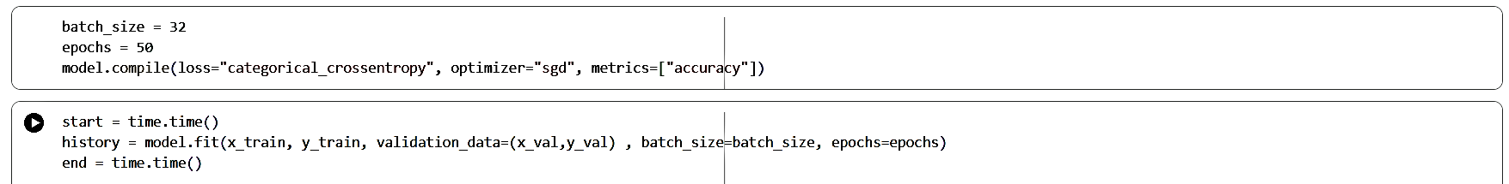
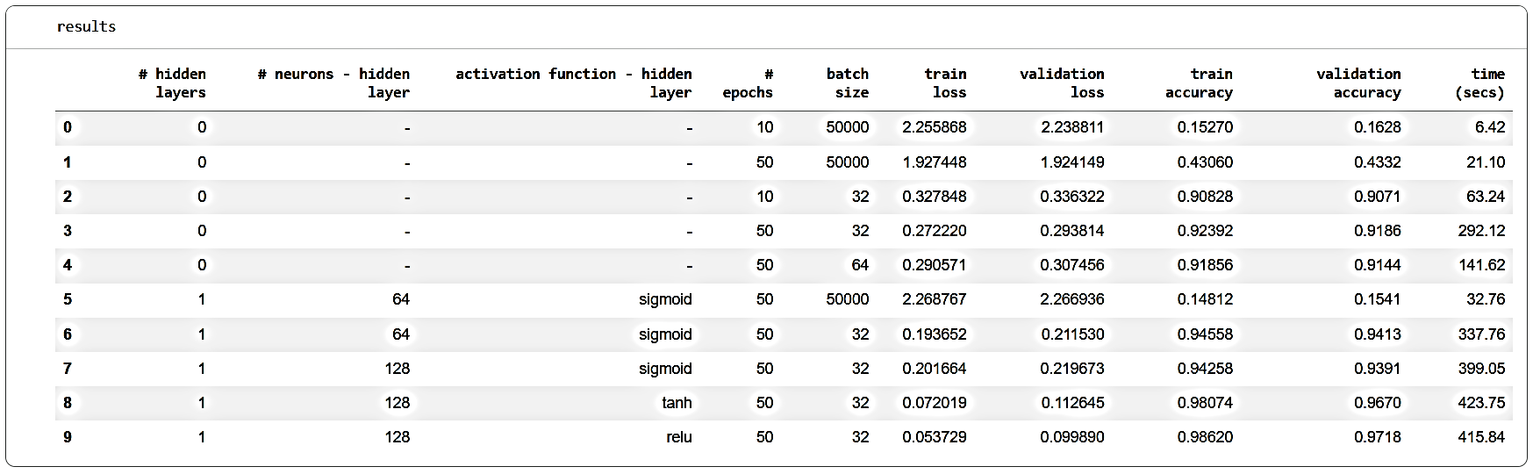
MODEL 10
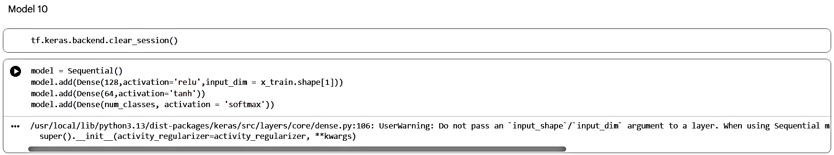
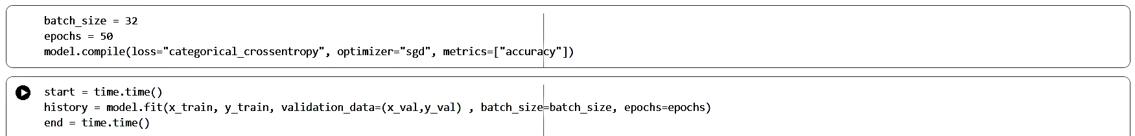
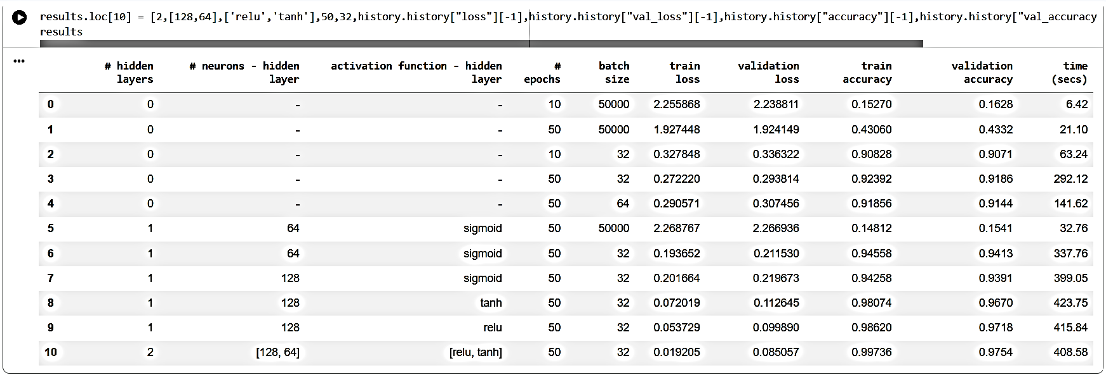
MODEL 11
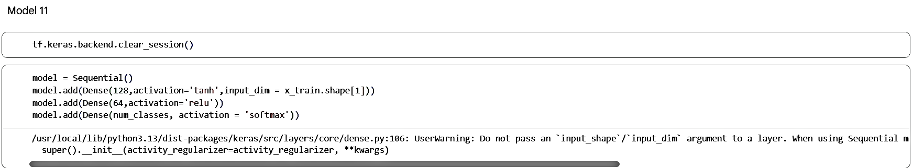
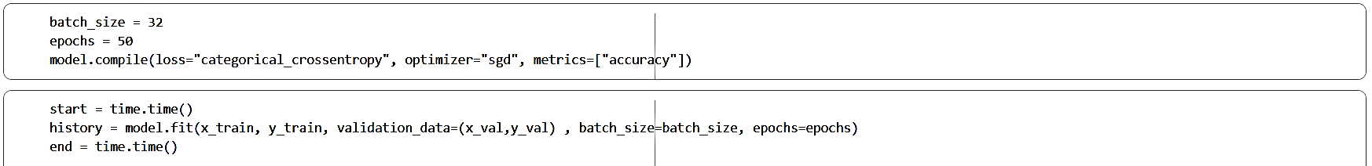

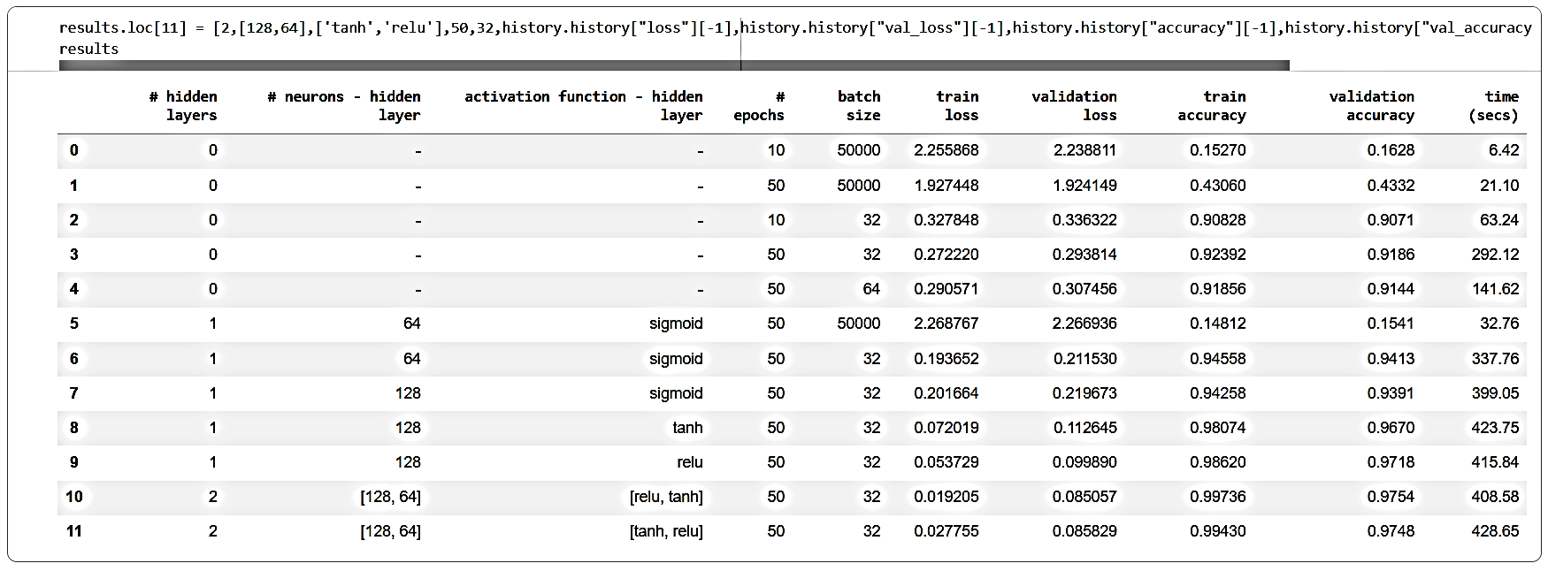
MODEL 12
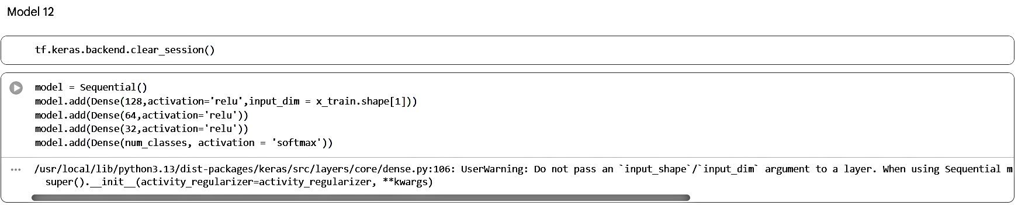
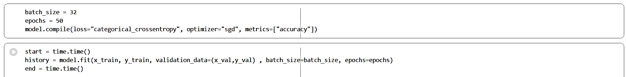
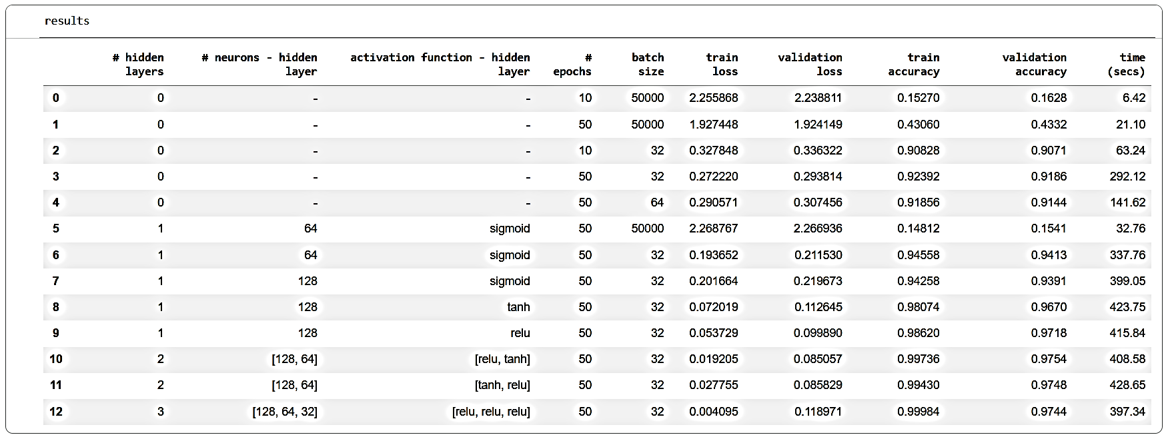

MODEL 13
