MODEL 0
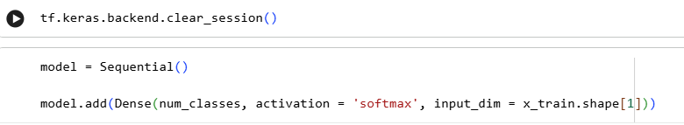

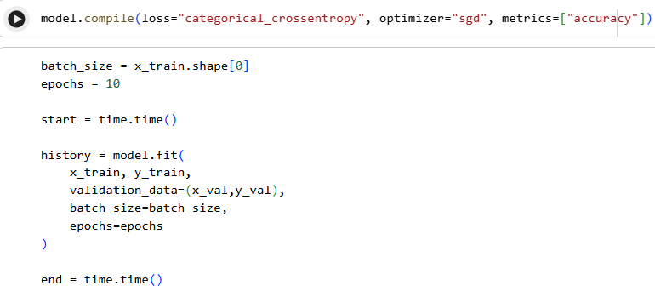

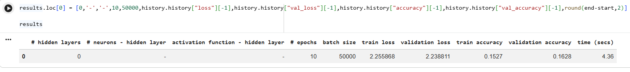
MODEL 1
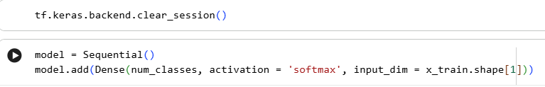

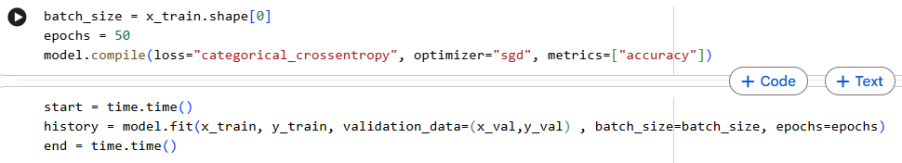
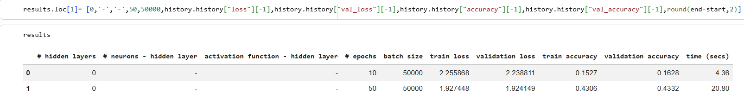
MODEL 2
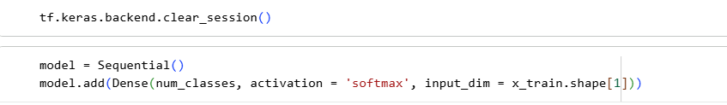

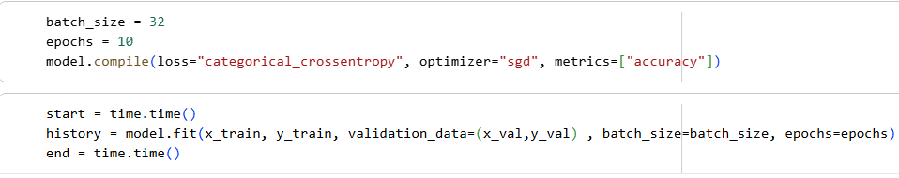

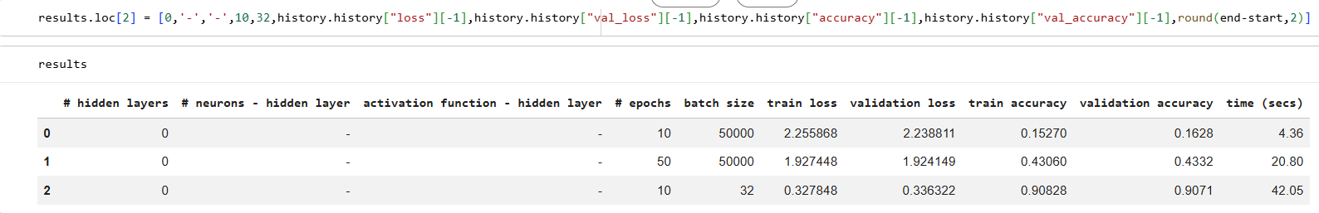
MODEL 3
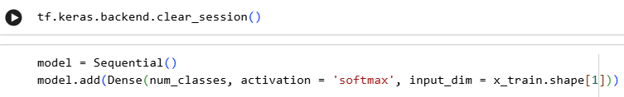

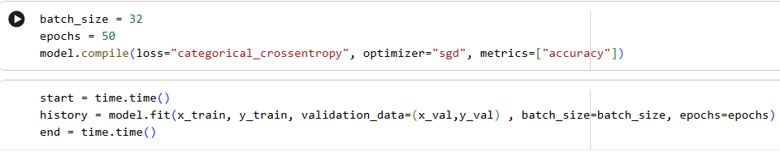

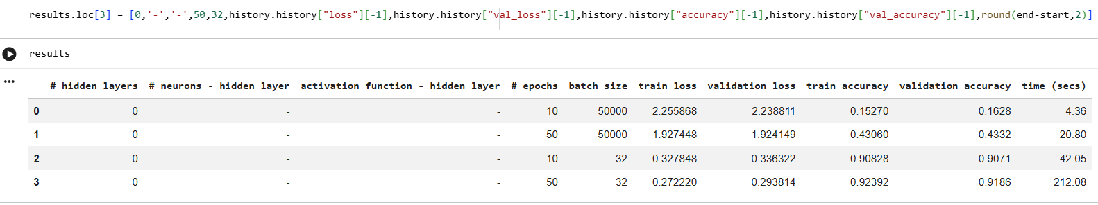
MODEL 4
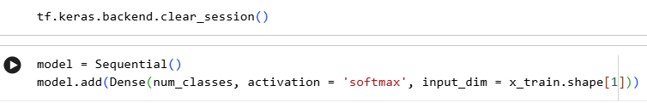

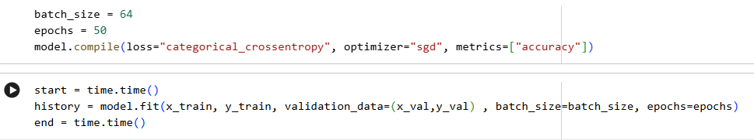

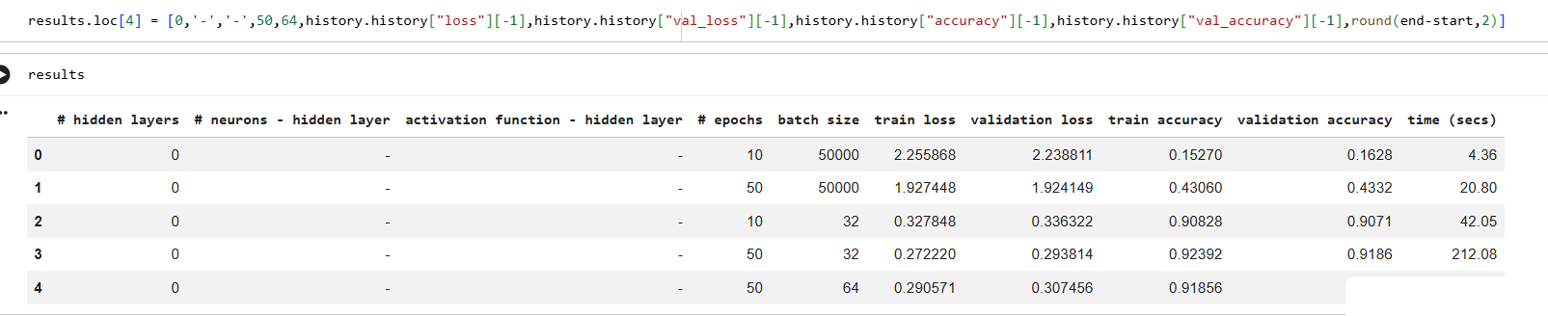

MODEL 5
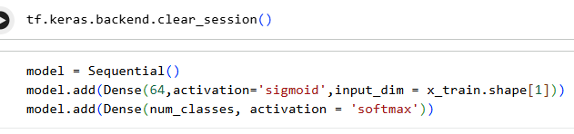

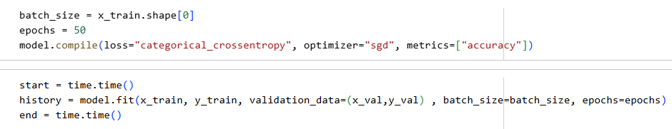

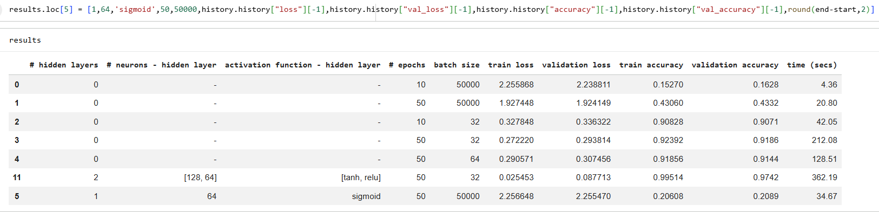
MODEL 6
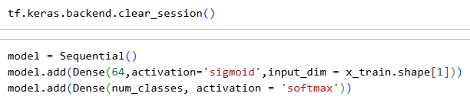

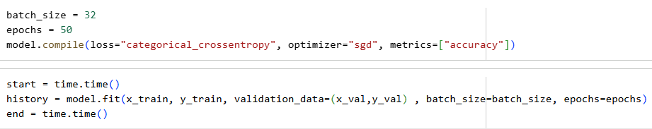
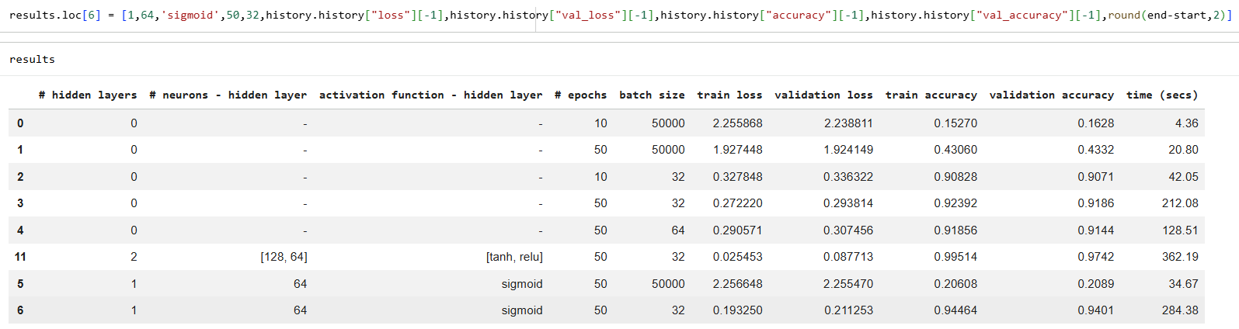
MODEL 7
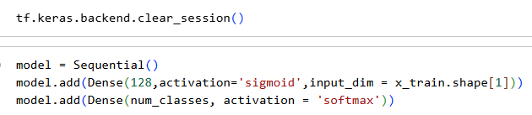

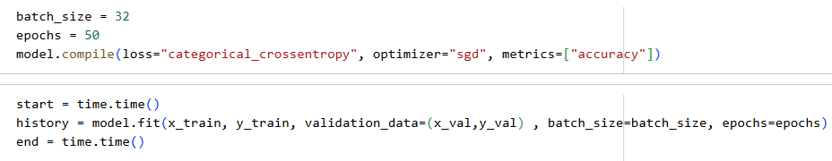

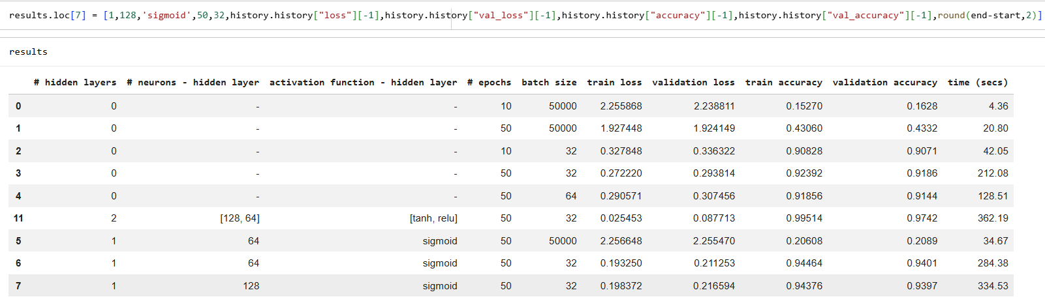
MODEL 8
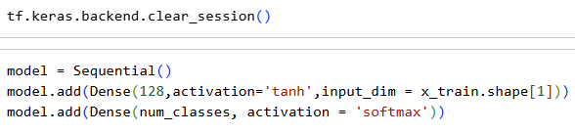

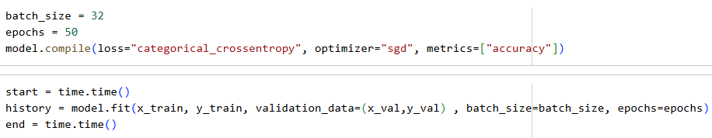

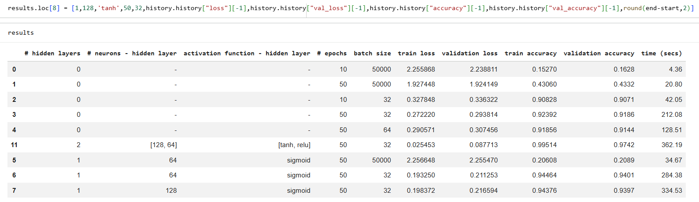

MODEL 9
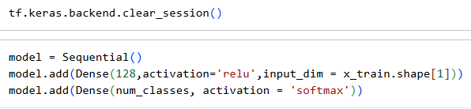

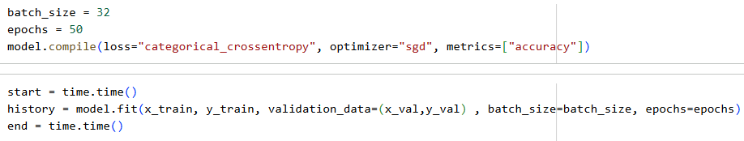

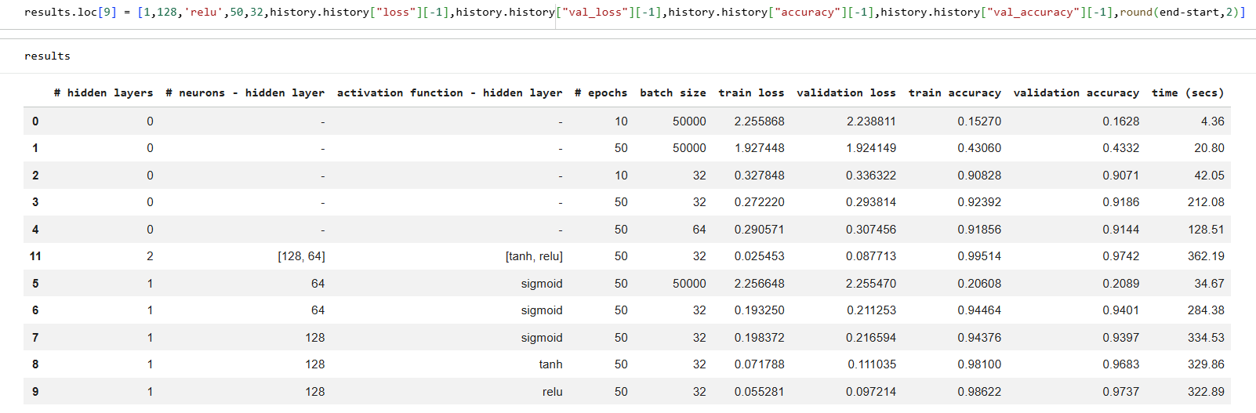
MODEL 10
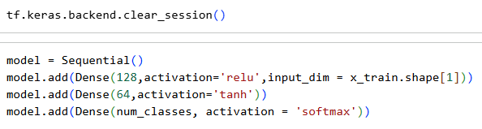

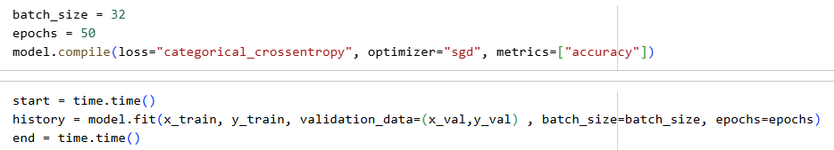

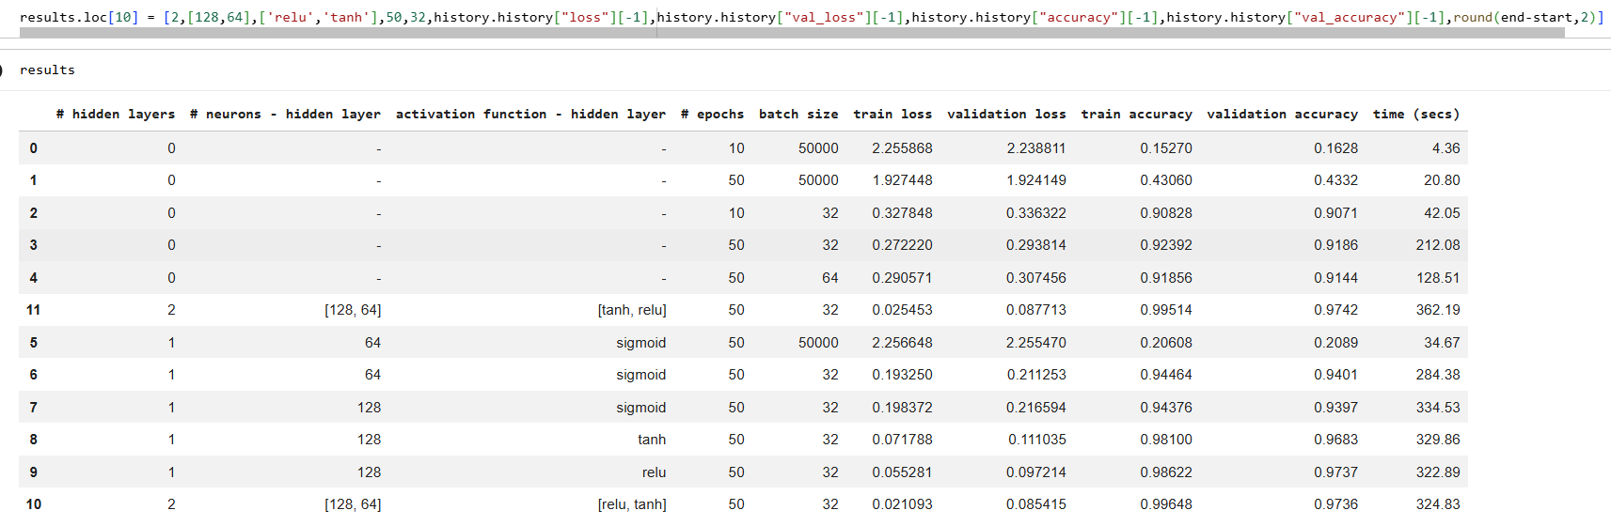
MODEL 11
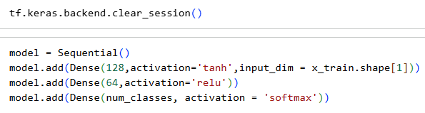

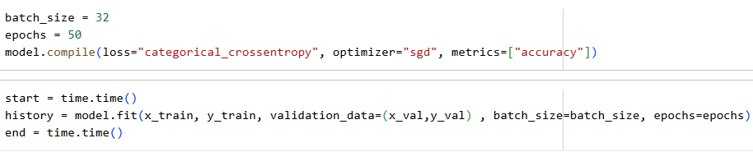
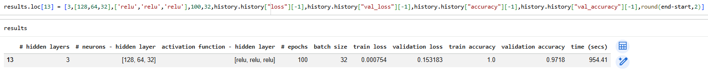

MODEL 12
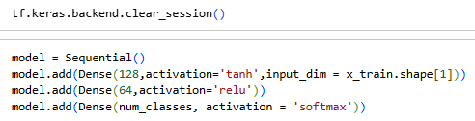

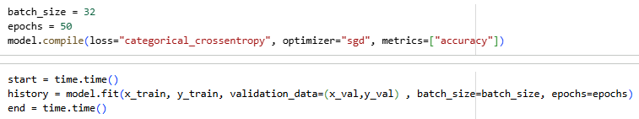

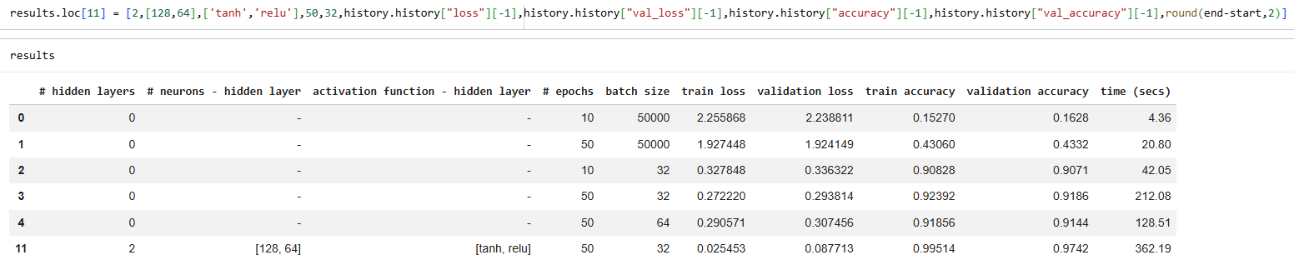
MODEL 13
