1.GAME PLAY ANALYSIS-II

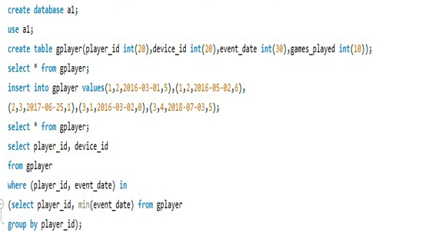

2.NOT BORING MOVIES

