1.DUPLICATE EMAILS

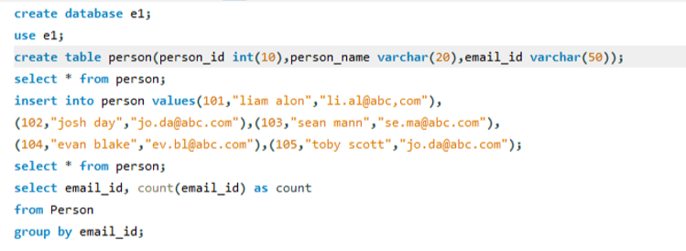

2. FIND FOLLOWERS COUNT

