Assignment-7

1.RISING TEMPERATURE:

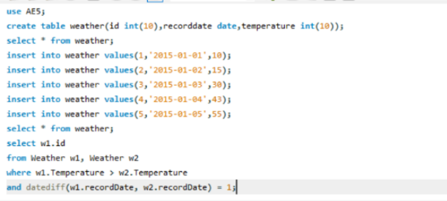

2. CLASSES MORE THAN 5 STUDENTS

