Assignment-10

1.SALES PERSON

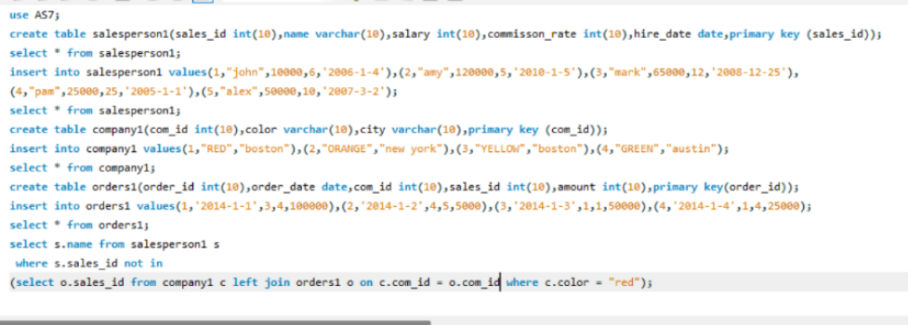

2. SALES ANALYSIS – I

