Assignment-8

1.REPORTED POSTS

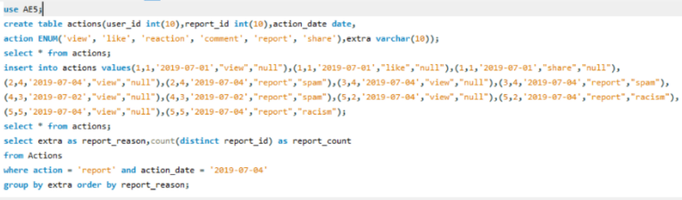

2. USER ACTIVITY FOR THE PAST 30 DAYS I

