Assignment-9

1.CUSTOMER PLACING THE LARGEST NUMBER OF ORDERS

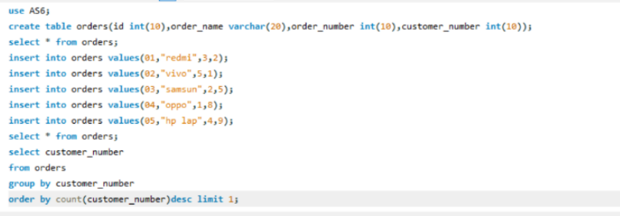

2. .BIG COUNTRIES

