Assiignment-6

1.ACTIVITY FOR THE PAST 30 DAYS II

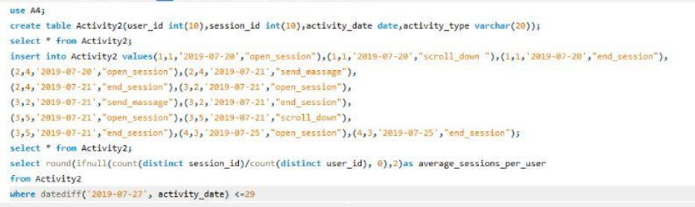

2. DAILY LEADS AND PARTNERS

