***Assignement-1***

1. Use the installation guide, to set up your system for performing the Tableau practical.

Refer to the Installation Guide in “Installation Guide – Tableau-10.0” section with the file

named “Installation Guide”

Note: In a word document, take screenshot of the final screen of installation step and

home screen of tableau and submit it.

Answer:

Steps:

download the Tableau Desktop use this link.

https://www.tableau.com/products/desktop/download .



Click the free student licence.

Fil the forms for license. To activate the Tableau .

You add some proof example id card.

You get a mail for product key from the tableau envirnment.

* 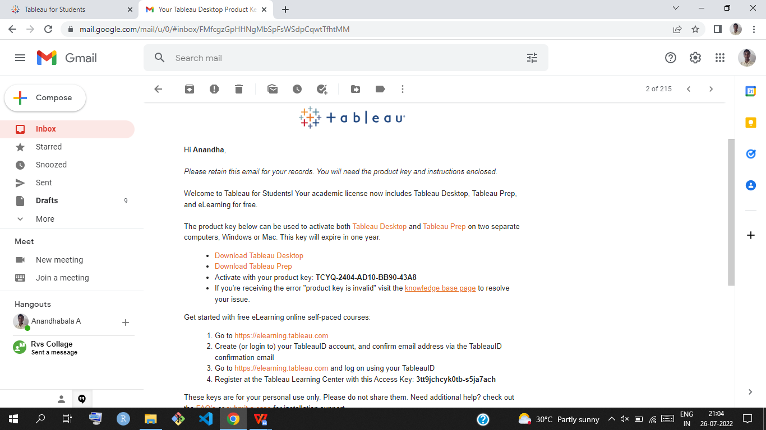

Download and install the Tableau use This mail.

After installing its ask Free trial or Activate.

Click Activate ,its ask product key that time your mail is have some product key

you copy and paste .its shows.

Its displays the SUCCESSFULLY ACTIVATED.

Click continue .the installation of a Tableau Desktop is completed.

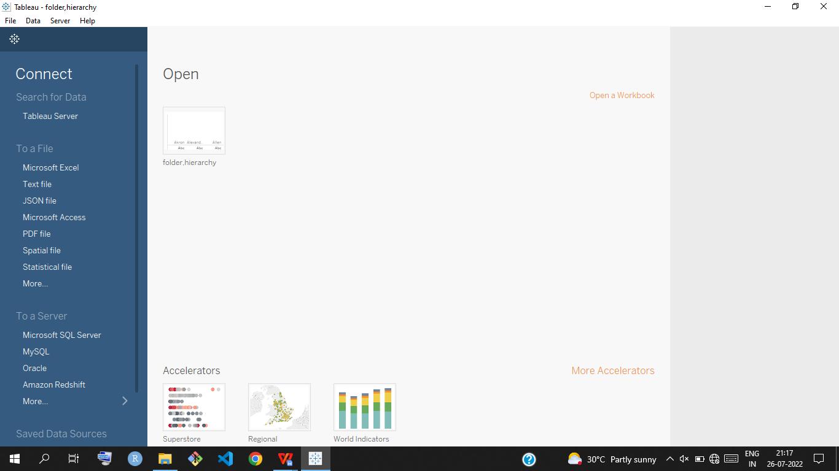

Complted the installation of Tableau DESKTOP.

2. Download the data – set (sales – product) from the link:

Establish the connection between tableau and data-set.

Perform left join, right join, cross joins between sales and product data-set

Note the difference between them joins in terms of data – set and visualization and compile them in a word document.

Answer:

Steps:

Open the tableau public .

Connect the two data sets of sales and product.

Perform the left join,right join,cross join:

CROSS JOIN :(category,sub-category from product data set),(orderdate,sales from sales data)

Ans:

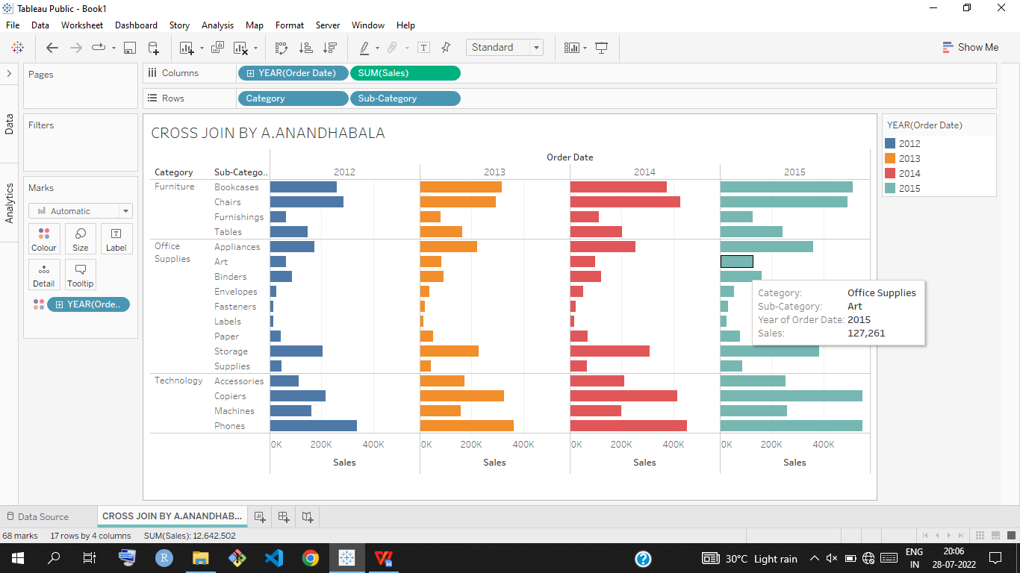

Left join: (product id ,sales from sales data set) (product name,sub-category from product data set)

Ans:

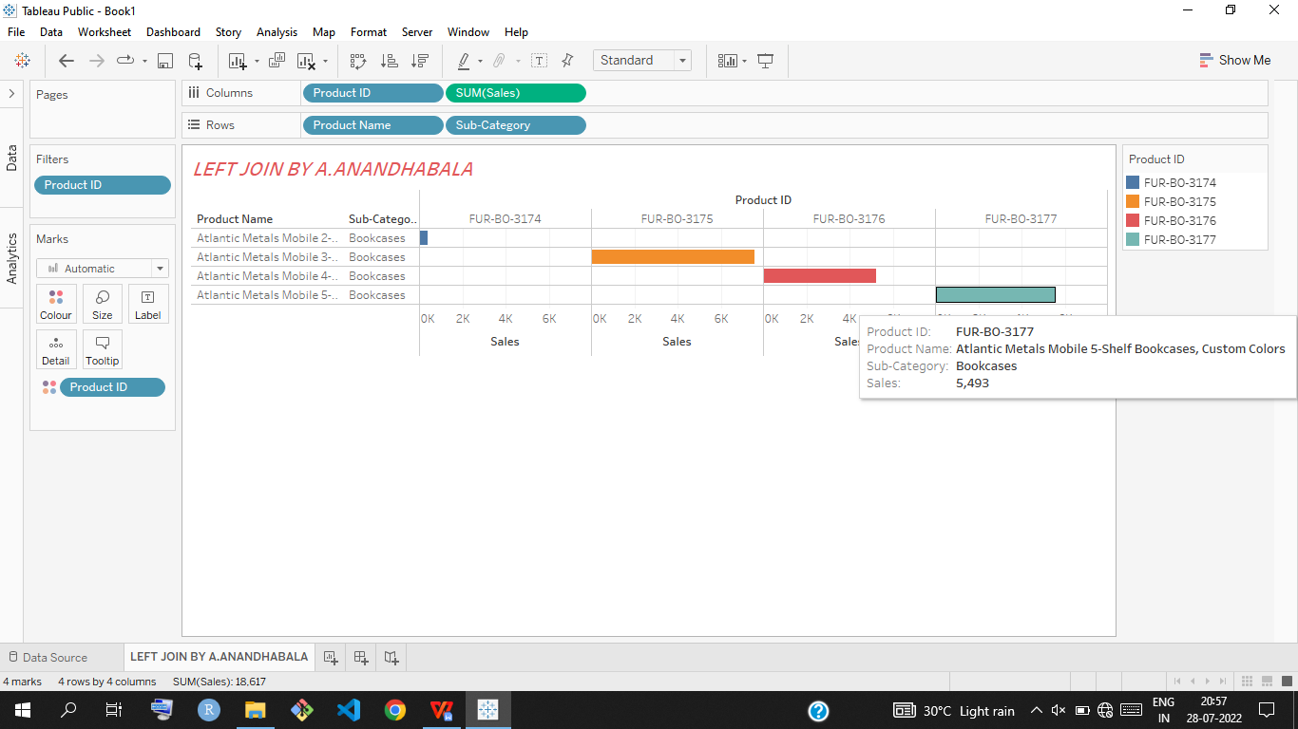

Right join: (sales ,market,order date from sales data set) (product- id from product data set).

Ans:

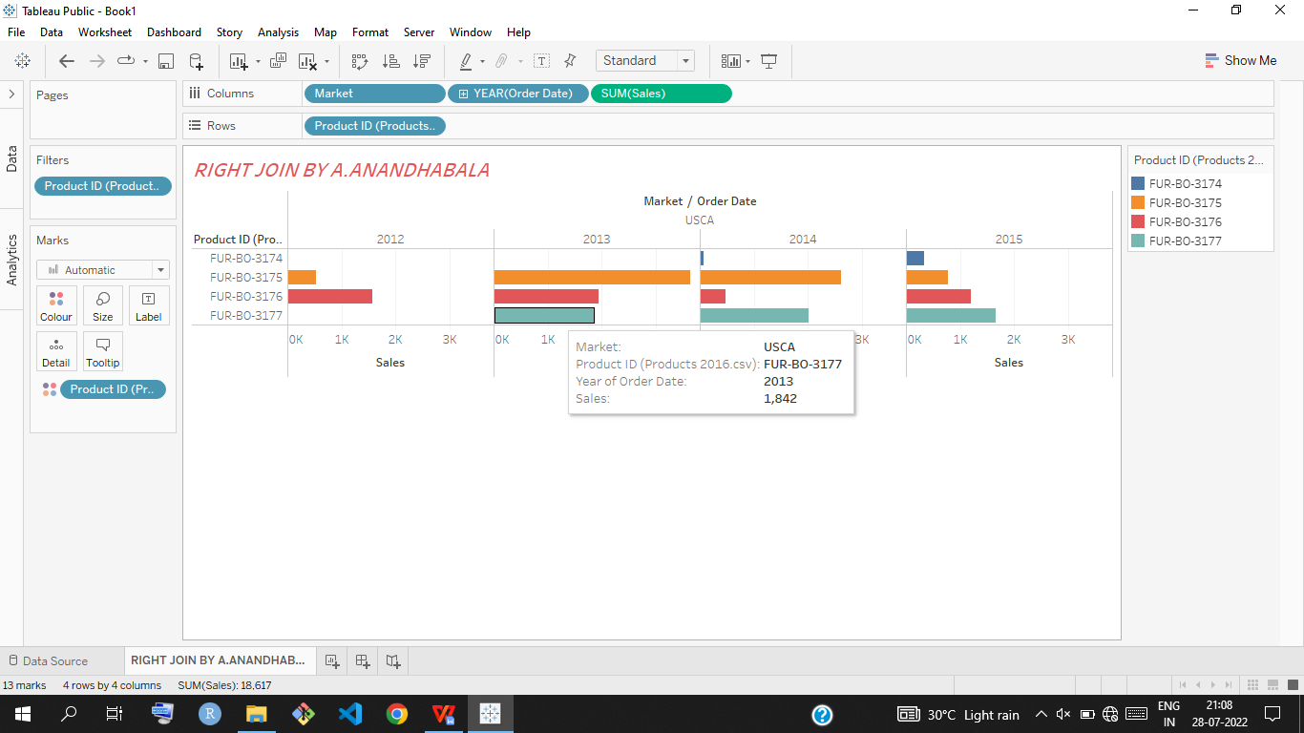

**Submitted by**

**Arshad.MK**