**BUSINESS INTELLIGENCE USING TABLEAU**

**Assignment-2**

**QUESTIONS:**

1. Download the dataset from the following link and use the data-set global superstore for this assignment.

Find the top 5 profitable products and arrange them in ascending order based on their number of sales.

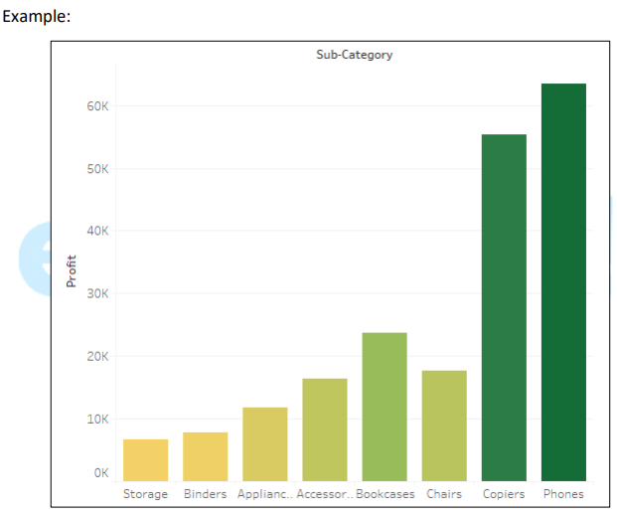

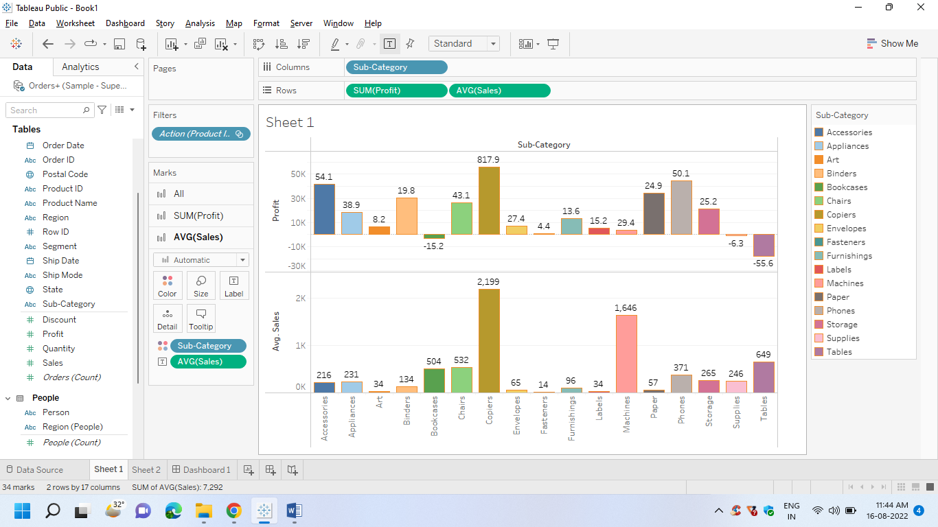

1. Create the best possible Graphical Visualization for profit generated over sales for all the distinct products available (with different ProductID)

