BI ASSIGNMENT-2
Name: SUMITHRA A
Reg no: 1P25CS017
Class: Ist M.SC COMPUTER SCIENCE

- What is a Data Warehouse and discuss about the need of ETL?

Data Warehouse:
A Data Warehouse is a system used to store consolidated data collected from various operational sources.
It is specially built to support data analysis, business intelligence, and reporting activities.
Unlike regular databases, a data warehouse focuses on historical trends rather than current transactions.
Key Features
- Stores historical and summarized data
- Combines data from multiple heterogeneous sources
- Optimized for queries and analysis
- Read-only in nature

Need of ETL in a Data Warehouse
ETL is a data integration mechanism that prepares raw data before storing it in the data warehouse.
Extract
Data is gathered from different operational systems such as:
- OLTP databases
- Spreadsheets
- Web applications
Transform
During transformation:
- Data is validated and formatted
- Inconsistent values are corrected
- Business rules are applied
- Data is converted into a common structure
Load
The final processed data is stored in the data warehouse tables for analysis.

Why ETL is Necessary
- Operational data is not directly suitable for analysis
- ETL removes redundancy and errors
- Ensures uniform data structure
- Enables fast and accurate reporting
- Maintains data integrity

Summary
A Data Warehouse acts as a decision-support system, while ETL plays a crucial role in preparing, integrating, and loading clean data into it.

- What is the difference between OLTP and OLAP?

OLTP (Online Transaction Processing) is designed for fast, real-time handling of day-to-day business transactions, while OLAP (Online Analytical Processing) is optimized for complex queries, reporting, and multidimensional data analysis to support decision-making. In short, OLTP powers operations, OLAP powers insights.

Feature | OLTP (Online Transaction Processing) | OLAP (Online Analytical Processing)
Purpose | Manages day-to-day business transactions | Supports data analysis and decision-making
Type of Operations | Insert, Update, Delete, Select | Complex queries, aggregations, analysis
Data Nature | Current, detailed data | Historical, summarized data
Database Design | Highly normalized | Denormalized (star/snowflake schema)
Number of Records | Small transactions, frequent access | Large volumes of data
Users | Clerks, end users, applications | Managers, analysts, decision-makers
Response Time | Very fast for simple queries | Optimized for complex queries
Data Updates | Continuous and real-time | Periodic (batch updates)
Examples | ATM transactions, order processing, banking systems | Sales analysis, trend analysis, forecasting

Conclusion:
- OLTP systems focus on efficient transaction handling and data integrity.
- OLAP systems focus on data analysis and reporting using historical data.
Both serve different purposes but together support effective business operations and strategic decision-making.

- Using PDI transformation read data from source and writes the data to target database.

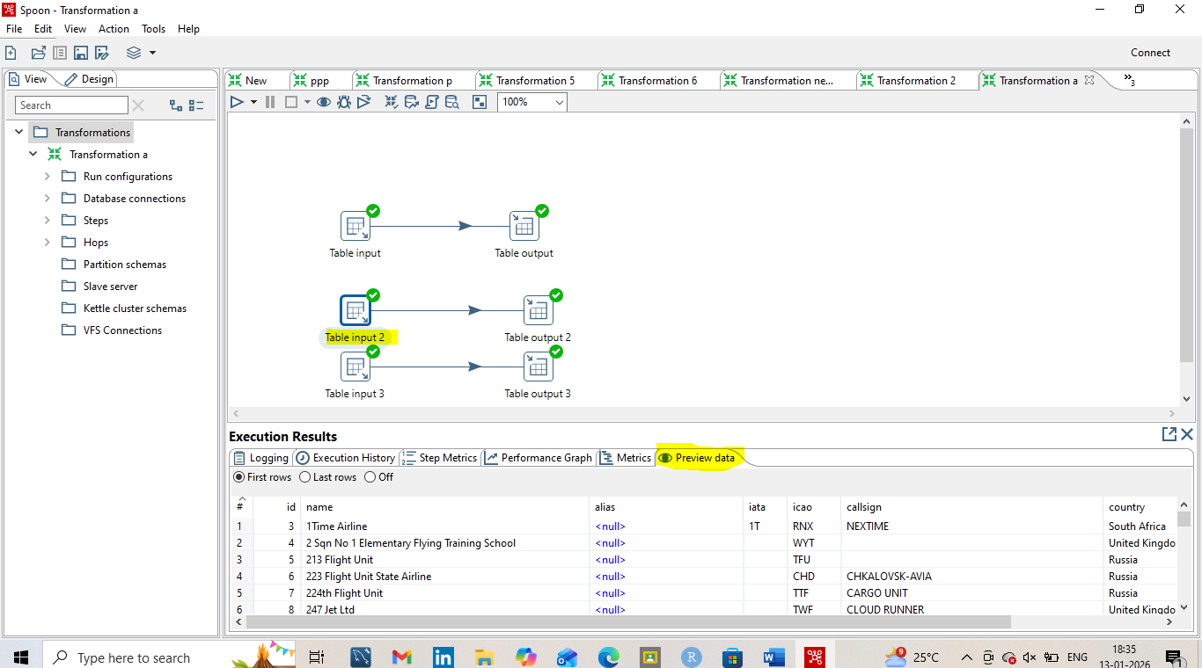
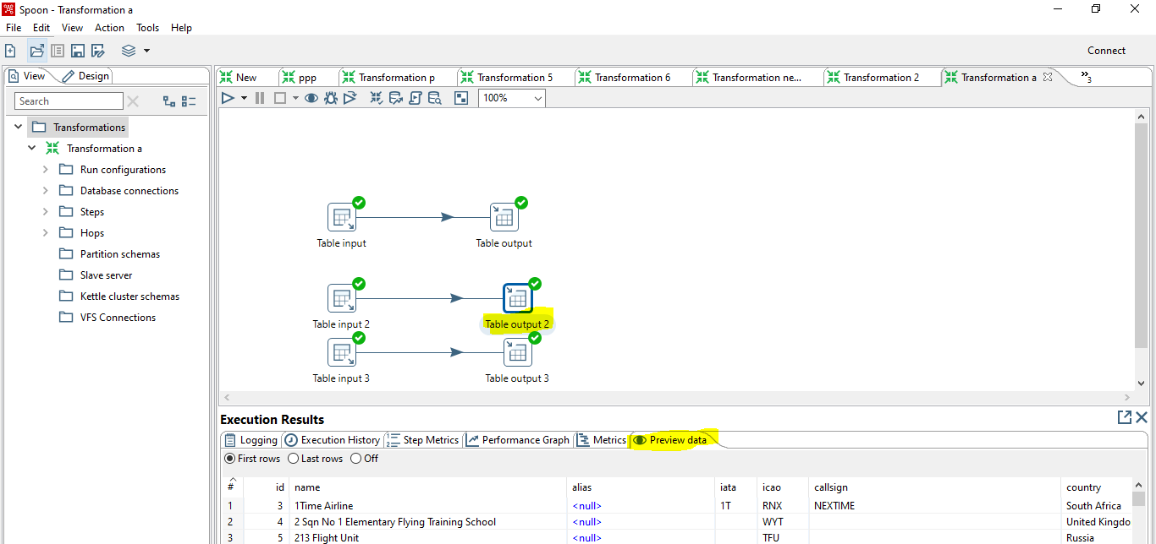
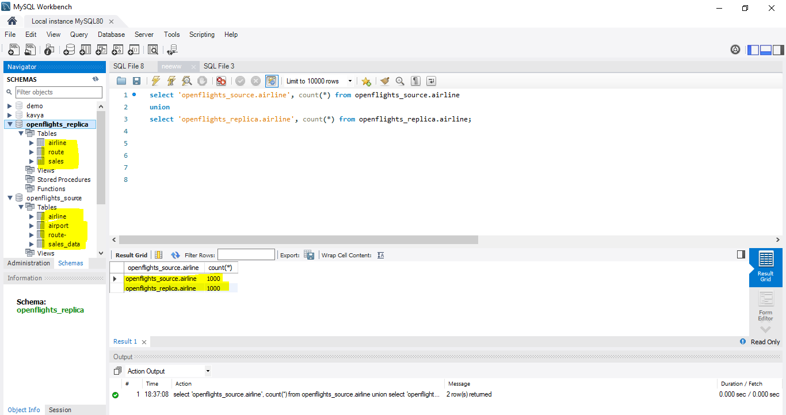
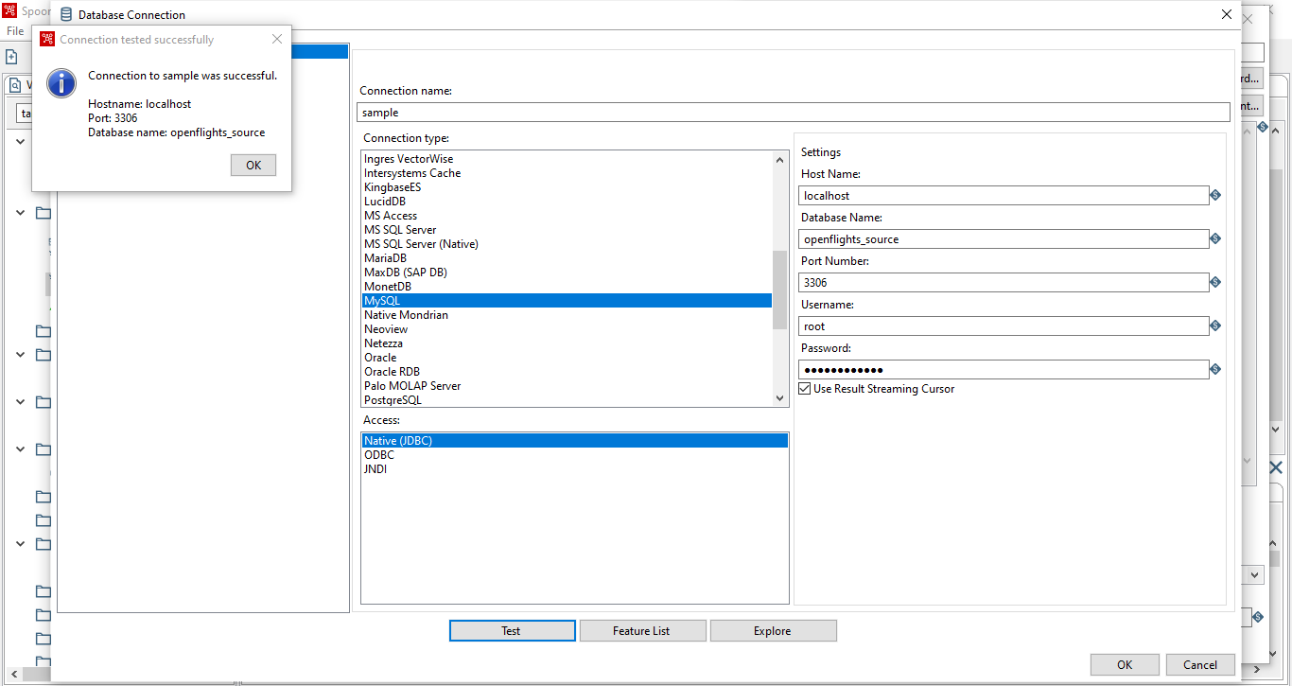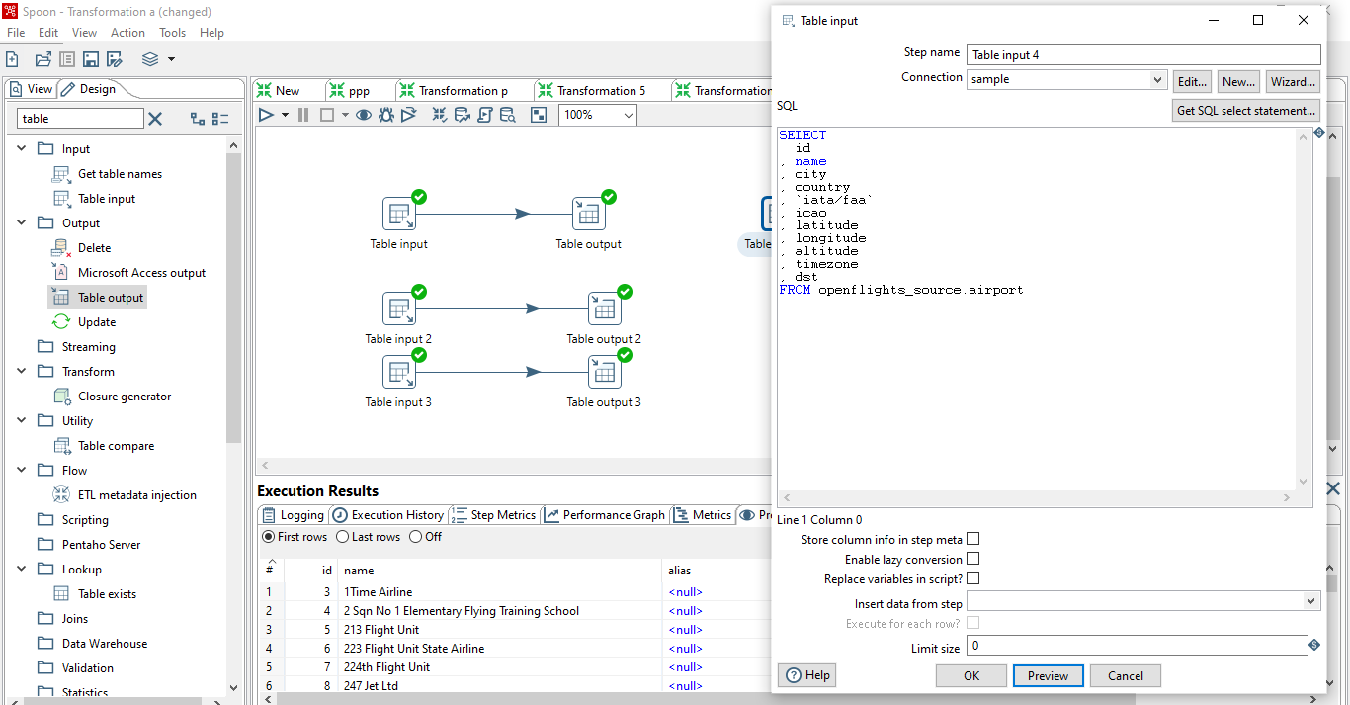
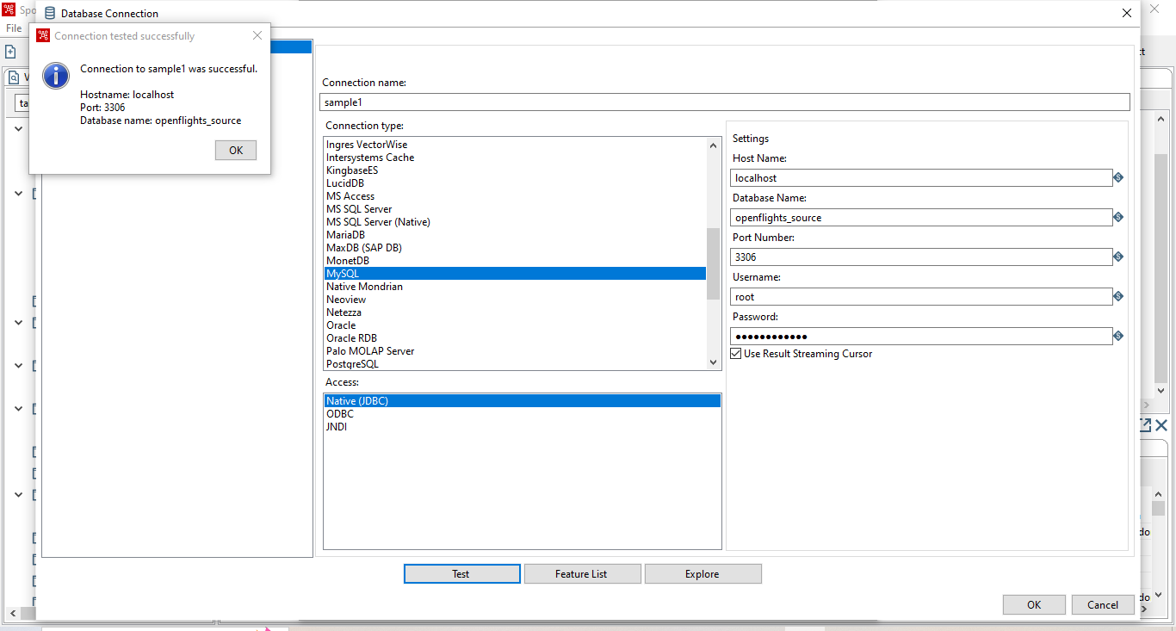
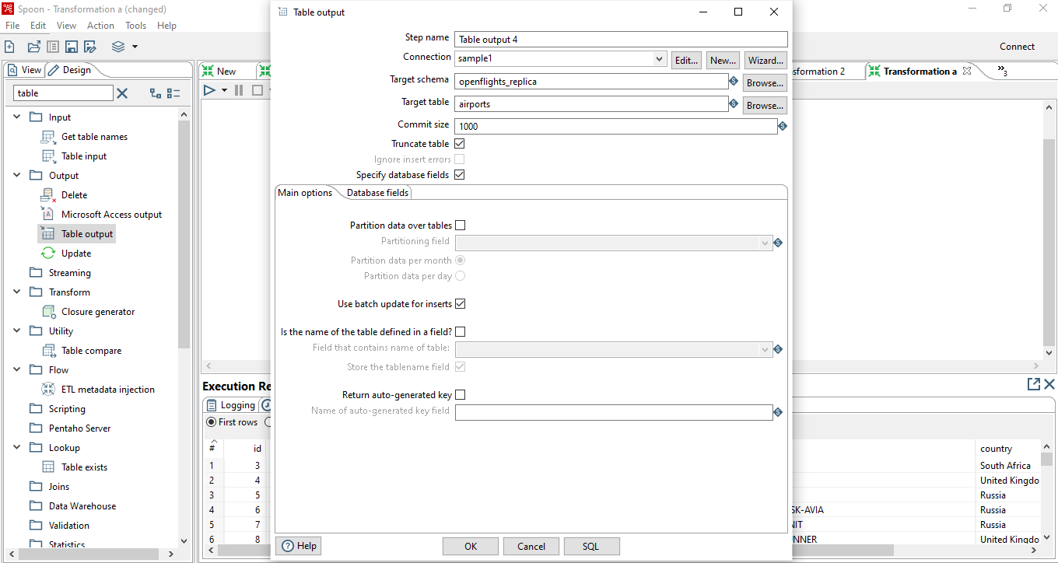
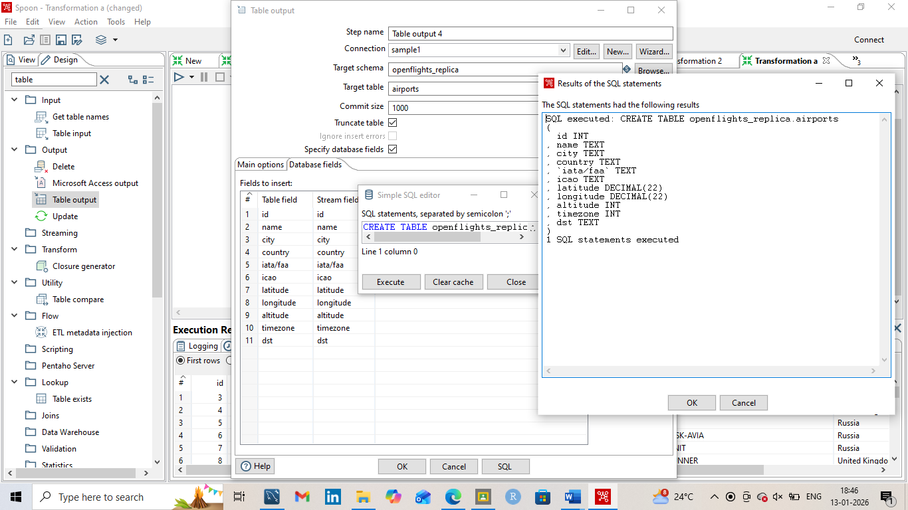
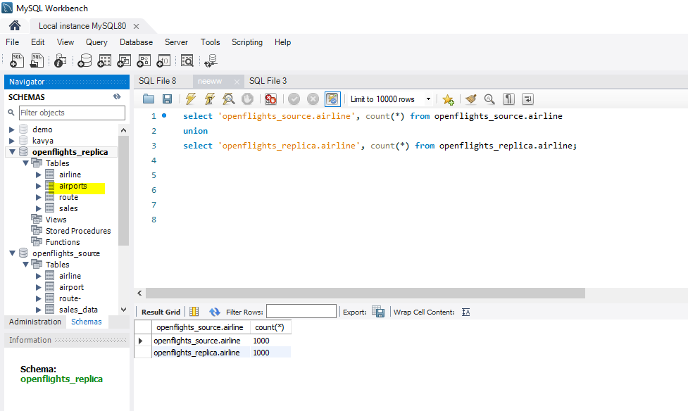
- Retrieve data from a CSV file and click preview rows to verify the file is being read correctly. (Use: Cust_dimension)

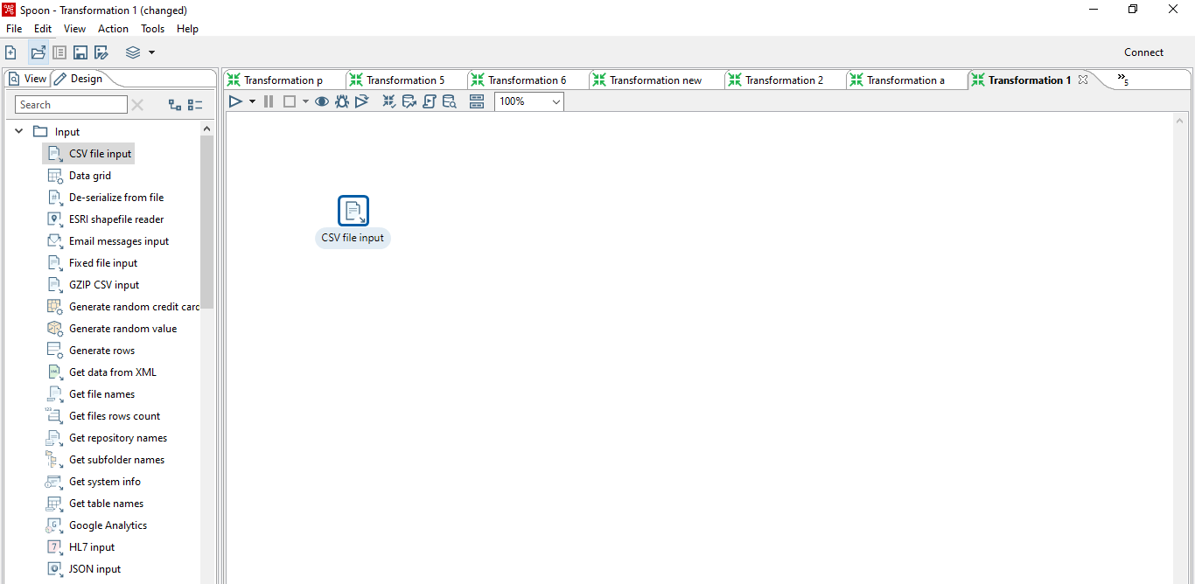
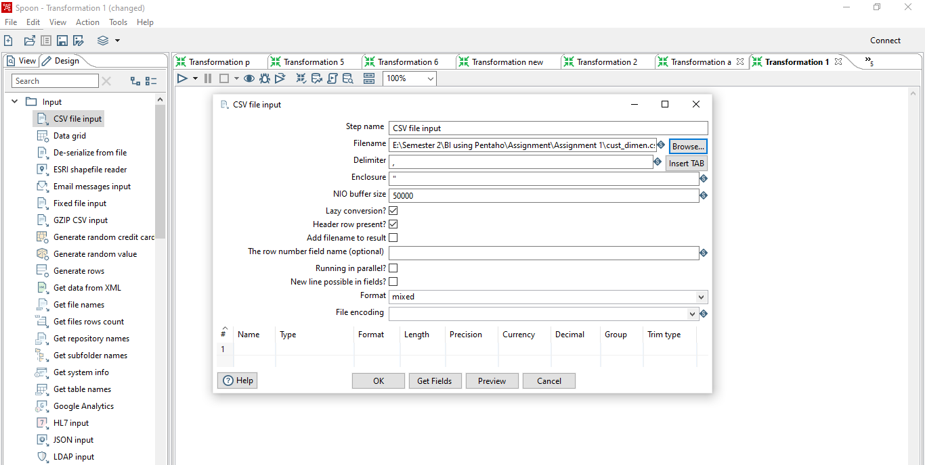
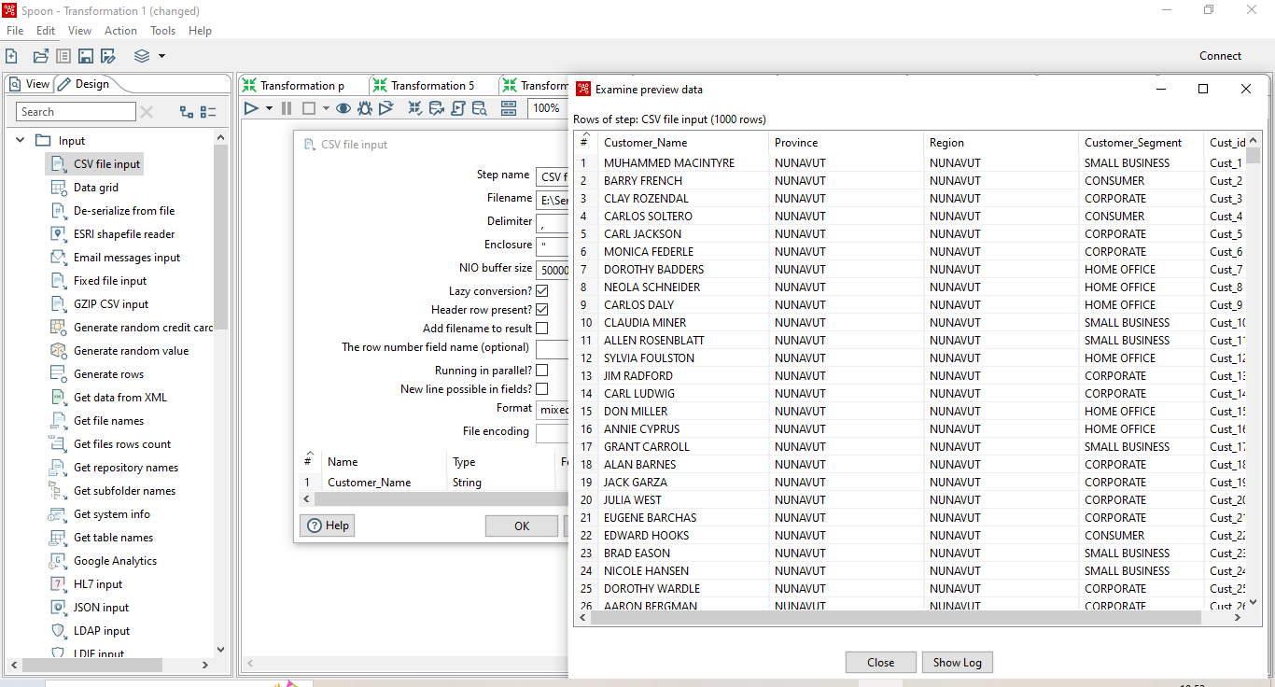
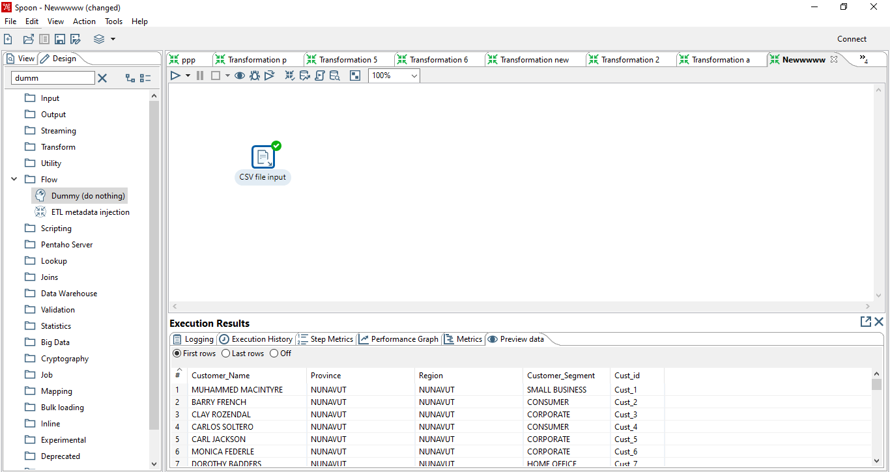
- To obtain a data, use the following component.
  - Merge
  - Sort
  - Unique
