**Unit-4**

**Assignment-4**

1**.**

**Problem Statement** Case Study: Educational Institute You have been hired by an educational

We are building a dashboard using Global Superstore Dataset.

Step 1:

* Click on the Sheet Tab and rename it as Running Total Profit by Segment
* Drag Segment field onto the Columns Shelf and apply a filter by selecting only Consumer
* Drag Profit field on to the Rows Shelf and apply quick table calculation of Running Total
* Drag Order Date field on to the Columns shelf and make it continuous measure
* Drag Category field on to the Colors Shelf
* 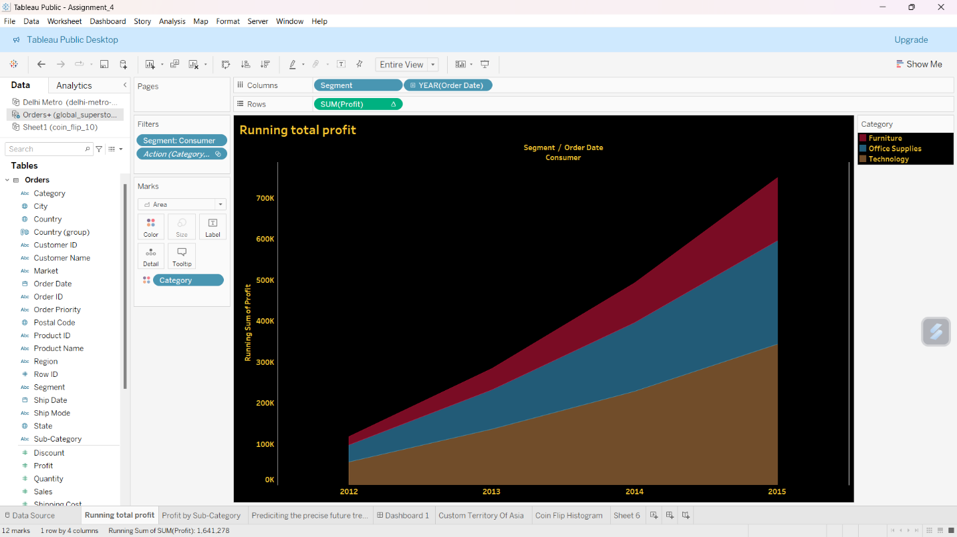Select Area chart option from the Marks Card.

Step 2:

* Add another sheet and rename it as Profit by Sub-Category
* Drag Sub-Category field on to the Rows shelf and Profit field on to the Columns shelf
* Sort Sub-Category into descending order
* 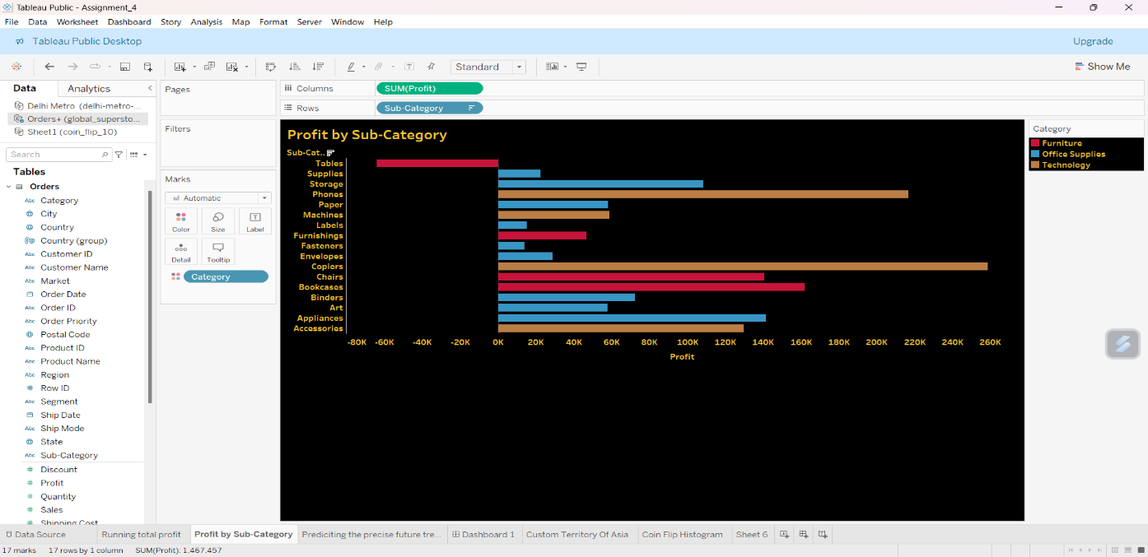Drag Category field on to the Colors shelf

Step 3:

* Click the Dashboard Tab
* Drag Running Total Profit by Segment sheet on to the view pane
* Drag Profit by Sub-Category sheet on to the view pane
* Now, we can interact with the Dashboard using the Legends
* Select the Office Supplies option from the Category Legend, only Office Supplies part

will be highlighted on the views

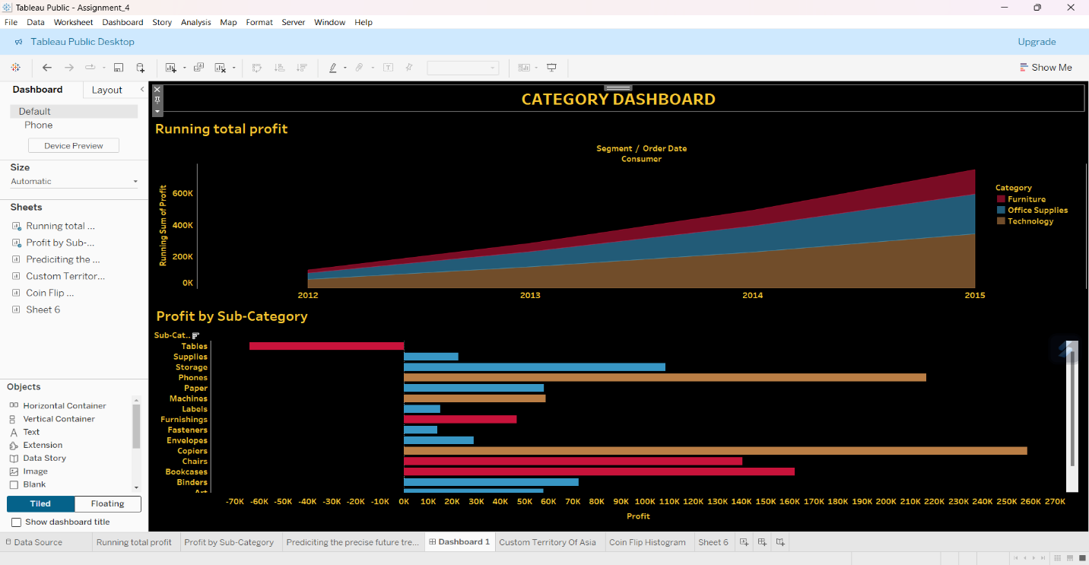

2.

**Demonstrate the following**:

a. Flip a coin 10 times and record the number of times the outcome is ‘heads’. Note

both the number of heads and the percentage of heads out of 10 flips.

b. Repeat this process 20 times, resulting in a total of 200-coin flips.

c. Record your results Coin Flip Spreadsheet Template.xlsx file and

save it.

d. Create a histogram to display the results of your experiment.

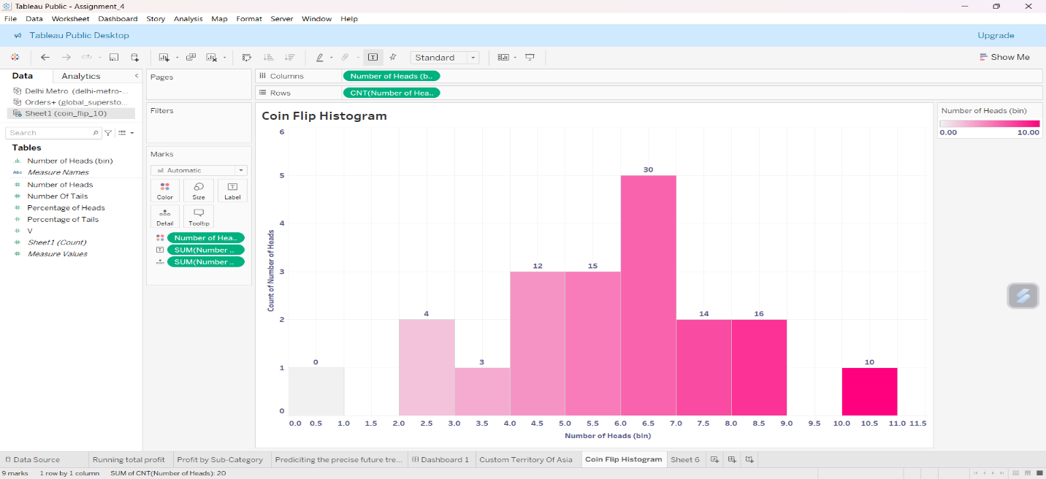

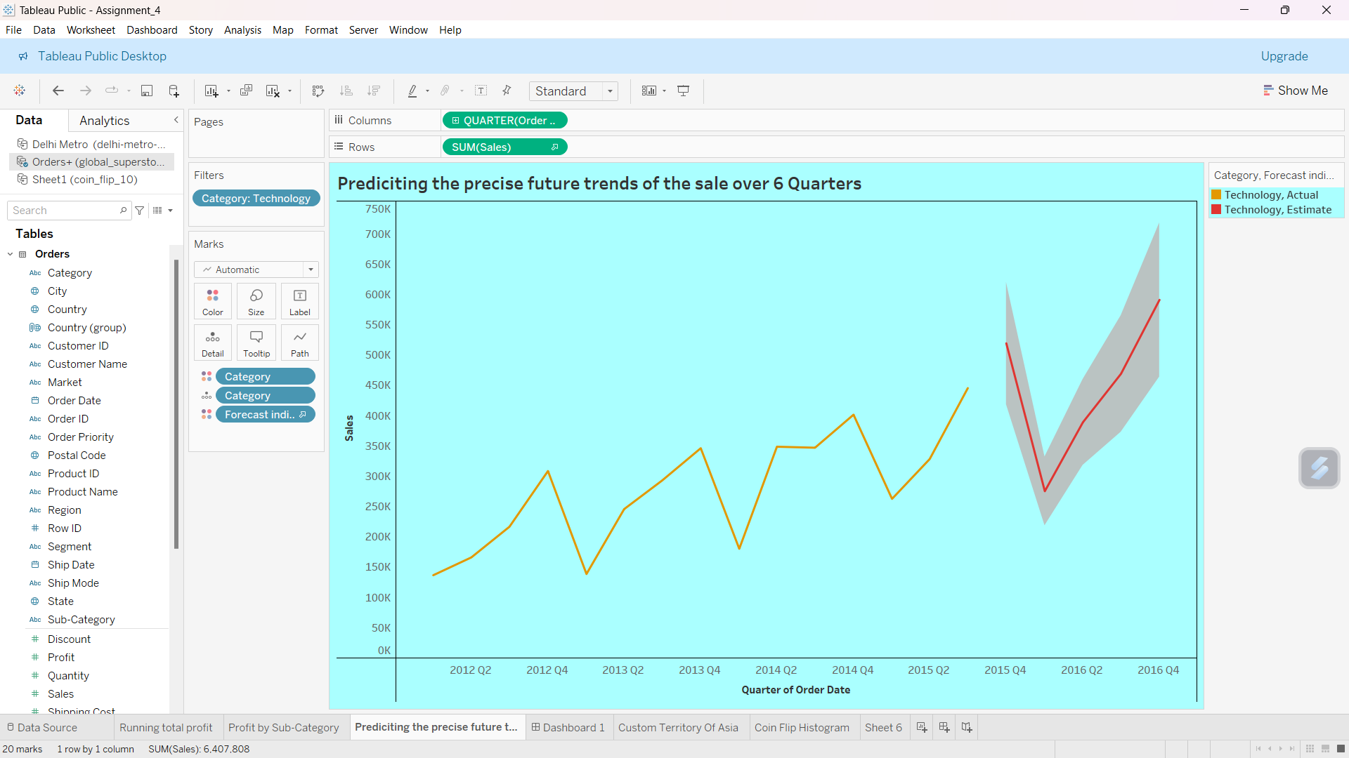3.Use the global superstore 2016 to create a visualization predicting the precise future trends of the sale of the product over 6 quarters.

4.

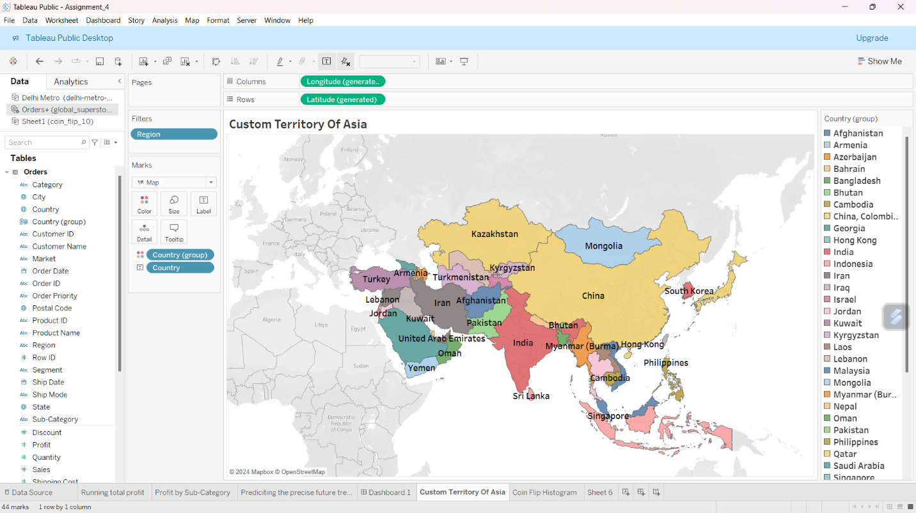Using the dataset “Global Superstore 2016”, create a custom territory for Asia (using lasso tool), with detailed view of countries.

5.Using the “Delhi’s Metro Map” as the background image, generate the coordinate for Red Line of metro. Data set:  Delhi Metro

