- Python Program to Add Two Numbers

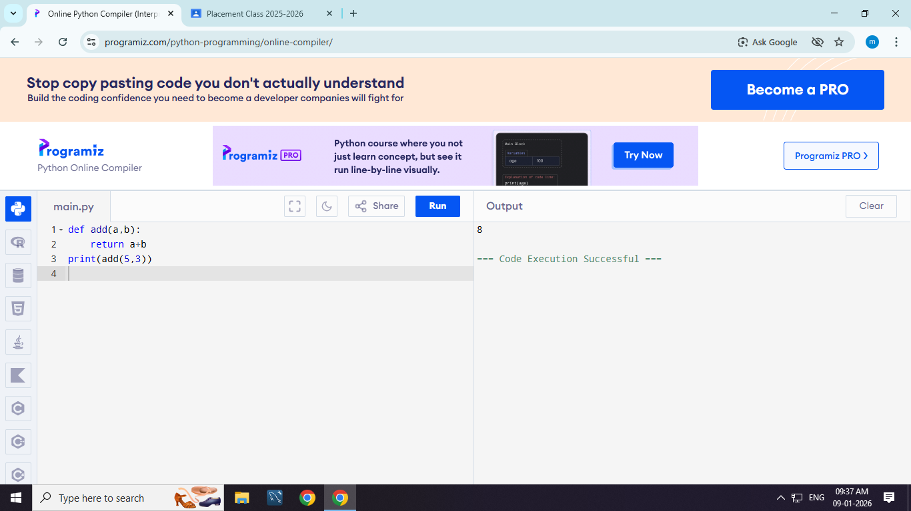

- Python Program to swap two numbers

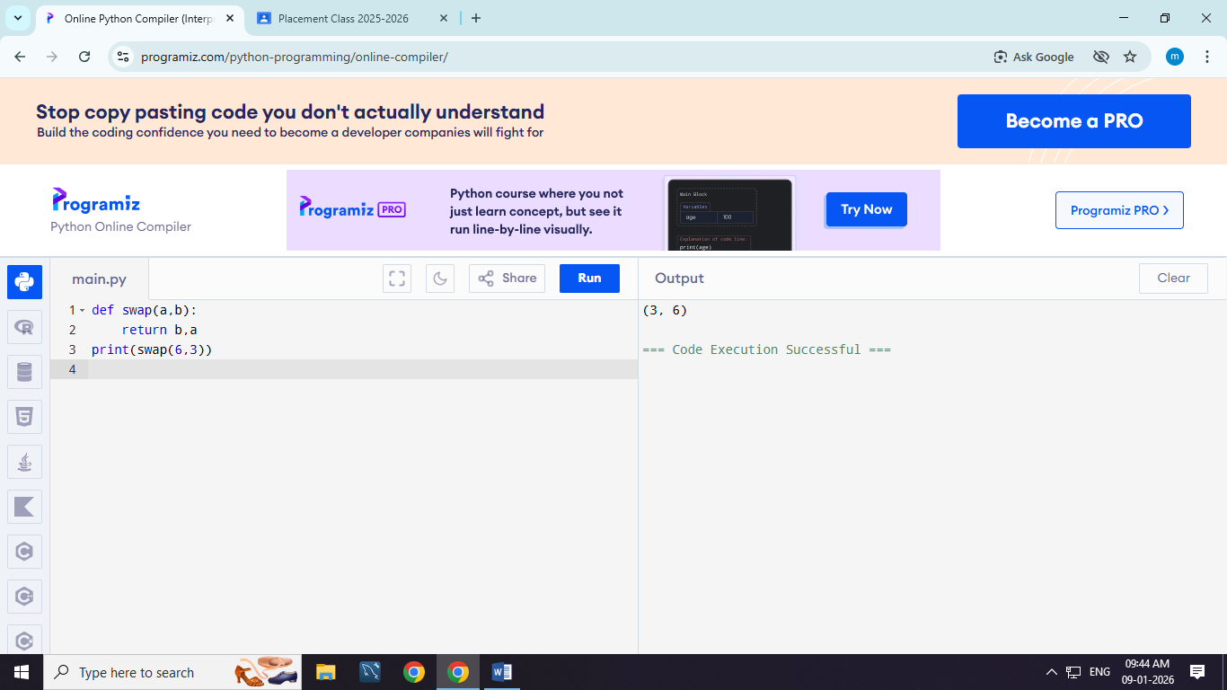

- Python Program to find square root of the number

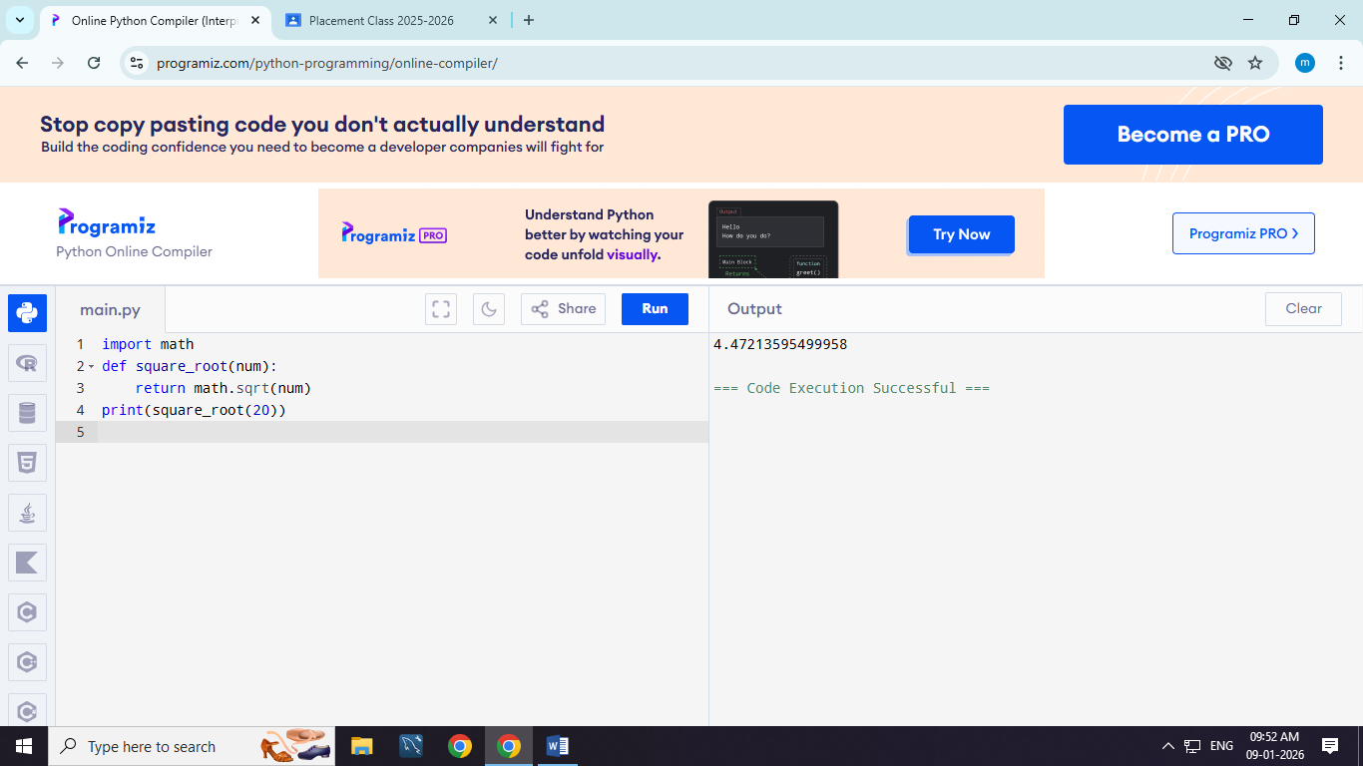

- Python Program to calculate the Area of Triangle

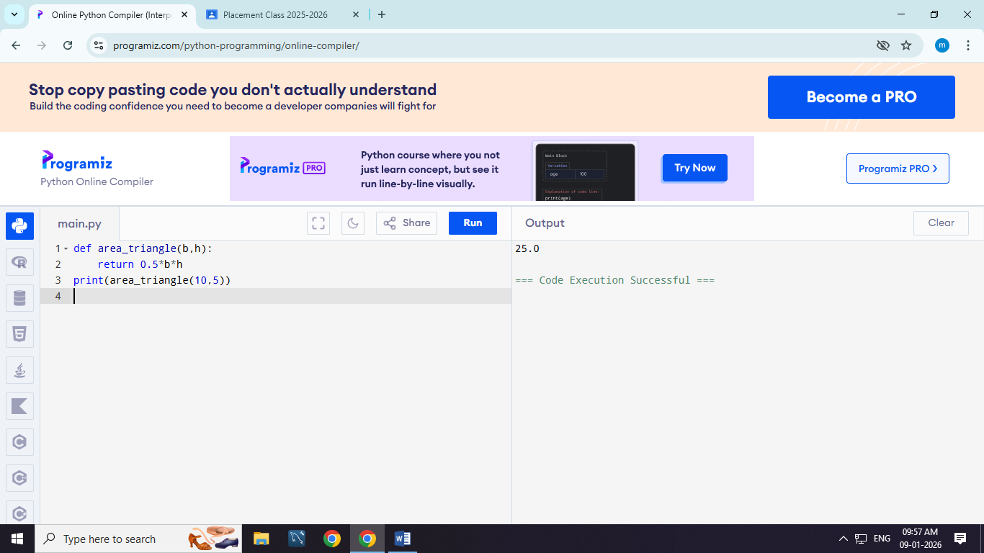

- Python Program to find factorial of a number

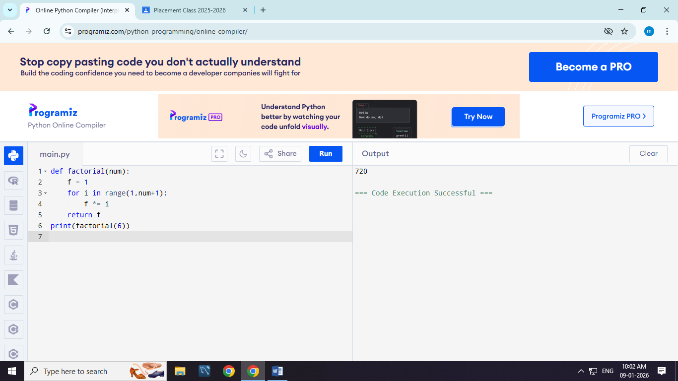

- Python Program to Check if a Number is Odd or Even

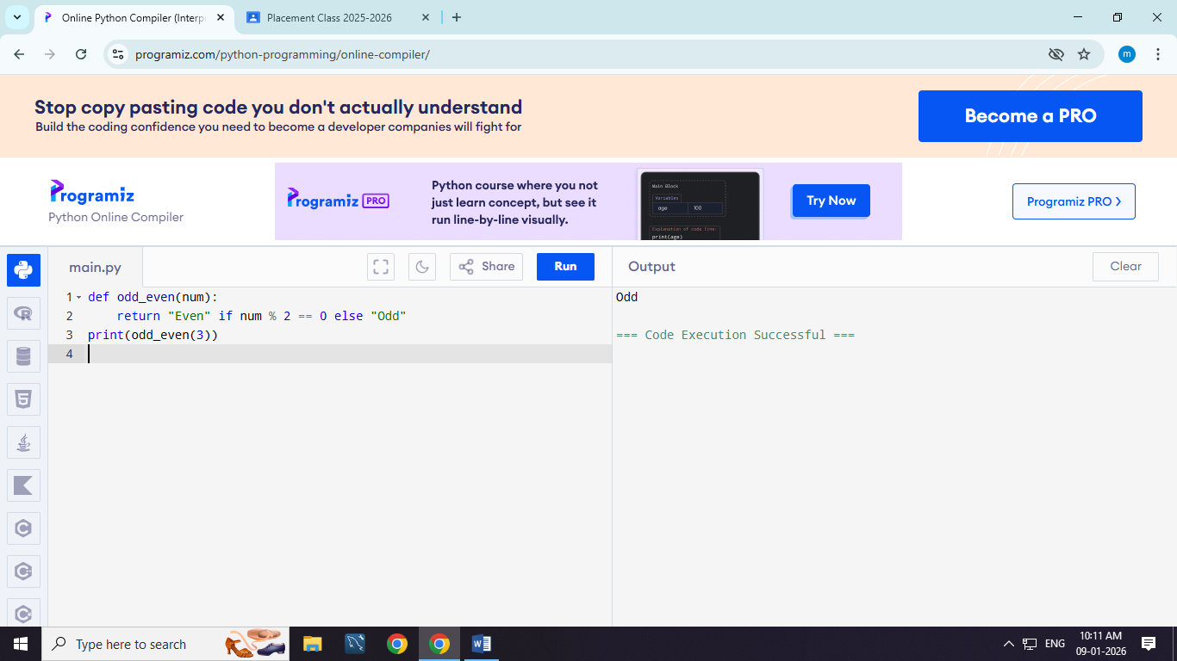

- Python Program to Check Leap Year

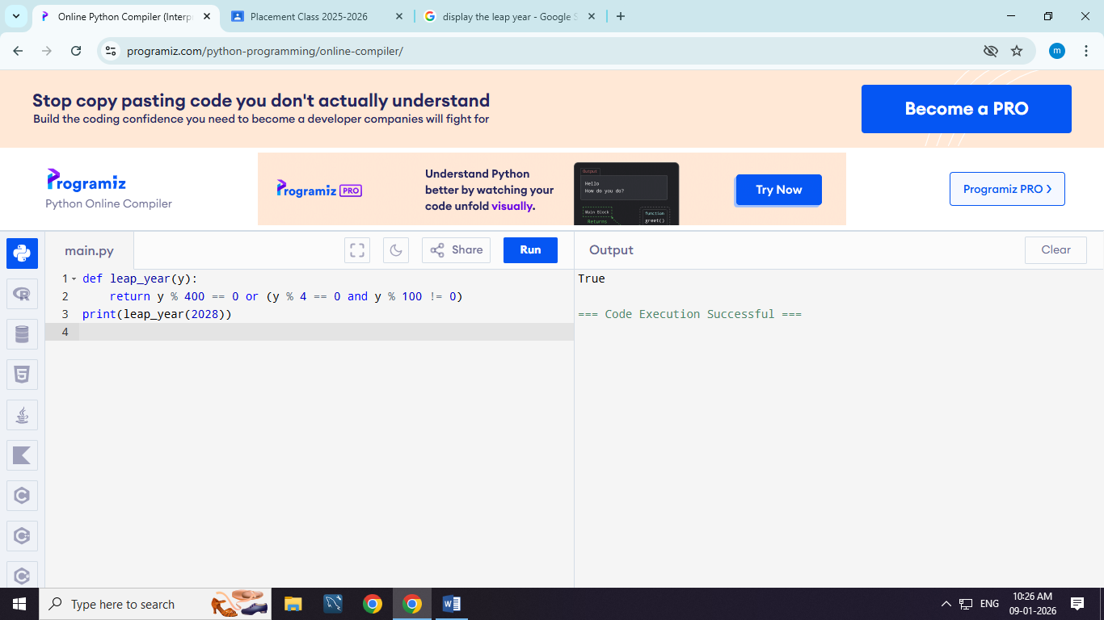

- Python Program to Check Prime Number

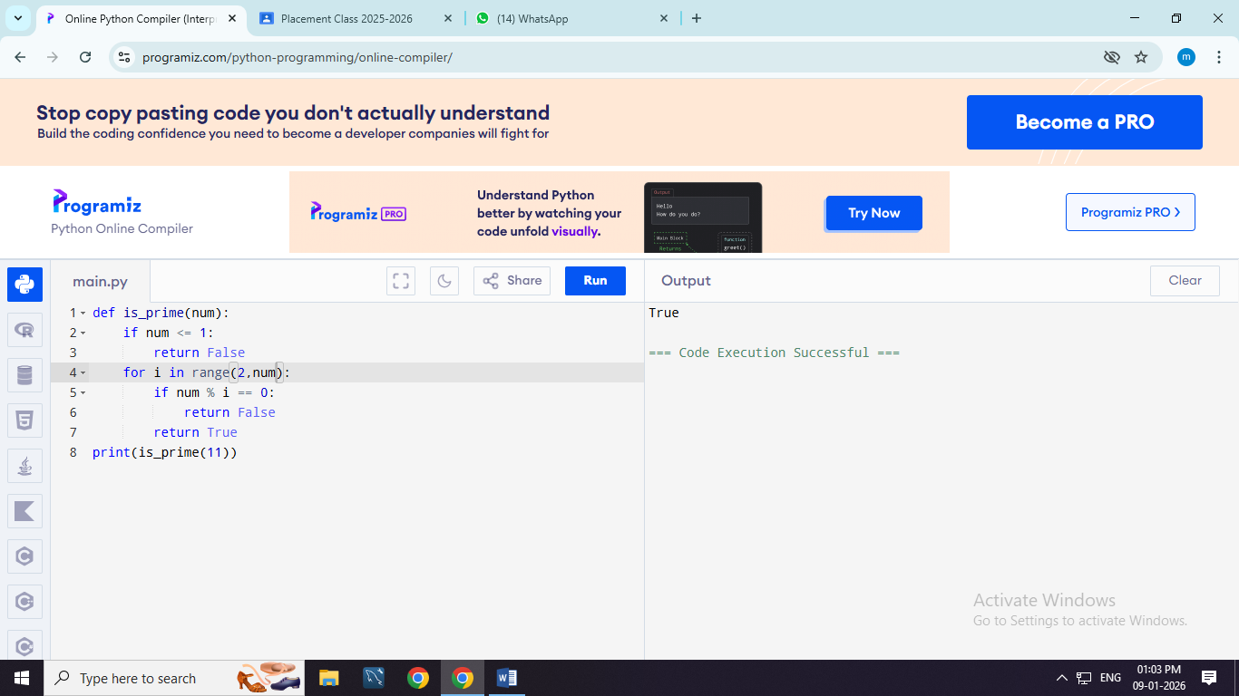

- Python Program to Print the Fibonacci sequence

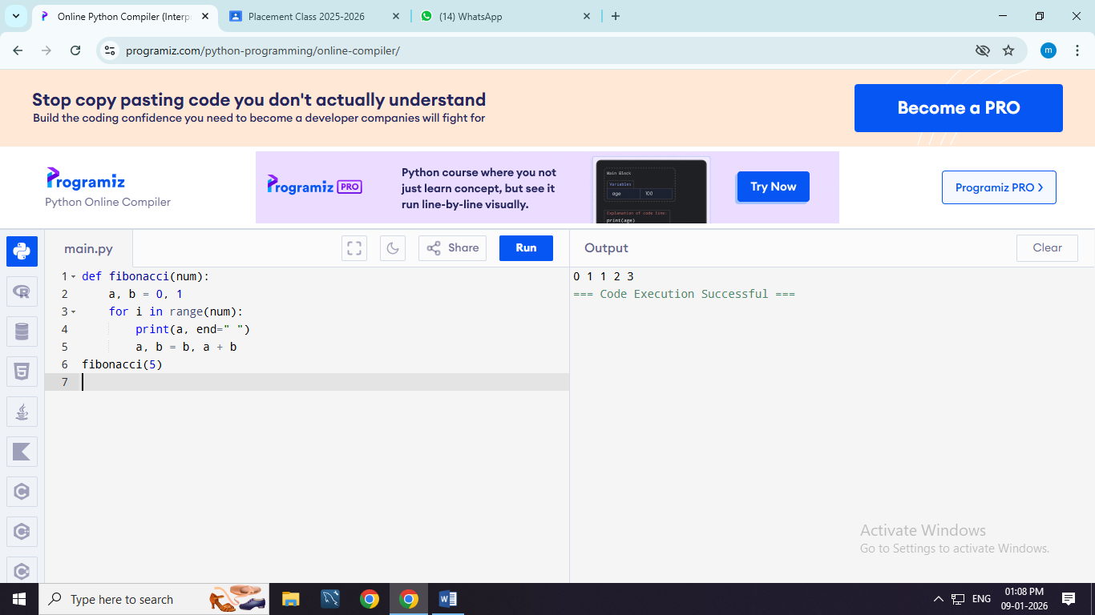

10. Python Program to Check Armstrong Number

