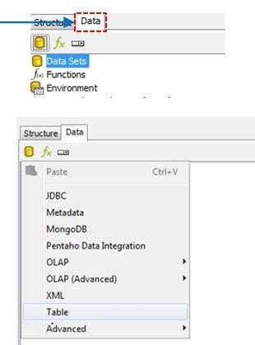

**Ex. No.: 06**

**Adding data source**

**A**

**im:**

a)

Adding data source (

033

_m2_ds_v.1.0 excel

file)

b)

Importing

Spread

sheet

**Algorithm:**

1

.Start the process.

2

.Create a data source

using Excel.

.Save the file in CSV format.

3

.Open Pentaho Launcher

4

tool for data integration.

5.

Import Spread sheet

6.

Create a report.

7

.S

ave the file.

8

.Stop the process.

**Screen Shot :**

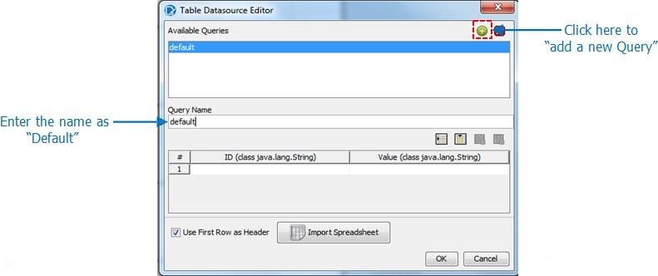



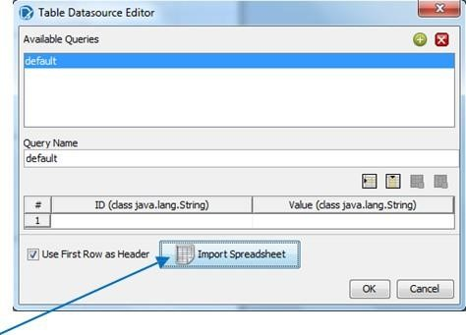

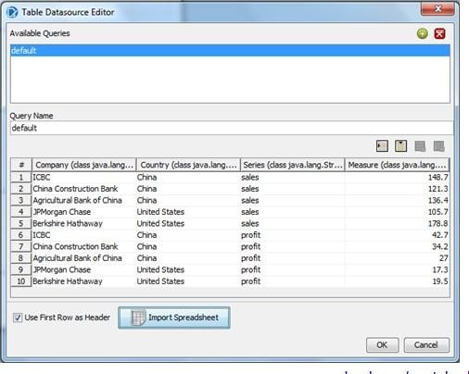

**Result :**

Thus the expected output is achieved successfully**.**